**TABLE OF CONTENTS**

**DEFINITION, INVESTIGATION AND ANALYSIS ………………………………………………….. 3**

Definition – Nature of the Problem ……………………………………………………………………. **4**

Investigation ………………………………………………………………………………………………………. **7**

Record Findings ……………………………………………………………………………………………….. **11**

System Flowchart …………………………………………………………………………………………….. **15**

Problems in the Existing System ……………………………………………………..……………….. **16**

Proposed Solution ………………………………………………….……………………..…………………. **18**

Alternate Solutions ……………………………………………………..…………………………………… **19**

User Requirements ……………………………………………………..…………………………………… **22**

Hardware Requirements ……………………………………………………..…………………………… **24**

Software Requirements ……………………………………………………..……………………………. **31**

**DESIGN …………………………………………………………………………………………………………. 35**

Objectives ………………………………………………………………………………………………………… **36**

Output Design ………………………………………………………………………………………………….. **38**

Input Design …………………………………………………………………………………………………….. **51**

Data Structures ………………………………………………………………………………………………… **75**

Process Model …………………………………………………………………………………………………. **90**

Test Plan ………………………………………………………………………………………………………… **104**

Intended Benefits …………………………………………………………………………………………… **123**

Limits of the Scope of the Solution …………………………………………………………………. **125**

**SOFTWARE DEVELOPMENT, PROGRAMMING, TESTING AND INSTALLATION...130**

Development …………………………………………………………………………………………………. **131**

Programming …………………………………………………………………………………………………. **197**

Testing …………………………………………………………………………………………………………… **249**

Installation …………………………………………………………………………………………………….. **337**

**SYSTEM MAINTENANCE DOCUMENTATION ………………………………………………… 372**

**USER GUIDE ……………………………………………………………………………………………….. 409**

**EVALUATION ………………………………………………………………………………………………. 455**

Discussion of the Degree of Success……………………………………………………………….. **456**

Evaluation of the Client’s and User’s Response………………………………………………. **460**

**DEFINITION, INVESTIGATION AND ANALYSIS**

**DEFINITION – NATURE OF THE PROBLEM**

**Description of the organization:**

The Smart Shop is located on Noul More, Wazirabad Road, Sialkot. It is medium sized shopping super store and is the chief stop for the people of the area to buy groceries. The shop is owned by Mr. Ahmad Chaudhry who is assisted by the manager Mr. Naeem Khan for smooth operation of the business. The shop has two more employees for doing other miscellaneous tasks so there are a total of four people working including the owner. The shop has most of the common groceries and items available plus there are separates sections for freezers, food items and perishables. It is a flourishing and economically active shop as the people of the area are dependent on it.

**Statement of the problem:**

The working of the shop is completely based on a manual system due to which the owner has to face numerous problems. The records and details are kept in registers and files but as they have increased, it has become very tedious to manage them and use them when required. The manual records can also be misplaced causing great losses. Due this manual system, stock management and reordering is very challenging and inefficient so the owner has to face potential losses sometimes. Besides being slow and inefficient, the current system is insecure and theft is a problem. The manual system is slow and time consuming which exhausts the employer and the employees and is unsuccessful as human error can be prevailed. With the manual system it is difficult to analyze the business as it is difficult to evaluate the customer’s choice and preference. My intention is to develop a stock management solution which will tackle the owner’s problems and improve the working of the shop.

**Current method used:**

The current method used is a manual system. When a customer checks out with the items, a sale invoice is created by writing down the details and is given to the customer. The invoice calculation is done using a calculator and details on the invoice are written by hand. A transaction log is used to keep record of daily sales and the owner reviews it at the end of the day. Price lists are used if the price of an item is unknown. There is a manual check on the quantities of the items and are reordered accordingly. When a supply is received, the other workers arrange the items to their designated places. A file is kept for recording the supply detail. The date and name of the supplier are written and the value of it. Then the invoice sent by the supplier is attached to a file. Each supplier has a separate file and the invoice is attached accordingly to that file. The invoice by the supplier includes the item details, their prices and the total value.

**Origin and Form of data:**

**SALES INVOICE:**

The sales invoice is a printed piece of paper which is filled by the cashier when a customer checks out with the items. The fields on this invoice are:

* Date: Records the date on which the sale was done.
* Sr# No: Simply filled accordingly with each item.
* Item Name: The name of the item is written in this field.
* Quantity: The quantity of each item bought is written in this field.
* Subtotal: The subtotal for each item is calculated by multiplying its price with the quantity.
* Total: This field shows the grand total by adding all the sub totals.

**PRICE LIST:**

It is printed material kept for reference is the price of some commodity is not known. There are several price lists for different types of commodities. Mostly the price of the items are known by the employees. It comprises of two fields:

* Item Name: The name of the item is present in this field.
* Price: The price of the respective item present in this field.

**SUPPLY INVOICE:**

When a supply is received from a supplier, an invoice is sent alongside which contains the details of the supply. There is more than one supplier so the invoice is kept in a separate file for each supplier. The fields in this invoice are:

* Date: Records the date on which the sale was done.
* Sr# No: Simply filled accordingly with each item.
* Description: The name of the item is written in this field.
* Price: The price of each item is written in this field.
* Quantity: The quantity of each item bought is written in this field.
* Subtotal: The subtotal for each item is calculated by multiplying its price with the quantity.
* Total: This field shows the grand total by adding all the sub totals.

**SUPPLIER DETAILS:**

It is a separate file in which details of all the suppliers is kept. The fields in this file are:

* Name: The name of the supplier is written in this field.
* Address: The corresponding address of the supplier is written in this field.
* Landline No: The landline number of the supplier is written in this field.
* Mobile No: The mobile number of the supplier is written in this field.
* E-mail: The e-mail of the supplier is written in this field.

**INVESTIGATION**

**Investigation Plan:**

To be able to get a perfect and concise understanding of the current manual system I need to do thorough investigation of it. Getting a clear picture of it would help me construct a more meaningful solution for the organization. I require a deep knowledge of how the process of demand and supply is done and how the stock is managed. The current manual records also need to be studied. The flaws need to be analyzed and a solution needs to be developed keeping in mind the experience of the employees. The first order of investigation would be an interview conducted with Mr. Ahmad Chaudhry who is the owner of the shop who is my client. He is the one who looks over and manages the shop so it is vital that a detailed conversation is done with him to identify the lacking of the system. Secondly, I will do detailed observations at key times of the shop so I can see for myself the flaws in the manual system and how the employees work in the current environment.

**Interview with the client:**

**Q: For how long has been this shop been working under the current system and when did the problems start to arise?**

A: The shop was established 3 years ago and has been working under this system from the start. The problems began when the business scale of the shop increased and our sales increased. Due to it, the size of records and workload gradually increased over the years and we have been facing problems since then.

**Q: Have been there any past attempts to replace the manual system in the past?**

A: No there have not been any attempts. However minor changes have been made in the manual system which are quite insignificant.

**Q: What major problems are you facing in the current manual system?**

A: In the current system, there is no proper check on the quantity of the items due to which stock management is very difficult. There is just a manual check on the quantities which is time consuming and inaccurate. Secondly, there is no record of the sales so it is difficult for us to forecast which item needs to be ordered most and sometimes an item is all sold and we don’t realize it immediately. Thirdly, there is a major problem of losing data. More than twice our supply details files were misplaced due to which we had to face many problems. Sometimes, the employees make mistakes while entering data due to which financial losses are suffered. Searching through the data is time consuming and tedious.

**Q: How do the three employees in your shop feel working under the current system?**

A: The difficulty for working manually has increased for all of us over the years. The employees have to work hard to cope with the difficulty level. Keeping manual check on the stock is a difficult task for them. Like I said sometimes they have made mistakes while entering supply details due to which I had to penalize them by deducting their salary which obviously they did not like. So it is difficult for them to work in an environment like this.

**Q: How many times did the problems reach a critical level?**

A: There were a few times. More than once, the supply details files got misplaced due to which we suffered a heavy loss. There was one occasion when the employee entered more quantity for supply received and we accidently paid the supplier more than we had to. Often mistakes are made while making sales invoices due to which we had to face customer criticism ruining the reputation of our shop.

**Q: What features would you look forward to in a new implemented system?**

A: The new system should be able to cope with all the current problems. It should make record handling and searching easier saving the time. It should help to keep record of sales and supply transactions. It should keep track of stock quantities and check for out of stock items. There should be a way to keep the records safe.

**Observation:**

The Smart Shop is in the vicinity of my house so had the chance to study and observe the system of the shop. I decided to conduct several observations at key times. I spent a lot of time sitting and observing the system while the employees guided me. The opening time for the shop is 9:00 a.m. and the closing time is 10:00 p.m. The owner of the shop, Mr. Ahmad Chaudhry is mostly present at the shop and his aided by the manager Mr. Naeem Khan. There are two more workers in the shop: Zain Kaleem and Ali Sarwar are responsible for guiding the customers and looking after the state of the shop. Both of them are responsible for arranging the supplies in the allocated places when received.

I got to know the process of invoice creation and verification. The owner did the job of the cashier mostly but in his absence the manager took his place. It was a very slow process and many customers had to wait to get their turn. The invoice calculation is done using a calculator and details on an invoice are written by hand and is given to the customer. The prices of the items are on a printed price list and are referred to when a price is to be known but mostly the prices of common items are known by the employees. Searching the price list was a time consuming task and caused frustration among the customers. After the sale, the daily log is updated accordingly.

The owner Mr. Ahmad Chaudhry handles the task of supply management and contacts the suppliers for it and is aided by the Mr. Naeem Khan. There is manual check on the remaining quantities of items which is exhausting for the workers. The workers keep a check of them and tell the owner which items need to be ordered. There are a number of suppliers and each supplies different commodities. When a supply is received, the other workers arrange the items to their designated places. A file is kept for recording the supply detail. The date and name of the supplier are written and the value of it. Then the invoice sent by the supplier is attached to a file. Each supplier has a separate file and the invoice is attached accordingly to that file. The invoice by the supplier includes the item details, their prices and the total value. The important problem was that the records were not arranged in a proper manner. I observed that the workers had to go through past supply records for some details which cost them a lot of time. At one instance, they were unable to find the specified record they needed which had probably been lost.

At the end of the day, the owner arrives at the shop to review the daily log and checks the finances of the shop. There was always the chance that the cashier makes error while filling the daily log when there are a lot of customers in the shop.

**Second Interview with the client:**

After the observation of the system, there were several questions and doubts in my mind which I needed to clear so I decided to conduct a second interview with the owner.

**Q: Which process is more affected by the inefficiency of the current system: sales or supply?**

A: I think supply is affected more. It forms the most important part of stock management. We have to look manually for previous supply records and store the invoices in files. Sales is not affected much as simple calculations need to be done but still keeping check on stock after a sale is hectic.

**Q: After my observation I have realized that the supply records are of extreme importance. Do you keep any backups for it?**

A: Yes they are of great importance but no, currently there are no backups. Like is said losing them is also a major problem for us.

**Q: I observed that you do not have any sales records. Why is that? And how do you do the process of sales forecasting?**

A: We do not have any sales records because that would be an extra burden. Keeping invoices after every sale adds to anther hectic task. As for sale forecasting, keeping a manual check on the stock helps me decide how much quantity I need to reorder in a specific month or period. But then again, it is difficult and tiresome.

**Q: Like you said, there is a manual check on the stock done by the employees. If there is any sort of theft or misplacing of stock by them, how would you keep track of that?**

A: Well there is no possible way to keep track of that and the stock as I have other tasks to do. I just look over my employees and trust them. Otherwise, there is no such system to prevent it currently.

**Q: Most probably a computerized system will be implemented. Do you have the financial resources for it and to what extent you and your employees are familiar with computers?**

A: Yes, a computerized system seems the best option. The shop has been making a lot of profits and has a decent marketing scale so yes we can afford it. The manager knows how to operate computers and two other employees have basic knowledge too. As for me, I use a personal computer daily at home so I have great deal of knowledge to use it.

**RECORD FINDINGS**

**Sales:**

The owner Mr. Ahmad Chaudhry works as the cashier at the counter and in his absence, the manager Mr. Naeem Khan performs the duty. When a customer checks out at the counter, a sales invoice is created and details are written on it by hand and is then given to the customer. After that the daily log is updated.

A scanned picture of a **sales invoice** is a follows:

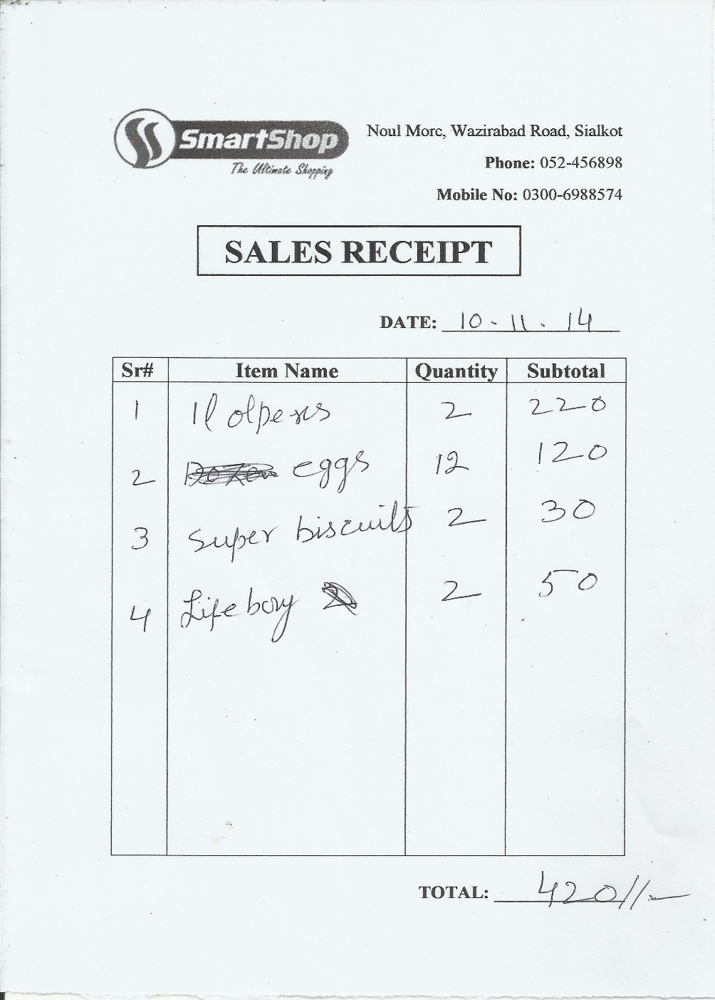

Mostly, the price of the items is known but if it is not known, then the **price lists** are used to refer to the price. It is found near the counter.

Scanned picture of two of the **price lists** are as follows:

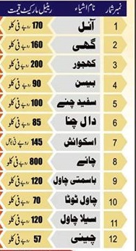

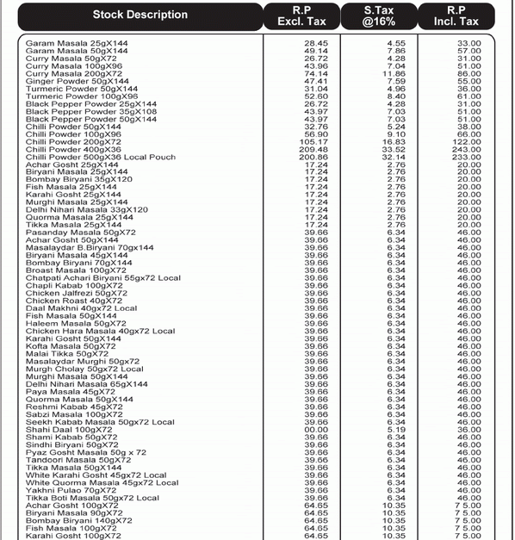

**Supply:**

A file is kept for recording the supply detail. The date and name of the supplier are written and the value of it. Then the invoice sent by the supplier is attached to a file. Each supplier has a separate file and the invoice is attached accordingly to that file. The invoice by the supplier includes the item details, their prices and the total value.

Following is a scanned picture of a supplier record in a separate file. It is the first page of the file:

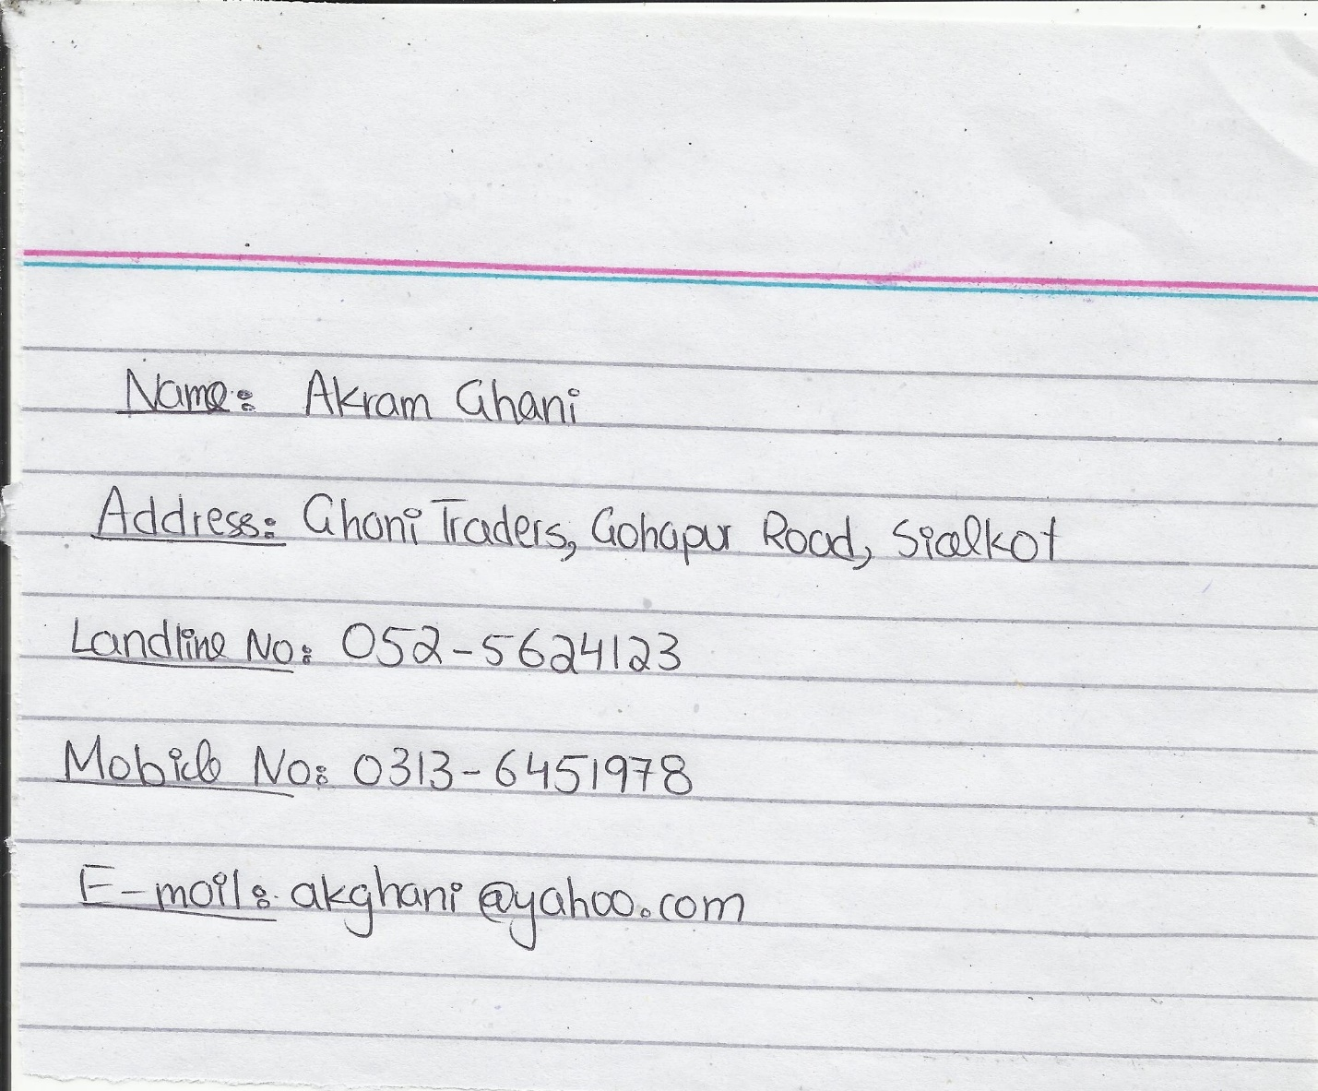

**SYSTEM FLOWCAHRT**



**PROBLEMS IN THE EXISTING SYSTEM**

* **Labor Intensive:**

A disadvantage of the current manual systems is that it is highly labor-intensive to operate. It requires continuous monitoring to ensure that each transaction is accounted for and that items are maintained at the appropriate stocking levels. Making invoices by hand, searching manually through records and handling supply, these require more labor. The time spent monitoring stock levels could be used on more productive activities for the business.

* **Stock control is difficult:**

In the existing system, the major problem is managing the stock. There is no proper system to keep track of item quantities, the employees walk through the shop counting the quantities checking if they are less than reorder level. Often an item is sold out and the owner has no idea so next time it is not available for the customer. The owner totally relies on honesty of employees as there is no way to track a possible theft by them.

* **Wastage of time:**

The manual system is very slow in working and all processes take too much time. Making a sales invoice is a slow process and so is the bill calculation. Keeping check on the stock also wastes the time. Furthermore, searching through the records is time consuming and tedious.

* **Prone to errors:**

It is main flaw of the existing system. Errors are often made while making sales invoice and bill calculations. Often errors are made in the supply invoices which are neglected due to which heavy losses are suffered. The workload on the employees makes the system vulnerable to these small mistakes. Errors while entering manual records also happens. There is no proper system to validate and correct the errors.

* **Loss of data:**

Loss of vital data is another major problem. As the number of files and registers is increasing, it is becoming difficult to store them. On some occasions files were lost due to which shop had to suffer losses. Currently no backups are kept so losing data is a critical problem.

* **No sales records:**

Currently no sales records are kept as it would increase problems. Due to this, stock management becomes difficult. Sales and stock forecasting also becomes difficult as the owner does not know how much of a quantity is usually sold. Calculating profits is problematic due to absence of sale records.

* **Insecurity:**

The current system is highly insecure. Fraud and theft can easily be committed by the employees and there is no way to track them. Some records are of high priority and there is no way for the owner to restrict their access to the employees. The records are vulnerable to theft and there are no backups.

**PROPOSED SOLUTION**

All the possible solutions were closely studied and they were analyzed from different working aspects and were finally evaluated. It was concluded that a “**Fully Computerized System**” would be implemented. A **database** would be developed using **Microsoft Access** which will meet all the requirements of the client. In this solution the whole manual system will be computerized. Fully automated and customized application software would be used. All the records and data will be stored in a computerized database. It would be constructed to meet the requirements of the shop and eradicate the problems which it is facing. All calculations would be performed by the computer itself.

The evaluation of the proposed system is as follows:

**Advantages:-**

* The system will be fast and accurate in its working making the processes more efficient.
* Stock Management would be easier.
* This system will reduce dependency on manpower.
* It will replace the paperwork saving the physical space.
* It will be more secure and would prevent unauthorized access and would reduce chances of data theft.
* The data can be organized efficiently in the form of tables and forms.
* Updating the records would be easier as compared to old manual system.
* Searching for data and records would become really easy and quick.
* The system will automatically generate reports.
* This system can also prevent frauds.
* The errors can be checked and removed by validation so this will result in more reliable data.
* Backup can be easily made so in case of any damage or if data gets corrupt then it can be retrieved through the backup.
* This system would be more easily customizable.

**Disadvantages:-**

* Power usage would increase. This would increase the electricity bill.
* Power failures may occur which can lead to data loss and hardware Malfunctioning.
* The initial cost will be high such as buying the hardware etc.
* Training of workforce can be time consuming.
* Despite various security measures, the system will be vulnerable to viruses, Trojans, hacking etc. leading to huge losses.
* Technical errors may be difficult to fix without programming knowledge.

**ALTERNATE SOLUTIONS**

There are other alternate solutions but the proposed solution was selected over them. The evaluation of these alternate solutions are as follows:

1. **Upgraded and Improved Manual System:-**

New well experienced employees can be hired to prevent mistakes and reduce errors and flaws. More employees can also be hired to make the processes of the shop quick. The files can be organized so searching becomes easy and items can be organized also. The employees can be given breaks during working so they are not exhausted and this reduces chance of human error. Copies of important data can be kept so that there is a backup.

**Advantages:-**

* Implementation is easy and changes to it can be made easily.
* Training of employees is not required.
* It is very economical and cost effective.
* It can save time to some extent.

**Disadvantages:-**

* The problem of security still remains same.
* Hiring more employees will result in less profit to the owner.
* The system will remain prone to human error.
* Checking of data is ineffective.
* Manual system is less reliable than computer in saving the records.
* Sorting the records and storing them is an exhaustive task.
* The system is not effective to maintain supply of items.

1. **Partially Computerized System (Spreadsheets):-**

In this system only some part of the current system would be computerized through spreadsheet and word processor software. The important records of sales and supply would be stored a kept differently in the computer. This will be easy to run the shop for both owner and employees and will prove better than manual system. The information would be organized accordingly.

**Advantages:-**

* Easy to store and view data as it is organized.
* The system is less costly to develop than the full computerized system.
* Spreadsheets can perform tasks quickly so time will be saved.
* The system is more effective and useful as compared to the complete manual system.
* Backup of records can be made easily.

**Disadvantages:-**

* This system would be less effective than a complete computerized system as some records would be entered manually which is time consuming.
* A person with computer knowledge would be required to maintain the spreadsheets and this will affect monthly costs.
* Choosing of records to be computerized and to be remained manual would be a hectic task.
* The mix-up of both computerized and manual records will lead to confusion.
* It would not help to generate different types of analysis and reports speedily.
* There would be no password protection in spreadsheet and the data will be insecure.

1. **Using Ready-Made Software:-**

Readymade software for shops can be purchased from the market or from the respective companies and then implemented. This will lead to more efficient and faster working and tasks will be carried out more easily.

**Advantages:-**

* It will lessen the workload on the employees.
* Initial cost will be less.
* The software will run smoothly and effectively as the software is tested and has a commercial status.
* It will show good and quick results.
* The data will be secured from any mishap because we can easily take the backup of data.

**Disadvantages:-**

* It may not fulfill the requirements of the shop.
* Training of the workforce to use the software can be complex.
* The software cannot be customized according to the changing requirements of the shop.
* Pirated copies in the market affect the hardware and operating system capabilities of the system.
* Normally these software are expensive and sometimes the license of the software has to be renewed after sometime.

**USER REQUIREMENTS**

After a detailed investigation and analysis, I was able to derive the user requirements of the new system. It is what the user expects of the new system. The requirements are as follows:

1. The system should reduce the workload on the owner and employees by simplifying the working of the shop. The tasks and processes should be made easy to perform the new system.
2. The new system should be time efficient. All the processes should be performed in a smaller time span and time should be of critical importance. Invoice making and bill calculation should be faster processes.
3. The system should make stock management easy and simplified. There should be a computerized way to keep check on quantities of the stock. Reorder levels should be known in the system.
4. The new system should have proper validation and verification checks to eradicate any type of errors so any entries made are perfect. The inaccurate data should not be allowed to enter the system.
5. The system should have a proper backup facility for records and data. So in case if data is lost, it can be easily retrieved and accessed.
6. The system should have proper facility to store sales records as it is an essential requirement of a new system and can be utilized for calculating profits and sales forecasting.
7. The new system should offer easy and efficient methods to search through the records in the database and according to a specified criteria so user only gets the information required.
8. The new system should be secure. It should be password protected to restrict any unauthorized access. It should store that records in such a way that theft or fraud cannot happen.
9. The new system should be beginner friendly. It should have an easy to use interface which simplifies any difficulties for the user and there should be a proper User Documentation to help the user encounter any problem faced.
10. The new system should make all data related processes easy and computerized i.e. searching, storing, updating, deleting and merging data.

Following is a scanned picture of the user requirements document signed by the client:

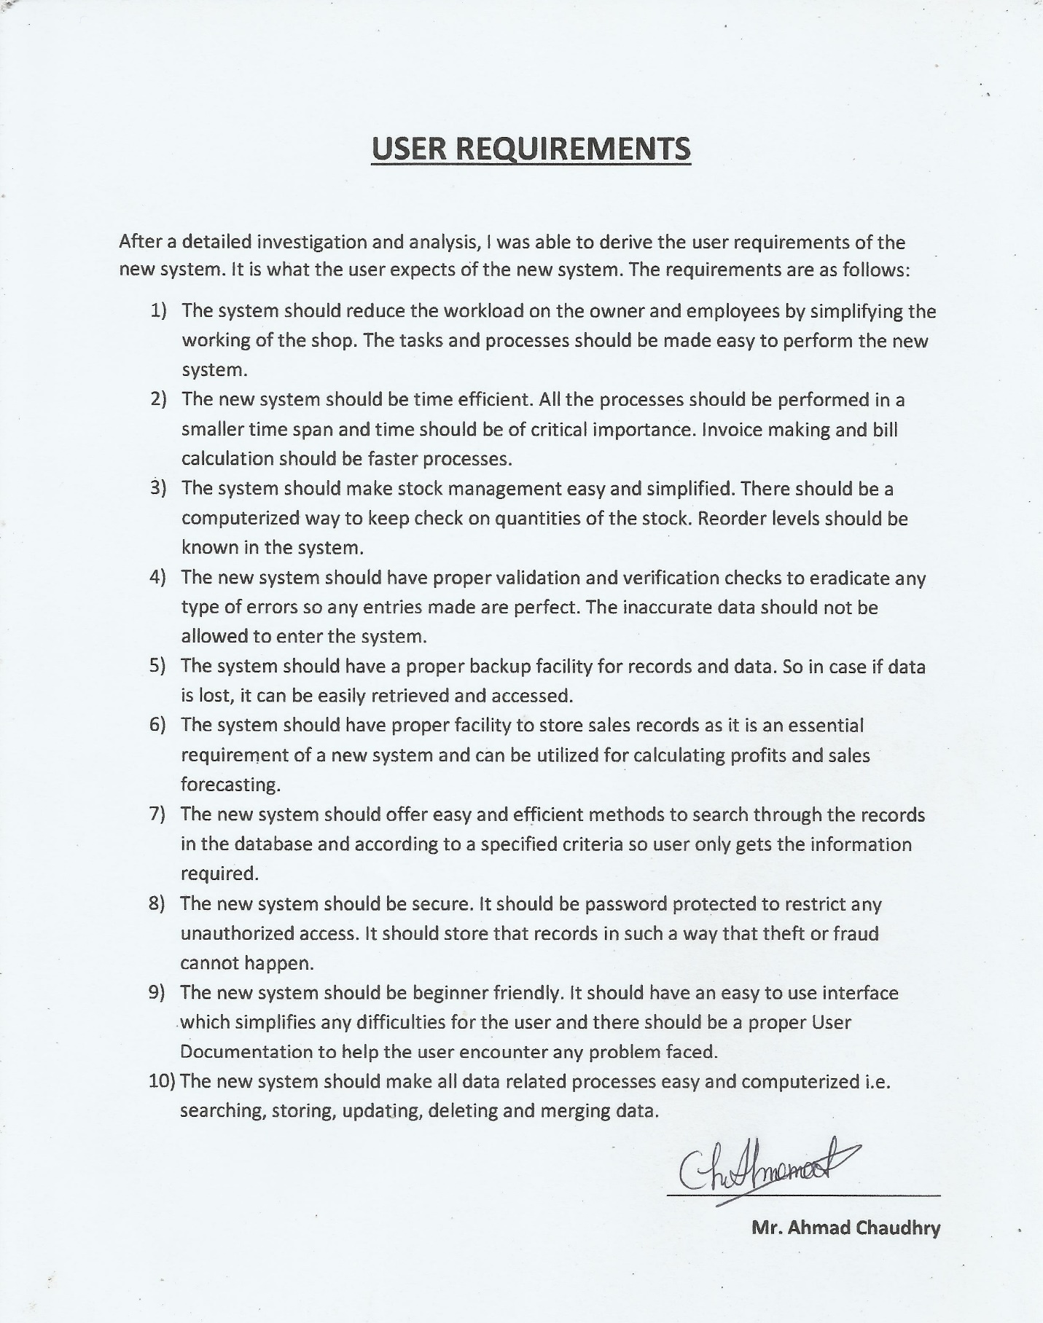

**HARDWARE REQUIREMENTS**

A computer system had to be purchased as there was no computer before. There are certain hardware requirements for the new system to run properly and efficiently. It was decided that a non-branded (custom-made) computer would be built. The hardware was selected according to need and also some factors were kept in mind.

The following factors were considered for the selection of hardware:-

* **Cost:** The cost of the hardware is the most important factor. It should be within the affordability range of the owner. The cost should be intermediate so that the owner can buy the hardware without any financial problem.
* **Warranty:** The hardware bought should have a good period of warranty, so if the hardware gets any fault during the warranty period then the user can get a replacement or get the hardware repaired.
* **Lifespan:** The hardware should have a long lifespan. It should work for a long period of time so that the owner does not have to replace the hardware again and again. It will help to reduce costs.
* **Functionality:** The hardware offer maximum functionality to the user. It should be steadfast in its actions. It should be able to work for long periods of time and should work perfectly under the physical conditions.

1. **Processor:-**

**Intel® Core™2 Duo Processor E4600**

**Specifications:-**

1. 2.4 GHz Clock Speed
2. 2 MB L2 Cache
3. Contains 2 Cores
4. LGA775 Socket

**Reasons for Selection:-**

It is a fast processor and would allow all processes to be carried out faster. Due to this speed a lot of time would be saved in processes such as data processing and generating reports. Multitasking would be smoother in computer due to this processor. The sales system and the stock processing system requires fast processing to maintain efficient working in the shop and this can be achieved through this processor. This processor is cost-effective as it is in reach of the owner’s affordability range. It has a long working lifespan and has 3 years warranty also. It is also very compatible with all the latest peripheral devices such as USB’s or latest printers.

1. **Motherboard:-**

**Intel Desktop Board DQ965GF**

**Specifications:-**

1. Micro ATX – LGA 775 Socket
2. Intel GMA 3000 Graphics Adapter
3. Intel High Definition Audio
4. Supports max size 8.0 GB RAM (DDR2 SDRAM).
5. Intel 82566DM Gigabit LAN

**Reasons for Recommendation:-**

The Intel Desktop Board DQ965GFis a really powerful motherboard and most importantly it is compatible with the chosen Intel Core 2 Duo processor. It contains the built in powerful Intel GMA 300 Graphics Adapter so interaction with the computer would be easy and there would be no use to buy additional graphics card. It has the built in features such as Intel High Definition Audio and Gigabit LAN which make it worth choosing. It is a cost-effective motherboard and has a long lifespan with 3 years of warranty. In short this motherboard will help us attach all the other hardware devices which are required by the shop for efficient working.

1. **RAM (Random Access Memory):-**

**Kingston KVR800D2N6 – 2GB RAM**

**Specifications:-**

1. Max Memory Size – 2048 MB
2. 800 MHz Speed
3. 240 pin DDR2 SDRAM

**Reasons for Recommendation:-**

The RAM is an important factor in the processing speed. The Kingston KVR800D2N6 – 1GB RAM is selected because it is compatible with the chosen motherboard. It is ideal for the computerized system as more memory will result in faster processing and efficient working. . It will load and provide faster access to data stored. Thus, Retrieving and searching of information about the items, supplier or sales would be more easy and efficient. This will allow the computer to generate reports and do all other processes quickly. By selecting this RAM the user will get quick response rate from the computer. It is cheap and durable and has a 2 years warranty.

1. **Hard Disk:-**

**Intel® Solid-State Drive 320 Series**

**Specifications:-**

1. 80 GB Capacity
2. Sustained sequential reads up to 270 MB/s
3. Sustained sequential writes up to 90 MB/s
4. Average transfer rate of 200 MB/s

**Reasons for Recommendation:-**

The hard disk will be the medium in which the database and the related files would be stored. A hard disk with a large capacity will allow the shop to store large amounts of data about items, sales, supplies and other sorts of details. The company could also partition the hard disk and organize its data more efficiently e.g. item details and sales details can be organized into separate hard disks. The hard disk also has a decent transfer rate. 80 GB is a lot of space for the shop to store its records and details and also the operating system and other necessary software’s are also to be installed so a large amount of space of hard disk should be available. The owner can purchase it easily and it has a long lifespan with 3 year warranty.

1. **Monitor:-**

**Dell E178WFP LCD Monitor**

**Specifications:-**

1. 14-inch Widescreen
2. Max Resolution 1440 x 900 at 60 Hz
3. 8 millisecond response time (typical)

**Reasons for Recommendation:-**

The Dell LCD Monitor is the best choice because they will provide best interaction between the user and the computer as it will give sharp image with high resolution and reports and forms etc. will be very clear for the user to see. LCD monitor consumes less power than the CRT Monitors and do not emit radiations like them. LCD monitors also have the features of high resolution and will provide sharp quality images for accessing important scanned documents in the shop. It is not much expensive and the owner can buy it. It has a warranty period of 2 years.

1. **Printer:-**

**HP ® LaserJet 1020 Printer**

**Specifications:-**

1. Print Technology : Laser
2. Up to 600 x 600 dpi Print quality
3. Printing speed up to 15 pages/minute
4. Input capacity up to 150 sheets
5. Output capacity up to 100 sheets

**Reasons for Recommendation:-**

The printer would allow obtaining hard copies of the electronic data. Using this printer forms and reports etc. can be printed out. HP LaserJet 1020 printer is chosen specifically because it has a great printing speed. The printing amount is high and color printing is not required so this is best choice. It is really economical and durable printer. It has a warranty period of 1 year.

1. **Scanner:**

**HP ® ScanJet G2410 Flatbed Scanner**

**Specifications:-**

1. Up to 1200 dpi Scan resolution
2. Scan size 216 x 297 mm
3. 2 front-panel buttons (Scan, Copy)
4. 48 bit color
5. IRIS optical character recognition (OCR) software to convert a scanned page into editable text.

**Reasons for Recommendation:-**

The HP ScanJet G2410 Flatbed Scanner is recommended because it has the ability to convert documents into text that can be edited using OCR technology and this will enable the user to edit any scanned document instead of rewriting it all again if required. It is required to store some of the important paper documents of the shop into the computer. The old manual system records can also be scanned and then saved. This scanner can easily scan color documents or pictures. It is cheap and easily available in the market. It has a warranty period of 1 year.

1. **Keyboard:-**

**HP ® Standard USB Keyboard**

**Specifications:-**

1. 104 Keys including keys for special functions
2. Switch Life 20 million keystrokes
3. Plug and Play

**Reasons for Recommendation:-**

HP produces the best keyboards which are efficient and reliable in working. The keyboard is designed to work for long tiresome jobs as the data entry will be high in the computer system. It is a QWERTY keyboard and is widely used. It will be very easy to use because of its simplicity. It is also not very noisy. It will help to reduce noise levels as the employees can concentrate on what work they are doing. It is durable and cheap and has a warranty period of 1 year.

1. **Mouse:-**

**HP ® USB Optical Mouse**

**Specifications:-**

1. Plug and Play
2. 3-Button Optical USB Mouse
3. USB cable connectivity

**Reasons for Recommendation:-**

The mouse is required for the navigation purpose and to select file and programs. The HP USB Optical Mouse is recommended as it can be used directly after being plugged in and it is compatible with the motherboard. The mouse with scroll button would allow better navigation through the database and the records. An optical mouse is the best option as it does not require maintenance like wheeled mouse and works best on even glass surfaces. It is cheap and durable with 1 year warranty.

1. **DVD/CD Rewritable Drive:-**

**Sony ® DRU-870S**

**Specifications:-**

1. Read Speed: DVD : 16x max and CD : 48x max
2. Write Speed: DVD-R : 24x max and DVD-RW : 6x max

CD-R: 48x max and CD-RW: 32x max

1. Access Time: DVD-160ms and CD-140ms
2. 2 MByte Cache
3. Burst Transfer Rate – 150MByte/s
4. Supports:- CD-ROM/DVD-ROM/DVD-R/DVD+R/DVD-RW/DVD+RW/

DVD-R DL/DVD+R9/DVD-RAM/CD-R/CD-RW

**Reasons for Recommendation:-**

CDs and DVDs are required to install software in the computer. As the sizes of the software has been increased with the passage of time and to stores the database and its components for safe keeping Sony ® DRU-870S is recommended. It is the perfect optical drive for this purpose; it can both read and write data on DVDs and CDs so there is no restriction on the selection of optical disk. It will allow the shop to create a backup of their database and other important files for safe keeping. If the database gets corrupted or files are lost then the backup in the DVDs/CDs can be used.

1. **UPS (Un-interruptible Power Supply):-**

**Belkin 1200VA Universal UPS**

**Specifications:-**

1. Provides up to 100 minutes backup time
2. USB and Serial connections
3. Automatic Shut Down software
4. 3 Battery Backup Sockets

**Reasons for Recommendation:-**

It is device whose purpose is to provide power for a given period of time when the main power shuts down. In our country, Pakistanload shedding is at its peak. There is no specific time when the electricity goes. This electric failure can cause data to be corrupted or even hardware failure. UPS prevents this loss. Belkin 1200VA Universal UPS is the best choice. More battery cartridges can also be installed with it to increase the runtime. It has a warranty period of 3 years.

**SOFTWARE REQUIREMENTS**

Software is the component which will let the user operate and interact with the computer system. Without software hardware is useless. So the software play an important role in the working process and provide an interface to the user to communicate with the hardware. Therefore it is necessary to choose the appropriate **off-the-shelf** software for the computer system.

The following factors were considered for the selection of software:-

* **Reliability:** The software should be reliable and smooth in working. It should perform the tasks with efficiency and speed. It should have an auto-save function in case of a failure or break-down.
* **Features:** The software should have the necessary features and functions so that the user can perform all the tasks easily and with perfection.
* **User-Interface:** The user interface should have WIMP (Windows Icon Menu Pointing) style of interaction. It should enable the user to use all features of the software with ease and it should be a friendly interface.
* **Economical:** The software should be cost-effective and should provide more features in low price.

1. **Operating System:-**

**Microsoft ® Windows 7 - Ultimate**

**Reasons for Recommendation:-**

Operating system is the most important computer software because it is the interface through which the user interacts with the computer. It allows the user to run other programs and store data on hard disk. It provides facilities to the user to manage different files, make the other connected peripheral devices to be installed and to work properly. Therefore it is necessary that the operating system should be fast, user-friendly and efficient. **Microsoft ® Windows 7** is chosen because it is the most used operating system and it has a friendly and simple user interface which will enable the shop employees to work easily and CONVENIENTLY. This operating system will enable us to operate the database and word processor software which are extremely necessary. All the computerized system will have a base on this operating system. It will be very easy for the employees to use and get adapted to this operating system. It will allow us to use the selected hardware in the most efficient and easy way for the requirements of the shop. The main reason for choosing the windows operating systems is that office suites, on which my software is based, only run on windows operating system.

1. **Database Management System:-**

**Microsoft ® Access 2013**

**Features:-**

1. Access 2013 has password protection with encryption which provides an extra level of security.
2. Access 2013 has better GUI (Graphical User Interface) which allows the user to use all the features of the software.
3. Microsoft ® Access 2013 is relational database management system which allows the fields of different tables to link with each other
4. It’s very relaxing and easy to create tables, forms and queries in one go by just using the wizards which constructs all these objects accurately.
5. Tables in Access 2013 can be designed using customized fields. The fields have formats, input mask, calculated formula, character length and even validation rules and texts. This ensures that accurate data is entered in the fields.
6. In Access 2013 queries can be made for searching, deleting and updating the records.
7. In Access 2013 forms can be made for entering and editing data in the tables, Controls can also be placed in the form to perform different tasks.

**Reasons for Recommendation:-**

MS Access is user-friendly, flexible and easy to use. It is simple to create tables for item information, sales details and supply details in an organized format. It will be the best choice for constructing the database for **The Smart Shop** due to its unique and useful features. Adding, editing, updating records of shop would be easier though this database management software. It has a friendly and simple user interface so it will be easy for the employees to understand and operate it. The whole software that will be constructed will be based on Microsoft Access. It will allow us to make the tables, forms and reports that are necessary for the shop.

1. **Word-Processor:-**

**Microsoft ® Word 2013**

**Features:-**

* Add Tables.
* Search and replace based on key words.
* Word wrap (e.g. auto adjusts a line to fit into paragraph alignment such as straight margins on left and right, etc.).
* File management (create/delete/move/search for files).
* Headers and footers and the automatic numbering of pages.
* Graphics (embed drawings and graphs into the document).
* Ability to set the page size and page orientation.
* Ability to change font style and font size (e.g. Arial, courier, times new roman, etc.).
* Ability to change margins (top, bottom and sides).
* Page format (e.g. paragraphs, columns, etc.).
* Importing text, graphics and pictures into the document body.
* Ability to add Water marks.
* Inserting and deleting text.
* Cut and paste/copy and paste (to prevent the need to re-type sections of text or to move/remove text).

**Reasons for Recommendation:-**

The word processor software was required to create the documentation. Microsoft Word will be used to provide user documentation for the user and technical documentation for the programmer. It is recommended because it is user-friendly, easy to use and flexible. It would be easy to demonstrate the flowcharts and diagrams in it as it has the tools for shapes and diagrams. It has all the required features which are necessary for producing a perfect documentation.

1. **Antivirus:-**

**Panda Antivirus Pro 2012**

**Features:-**

1. Anti-Virus
2. Anti-Malware
3. Firewall
4. Anti-Spyware
5. USB Vaccine
6. Panda Safe CD
7. Safe Browsing

**Reasons for Recommendation:-**

Antivirus software is strongly required with the use of it the whole computer is safe and there can be no more chance of system failure or loss of data. Panda Antivirus is recommended because it will protect the database and computer from hacking. It will increase the security level and also help to avoid the data loss from the database. It is cost-effective software as it is not expensive and offers more security features in fewer prices.

**DESIGN**

**OBJECTIVES**

1. There should be proper navigation forms which allow the user to move between different parts of the database and select required items providing an easier access.
2. There should be a customized login screen which restricts unauthorized access by using a username and password making the system secure.
3. The data entry fields should accept normal (valid) data and extreme (boundary) data which is described by the validation checks
4. The data entry fields should reject abnormal (invalid) data which violates validation rules and show error messages stating the problem with the entered data.
5. The user should be provided with proper search options allowing him to search through the database with several criteria.
6. The system should have a Password change facility allowing the user to change the password when necessary making the system less vulnerable.
7. The system should do all the necessary calculations e.g. calculating totals. The user would not have to perform manual calculations.
8. Data redundancy should be reduced by using primary keys so that no repetition happens and each record is unique.
9. There should be automatic stock quantity updating. After a sale, the quantity should decrease accordingly and after a supply is received, quantity should increase accordingly.
10. There should be separate tables to store records of stock, suppliers, sales, orders and supply received.
11. The user should be trained to keep proper backups of the database after a specified period of time so that it can be accessed when needed.
12. The data entry forms should allow the user to navigate through records and allow updating and deletion of the respective records.
13. The new system should be properly documented. There should be System Maintenance Documentation for a system developer. There should be a User Guide for the user to help him use the system and solve any problem faced.

Following is a scanned picture of the Objectives document signed by the client:

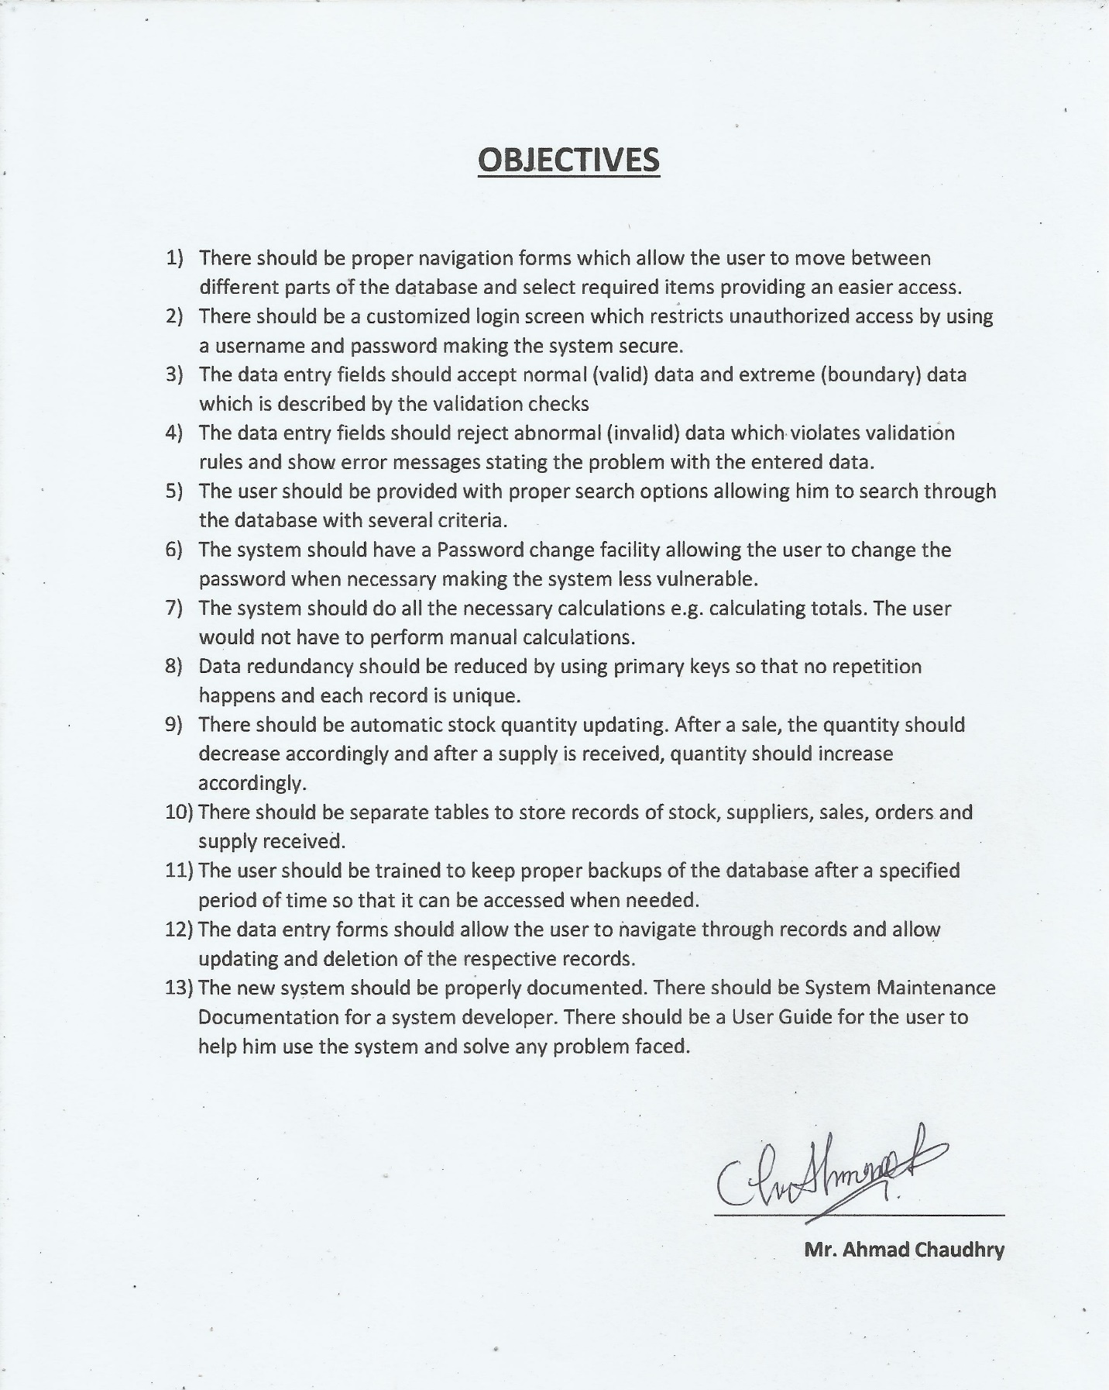

**OUTPUT DESIGN**

A proper output design needs to be created because all the interface and shape of the database will be dependent on it. I created various designs on paper and showed them to the client. All of them were accepted by him but only some required minor changes. After the clients approval I am able to draw the mockups of the output design on computer.

The output design of the database consists of two parts:

* Report Design
* Navigation Form Design

**Report Design:**

The reports in the database will be used to display records. Each report will show data from its respective table. The reports in the database will be:

1. Stock Report
2. Suppliers Report
3. Sales Report
4. Orders Report
5. Supply Received Report
6. **Stock Report:**

This report will be linked to the **Stock Table** and it will show the records from it. All the fields from the **Stock Table** will be on this report, each showing data therefore forming a complete record.

|  |  |  |  |  |  |  |
| --- | --- | --- | --- | --- | --- | --- |
| Item ID | Item Name | Category | Current Quantity | Cost Price | Sale Price | Reorder Level |
| 1 | - | - | - | - | - | - |
| 2 | - | - | - | - | - | - |
| 3 | - | - | - | - | - | - |
| 4 | - | - | - | - | - | - |

**Report Logo**

Print Report

Close

Date

**STOCK REPORT**

\

Page Number out of Total Pages

**‘**

**‘Date’**

It will show the current date.

**‘Print Report’ Button**

Clicking this button will run the print button command and will print the Stock Report.

**‘Close’ Button**

Clicking this button will close the Stock Report.

1. **Suppliers Report:**

This report will be linked to the **Suppliers Table** and it will show the records from it. All the fields from the **Suppliers Table** will be on this report, each showing data therefore forming a complete record.

**Report Logo**

Print Report

Close

Date

**SUPPLIERS REPORT**

|  |  |  |  |  |  |
| --- | --- | --- | --- | --- | --- |
| Supplier ID | Supplier Name | Address | Landline No | Mobile No | Email |
| 1 | - | - | - | - | - |
| 2 | - | - | - | - | - |
| 3 | - | - | - | - | - |
| 4 | - | - | - | - | - |

Page Number out of Total Pages

\

**‘**

**‘Date’**

It will show the current date.

**‘Print Report’ Button**

Clicking this button will run the print button command and will print the Suppliers Report.

**‘Close’ Button**

Clicking this button will close the Suppliers Report.

1. **Sales Report:**

This report will be linked to the **Sales Table** and it will show the records from it. All the fields from the **Sales Table** will be on this report, each showing data therefore forming a complete record.

**Report Logo**

Print Report

Close

Date

**SALES REPORT**

|  |  |  |
| --- | --- | --- |
| Sale ID | Sale Date |  |
| 1 | - | View Details |
| 2 | - | View Details |
| 3 | - | View Details |
| 4 | - | View Details |

Page Number out of Total Pages

\

**‘**

**‘View Details’**

It is not a field. It is a link added as a column to the report. An OnClick event will be added to it using VBA. When the user clicks it, the **Sales Form** will open up showing the specified record according to the **Sale ID** and the respective records from **Sales Details Table** will be on the sub form too.

**‘Date’**

It will show the current date.

**‘Print Report’ Button**

Clicking this button will run the print button command and will print the Sales Report.

**‘Close’ Button**

Clicking this button will close the Sales Report.

1. **Orders Report:**

This report will be linked to the **Orders Table** and it will show the records from it. All the fields from the **Orders Table** will be on this report, each showing data therefore forming a complete record.

**Report Logo**

Print Report

Close

Date

**ORDERS REPORT**

|  |  |  |  |  |  |
| --- | --- | --- | --- | --- | --- |
| Order ID | Supplier ID | Supplier Name | Order Date | Status |  |
| 1 | - | - | - | - | View Details |
| 2 | - | - | - | - | View Details |
| 3 | - | - | - | - | View Details |
| 4 | - | - | - | - | View Details |

Page Number out of Total Pages

\

**‘**

**‘View Details’**

It is not a field. It is a link added as a column to the report. An OnClick event will be added to it using VBA. When the user clicks it, the **Orders Form** will open up showing the specified record according to the **Order ID** and the respective records from **Order Details Table** will be on the sub form too.

**‘Date’**

It will show the current date.

**‘Print Report’ Button**

Clicking this button will run the print button command and will print the Orders Report.

**‘Close’ Button**

Clicking this button will close the Orders Report.

1. **Supply Received Report:**

This report will be linked to the **Supply Received Table** and it will show the records from it. All the fields from the **Supply Received Table** will be on this report, each showing data therefore forming a complete record.

**Report Logo**

Print Report

Close

Date

**SUPPLY REPORT**

|  |  |  |  |  |  |
| --- | --- | --- | --- | --- | --- |
| Supply ID | Supplier ID | Supplier Name | Order ID | ReceivedDate |  |
| 1 | - | - | - | - | View Details |
| 2 | - | - | - | - | View Details |
| 3 | - | - | - | - | View Details |
| 4 | - | - | - | - | View Details |

Page Number out of Total Pages

\

**‘**

**‘View Details’**

It is not a field. It is a link added as a column to the report. An OnClick event will be added to it using VBA. When the user clicks it, the **Supply Received Form** will open up showing the specified record according to the **Supply ID** and the respective records from **Supply Received Details Table** will be on the sub form too.

**‘Date’**

It will show the current date.

**‘Print Report’ Button**

Clicking this button will run the print button command and will print the Supply Received Report.

**‘Close’ Button**

Clicking this button will close the Supply Received Report.

**Navigation Form Design:**

The navigation forms will allow the user to move between different parts of the database and select required items providing an easier access. It will be a link to all of the objects in the database. These forms will provide an interface to the user which is a form of an output.

There will be six navigation forms in the database:

1. Main Menu
2. Stock Menu
3. Suppliers Menu
4. Sales Menu
5. Orders Menu
6. Supply Received Menu
7. **Main Menu:**

This form will be the main form of the database. It will automatically open up after the user passes the login screen. It will be a link to the other navigation forms.

**MAIN MENU**

**Company Logo**

Stock Menu

Suppliers Menu

Orders Menu

Sales Menu

Supply Received Menu

**Close Database** ClosReport

\

**‘**

Change Database Password

|  |  |  |
| --- | --- | --- |
| **Object Name** | **Object Type** | **Description** |
| Stock Menu | Button | Clicking this button will open the **Stock Menu** form |
| Suppliers Menu | Button | Clicking this button will open the **Suppliers Menu** form |
| Sales Menu | Button | Clicking this button will open the **Sales Menu** form |
| Orders Menu | Button | Clicking this button will open the **Orders Menu** form |
| Supply Received | Button | Clicking this button will open the **Supply Received Menu** form |
| Close Database | Button | Clicking this button will close the database |
| Change Database Password | Label | It is a link. Clicking it will open the **Change Password** form. The user will be able to change the password through the form |

1. **Stock Menu:**

This form will allow the user to view all the objects and processes in the database related to Stock. It will have buttons to open up the object the user wants.

**STOCK MENU**

**Close Database** ClosReport

**Main Menu**

**Company Logo**

**Find Item(s) by:**

Stock Form

Name

Item ID

Stock Report

Category

\

Items to be Reordered

**‘**

|  |  |  |
| --- | --- | --- |
| **Object Name** | **Object Type** | **Description** |
| Main Menu | Button | Clicking this button will return the user to the **Main Menu** form |
| Close Database | Button | Clicking this button will close the database |
| Stock Form | Button | Clicking this button will open the **Stock Form** |
| Stock Report | Button | Clicking this button will open the **Stock Report** |
| Items to be reordered | Button | Clicking this button will open up the **Stock Report** but it will only display records according to specific criteria |
| Item ID | Button | Clicking this button will open the **Find Item by ID** form |
| Name | Button | Clicking this button will open the **Find Item by Name** form |
| Category | Button | Clicking this button will open the **Find Item by Category** form |

1. **Suppliers Menu:**

This form will allow the user to view all the objects and processes in the database related to Suppliers. It will have buttons to open up the object the user wants.

**SUPPLIERS MENU**

**Close Database** ClosReport

**Main Menu**

**Company Logo**

**Find Supplier by:**

Suppliers Form

Supplier ID

Name

Suppliers Report

\

**‘**

|  |  |  |
| --- | --- | --- |
| **Object Name** | **Object Type** | **Description** |
| Main Menu | Button | Clicking this button will return the user to the **Main Menu** form |
| Close Database | Button | Clicking this button will close the database |
| Suppliers Form | Button | Clicking this button will open the **Suppliers Form** |
| Suppliers Report | Button | Clicking this button will open the **Suppliers Report** |
| Supplier ID | Button | Clicking this button will open the **Find Supplier by ID** form |
| Name | Button | Clicking this button will open the **Find Supplier by Name** form |

1. **Sales Menu:**

This form will allow the user to view all the objects and processes in the database related to Sales. It will have buttons to open up the object the user wants.

**SALES MENU**

**Close Database** ClosReport

**Main Menu**

**Company Logo**

Sales Form

**Find Sale(s) by:**

Date

Sale ID

Range of Dates

Sales Report

\

**‘**

|  |  |  |
| --- | --- | --- |
| **Object Name** | **Object Type** | **Description** |
| Main Menu | Button | Clicking this button will return the user to the **Main Menu** form |
| Close Database | Button | Clicking this button will close the database |
| Sales Form | Button | Clicking this button will open the **Sales Form** |
| Sales Report | Button | Clicking this button will open the **Sales Report** |
| Sale ID | Button | Clicking this button will open the **Find Sale by ID** form |
| Date | Button | Clicking this button will open the **Find Sale by Date** form |
| Range of Dates | Button | Clicking this button will open the **Find Sales From Until** form |

1. **Orders Menu:**

This form will allow the user to view all the objects and processes in the database related to Orders. It will have buttons to open up the object the user wants.

**ORDERS MENU**

**Close Database** ClosReport

**Main Menu**

**Company Logo**

**Find Order(s) by:**

Orders Form

Date

Order ID

Orders Report

Supplier

Pending Orders

\

Range of Dates

Received Orders

**‘**

|  |  |  |
| --- | --- | --- |
| **Object Name** | **Object Type** | **Description** |
| Main Menu | Button | Clicking this button will return the user to the **Main Menu** form |
| Close Database | Button | Clicking this button will close the database |
| Orders Form | Button | Clicking this button will open the **Orders Form** |
| Orders Report | Button | Clicking this button will open the **Orders Report** |
| Pending Orders | Button | Clicking this button will open up the **Orders Report** but it will only display records according to specific criteria. |
| Received Orders | Button | Clicking this button will open up the **Orders Report** but it will only display records according to specific criteria. |
| Order ID | Button | Clicking this button will open the **Find Order by ID** form |
| Date | Button | Clicking this button will open the **Find Order by Date** form |
| Supplier | Button | Clicking this button will open the **Find Order by Supplier** form |
| Range of Dates | Button | Clicking this button will open the **Find Orders From Until** form |

1. **Supply Received Menu:**

This form will allow the user to view all the objects and processes in the database related to Supply Received. It will have buttons to open up the object the user wants.

**SUPPLY RECEIVED MENU**

**Close Database** ClosReport

**Main Menu**

**Company Logo**

Supply Received Form

**Find Supply by:**

Supply ID

Order ID

Date

Supplier

Supply Received Report

\

Range of Dates

**‘**

|  |  |  |
| --- | --- | --- |
| **Object Name** | **Object Type** | **Description** |
| Main Menu | Button | Clicking this button will return the user to the **Main Menu** form |
| Close Database | Button | Clicking this button will close the database |
| Supply Received Form | Button | Clicking this button will open the **Supply Received Form** |
| Supply Received Report | Button | Clicking this button will open the **Supply Received Report** |
| Supply ID | Button | Clicking this button will open the **Find Supply by ID** form |
| Order ID | Button | Clicking this button will open the **Find Supply by Order ID** form |
| Supplier | Button | Clicking this button will open the **Find Supply by Supplier** form |
| Date | Button | Clicking this button will open the **Find Supply by Date** form |
| Range of Dates | Button | Clicking this button will open the **Find Supply Received From Until** form |

**INPUT DESIGN**

A proper input design needs to be created as the user will enter data through it and needs a proper interaction with it. I created various designs on paper and showed them to the client and explained some of the validation logic to him. All of them were accepted by him but only some required minor changes. After the clients approval I am able to draw the mockups of the input design on computer.

The input design of the Database consists of two parts:

* Login Form Design
* Data Entry Form Design
* Search Form Design

**Login Form Design:**

One of the major objective was to restrict unauthorized access to the database. The login form will fulfill that objective. There will be two forms related to login

1. Login Form
2. Change Password Form
3. **Login Form:**

It will show when the database file will be opened. This form will restrict any unauthorized access and will open the database only if the credentials are correct.

Login Screen

Username:

Password:

Login

Exit

**‘Login’ Button**

Clicking this button will allow access and open the database if the Username and Password are correct.

**‘Exit’ Button**

Clicking this button will close the database.

1. **Change Password Form:**

This form will allow the user to change the password of the database if it is compromised or any need of it I felt.

Change Password

Current Password:

New Password:

Re-enter New Password:

OK

Close

**‘OK’ Button**

Clicking this button will change the password if current password is correct and the new passwords match.

**‘Close’ Button**

Clicking this button will close the form.

**Data Entry Form Design:**

The user will enter the data through the data entry forms and then the data will be stored in the specified data table. The validation for the each form has been included in this design specification. If the user enter data violating the validation rules a custom error message will be shown. The data entry forms in this database will be:

1. Stock Form
2. Suppliers Form
3. Sales Form
4. Orders Form
5. Supply Received Form
6. **Stock Form:**

This form will be linked to the **Stock Table**. All the records entered in this form will be stored in the **Stock Table**.

**Company Logo**

Date

**STOCK FORM**

Time

Item ID:

Item Name:

**V**

Category:

Current Quantity:

\

Cost Price:

**‘**

Sale Price:

Reorder Level:

Print Record

Clear Fields

Delete Record

Save and New

**Close**

Next Record

Previous Record

Last Record

First Record

**Form Validation**

All the validation of the fields will be done using **VBA** Code. The validation rules in table design will not be used.

|  |  |  |  |
| --- | --- | --- | --- |
| **Field Name** | **Format** | **Validation Rule** | **Validation Rule Description** |
| Item ID | - | - | - |
| Item Name | - | IsNull() = False And  Len() <= 60 | Field is required and Length should be less and equal to 60 |
| Category | - | IsNull() = False | Field is required |
| Current Quantity | - | IsNull() = False  And  >=0 | Field is required and Allow number greater or equal to 0 |
| Cost Price | "Rs "#,##0.00 | IsNull() = False  And  >0 | Field is required and Allow number greater than 0 |
| Sale Price | "Rs "#,##0.00 | IsNull() = False  And  >0 | Field is required and Allow number greater than 0 |
| Reorder Level | - | >0 | Allow number greater than 0 |

|  |  |  |
| --- | --- | --- |
| **Object Name** | **Object Type** | **Description** |
| Date | Label | It will show the current date |
| Time | Label | It will show the current time |
| Save and New | Button | Clicking this button will save the current record and reload form for new record |
| Clear Fields | Button | Clicking this button will unload the form and clear fields |
| Delete Record | Button | Clicking this button will delete the current record |
| Print Record | Button | Clicking this button will print the current record |
| Close | Button | Clicking this button will close the form |
| First Record | Button | Clicking this button will show the first record |
| Last Record | Button | Clicking this button will show the last record |
| Previous Record | Button | Clicking this button will show the previous record |
| Next Record | Button | Clicking this button will show the next record |

1. **Suppliers Form:**

This form will be linked to the **Suppliers Table**. All the records entered in this form will be stored in the **Suppliers Table**.

**Company Logo**

Date

**SUPPLIERS FORM**

Time

Supplier ID:

Supplier Name:

Address:

\

Landline No:

**‘**

Mobile No:

Email:

Print Record

Clear Fields

Delete Record

Save and New

**Close**

Next Record

Previous Record

Last Record

First Record

**Form Validation**

All the validation of the fields will be done using **VBA** Code. The validation rules in table design will not be used.

|  |  |  |  |
| --- | --- | --- | --- |
| **Field Name** | **Format** | **Validation Rule** | **Validation Rule Description** |
| Supplier ID | - | - | - |
| Supplier Name | - | IsNull() = False And  Len() <= 40 | Field is required and Length should be less and equal to 40 |
| Address | - | IsNull() = False | Field is required |
| Landline No | !@@@-@@@@@@@ | Len() <= 10  And  IsNumeric() = True | Length should be less and equal to 10 and Allow numbers only |
| Mobile No | !@@@@-@@@@@@@ | IsNull() = False  And  Len() <= 11  And  IsNumeric() = True | Field is required and Length should be less and equal to 11 and Allow numbers only |
| Email | - | - | - |

|  |  |  |
| --- | --- | --- |
| **Object Name** | **Object Type** | **Description** |
| Date | Label | It will show the current date |
| Time | Label | It will show the current time |
| Save and New | Button | Clicking this button will save the current record and reload form for new record |
| Clear Fields | Button | Clicking this button will unload the form and clear fields |
| Delete Record | Button | Clicking this button will delete the current record |
| Print Record | Button | Clicking this button will print the current record |
| Close | Button | Clicking this button will close the form |
| First Record | Button | Clicking this button will show the first record |
| Last Record | Button | Clicking this button will show the last record |
| Previous Record | Button | Clicking this button will show the previous record |
| Next Record | Button | Clicking this button will show the next record |

1. **Sales Form:**

This form will be linked to the **Sales Table**. There is a sub form in this form called **Sales Details Form** and is linked to the **Sales Details Table**. All the records entered in this form will be stored in the **Sales Table** and **Sales Details Table** accordingly.

**Company Logo**

Date

**SALES FORM**

Time

Sale Date:

Sale ID:

|  |  |  |  |  |  |
| --- | --- | --- | --- | --- | --- |
| **Sale ID** | **Item ID** | **Item Name** | **Quantity** | **Sale Price** | **Subtotal** |
|  |  |  |  |  |  |
|  |  |  |  |  |  |
|  |  |  |  |  |  |
|  |  |  |  |  |  |
|  |  |  |  |  |  |
|  |  |  |  |  |  |
|  |  |  |  |  |  |
|  |  |  |  |  |  |

\

**‘**

Total:

Save and New

Delete Record

Print Record

**Close**

Next Record

Previous Record

Last Record

First Record

**Form Validation**

All the validation of the fields will be done using **VBA** Code. The validation rules in table design will not be used. The validation for sub form fields is also shown.

|  |  |  |  |
| --- | --- | --- | --- |
| **Field Name** | **Format** | **Validation Rule** | **Validation Rule Description** |
| Sale ID | - | - | - |
| Sale Date | Medium Date | IsNull() = False And  = Date | Field is required and Value should be equal to current date |
| Item ID | - | IsNull() = False  And  >0 | Field is required and Allow number greater than 0 |
| Item Name | - | IsNull = False | Field is required |
| Quantity | - | IsNull() = False  And  >=0 | Field is required and Allow number greater or equal to 0 |
| Sale Price | "Rs "#,##0.00 | IsNull() = False  And  >0 | Field is required and Allow number greater than 0 |
| Subtotal | "Rs "#,##0.00 | - | - |

|  |  |  |
| --- | --- | --- |
| **Object Name** | **Object Type** | **Description** |
| Date | Label | It will show the current date |
| Time | Label | It will show the current time |
| Save and New | Button | Clicking this button will save the current record and reload form for new record |
| Delete Record | Button | Clicking this button will delete the current record |
| Print Record | Button | Clicking this button will print the current record |
| Close | Button | Clicking this button will close the form |
| First Record | Button | Clicking this button will show the first record |
| Last Record | Button | Clicking this button will show the last record |
| Previous Record | Button | Clicking this button will show the previous record |
| Next Record | Button | Clicking this button will show the next record |

1. **Orders Form:**

This form will be linked to the **Orders Table**. There is a sub form in this form called **Order Details Form** and is linked to the **Order Details Table**. All the records entered in this form will be stored in the **Orders Table** and **Order Details Table** accordingly.

**Company Logo**

Date

**ORDERS FORM**

Time

Order Date:

**V**

Status:

Order ID:

**V**

Supplier Name:

Supplier ID:

|  |  |  |  |  |  |
| --- | --- | --- | --- | --- | --- |
| **Order ID** | **Item ID** | **Item Name** | **Quantity** | **Cost Price** | **Subtotal** |
|  |  |  |  |  |  |
|  |  |  |  |  |  |
|  |  |  |  |  |  |
|  |  |  |  |  |  |
|  |  |  |  |  |  |
|  |  |  |  |  |  |
|  |  |  |  |  |  |
|  |  |  |  |  |  |

\

**‘**

Total:

Save and New

Delete Record

Print Record

**Close**

First Record

Last Record

Previous Record

Next Record

**Form Validation**

All the validation of the fields will be done using **VBA** Code. The validation rules in table design will not be used. The validation for sub form fields is also shown.

|  |  |  |  |
| --- | --- | --- | --- |
| **Field Name** | **Format** | **Validation Rule** | **Validation Rule Description** |
| Order ID | - | - | - |
| Order Date | Medium Date | IsNull() = False | Field is required |
| Status |  | IsNull() = False | Field is required |
| Supplier ID | - | IsNull() = False  And  >0 | Field is required and Allow number greater than 0 |
| Supplier Name | - | IsNull() = False | Field is required |
| Item ID | - | IsNull() = False  And  >0 | Field is required and Allow number greater than 0 |
| Item Name | - | IsNull = False | Field is required |
| Quantity | - | IsNull() = False  And  >=0 | Field is required and Allow number greater or equal to 0 |
| Cost Price | "Rs "#,##0.00 | IsNull() = False  And  >0 | Field is required and Allow number greater than 0 |
| Subtotal | "Rs "#,##0.00 | - | - |

|  |  |  |
| --- | --- | --- |
| **Object Name** | **Object Type** | **Description** |
| Date | Label | It will show the current date |
| Time | Label | It will show the current time |
| Save and New | Button | Clicking this button will save the current record and reload form for new record |
| Delete Record | Button | Clicking this button will delete the current record |
| Print Record | Button | Clicking this button will print the current record |
| Close | Button | Clicking this button will close the form |
| First Record | Button | Clicking this button will show the first record |
| Last Record | Button | Clicking this button will show the last record |
| Previous Record | Button | Clicking this button will show the previous record |
| Next Record | Button | Clicking this button will show the next record |

1. **Supply Received Form:**

This form will be linked to the **Supply Received Table**. There is a sub form in this form called **Supply Received Details Form** and is linked to the **Supply Received Details Table**. All the records entered in this form will be stored in the **Supply Received Table** and **Supply Received Details Table** accordingly.

**Company Logo**

Date

**SUPPLY FORM**

Time

Supply ID:

Order ID:

Received Date:

Fill Details

**V**

Supplier Name:

Supplier ID:

|  |  |  |  |  |  |
| --- | --- | --- | --- | --- | --- |
| **Supply ID** | **Item ID** | **Item Name** | **Quantity** | **Cost Price** | **Subtotal** |
|  |  |  |  |  |  |
|  |  |  |  |  |  |
|  |  |  |  |  |  |
|  |  |  |  |  |  |
|  |  |  |  |  |  |
|  |  |  |  |  |  |
|  |  |  |  |  |  |
|  |  |  |  |  |  |

\

**‘**

Total:

Save and New

Delete Record

Print Record

**Close**

First Record

Last Record

Previous Record

Next Record

**Form Validation**

All the validation of the fields will be done using **VBA** Code. The validation rules in table design will not be used. The validation for sub form fields is also shown.

|  |  |  |  |
| --- | --- | --- | --- |
| **Field Name** | **Format** | **Validation Rule** | **Validation Rule Description** |
| Supply ID | - | - | - |
| Order ID | - | >0 | Allow number greater than 0 |
| Received Date | Medium Date | IsNull() = False | Field is required |
| Supplier ID | - | IsNull() = False  And  >0 | Field is required and Allow number greater than 0 |
| Supplier Name | - | IsNull() = False | Field is required |
| Item ID | - | IsNull() = False  And  >0 | Field is required and Allow number greater than 0 |
| Item Name | - | IsNull = False | Field is required |
| Quantity | - | IsNull() = False  And  >=0 | Field is required and Allow number greater or equal to 0 |
| Cost Price | "Rs "#,##0.00 | IsNull() = False  And  >0 | Field is required and Allow number greater than 0 |
| Subtotal | "Rs "#,##0.00 | - | - |

|  |  |  |
| --- | --- | --- |
| **Object Name** | **Object Type** | **Description** |
| Date | Label | It will show the current date |
| Time | Label | It will show the current time |
| Fill Details | Button | Clicking this button will fill the form automatically based on Order ID entered |
| Save and New | Button | Clicking this button will save the current record and reload form for new record |
| Delete Record | Button | Clicking this button will delete the current record |
| Print Record | Button | Clicking this button will print the current record |
| Close | Button | Clicking this button will close the form |
| First Record | Button | Clicking this button will show the first record |
| Last Record | Button | Clicking this button will show the last record |
| Previous Record | Button | Clicking this button will show the previous record |
| Next Record | Button | Clicking this button will show the next record |

**Search Form Design:**

The search forms will allow the user to input data and find records according to the input. The result will be displayed on either form or report.

The search forms in this database will be:

1. Find Item by ID
2. Find Item by Name
3. Find Item by Category
4. Find Supplier by ID
5. Find Supplier by Name
6. Find Sale by ID
7. Find Sale by Date
8. Find Sales From Until
9. Find Order by ID
10. Find Order by Date
11. Find Order by Supplier
12. Find Orders From Until
13. Find Supply by ID
14. Find Supply by Order ID
15. Find Supply by Supplier
16. Find Supply by Date
17. Find Supply Received From Until
18. **Find Item by ID:**

This form will allow the user to search for a record using the **ItemID**. As there will be a single record result so a form will open up to show the result.

Enter Item ID

Item ID:

Cancel

OK

**‘OK’ Button**

Clicking this button will open the **Stock Form** showing the record according to the value entered.

**‘Cancel’ Button**

Clicking this button will close the form.

1. **Find Item by Name:**

This form will allow the user to search for a record using the **ItemName**. It will be a combo box so user can only enter/select existing item name. As there will be a single record result so a form will open up to show the result.

Enter Item Name

Item Name:

**V**

Cancel

OK

**‘OK’ Button**

Clicking this button will open the **Stock Form** showing the record according to the value entered.

**‘Cancel’ Button**

Clicking this button will close the form.

1. **Find Item by Category:**

This form will allow the user to search for records using the **Category**. It will be a combo box so user can only enter/select available categories. As there will be a multiple records result so a report will open up to show the results.

Select Category

Category:

**V**

Cancel

OK

**‘OK’ Button**

Clicking this button will open the **Stock Report** showing the records according to the value entered.

**‘Cancel’ Button**

Clicking this button will close the form.

1. **Find Supplier by ID:**

This form will allow the user to search for a record using the **SupplierID**. As there will be a single record result so a form will open up to show the result.

Enter Supplier ID

Supplier ID:

Cancel

OK

**‘OK’ Button**

Clicking this button will open the **Suppliers Form** showing the record according to the value entered.

**‘Cancel’ Button**

Clicking this button will close the form

1. **Find Supplier by Name:**

This form will allow the user to search for a record using the **SupplierName**. It will be a combo box so user can only enter/select existing supplier name. As there will be a single record result so a form will open up to show the result.

Enter Supplier Name

**V**

Supplier Name:

Cancel

OK

**‘OK’ Button**

Clicking this button will open the **Suppliers Form** showing the record according to the value entered.

**‘Cancel’ Button**

Clicking this button will close the form.

1. **Find Sale by ID:**

This form will allow the user to search for a record using the **SaleID**. As there will be a single record result so a form will open up to show the result.

Enter Sale ID

Sale ID:

Cancel

OK

**‘OK’ Button**

Clicking this button will open the **Sales Form** showing the record according to the value entered.

**‘Cancel’ Button**

Clicking this button will close the form.

1. **Find Sale by Date:**

This form will allow the user to search for records using the **SaleDate**. As there will be a multiple records result so a report will open up to show the results.

Enter Date

Sale Date:

Cancel

OK

**‘OK’ Button**

Clicking this button will open the **Sales Report** showing the records according to the value entered.

**‘Cancel’ Button**

Clicking this button will close the form.

1. **Find Sales From Until:**

This form will allow the user to search for records using the **SaleDate**. As there will be a multiple records result so a report will open up to show the results.

Enter Dates

From:

Until:

OK

Cancel

**‘OK’ Button**

Clicking this button will open the **Sales Report** showing the records according to the values entered.

**‘Cancel’ Button**

Clicking this button will close the form.

1. **Find Order by ID:**

This form will allow the user to search for a record using the **OrderID**. As there will be a single record result so a form will open up to show the result.

Enter Order ID

Order ID:

Cancel

OK

**‘OK’ Button**

Clicking this button will open the **Orders Form** showing the record according to the value entered.

**‘Cancel’ Button**

Clicking this button will close the form.

1. **Find Order by Date:**

This form will allow the user to search for records using the **OrderDate**. As there will be a multiple records result so a report will open up to show the results.

Enter Date

Order Date:

Cancel

OK

**‘OK’ Button**

Clicking this button will open the **Orders Report** showing the records according to the value entered.

**‘Cancel’ Button**

Clicking this button will close the form.

1. **Find Order by Supplier:**

This form will allow the user to search for records using the **SupplierName**. It will be a combo box so user can only enter/select existing supplier name. As there will be a multiple records result so a report will open up to show the results.

Select Supplier

**V**

Supplier Name:

Cancel

OK

**‘OK’ Button**

Clicking this button will open the **Orders Report** showing the records according to the value entered.

**‘Cancel’ Button**

Clicking this button will close the form.

1. **Find Orders From Until:**

This form will allow the user to search for records using the **OrderDate**. As there will be a multiple records result so a report will open up to show the results.

Enter Dates

From:

Until:

OK

Cancel

**‘OK’ Button**

Clicking this button will open the **Orders Report** showing the records according to the values entered.

**‘Cancel’ Button**

Clicking this button will close the form

1. **Find Supply by ID:**

This form will allow the user to search for a record using the **SupplyID**. As there will be a single record result so a form will open up to show the result.

Enter Supply ID

Supply ID:

Cancel

OK

**‘OK’ Button**

Clicking this button will open the **Supply Received Form** showing the record according to the value entered.

**‘Cancel’ Button**

Clicking this button will close the form.

1. **Find Supply by Order ID:**

This form will allow the user to search for a record using the **OrderID**. As there will be a single record result so a form will open up to show the result.

Enter Order ID

Order ID:

Cancel

OK

**‘OK’ Button**

Clicking this button will open the **Supply Received Form** showing the record according to the value entered.

**‘Cancel’ Button**

Clicking this button will close the form.

1. **Find Supply by Supplier:**

This form will allow the user to search for records using the **SupplierName**. It will be a combo box so user can only enter/select existing supplier name. As there will be a multiple records result so a report will open up to show the results.

Select Supplier

**V**

Supplier Name:

Cancel

OK

**‘OK’ Button**

Clicking this button will open the **Supply Received Report** showing the records according to the value entered.

**‘Cancel’ Button**

Clicking this button will close the form.

1. **Find Supply by Date:**

This form will allow the user to search for records using the **ReceivedDate**. As there will be a multiple records result so a report will open up to show the results.

Enter Date

Received Date:

Cancel

OK

**‘OK’ Button**

Clicking this button will open the **Supply Received Report** showing the records according to the value entered.

**‘Cancel’ Button**

Clicking this button will close the form.

1. **Find Supply Received From Until:**

This form will allow the user to search for records using the **ReceivedDate**. As there will be a multiple records result so a report will open up to show the results.

Enter Dates

From:

Until:

OK

Cancel

**‘OK’ Button**

Clicking this button will open the **Supply Received Report** showing the records according to the values entered.

**‘Cancel’ Button**

Clicking this button will close the form

**DATA STRUCTURES**

**Entity-Relationship Diagram:**

The diagram below is a basic entity relationship diagram. It simply shows the relationship between various tables.



This is a detailed version of the E-R diagram showing the tables and their fields.



**Tables:**

The tables in the database will serve the purpose of data structures in this solution. Normalization will be done to organize the fields and tables of the database to minimize redundancy and the larger tables will be divided into smaller so relationships can be defined between them.

The tables in this database will be:

1. Stock Table
2. Suppliers Table
3. Sales Table
4. Sales Details Table
5. Orders Table
6. Order Details Table
7. Supply Received Table
8. Supply Received Details Table
9. **Stock Table:**

This table will store data about each item in the shop. The table below shows the fields in the table and the other details about them.

Primary Key: ItemID

|  |  |  |  |  |
| --- | --- | --- | --- | --- |
| **Field Name** | **Data Type** | **Field Size** | **Format** | **Description** |
| ItemID | AutoNumber | Long Integer | - | It is the unique number assigned to every item and is auto generated |
| ItemName | Short Text | 60 | - | The name of the item is stored in this field |
| Category | Short Text | - | - | The category of the item is selected from combo box and stored in this field |
| CurrentQuantity | Number | Long Integer | - | The present quantity of the item is stored in this field |
| CostPrice | Number | Long Integer | "Rs "#,##0.00 | The cost price of the item is stored in this field |
| SalePrice | Number | Long Integer | "Rs "#,##0.00 | The selling price of the item is stored in this field |
| ReorderLevel | Number | Long Integer | - | The quantity at which item needs to be reordered is stored in this field |

All the validation of the fields will be done using **VBA** Code on the **Stock Form**. The validation rules in table design will not be used.

|  |  |  |
| --- | --- | --- |
| **Field Name** | **Validation Rule** | **Validation Rule Description** |
| ItemID | - | - |
| ItemName | IsNull() = False And  Len() <= 60 | Field is required and Length should be less and equal to 60 |
| Category | IsNull() = False | Field is required |
| CurrentQuantity | IsNull() = False And  >=0 | Field is required and Allow number greater or equal to 0 |
| CostPrice | IsNull() = False  And  >0 | Field is required and Allow number greater than 0 |
| SalePrice | IsNull() = False  And  >0 | Field is required and Allow number greater than 0 |
| ReorderLevel | >0 | Allow number greater than 0 |

1. **Suppliers Table**

This table will store data about each supplier. The table below shows the fields in the table and the other details about them.

Primary Key: SupplierID

|  |  |  |  |  |
| --- | --- | --- | --- | --- |
| **Field Name** | **Data Type** | **Field Size** | **Format** | **Description** |
| SupplierID | AutoNumber | Long Integer | - | It is the unique number assigned to every supplier and is auto generated |
| SupplierName | Short Text | 40 | - | The name of the supplier is stored in this field |
| Address | Short Text | 150 | - | The address of the supplier is stored in this field |
| LandlineNo | Short Text | 10 | !@@@-@@@@@@@ | The landline number of the supplier is stored in this field |
| MobileNo | Short Text | 11 | !@@@@-@@@@@@@ | The mobile number of the supplier is stored in this field |
| Email | Short Text | 40 | - | The email of the supplier is stored in this field |

All the validation of the fields will be done using **VBA** Code on the **Suppliers Form**. The validation rules in table design will not be used.

|  |  |  |
| --- | --- | --- |
| **Field Name** | **Validation Rule** | **Validation Rule Description** |
| SupplierID | - | - |
| SupplierName | IsNull() = False And  Len() <= 40 | Field is required and Length should be less and equal to 40 |
| Address | IsNull() = False | Field is required |
| LandlineNo | Len() <= 10  And  IsNumeric() = True | Length should be less and equal to 10 and Allow numbers only |
| MobileNo | IsNull() = False  And  Len() <= 11  And  IsNumeric() = True | Field is required and Length should be less and equal to 11 and Allow numbers only |
| Email | - | - |

1. **Sales Table:**

This table will store data about the sales that happen. The table below shows the fields in the table and the other details about them.

Primary Key: SaleID

|  |  |  |  |  |
| --- | --- | --- | --- | --- |
| **Field Name** | **Data Type** | **Field Size** | **Format** | **Description** |
| SaleID | AutoNumber | Long Integer | - | It is the unique number assigned to every sale and is auto generated |
| SaleDate | Date/Time | - | Medium Date | The date of the sale in stored in this field |

All the validation of the fields will be done using **VBA** Code on the **Sales Form**. The validation rules in table design will not be used.

|  |  |  |
| --- | --- | --- |
| **Field Name** | **Validation Rule** | **Validation Rule Description** |
| SaleID | - | - |
| SaleDate | IsNull() = False And  = Date | Field is required and Value should be equal to current date |

1. **Sales Details Table:**

This table will store data about details of each sale. The table below shows the fields in the table and the other details about them.

|  |  |  |  |  |
| --- | --- | --- | --- | --- |
| **Field Name** | **Data Type** | **Field Size** | **Format** | **Description** |
| SaleID | Number | Long Integer | - | The ID of the sale is stored in this field |
| ItemID | Number | Long Integer | - | The ID of the item is stored in this field |
| ItemName | Short Text | - | - | The name of the item selected from the combo box and stored in this field |
| Quantity | Number | Long Integer | - | The quantity of the item is stored in this field |
| SalePrice | Number | Long Integer | "Rs "#,##0.00 | The selling price of the item is stored in this field |
| Subtotal | Calculated | Long Integer | "Rs "#,##0.00 | It is a calculated field which stores the product of Quantity and SalePrice |

All the validation of the fields will be done using **VBA** Code on the **Sales Form**. The validation rules in table design will not be used.

|  |  |  |
| --- | --- | --- |
| **Field Name** | **Validation Rule** | **Validation Rule Description** |
| SaleID | - | - |
| ItemID | IsNull() = False  And  >0 | Field is required and Allow number greater than 0 |
| ItemName | IsNull = False | Field is required |
| Quantity | IsNull() = False  And  >=0 | Field is required and Allow number greater or equal to 0 |
| SalePrice | IsNull() = False  And  >0 | Field is required and Allow number greater than 0 |
| Subtotal | - | - |

1. **Orders Table:**

This table will store data about each order that is placed. The table below shows the fields in the table and the other details about them.

Primary Key: OrderID

|  |  |  |  |  |
| --- | --- | --- | --- | --- |
| **Field Name** | **Data Type** | **Field Size** | **Format** | **Description** |
| OrderID | AutoNumber | Long Integer | - | It is the unique number assigned to every order and is auto generated |
| SupplierID | Number | Long Integer | - | The ID of the supplier is stored in this field |
| SupplierName | Short Text | - | - | The name of the supplier is selected from the combo box and stored in this field |
| OrderDate | Date/Time | - | Medium Date | The date of the order is stored in this field |
| Status | Short Text | - | - | The order status is selected from the combo box and stored in this field |

All the validation of the fields will be done using **VBA** Code on the **Orders Form**. The validation rules in table design will not be used.

|  |  |  |
| --- | --- | --- |
| **Field Name** | **Validation Rule** | **Validation Rule Description** |
| Order ID | - | - |
| SupplierID | IsNull() = False  And  >0 | Field is required and Allow number greater than 0 |
| SupplierName | IsNull() = False | Field is required |
| OrderDate | IsNull() = False | Field is required |
| Status | IsNull() = False | Field is required |

1. **Order Details Table:**

This table will store data about details of each order. The table below shows the fields in the table and the other details about them.

|  |  |  |  |  |
| --- | --- | --- | --- | --- |
| **Field Name** | **Data Type** | **Field Size** | **Format** | **Description** |
| OrderID | Number | Long Integer | - | The ID of the order is stored in this field |
| ItemID | Number | Long Integer | - | The ID of the item is stored in this field |
| ItemName | Short Text | - | - | The name of the item selected from the combo box and stored in this field |
| Quantity | Number | Long Integer | - | The quantity of the item is stored in this field |
| CostPrice | Number | Long Integer | "Rs "#,##0.00 | The cost price of the item is stored in this field |
| Subtotal | Calculated | Long Integer | "Rs "#,##0.00 | It is a calculated field which stores the product of Quantity and CostPrice |

All the validation of the fields will be done using **VBA** Code on the **Orders Form**. The validation rules in table design will not be used.

|  |  |  |
| --- | --- | --- |
| **Field Name** | **Validation Rule** | **Validation Rule Description** |
| OrderID | - | - |
| ItemID | IsNull() = False  And  >0 | Field is required and Allow number greater than 0 |
| ItemName | IsNull = False | Field is required |
| Quantity | IsNull() = False  And  >=0 | Field is required and Allow number greater or equal to 0 |
| CostPrice | IsNull() = False  And  >0 | Field is required and Allow number greater than 0 |
| Subtotal | - | - |

1. **Supply Received Table:**

This table will store data about each supply that is received. The table below shows the fields in the table and the other details about them.

Primary Key: SupplyID

|  |  |  |  |  |
| --- | --- | --- | --- | --- |
| **Field Name** | **Data Type** | **Field Size** | **Format** | **Description** |
| SupplyID | AutoNumber | Long Integer | - | It is the unique number assigned to every supply and is auto generated |
| SupplierID | Number | Long Integer | - | The ID of the supplier is stored in this field |
| SupplierName | Short Text | - | - | The name of the supplier is selected from the combo box and stored in this field |
| OrderID | Number | Long Integer | - | The ID of the order is stored in this field |
| ReceivedDate | Date/Time | - | Medium Date | The date on which supply was received is stored in this field |

All the validation of the fields will be done using **VBA** Code on the **Supply Received Form**. The validation rules in table design will not be used.

|  |  |  |
| --- | --- | --- |
| **Field Name** | **Validation Rule** | **Validation Rule Description** |
| Supply ID | - | - |
| SupplierID | IsNull() = False  And  >0 | Field is required and Allow number greater than 0 |
| SupplierName | IsNull() = False | Field is required |
| OrderID | >0 | Allow number greater than 0 |
| ReceivedDate | IsNull() = False | Field is required |

1. **Supply Received Details Table:**

This table will store data about details of each supply that is received. The table below shows the fields in the table and the other details about them.

|  |  |  |  |  |
| --- | --- | --- | --- | --- |
| **Field Name** | **Data Type** | **Field Size** | **Format** | **Description** |
| SupplyID | Number | Long Integer | - | The ID of the supply is stored in this field |
| ItemID | Number | Long Integer | - | The ID of the item is stored in this field |
| ItemName | Short Text | - | - | The name of the item selected from the combo box and stored in this field |
| Quantity | Number | Long Integer | - | The quantity of the item is stored in this field |
| CostPrice | Number | Long Integer | "Rs "#,##0.00 | The cost price of the item is stored in this field |
| Subtotal | Calculated | Long Integer | "Rs "#,##0.00 | It is a calculated field which stores the product of Quantity and CostPrice |

All the validation of the fields will be done using **VBA** Code on the **Supply Received Form**. The validation rules in table design will not be used.

|  |  |  |
| --- | --- | --- |
| **Field Name** | **Validation Rule** | **Validation Rule Description** |
| SupplyID | - | - |
| ItemID | IsNull() = False  And  >0 | Field is required and Allow number greater than 0 |
| ItemName | IsNull = False | Field is required |
| Quantity | IsNull() = False  And  >=0 | Field is required and Allow number greater or equal to 0 |
| CostPrice | IsNull() = False  And  >0 | Field is required and Allow number greater than 0 |
| Subtotal | - | - |

**Data Relationships:**

Once the tables will be created, relationship between the fields within tables will be created. A relationship is usually made because the data stored in one field of one table is related to data in a field of another table. The relationships in between the tables will be:

|  |  |  |  |
| --- | --- | --- | --- |
| **No.** | **Table** |  | **Table** |
| 1 | Stock | To | Sales Details |
| 2 | Stock | To | Supply Received Details |
| 3 | Stock | To | Order Details |
| 4 | Sales | To | Sales Details |
| 5 | Supply Received | To | Supply Received Details |
| 6 | Orders | To | Order Details |
| 7 | Orders | To | Supply Received |
| 8 | Suppliers | To | Orders |
| 9 | Suppliers | To | Supply Received |

1. **Stock Table TO Sales Details Table**

**Sales Details**

∞

1

**Stock**

ItemID

ItemID

**Relationship Type:** One-To-Many

**Data Integrity:** Enforce Referential Integrity; Cascade Update Related Fields; Cascade

Delete Related Records

1. **Stock Table TO Supply Received Details Table**

**Supply Received Details**

∞

1

**Stock**

ItemID

ItemID

**Relationship Type:** One-To-Many

**Data Integrity:** Enforce Referential Integrity; Cascade Update Related Fields; Cascade

Delete Related Records

1. **Stock Table TO Order Details Table**

∞

1

**Order Details**

**Stock**

ItemID

ItemID

**Relationship Type:** One-To-Many

**Data Integrity:** Enforce Referential Integrity; Cascade Update Related Fields; Cascade

Delete Related Records

1. **Sales Table TO Sales Details Table**

∞

1

**Sales Details**

**Sales**

SaleID

SaleID

**Relationship Type:** One-To-Many

**Data Integrity:** Enforce Referential Integrity; Cascade Update Related Fields; Cascade

Delete Related Records

1. **Supply Received Table TO Supply Received Details Table**

**Supply Received Details**

**Supply Received**

∞

1

SupplyID

SupplyID

**Relationship Type:** One-To-Many

**Data Integrity:** Enforce Referential Integrity; Cascade Update Related Fields; Cascade

Delete Related Records

1. **Orders Table TO Order Details Table**

∞

1

**Order Details**

**Orders**

OrderID

OrderID

**Relationship Type:** One-To-Many

**Data Integrity:** Enforce Referential Integrity; Cascade Update Related Fields; Cascade

Delete Related Records

1. **Orders Table TO Supply Received Table**

**Supply Received**

∞

1

**Orders**

OrderID

OrderID

**Relationship Type:** One-To-Many

**Data Integrity:** Enforce Referential Integrity; Cascade Update Related Fields; Cascade

Delete Related Records

1. **Suppliers Table TO Orders Table**

∞

1

**Orders**

**Suppliers**

SupplierID

SupplierID

**Relationship Type:** One-To-Many

**Data Integrity:** Enforce Referential Integrity; Cascade Update Related Fields; Cascade

Delete Related Records

1. **Suppliers Table TO Supply Received Table**

**Supply Received**

∞

1

**Suppliers**

SupplierID

SupplierID

**Relationship Type:** One-To-Many

**Data Integrity:** Enforce Referential Integrity; Cascade Update Related Fields; Cascade

Delete Related Records

**PROCESS MODEL**

Following is a Data Flow Diagram (DFD) of the new system.



**Code Design:**

Program code is a necessary part of the solution because it will customize and add functionality to the database according to the requirements. All the code will be written in **VBA** and will be on the forms and reports.

In this section all the program code, to be created, will be explained using algorithms and will be in the form of **Pseudocode**.

* **Login Form:**

The primary code of the Login form will be in the **OnClick** event of the **Login** button.

Below is the simple Pseudocode:

**Login (OnClick)**

OPEN RECORDSET(LoginTable)

MOVE TO FIRST RECORD

Password = RECORDSET(“Password”)

Username = “ch.ahmad”

IF Form.Username = Null THEN

SHOW MESSAGE “Username is required!”

SET FOCUS Form.Username

EXIT SUBROUTINE

END IF

IF Form.Username <> Username THEN

SHOW Label “Wrong Username”

SET FOCUS Form.Username

EXIT SUBROUTINE

END IF

IF Form.Password = Null THEN

SHOW MESSAGE “Password is required!”

SET FOCUS Form.Password

EXIT SUBROUTINE

END IF

IF Form.Password <> Passoword THEN

SHOW Label “Wrong Password”

SET FOCUS Form.Password

EXIT SUBROUTINE

END IF

ClOSE RECORDSET

OPEN Main Menu

CLOSE Login Form

* **Change Password Form:**

The primary code of the Change Password form will be in the **OnClick** event of the **OK** button.

Below is the simple Pseudocode:

**OK (OnClick)**

OPEN RECORDSET(LoginTable)

MOVE TO FIRST RECORD

Password = RECORDSET(“Password”)

IF Form.Password = Null THEN

SHOW MESSAGE “Password is required!”

SET FOCUS Form.Password

EXIT SUBROUTINE

END IF

IF Form.Password <> Passoword THEN

SHOW Label “Wrong Password”

SET FOCUS Form.Password

EXIT SUBROUTINE

END IF

IF Form.NewPassword = Null THEN

SHOW MESSAGE “Enter new password!”

SET FOCUS Form.Password

EXIT SUBROUTINE

END IF

IF Form.ReNewPassword = Null THEN

SHOW MESSAGE “Re-enter new password!”

SET FOCUS Form.Password

EXIT SUBROUTINE

END IF

IF Form.NewPassword <> Form.ReNewPassoword THEN

SHOW Label “Password don’t match”

SET FOCUS Form.ReNewPassword

EXIT SUBROUTINE

END IF

EDIT RECORDSET

RECORDSET(“Pasword”) = Form.NewPassword

UPDATE RECORDSET

CLOSE RECORDSET

SHOW MESSAGE “Password changed successfully!”

CLOSE Change Password Form

* **Stock Form**

The code for validation has been described in **Input Design** Section. The remaining code will be on the **OnClick** event of **Save and New** and **Close** button.

**Save and New (OnClick)**

IF Form.ItemName = Null THEN

SHOW MESSAGE “Item Name is required!”

ELSE IF Form.Category = Null THEN

SHOW MESSAGE “Category is required!”

ELSE IF Form.CurrentQuantity = Null THEN

SHOW MESSAGE “Current Quantity is required!”

ELSE IF Form.CostPrice = Null THEN

SHOW MESSAGE “Cost Price is required!”

ELSE IF Form.SalePrice = Null THEN

SHOW MESSAGE “Sale Price is required!”

ELSE

SAVE Current Record

GO TO New Record

END IF

**Close (OnClick)**

IF Form.Dirty = True THEN

IF MSGBOX “Do you want to save current record?” Choice = Yes THEN

CALL Save SUBROUTINE

IF Form.Dirty = False THEN

CLOSE Stock Form

END IF

ELSE IF Choice = No THEN

Form.Undo

CLOSE Stock Form

END IF

ELSE

CLOSE Stock Form

END IF

* **Suppliers Form**

The code for validation has been described in **Input Design** Section. The remaining code will be on the **OnClick** event of **Save and New** and **Close** button.

**Save and New (OnClick)**

IF Form.SupplierName = Null THEN

SHOW MESSAGE “Supplier Name is required!”

ELSE IF Form.Address = Null THEN

SHOW MESSAGE “Address is required!”

ELSE IF Form.MobileNo = Null THEN

SHOW MESSAGE “Mobile No is required!”

ELSE

SAVE Current Record

GO TO New Record

END IF

**Close (OnClick)**

IF Form.Dirty = True THEN

IF MSGBOX “Do you want to save current record?” Choice = Yes THEN

CALL Save SUBROUTINE

IF Form.Dirty = False THEN

CLOSE Stock Form

END IF

ELSE IF Choice = No THEN

Form.Undo

CLOSE Stock Form

END IF

ELSE

CLOSE Stock Form

END IF

* **Sales Form**

The code for validation has been described in **Input Design** Section. The remaining code will be on the **OnClick** event of **Save and New** and **Close** button.

**Save and New (OnClick)**

IF Form.SaleDate = Null THEN

SHOW MESSAGE “Sale Date is required!”

ELSE IF SalesDetailsForm.ItemName = Null THEN

SHOW MESSAGE “Item Name is required!”

ELSE IF SalesDetailsForm.ItemID = Null THEN

SHOW MESSAGE “Item ID is required!”

ELSE IF SalesDetailsForm.Quantity = Null THEN

SHOW MESSAGE “Quantity is required!”

ELSE IF SalesDetailsForm.SalePrice = Null THEN

SHOW MESSAGE “Sale Price is required!”

ELSE

SAVE Current Record

GO TO New Record

END IF

**Close (OnClick)**

IF Form.Temp = “Yes” THEN

IF MSGBOX “Do you want to save current record?” Choice = Yes THEN

CALL Save SUBROUTINE

IF Form.Temp = “No” THEN

CLOSE Sales Form

END IF

ELSE IF Choice = No THEN

DELETE Current Record

CLOSE Sales Form

END IF

ELSE

CLOSE Sales Form

END IF

* **Sales Details Form**

The code will be on the **AfterUpdate** event of **ItemName** and **Quantity** fields.

**ItemName (AfterUpdate)**

OPEN RECORDSET(StockTable)

RECORDSET.SEEK = Form.ItemName

Form.SalePrice = RECORDSET(“SalePrice”)

Form.ItemID = RECORDSET(“ItemID”)

CLOSE RECORDSET

**Quantity (AfterUpdate)**

OPEN RECORDSET(StockTable)

RECORDSET.SEEK = Form.ItemID

EDIT RECORDSET

IF Form.Quantity < RECORDSET(“Quantity”) THEN

RECORDSET(“Quantity”) = RECORDSET(“CurrentQuantity”) – Form.Quantity

ELSE

SHOW MESSAGE “The Current Quantity of ” & Form.ItemName & “ is ” & REOCORDSET("CurrentQuantity") & ". Enter a value less or equal to it."

END IF

UPDATE RECORDSET

CLOSE RECORDSET

* **Orders Form**

The code for validation has been described in **Input Design** Section. The remaining code will be on the **OnClick** event of **Save and New** and **Close** button and the **AfterUpdate** event of **SupplierName** field.

**Save and New (OnClick)**

IF Form.SupplierID = Null THEN

SHOW MESSAGE “Supplier ID is required!”

ELSE IF Form.SupplierName = Null THEN

SHOW MESSAGE “Supplier Name is required!”

ELSE IF Form.OrderDate= Null THEN

SHOW MESSAGE “Order Date is required!”

ELSE IF Form.Status = Null THEN

SHOW MESSAGE “Status is required!”

ELSE IF OrderDetailsForm.ItemName = Null THEN

SHOW MESSAGE “Item Name is required!”

ELSE IF OrderDetailsForm.ItemID = Null THEN

SHOW MESSAGE “Item ID is required!”

ELSE IF OrderDetailsForm.Quantity = Null THEN

SHOW MESSAGE “Quantity is required!”

ELSE IF OrderDetailsForm.CostPrice = Null THEN

SHOW MESSAGE “Cost Price is required!”

ELSE

SAVE Current Record

GO TO New Record

END IF

**Close (OnClick)**

IF Form.Temp = “Yes” THEN

IF MSGBOX “Do you want to save current record?” Choice = Yes THEN

CALL Save SUBROUTINE

IF Form.Temp = “No” THEN

CLOSE Orders Form

END IF

ELSE IF Choice = No THEN

DELETE Current Record

CLOSE Orders Form

END IF

ELSE

CLOSE Orders Form

END IF

**SupplierName (AfterUpdate)**

OPEN RECORDSET(SuppliersTable)

RECORDSET.SEEK = Form.SupplierName

Form.SupplierID = RECORDSET(“SupplierID”)

CLOSE RECORDSET

* **Order Details Form:**

The code will be on the **AfterUpdate** event of **ItemName** and **Quantity** fields.

**ItemName (AfterUpdate)**

OPEN RECORDSET(StockTable)

RECORDSET.SEEK = Form.ItemName

Form.CostPrice = RECORDSET(“CostPrice”)

Form.ItemID = RECORDSET(“ItemID”)

CLOSE RECORDSET

**Quantity (AfterUpdate)**

OPEN RECORDSET(StockTable)

RECORDSET.SEEK = Form.ItemID

IF Form.Quantity < RECORDSET(“ReorderLevel”) THEN

SHOW MESSAGE “The minimum quantity of ” & Me!ItemName & “ that can be ordered is ” & rst("ReorderLevel") & “. Enter a value greater or equal to it.”

END IF

UPDATE RECORDSET

CLOSE RECORDSET

* **Supply Received Form**

The code for validation has been described in **Input Design** Section. The remaining code will be on the **OnClick** event of **Save and New**, **Close** and **Fill Details** button and the **AfterUpdate** event of **OrderID** field.

**Save and New (OnClick)**

IF Form.SupplierID = Null THEN

SHOW MESSAGE “Supplier ID is required!”

ELSE IF Form.SupplierName = Null THEN

SHOW MESSAGE “Supplier Name is required!”

ELSE IF Form.ReceivedDate= Null THEN

SHOW MESSAGE “Received Date is required!”

ELSE IF Form.Status = Null THEN

SHOW MESSAGE “Status is required!”

ELSE IF SupplyReceivedDetailsForm.ItemName = Null THEN

SHOW MESSAGE “Item Name is required!”

ELSE IF SupplyReceivedDetailsForm.ItemID = Null THEN

SHOW MESSAGE “Item ID is required!”

ELSE IF SupplyReceivedDetailsForm.Quantity = Null THEN

SHOW MESSAGE “Quantity is required!”

ELSE IF OrderDetailsForm.CostPrice = Null THEN

SHOW MESSAGE “Cost Price is required!”

ELSE

SAVE Current Record

GO TO New Record

END IF

**Close (OnClick)**

IF Form.Temp = “Yes” THEN

IF MSGBOX “Do you want to save current record?” Choice = Yes THEN

CALL Save SUBROUTINE

IF Form.Temp = “No” THEN

CLOSE Supply Received Form

END IF

ELSE IF Choice = No THEN

DELETE Current Record

CLOSE Supply Received Form

END IF

ELSE

CLOSE Supply Received Form

END IF

**Fill Details (OnClick)**

OPEN RECORDSET1(OrdersTable)

OPEN RECORDSET2(OrderDetailsTable)

RECORDSET3 = Form.SupplyReceivedDetailsForm.Recordset

RECORDSET1.SEEK = Form.OrderID

RECORDSET2.SEEK = Form.OrderID

IF Form.OrderID <> Null THEN

IF MSGBOX "Do you want to fill the fields automatically based on the following order:" & _

"Order ID: " & rst1("OrderID") & _

"Supplier ID: " & rst1("SupplierID") & _

"Supplier Name: " & rst1("SupplierName") & _

"Order Date: " & rst1("OrderDate"),” Choice = Yes THEN

Form.SupplierID = RECORDSET1(“SupplierID”)

From.SupplierName = RECORDSET1(“SupplierName”)

CLOSE RECORDSET1

DO WHILE NOT RECORDSET2.EOF

IF Form.OrderID = RECORDSET2(“OrderID”) THEN

RECORDSET3.AddNew

RECORDSET3(“SupplyID”) = Form.SupplyID

RECORDSET3(“ItemID”) = Form.ItemID

RECORDSET3(“ItemName”) = Form.ItemName

RECORDSET3(“CostPrice”) = Form.CostPrice

RECORDSET3.UPDATE

END IF

ENDWHILE

CLOSE RECORDSET2

ELSE

SHOW MESSAGE “Enter Order ID First”

END IF

**OrderID (AfterUpdate)**

OPEN RECORDSET(“OrdersTable”)

RECORDSET.SEEK = Form.OrderID

RECODSET.EDIT

RECORDSET(“Status”) = “RECEIVED”

RECORDSET.UPDATE

RECORDSET.CLOSE

* **Supply Received Details Form:**

The code will be on the **AfterUpdate** event of **ItemName** and **Quantity** fields.

**ItemName (AfterUpdate)**

OPEN RECORDSET(StockTable)

RECORDSET.SEEK = Form.ItemName

Form.CostPrice = RECORDSET(“CostPrice”)

Form.ItemID = RECORDSET(“ItemID”)

CLOSE RECORDSET

**Quantity (AfterUpdate)**

OPEN RECORDSET(StockTable)

RECORDSET.SEEK = Form.ItemID

RECORDSET.EDIT

RECORDSET(“CurrentQuantity”) = RECORDSET(“CurrentQuantity”) + Form.Quantity

RECORDSET.UPDATE

CLOSE RECORDSET

**TEST PLAN**

Before performing testing, a good testing plan has to be drafted so the testing done is fruitful. To achieve this testing will be done for every input form. Each and every part of the program will be tested thoroughly.

The testing of the database solution is divided into four parts:

* Testing of Data Entry Forms
* Testing of Login Routine
* Testing of Buttons
* Testing of Subroutines

**Testing of Data Entry Forms:**

This will be the most essential testing as it will ensure that data is entered correctly and in the correct format. Three types of data will be inserted where necessary:

* **Valid (Normal) Data:**

This test will involve the entering of data which is acceptable / valid and has expected outcome, so the system can process it.

* **Invalid (Abnormal) Data:**

This test will involve the entering of data which is outside the limit of acceptability / validity and should cause the system to show an error message.

* **Extreme (Boundary) Data:**

This test will involve the entering of data which is at the limit of acceptability / validity. This enables the records to be correct for future processing.

The data entry forms to be tested are:

1. Stock Form
2. Suppliers Form
3. Sales Form
4. Orders Form
5. Supply Received Form
6. **Stock Form:**

|  |  |  |  |  |  |  |
| --- | --- | --- | --- | --- | --- | --- |
| **Test No.** | **Objective No.** | **Field Name** | **Data Type** | **Test Data** | **Test Type** | **Expected Result** |
| **1** | 3 | ItemName | A valid Item Name | Nestle Juice | Normal Data | Data Recorded |
| **2** | 4 | ItemName | Name of 65 characters | Dalda Cooking Oil 5Litre Pack Omega 3 Cholestrol Free 1 pouch of 1Litre | Abnormal Data | Error Message |
| **3** | 3 | ItemName | Name of 60 characters | Dalda Cooking Oil 5Litre Pack Omega 3 Cholestrol Free 1 pouch of 1 | Extreme Data | Data Recorded |
| **4** | 3 | Category | A value from the list | BEVERAGES | Normal Data | Data Recorded |
| **5** | 4 | Category | A value outside the list | COLD DRINKS | Abnormal Data | Error Message |
| **6** | 3 | CurrentQuantity | A number greater than 0 | 10 | Normal Data | Data Recorded |
| **7** | 4 | CurrentQuantity | A number less than 0 | -5 | Abnormal Data | Error Message |
| **8** | 3 | CurrentQuantity | A number equal to 0 | 0 | Extreme Data | Data Recorded |
| **9** | 3 | CostPrice | A number greater than 0 | 100 | Normal Data | Data Recorded |
| **10** | 4 | CostPrice | A number less than 0 | -10 | Abnormal Data | Error Message |
| **11** | 3 | CostPrice | A number equal to 1 | 1 | Extreme Data | Data Recorded |
| **12** | 3 | SalePrice | A number greater than 0 | 100 | Normal Data | Data Recorded |
| **13** | 4 | SalePrice | A number less than 0 | -10 | Abnormal Data | Error Message |
| **14** | 3 | SalePrice | A number equal to 1 | 1 | Extreme Data | Data Recorded |
| **15** | 3 | ReorderLevel | A number greater than 0 | 30 | Normal Data | Data Recorded |
| **16** | 4 | ReorderLevel | A number less than 0 | -5 | Abnormal Data | Error Message |
| **17** | 3 | ReorderLevel | A number equal to 1 | 1 | Extreme Data | Data Recorded |

1. **Suppliers Form:**

|  |  |  |  |  |  |  |
| --- | --- | --- | --- | --- | --- | --- |
| **Test No.** | **Objective No.** | **Field Name** | **Data Type** | **Test Data** | **Test Type** | **Expected Result** |
| **18** | 3 | SupplierName | A valid Name | Shahid Azam | Normal Data | Data Recorded |
| **19** | 4 | SupplierName | Name of 45 characters | Muhammad Shahid Azam Khan Jatoi Malik Qayyum Ahmad | Abnormal Data | Error Message |
| **20** | 3 | SupplierName | Name of 40 characters | Muhammad Shahid Azam Khan Jatoi Malik Qayyum | Extreme Data | Data Recorded |
| **21** | 3 | LandlineNo | A valid Landline No | 0524534596 | Normal Data | Data Recorded |
| **22** | 4 | LandlineNo | Text | Four | Abnormal Data | Error Message |
| **23** | 4 | LandlineNo | A Landline No of 11 characters | 05245567896 | Abnormal Data | Error Message |
| **24** | 3 | MobileNo | A valid Mobile No | 03335647823 | Normal Data | Data Recorded |
| **25** | 4 | MobileNo | Text | Five | Abnormal Data | Error Message |
| **26** | 4 | MobileNo | A Mobile No of 12 characters | 033385478562 | Abnormal Data | Error Message |

1. **Sales Form:**

|  |  |  |  |  |  |  |
| --- | --- | --- | --- | --- | --- | --- |
| **Test No.** | **Objective No.** | **Field Name** | **Data Type** | **Test Data** | **Test Type** | **Expected Result** |
| **27** | 3 | SaleDate | Valid date | 19-Nov-14 | Normal Data | Data Recorded |
| **28** | 4 | SaleDate | Future Date | 20-Nov-14 | Abnormal Data | Error Message |
| **29** | 3 | ItemID | A number greater than 0 | 5 | Normal Data | Data Recorded |
| **30** | 4 | ItemID | A number less than 0 | -1 | Abnormal Data | Error Message |
| **31** | 3 | ItemID | A number equal to 1 | 1 | Extreme Data | Data Recorded |
| **32** | 3 | ItemName | A value from the list | DAWN BREAD (M) | Normal Data | Data Recorded |
| **33** | 4 | ItemName | A value outside the list | BANANAS | Abnormal Data | Error Message |
| **34** | 3 | Quantity | A number greater than 0 | 10 | Normal Data | Data Recorded |
| **35** | 4 | Quantity | A number less than 0 | -5 | Abnormal Data | Error Message |
| **36** | 3 | Quantity | A number equal to 0 | 0 | Extreme Data | Data Recorded |
| **37** | 3 | SalePrice | A number greater than 0 | 100 | Normal Data | Data Recorded |
| **38** | 4 | SalePrice | A number less than 0 | -10 | Abnormal Data | Error Message |
| **39** | 3 | SalePrice | A number equal to 1 | 1 | Extreme Data | Data Recorded |

1. **Orders Form:**

|  |  |  |  |  |  |  |
| --- | --- | --- | --- | --- | --- | --- |
| **Test No.** | **Objective No.** | **Field Name** | **Data Type** | **Test Data** | **Test Type** | **Expected Result** |
| **40** | 3 | OrderDate | Valid date | 19-Nov-14 | Normal Data | Data Recorded |
| **41** | 3 | Status | A value from the list | PENDING | Normal Data | Data Recorded |
| **42** | 4 | Status | A value outside the list | UNKNOWN | Abnormal Data | Error Message |
| **43** | 3 | SupplierID | A number greater than 0 | 2 | Normal Data | Data Recorded |
| **44** | 4 | SupplierID | A number less than 0 | -2 | Abnormal Data | Error Message |
| **45** | 3 | SupplierID | A number equal to 1 | 1 | Extreme Data | Data Recorded |
| **46** | 3 | SupplierName | A value from the list | SHAHID AZAM | Normal Data | Data Recorded |
| **47** | 4 | SupplierName | A value outside the list | SHER KHAN | Abnormal Data | Error Message |
| **48** | 3 | ItemID | A number greater than 0 | 5 | Normal Data | Data Recorded |
| **49** | 4 | ItemID | A number less than 0 | -1 | Abnormal Data | Error Message |
| **50** | 3 | ItemID | A number equal to 1 | 1 | Extreme Data | Data Recorded |
| **51** | 3 | ItemName | A value from the list | DAWN BREAD (M) | Normal Data | Data Recorded |
| **52** | 4 | ItemName | A value outside the list | BANANAS | Abnormal Data | Error Message |
| **53** | 3 | Quantity | A number greater than 0 | 10 | Normal Data | Data Recorded |
| **54** | 4 | Quantity | A number less than 0 | -5 | Abnormal Data | Error Message |
| **55** | 3 | Quantity | A number equal to 0 | 0 | Extreme Data | Data Recorded |
| **56** | 3 | CostPrice | A number greater than 0 | 80 | Normal Data | Data Recorded |
| **57** | 4 | CostPrice | A number less than 0 | -5 | Abnormal Data | Error Message |
| **58** | 3 | CostPrice | A number equal to 1 | 1 | Extreme Data | Data Recorded |

1. **Supply Received Form:**

|  |  |  |  |  |  |  |
| --- | --- | --- | --- | --- | --- | --- |
| **Test No.** | **Objective No.** | **Field Name** | **Data Type** | **Test Data** | **Test Type** | **Expected Result** |
| **59** | 3 | OrderID | A number greater than 0 | 4 | Normal Data | Data Recorded |
| **60** | 4 | OrderID | A number less than 0 | -4 | Abnormal Data | Error Message |
| **61** | 3 | OrderID | A number equal to 1 | 1 | Extreme Data | Data Recorded |
| **62** | 3 | ReceivedDate | Valid date | 19-Nov-14 | Normal Data | Data Recorded |
| **63** | 3 | SupplierID | A number greater than 0 | 2 | Normal Data | Data Recorded |
| **64** | 4 | SupplierID | A number less than 0 | -2 | Abnormal Data | Error Message |
| **65** | 3 | SupplierID | A number equal to 1 | 1 | Extreme Data | Data Recorded |
| **66** | 3 | SupplierName | A value from the list | SHAHID AZAM | Normal Data | Data Recorded |
| **67** | 4 | SupplierName | A value outside the list | SHER KHAN | Abnormal Data | Error Message |
| **68** | 3 | ItemID | A number greater than 0 | 5 | Normal Data | Data Recorded |
| **69** | 4 | ItemID | A number less than 0 | -1 | Abnormal Data | Error Message |
| **70** | 3 | ItemID | A number equal to 1 | 1 | Extreme Data | Data Recorded |
| **71** | 3 | ItemName | A value from the list | DAWN BREAD (M) | Normal Data | Data Recorded |
| **72** | 4 | ItemName | A value outside the list | BANANAS | Abnormal Data | Error Message |
| **73** | 3 | Quantity | A number greater than 0 | 10 | Normal Data | Data Recorded |
| **74** | 4 | Quantity | A number less than 0 | -5 | Abnormal Data | Error Message |
| **75** | 3 | Quantity | A number equal to 0 | 0 | Extreme Data | Data Recorded |
| **76** | 3 | CostPrice | A number greater than 0 | 80 | Normal Data | Data Recorded |
| **77** | 4 | CostPrice | A number less than 0 | -5 | Abnormal Data | Error Message |
| **78** | 3 | CostPrice | A number equal to 1 | 1 | Extreme Data | Data Recorded |

**Testing of Login Routine:**

The security of data is of paramount importance. A login form is to be developed in order to restrict unauthorized access to the database and a change password form if it is needed to be changed.

The two forms to be tested under this section are:

1. Login Form
2. Change Password Form
3. **Login Form:**

The test data will be entered in the fields and then the **Login** Button will be clicked to get expected result. The objective being referenced and tested here is **Objective no. 2.**

|  |  |  |  |  |  |
| --- | --- | --- | --- | --- | --- |
| **Test No.** | **Field Name** | **Data Type** | **Test Data** | **Test Type** | **Expected Result** |
| **79** | Username and Password | A valid username and a valid password | ch.ahmad and tss2014 | Normal Data | Login is successful |
| **80** | Username | An invalid username | alikhan | Abnormal Data | Error shown on Label |
| **81** | Username | - | (Field left blank) | Abnormal Data | Error Message |
| **82** | Password | An invalid password | pass123 | Abnormal Data | Error shown on Label |
| **83** | Password | - | (Field left blank) | Abnormal Data | Error Message |

1. **Change Password Form:**

The test data will be entered in the fields and then the **OK** Button will be clicked to get the expected result. The objective being referenced and tested here is **Objective no. 6.**

|  |  |  |  |  |  |
| --- | --- | --- | --- | --- | --- |
| **Test No.** | **Field Name** | **Data Type** | **Test Data** | **Test Type** | **Expected Result** |
| **84** | All fields | Valid data | tss2014, new 2014 and new2014 | Normal Data | Message informing that password has changed |
| **85** | Current Password | A valid password | tss2014 | Normal Data | Data Accepted |
| **86** | Current Password | An invalid password | pass123 | Abnormal Data | Error shown on Label |
| **87** | Current Password | - | (Field left blank) | Abnormal Data | Error Message |
| **88** | New Password | - | (Field left blank) | Abnormal Data | Error Message |
| **89** | Re-enter New Password | - | (Field left blank) | Abnormal Data | Error Message |
| **90** | Re-enter New Password | Same password entered as in New Password field | new2014 | Normal Data | Data Accepted |
| **91** | Re-enter New Password | Different password entered than New Password field | old2014 | Abnormal Data | Error shown on Label |

**Testing of Buttons:**

There will be a lot of command buttons in the database. Some will perform simple commands such as record navigation and closing objects whereas other will perform complex tasks and will have complex program code involved.

There will be command buttons involved in each form. The testing of the important buttons will be done and shown. In each case, the button is to be clicked to get expected result.

1. **Stock Form:**

|  |  |  |  |
| --- | --- | --- | --- |
| **Test No.** | **Button** | **Test Case** | **Expected Result** |
| **92** | Save and New | All the required fields are filled | Record is saved and fields are cleared |
| **93** | Save and New | ItemName field is left blank | Error Message |
| **94** | Save and New | Category field is left blank | Error Message |
| **95** | Save and New | CurrentQuantity field is left blank | Error Message |
| **96** | Save and New | CostPrice field is left blank | Error Message |
| **97** | Save and New | SalePrice field is left blank | Error Message |
| **98** | Close | Form is not updated | Form is closed |
| **99** | Close | Form is updated | Confirmation message to save the record |

1. **Suppliers Form:**

|  |  |  |  |
| --- | --- | --- | --- |
| **Test No.** | **Button** | **Test Case** | **Expected Result** |
| **100** | Save and New | All the required fields are filled | Record is saved and fields are cleared |
| **101** | Save and New | SupplierName field is left blank | Error Message |
| **102** | Save and New | Address field is left blank | Error Message |
| **103** | Save and New | MobileNo field is left blank | Error Message |
| **104** | Close | Form is not updated | Form is closed |
| **105** | Close | Form is updated | Confirmation message to save the record |

1. **Sales Form:**

|  |  |  |  |
| --- | --- | --- | --- |
| **Test No.** | **Button** | **Test Case** | **Expected Result** |
| **106** | Save and New | All the required fields are filled | Record is saved and fields are cleared |
| **107** | Save and New | SaleDate field is left blank | Error Message |
| **108** | Save and New | ItemName field is left blank | Error Message |
| **109** | Save and New | ItemID field is left blank | Error Message |
| **110** | Save and New | Quantity field is left blank | Error Message |
| **111** | Save and New | SalePrice field is left blank | Error Message |
| **112** | Close | Form is not updated | Form is closed |
| **113** | Close | Form is updated | Confirmation message to save the record |

1. **Orders Form:**

|  |  |  |  |
| --- | --- | --- | --- |
| **Test No.** | **Button** | **Test Case** | **Expected Result** |
| **114** | Save and New | All the required fields are filled | Record is saved and fields are cleared |
| **115** | Save and New | SupplierID field is left blank | Error Message |
| **116** | Save and New | SupplierName field is left blank | Error Message |
| **117** | Save and New | OrderDate field is left blank | Error Message |
| **118** | Save and New | Status field is left blank | Error Message |
| **119** | Save and New | ItemName field is left blank | Error Message |
| **120** | Save and New | ItemID field is left blank | Error Message |
| **121** | Save and New | Quantity field is left blank | Error Message |
| **122** | Save and New | CostPrice field is left blank | Error Message |
| **123** | Close | Form is not updated | Form is closed |
| **124** | Close | Form is updated | Confirmation message to save the record |

1. **Supply Received Form:**

|  |  |  |  |
| --- | --- | --- | --- |
| **Test No.** | **Button** | **Test Case** | **Expected Result** |
| **125** | Fill Details | OrderID is entered in the field | Confirmation message to fill details automatically in the form |
| **126** | Fill Details | OrderID field is left blank | Error Message |
| **127** | Save and New | All the required fields are filled | Record is saved and fields are cleared |
| **128** | Save and New | SupplierID field is left blank | Error Message |
| **129** | Save and New | SupplierName field is left blank | Error Message |
| **130** | Save and New | ReceivedDate field is left blank | Error Message |
| **131** | Save and New | ItemName field is left blank | Error Message |
| **132** | Save and New | ItemID field is left blank | Error Message |
| **133** | Save and New | Quantity field is left blank | Error Message |
| **134** | Save and New | CostPrice field is left blank | Error Message |
| **135** | Close | Form is not updated | Form is closed |
| **136** | Close | Form is updated | Confirmation message to save the record |

**Testing of Subroutines:**

The whole programming of the database is based on subroutines which will be executed when required. In this section, the testing of the significant subroutines will be done.

The subroutines to be tested are:

1. Sales Form – ItemName (AfterUpdate)
2. Sales Form – Quantity (AfterUpdate)
3. Orders Form – SupplierName (AfterUpdate)
4. Orders Form – ItemName (AfterUpdate)
5. Orders Form – Quantity (AfterUpdate)
6. Supply Received Form – OrderID (AfterUpdate)
7. Supply Received Form – SupplierName (AfterUpdate)
8. Supply Received Form – ItemName (AfterUpdate)
9. Supply Received Form – Quantity (AfterUpdate)
10. **Sales Form – ItemName (AfterUpdate):**

This subroutine will be on the sub form. The purpose of this subroutine is to automatically fill the **ItemID** and **SalePrice** fields when the **ItemName** is entered/selected in the combo box.

|  |  |  |  |
| --- | --- | --- | --- |
| **Test No.** | **Test Case** | **Test Data** | **Expected Result** |
| **137** | The ItemName is entered/selected in the combo box | DAWN BREAD (M) | The ItemID and SalePrice fields are filled automatically according to the choice |

1. **Sales Form – Quantity (AfterUpdate):**

This subroutine will be on the sub form. The purpose of this subroutine is to decrease the **CurrentQuantity** in **Stock Table** by the **Quantity** in the **Sales Form**. Also it give an error if a quantiy greater than current quantity is entered.

The objective being referenced is **Objective No. 9**.

|  |  |  |  |
| --- | --- | --- | --- |
| **Test No.** | **Test Case** | **Test Data** | **Expected Result** |
| **138** | A Quantity of an item is entered which is greater than CurrentQuantity | 100 | Error Message |
| **139** | A valid Quantity is entered | 10 | The CurrentQuantity in Stock Table decreases by 10 |

1. **Orders Form – SupplierName (AfterUpdate):**

This subroutine will be on the main form. The purpose of this subroutine is to automatically fill the **SupplierID** field when the **SupplierName** is entered/selected in the combo box.

|  |  |  |  |
| --- | --- | --- | --- |
| **Test No.** | **Test Case** | **Test Data** | **Expected Result** |
| **140** | The SupplierName is entered/selected in the combo box | SHAHID AZAM | The SupplierID field is filled automatically according to the choice |

1. **Orders Form – ItemName (AfterUpdate):**

This subroutine will be on the sub form. The purpose of this subroutine is to automatically fill the **ItemID** and **CostPrice** fields when the **ItemName** is entered/selected in the combo box.

|  |  |  |  |
| --- | --- | --- | --- |
| **Test No.** | **Test Case** | **Test Data** | **Expected Result** |
| **141** | The ItemName is entered/selected in the combo box | DAWN BREAD (M) | The ItemID and CostPrice fields are filled automatically according to the choice |

1. **Orders Form – Quantity (AfterUpdate):**

This subroutine will be on the sub form. The purpose of this subroutine is to give an error message if value in **Quantity** field is less than value **ReorderLeve**l field in **Stock Table.**

|  |  |  |  |
| --- | --- | --- | --- |
| **Test No.** | **Test Case** | **Test Data** | **Expected Result** |
| **142** | A Quantity of an item is entered which is less than ReorderLevel | 10 | Error Message |

1. **Supply Received Form – OrderID (AfterUpdate):**

This subroutine will be on the sub form. The purpose of this subroutine is to change the **Status** in **Orders Table** to “RECEIVED” after the **OrderID** is entered in the form.

|  |  |  |  |
| --- | --- | --- | --- |
| **Test No.** | **Test Case** | **Test Data** | **Expected Result** |
| **143** | A valid OrderID is entered | 4 | The Status of the order in Orders Table changes to “RECEIVED” |

1. **Supply Received Form – SupplierName (AfterUpdate):**

This subroutine will be on the main form. The purpose of this subroutine is to automatically fill the **SupplierID** field when the **SupplierName** is entered/selected in the combo box.

|  |  |  |  |
| --- | --- | --- | --- |
| **Test No.** | **Test Case** | **Test Data** | **Expected Result** |
| **144** | The SupplierName is entered/selected in the combo box | SHAHID AZAM | The SupplierID field is filled automatically according to the choice |

1. **Supply Received Form – ItemName (AfterUpdate):**

This subroutine will be on the sub form. The purpose of this subroutine is to automatically fill the **ItemID** and **CostPrice** fields when the **ItemName** is entered/selected in the combo box.

|  |  |  |  |
| --- | --- | --- | --- |
| **Test No.** | **Test Case** | **Test Data** | **Expected Result** |
| **145** | The ItemName is entered/selected in the combo box | DAWN BREAD (M) | The ItemID and CostPrice fields are filled automatically according to the choice |

1. **Supply Received Form – Quantity (AfterUpdate):**

This subroutine will be on the sub form. The purpose of this subroutine is to increase the **CurrentQuantity** in **Stock Table** by the **Quantity** in the **Supply Received Form**.

The objective being referenced is **Objective No. 9**.

|  |  |  |  |
| --- | --- | --- | --- |
| **Test No.** | **Test Case** | **Test Data** | **Expected Result** |
| **146** | A valid Quantity is entered | 50 | The CurrentQuantity in Stock Table increases by 50 |

**INTENDED BENEFITS**

* **Reduced workload:**

The new system will reduce the workload on the employees and the owner. In the old system, most of the time was consumed making invoices manually and searching manually through the records. The owner had to go through every details manually to handle supply. The benefit of the new system will be that it will automate the processes like invoice making, bill calculation and record searching therefore reducing the workload.

* **Easier stock management:**

The new system will make stock management far easier. In the old system, the employees had to keep a manual check on the item quantities which was hectic and erroneous. The new system will have automatic stock management as it will deduct quantities after sale and add quantities after supply is received. The owner will be able to see items that need to be ordered too and the current quantities.

* **Better time management:**

The new system will save a lot of time of the owner and employees. The old system had a major disadvantage of being slow and cumbersome and wasted a lot of time on searching records, invoice making and bill calculation and keeping manual check on stock. Using the new system, the user will be able to search through the records more quickly than before. The new system will automate these processes making them faster and will save a lot of time and effort. This will eventually increase customer satisfaction.

* **Less Errors:**

The major benefit of the new system will be that it will reduce the errors and wrong data entry. The old system was prone to errors due to the workload and errors were made while making invoices and doing calculations which led to heavy losses. The new system will use validation checks to ensure no error are made in data entry and calculations by the computer will ensure no error is made.

* **Availability of backups:**

The new system will have backups incase original data is lost. The old system had manual records and no backups so if anything was lost, it could not be retrieved which causes problems. The new system will have fresh backups after a certain time span and it could be used if original one is lost ensuring no damage is done to the shop’s business.

* **Increased Security:**

The new system will be more secure than the old system. There was no proper system of security in the old system and high priority documents were vulnerable to theft and fraud was easy to commit. In the new system, as records will be computerized, they would be safe from theft. Password will restrict any unauthorized access making the system more secure.

**LIMITS OF THE SCOPE OF THE SOLUTION**

The new system will have several limitations in its scope. These are mainly due to the financial constraints of the client and availability of hardware and software.

* The main limitation is that the owner is reluctant to spend too much money on a new system. Although the shop makes handsome profits, the client has shown some hesitation on the matter of investing money in the new system. Due to this financial limitation, the hardware and software which was recommended, not bought. To cope with this limitation, I advised the client to go for cheaper and second hand hardware which proved successful but still less than what was recommended.
* Another limitation is the knowledge of the workforce. The client, who is the owner of the shop, knows how to use computers comprehensively and can operate the new system. But the manager and the other employees only have a basic employees have a limited knowledge of computers and it will be hard for them to use the system in absence of the owner. To cope with this limitation, I will train them to use it and prepare a comprehensive and easy to understand **User Documentation** so that they can get help if in problem.
* In the hardware requirements specification, it was decided that a **2GB RAM** would be used. Due to the financial constraints, **1GB RAM** will be used for the new system. This will affect the performance of the computer and new system greatly. To cope with this limitation, any unnecessary software and program will be removed from the computer to increase performance and I have tried my best to produce a system which works perfectly with the available hardware.
* In the software requirements specification, it was decided that **Panda Antivirus Pro 2012** would be used as antivirus software. Due to financial constraint, the client is unable to buy it as its license is expensive and also it would be hard to run it on lesser RAM. This would make the computer vulnerable to virus and spyware and will affect the system. To handle this limitation, the default antivirus in **Windows 7** will be used. Although it’s not as good but it will work to protect the system.
* In the hardware specification, it was decided that a **UPS** would be used for the computer in case of power failure which is common. The owner has decided not to buy the UPS due to which a limitation has been created. Due to frequent load shedding and power failures, damage can be caused to hardware and the computer. The shop has a generator to deal with power failures so it will be used to power up the computer in that case.

**Size of Fields:**

The size of fields will determine the overall expected size of the database. The exact size of the total file is hard to determine as the number of records will only be an estimate so it will be just an expected size. The total size of a file is expected by one month after system has been implemented.

1. **Stock Table:**

|  |  |  |  |
| --- | --- | --- | --- |
| **Field Name** | **Data Type** | **Field Size** | **Estimated Size** |
| ItemID | AutoNumber | Long Integer | 8 Bytes |
| ItemName | Short Text | 60 | 60 Bytes |
| Category | Short Text | - | 20 Bytes |
| CurrentQuantity | Number | Long Integer | 8 Bytes |
| CostPrice | Number | Long Integer | 8 Bytes |
| SalePrice | Number | Long Integer | 8 Bytes |
| ReorderLevel | Number | Long Integer | 8 Bytes |

**Estimated size of one record:** 8+60+20+8+8+8+8 = 120 Bytes

**Estimated number of records after one month:** 400

**Total size of Stock File:** 120 x 400 = 48000 Bytes (approx. 48 KB)

1. **Suppliers Table:**

|  |  |  |  |
| --- | --- | --- | --- |
| **Field Name** | **Data Type** | **Field Size** | **Estimated Size** |
| SupplierID | AutoNumber | Long Integer | 8 Bytes |
| SupplierName | Short Text | 40 | 40 Bytes |
| Address | Short Text | 150 | 150 Bytes |
| LandlineNo | Short Text | 10 | 10 Bytes |
| MobileNo | Short Text | 11 | 11 Bytes |
| Email | Short Text | 40 | 40 Bytes |

**Estimated size of one record:** 8+40+150+10+11+40 = 259 Bytes

**Estimated number of records after one month:** 10

**Total size of Stock File:** 259 x 10 = 2590 Bytes (approx. 2.6 KB)

1. **Sales Table:**

|  |  |  |  |
| --- | --- | --- | --- |
| **Field Name** | **Data Type** | **Field Size** | **Estimated Size** |
| SaleID | AutoNumber | Long Integer | 8 Bytes |
| SaleDate | Date/Time | - | 10 Bytes |

**Estimated size of one record:** 8+10 = 18 Bytes

**Estimated number of records after one month:** 1200

**Total size of Stock File:** 18 x 1200 = 21600 Bytes (approx. 21.6 KB)

1. **Sales Details Table:**

|  |  |  |  |
| --- | --- | --- | --- |
| **Field Name** | **Data Type** | **Field Size** | **Estimated Size** |
| SaleID | Number | Long Integer | 8 Bytes |
| ItemID | Number | Long Integer | 8 Bytes |
| ItemName | Short Text | - | 40 Bytes |
| Quantity | Number | Long Integer | 8 Bytes |
| SalePrice | Number | Long Integer | 8 Bytes |
| Subtotal | Calculated | Long Integer | 8 Bytes |

**Estimated size of one record:** 8+8+40+8+8+8= 80 Bytes

**Estimated number of records after one month:** 6000

**Total size of Stock File:** 80 x 6000 = 480000 Bytes (approx. 480 KB)

1. **Orders Table:**

|  |  |  |  |
| --- | --- | --- | --- |
| **Field Name** | **Data Type** | **Field Size** | **Estimated Size** |
| OrderID | AutoNumber | Long Integer | 8 Bytes |
| SupplierID | Number | Long Integer | 8 Bytes |
| SupplierName | Short Text | - | 40 Bytes |
| OrderDate | Date/Time | - | 10 Bytes |
| Status | Short Text | - | 10 Bytes |

**Estimated size of one record:** 8+8+40+10+10= 76 Bytes

**Estimated number of records after one month:** 50

**Total size of Stock File:** 76 x 50 = 3800 Bytes (approx. 3.8 KB)

1. **Order Details Table:**

|  |  |  |  |
| --- | --- | --- | --- |
| **Field Name** | **Data Type** | **Field Size** | **Estimated Size** |
| OrderID | Number | Long Integer | 8 Bytes |
| ItemID | Number | Long Integer | 8 Bytes |
| ItemName | Short Text | - | 40 Bytes |
| Quantity | Number | Long Integer | 8 Bytes |
| CostPrice | Number | Long Integer | 8 Bytes |
| Subtotal | Calculated | Long Integer | 8 Bytes |

**Estimated size of one record:** 8+8+40+8+8+8= 80 Bytes

**Estimated number of records after one month:** 500

**Total size of Stock File:** 80 x 500 = 40000 Bytes (approx. 40 KB)

1. **Supply Received Table:**

|  |  |  |  |
| --- | --- | --- | --- |
| **Field Name** | **Data Type** | **Field Size** | **Estimated Size** |
| SupplyID | AutoNumber | Long Integer | 8 Bytes |
| SupplierID | Number | Long Integer | 8 Bytes |
| SupplierName | Short Text | - | 40 Bytes |
| OrderID | Number | Long Integer | 8 Bytes |
| ReceivedDate | Date/Time | - | 10 Bytes |

**Estimated size of one record:** 8+8+40+8+10= 74 Bytes

**Estimated number of records after one month:** 50

**Total size of Stock File:** 74 x 50 = 3700 Bytes (approx. 3.7 KB)

1. **Supply Rceived Details Table:**

|  |  |  |  |
| --- | --- | --- | --- |
| **Field Name** | **Data Type** | **Field Size** | **Estimated Size** |
| SupplyID | Number | Long Integer | 8 Bytes |
| ItemID | Number | Long Integer | 8 Bytes |
| ItemName | Short Text | - | 40 Bytes |
| Quantity | Number | Long Integer | 8 Bytes |
| CostPrice | Number | Long Integer | 8 Bytes |
| Subtotal | Calculated | Long Integer | 8 Bytes |

**Estimated size of one record:** 8+8+40+8+8+8= 80 Bytes

**Estimated number of records after one month:** 500

**Total size of Stock File:** 80 x 500 = 40000 Bytes (approx. 40 KB)

**TOTAL ESTIMATED SIZE OF ALL FILES:**

48+20.6+21.6+480+3.8+40+3.7+40 = 657.7 KB

**SOFTWARE DEVELOPMENT, PROGRAMMING, TESTING AND INSTALLATION**

**SOFTWARE DEVELOPMENT**

The design specification has been developed and the objectives, input design and output design have been fully agreed with the client. As discussed, **Microsoft Access 2013** is used to create the database and all the program code is written in **VBA**. All the components of the database are shown in this development section.

The **Leszynski naming convention is used to name the objects in the database which makes it easier to use them in the coding.**

The components of the database are:

* Tables
* Data Relationships
* Login Routine Forms
* Navigation Forms
* Data Entry Forms
* Search Forms
* Reports

**Tables:**

According to the design specification, the tables required were created. **The tables in the database are:**

1. Stock Table
2. Suppliers Table
3. Sales Table
4. Sales Details Table
5. Orders Table
6. Order Details Table
7. Supply Received Table
8. Supply Received Details Table
9. **Stock Table:**

This table will store data about each item in the shop. The name of this table in the database according to the naming convention is **tblStock.**

**Datasheet View:**

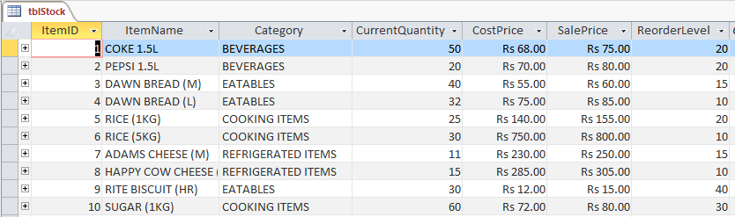

**Design View:**

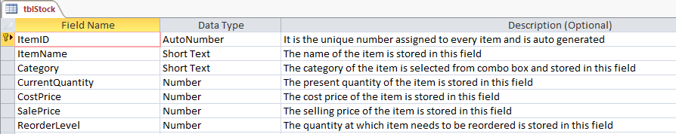

**Design View of “ItemID” field:**

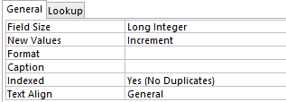

**Design View of “ItemName” field:**

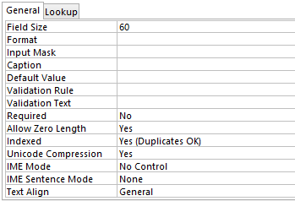

**Design View of “Category” field:**

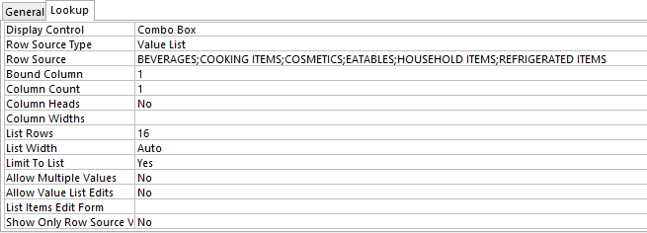

**Design View of “CurrentQuantity” field:**

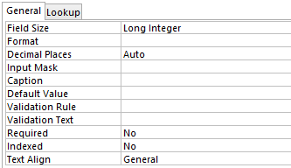

**Design View of “CostPrice” field:**

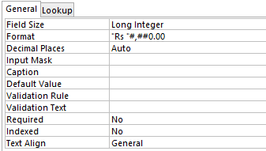

**Design View of “SalePrice” field:**



**Design View of “ReorderLevel” field:**



1. **Suppliers Table:**

This table will store data about each supplier. The name of this table in the database according to the naming convention is **tblSuppliers.**

**Datasheet View:**

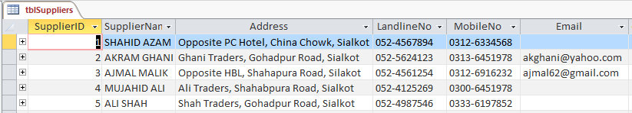

**Design View:**

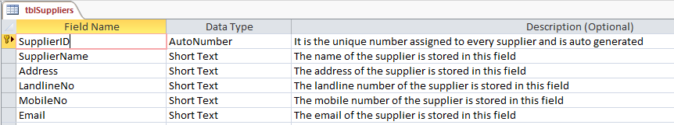

**Design View of “SupplierID” field:**



**Design View of “SupplierName” field:**

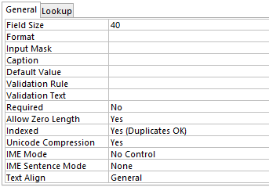

**Design View of “Address” field:**

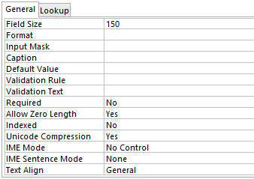

**Design View of “LandlineNo” field:**

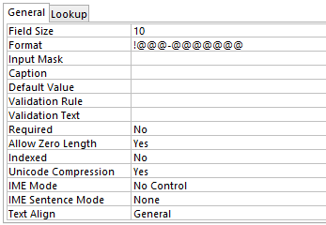

**Design View of “MobileNo” field:**

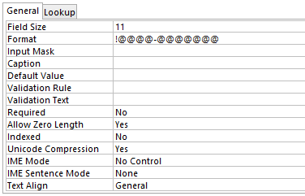

**Design View of “Email” field:**

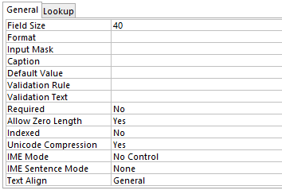

1. **Sales Table:**

This table will store data about the sales that happen. The name of this table in the database according to the naming convention is **tblSales.**

**Datasheet View:**

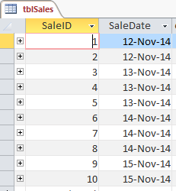

**Design View:**

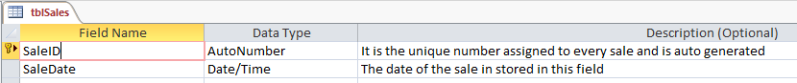

**Design View of “SaleID” field:**



**Design View of “SaleDate” field:**

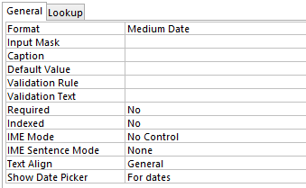

1. **Sales Details Table:**

This table will store data about details of each sale. The name of this table in the database according to the naming convention is **tblSalesDetails.**

**Datasheet View:**

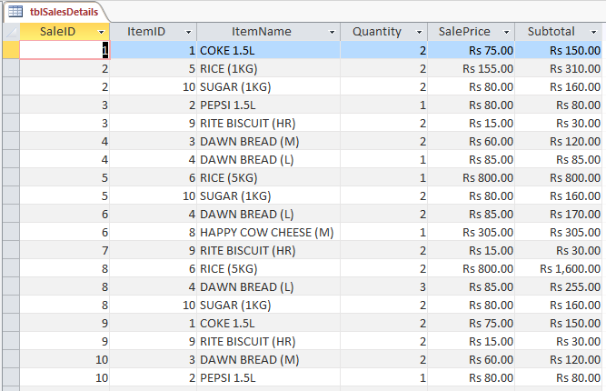

**Design View:**

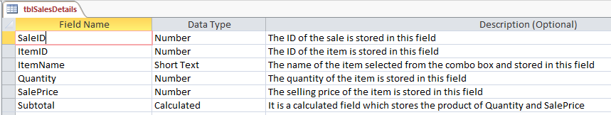

**Design View of “SaleID” field:**

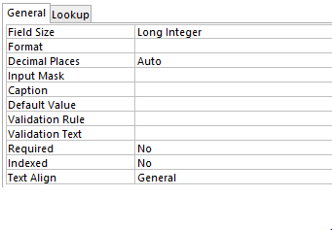

**Design View of “ItemID” field:**

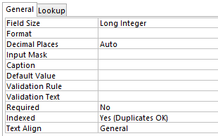

**Design View of “ItemName” field:**

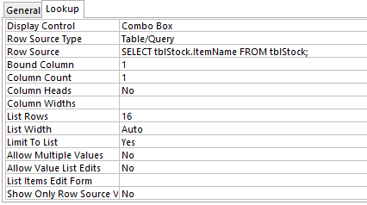

**Design View of “Quantity” field:**

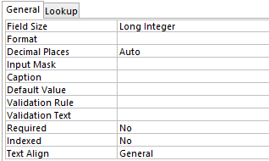

**Design View of “SalePrice” field:**

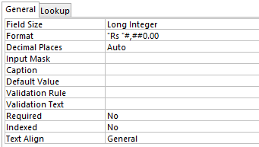

**Design View of “Subtotal” field:**

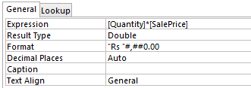

1. **Orders Table:**

This table will store data about each order that is placed. The name of this table in the database according to the naming convention is **tblOrders.**

**Datasheet View:**

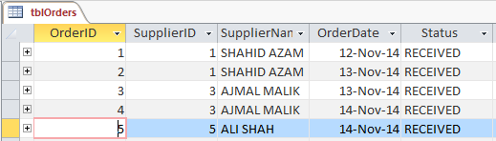

**Design View:**

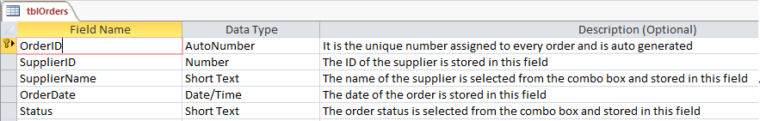

**Design View of “OrderID” field:**

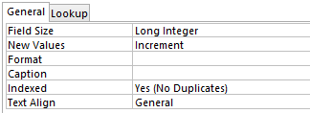

**Design View of “SupplierID” field:**

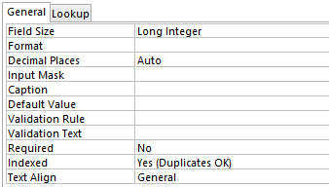

**Design View of “SupplierName” field:**

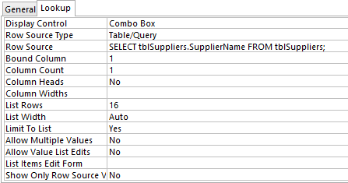

**Design View of “OrderDate” field:**

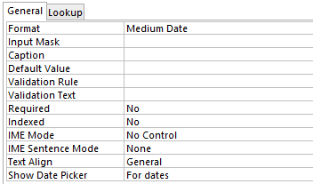

**Design View of “Status” field:**

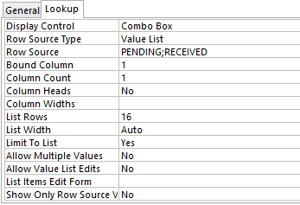

1. **Order Details Table:**

This table will store data about details of each order. The name of this table in the database according to the naming convention is **tblOrderDetails.**

**Datasheet View:**

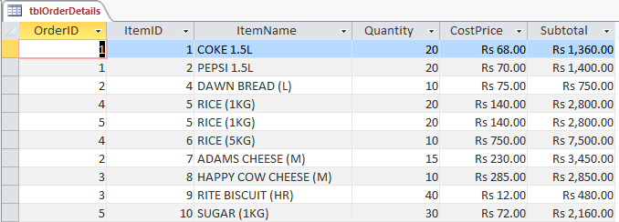

**Design View:**

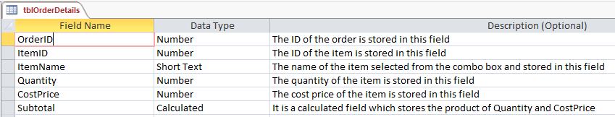

**Design View of “OrderID” field:**



**Design View of “ItemID” field:**



**Design View of “ItemName” field:**



**Design View of “Quantity” field:**



**Design View of “CostPrice” field:**



**Design View of “Subtotal” field:**

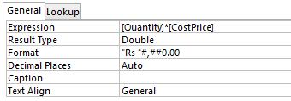

1. **Supply Received Table:**

This table will store data about each order that is placed. The name of this table in the database according to the naming convention is **tblSupplyReceived.**

**Datasheet View:**

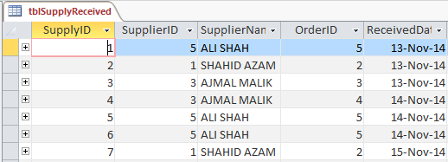

**Design View:**

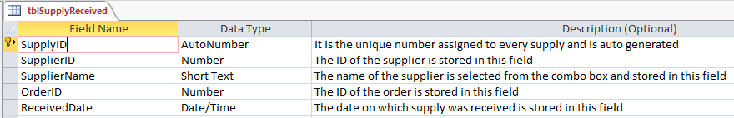

**Design View of “SupplyID” field:**



**Design View of “SupplierID” field:**



**Design View of “SupplierName” field:**



**Design View of “OrderID” field:**



**Design View of “ReceivedDate” field:**



1. **Supply Received Details Table:**

This table will store data about details of each supply that is received. The name of this table in the database according to the naming convention is **tblSupplyReceivedDetails.**

**Datasheet View:**

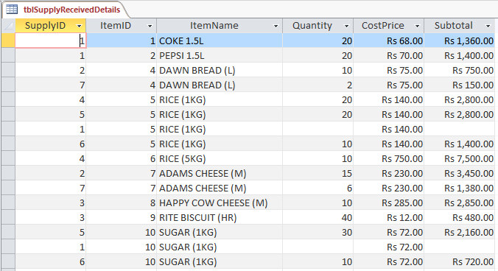

**Design View:**

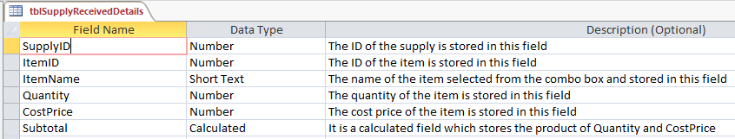

**Design View of “SupplyID” field:**



**Design View of “ItemID” field:**



**Design View of “ItemName” field:**



**Design View of “Quantity” field:**



**Design View of “CostPrice” field:**



**Design View of “Subtotal” field:**



**Data Relationships:**

The following diagram shows the relationships between the tables as decided according to the design plan.

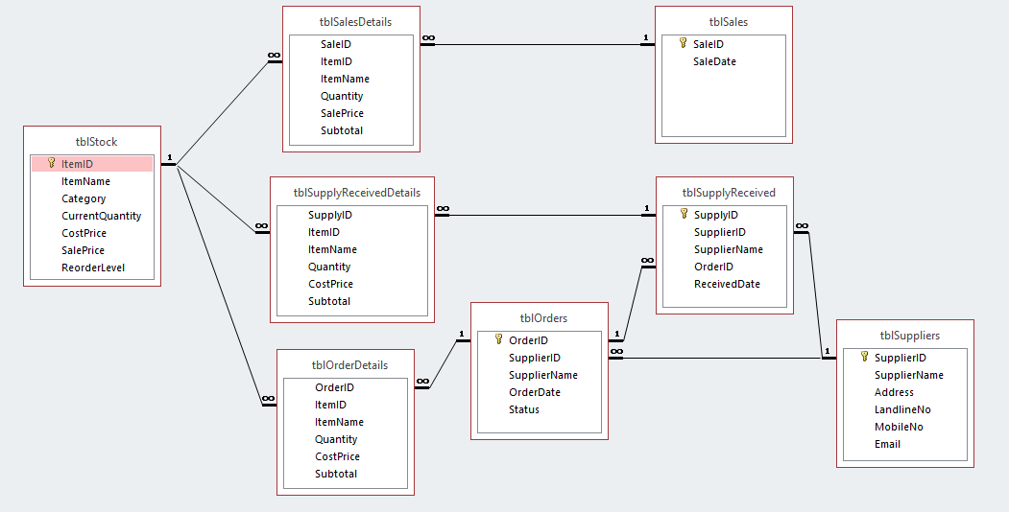

**Login Routine Forms:**

According to the design specification, the login routine forms required were created.

The login routine forms in this database will be:

1. Login Form
2. Change Password Form
3. **Login Form:**

This forms opens up when the database file is opened. The properties are set to Pop Up and Modal which means the user cannot access any part of the database without passing the login form. The name of this form in the database according to the naming convention is **frmLogin.**

**Form View:**

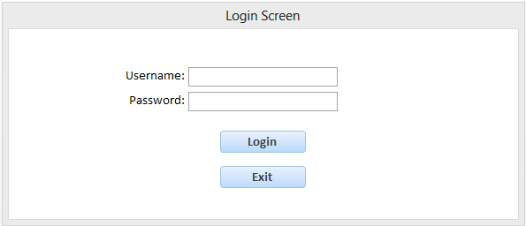

**Design View:**

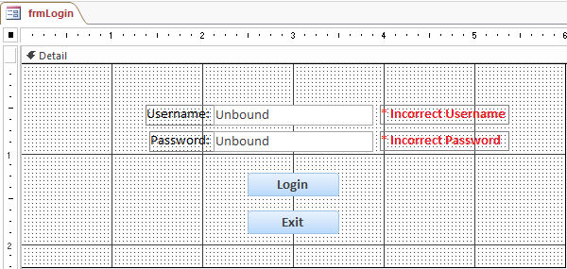

1. **Change Password Form:**

This form will allow the user to change the current password of the database. The name of this form in the database according to the naming convention is **frmChangePassword.**

**Form View:**

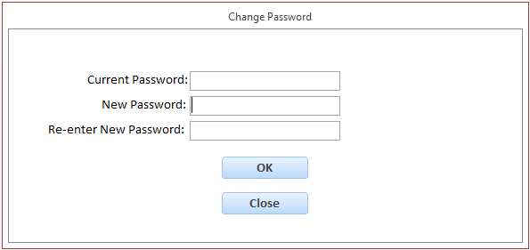

**Design View:**

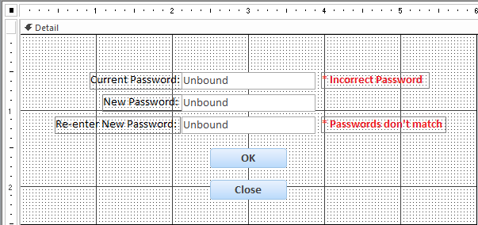

**Navigation Forms:**

The navigation forms allow the user to move between different parts of the database and select required items providing an easier access. These are a link to all of the objects in the database. These forms provide an interface to the user which is a form of an output.

There are six navigation forms in the database:

1. Main Menu
2. Stock Menu
3. Suppliers Menu
4. Sales Menu
5. Orders Menu
6. Supply Received Menu
7. **Main Menu:**

This form is the main form of the database. It will automatically open up after the user passes the login screen. It is a link to the other navigation forms. The name of this form in the database according to the naming convention is **frmMainMenu.**

**Form View:**

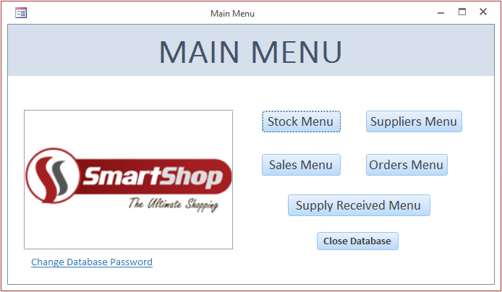

**Design View:**

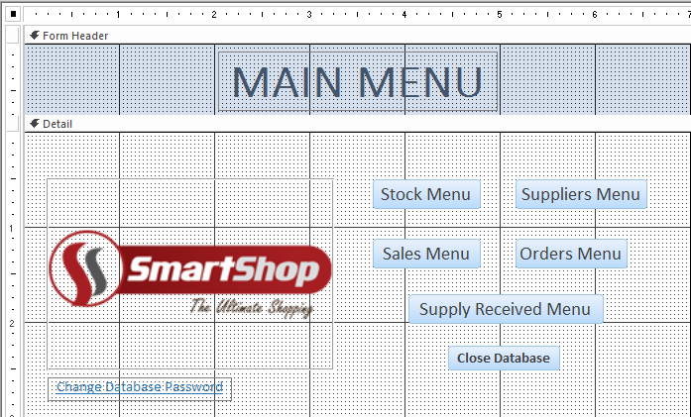

1. **Stock Menu:**

This form allows the user to view all the objects and processes in the database related to Stock. It has buttons to open up the object the user wants. The name of this form in the database according to the naming convention is **frmStockMenu.**

**Form View:**

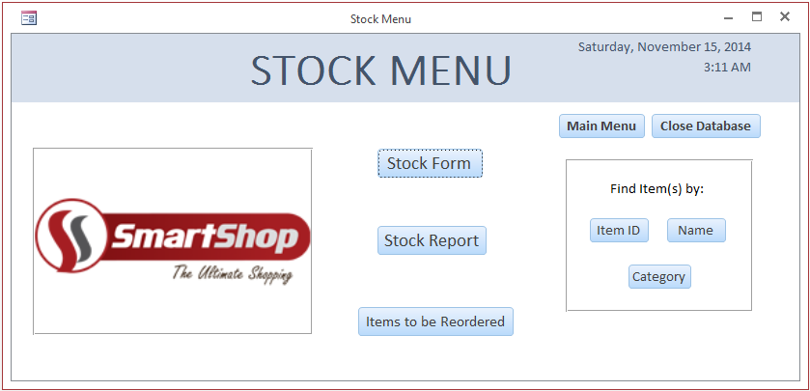

**Design View:**

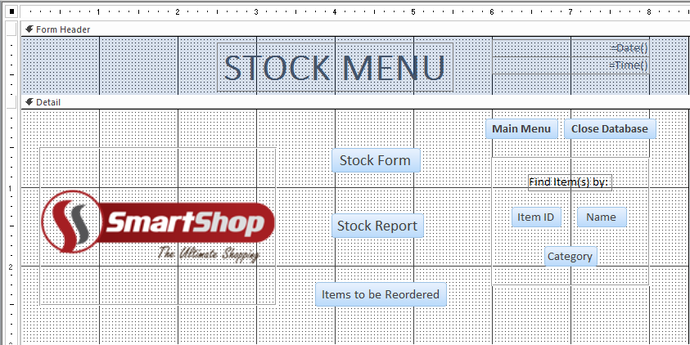

1. **Suppliers Menu:**

This form allows the user to view all the objects and processes in the database related to Suppliers. It has buttons to open up the object the user wants. The name of this form in the database according to the naming convention is **frmSuppliersMenu.**

**Form View:**

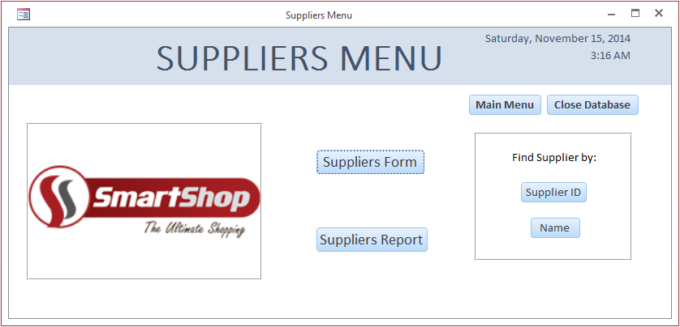

**Design View:**

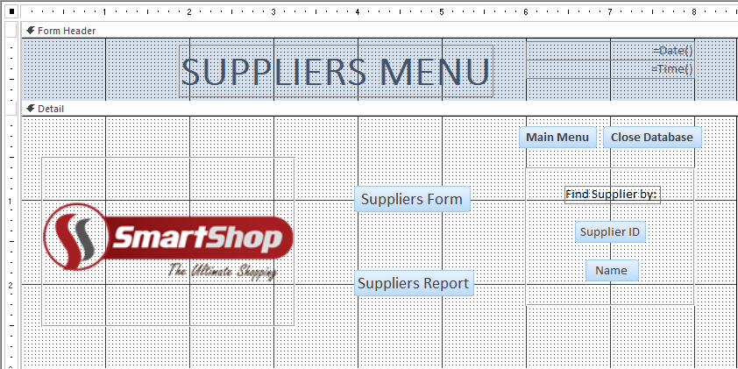

1. **Sales Menu:**

This form allows the user to view all the objects and processes in the database related to Sales. It has buttons to open up the object the user wants. The name of this form in the database according to the naming convention is **frmSalesMenu.**

**Form View:**

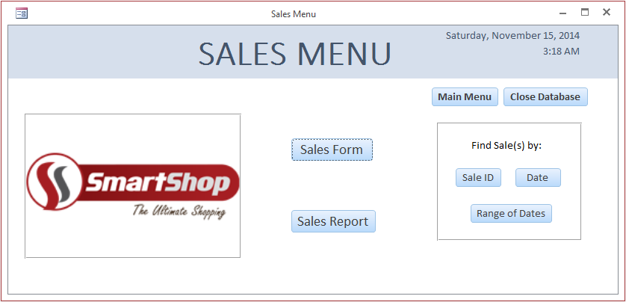

**Design View:**

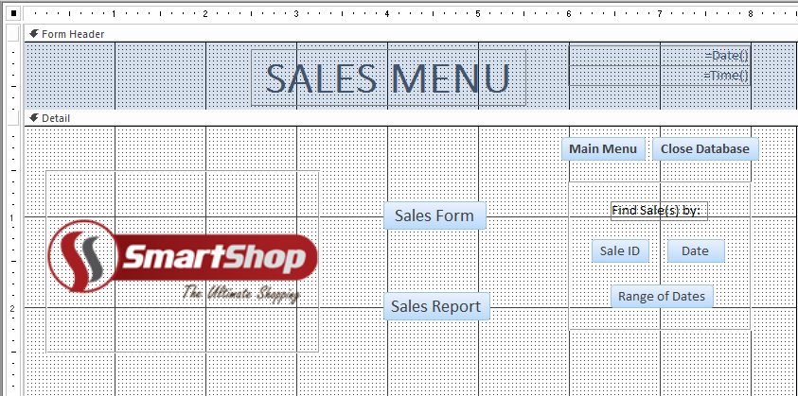

1. **Orders Menu:**

This form allows the user to view all the objects and processes in the database related to Orders. It has buttons to open up the object the user wants. The name of this form in the database according to the naming convention is **frmOrdersMenu.**

**Form View:**

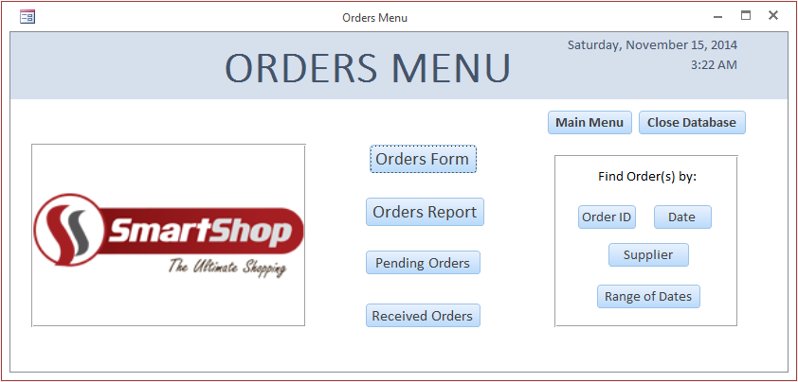

**Design View:**

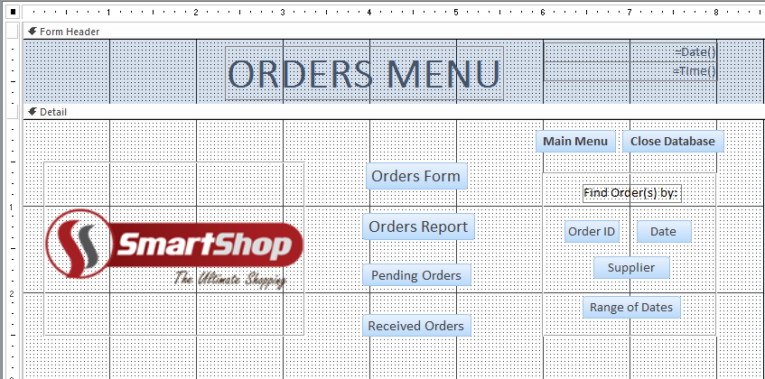

1. **Supply Received Menu:**

This form allows the user to view all the objects and processes in the database related to Supply Received. It has buttons to open up the object the user wants. The name of this form in the database according to the naming convention is **frmSupplyReceivedMenu.**

**Form View:**

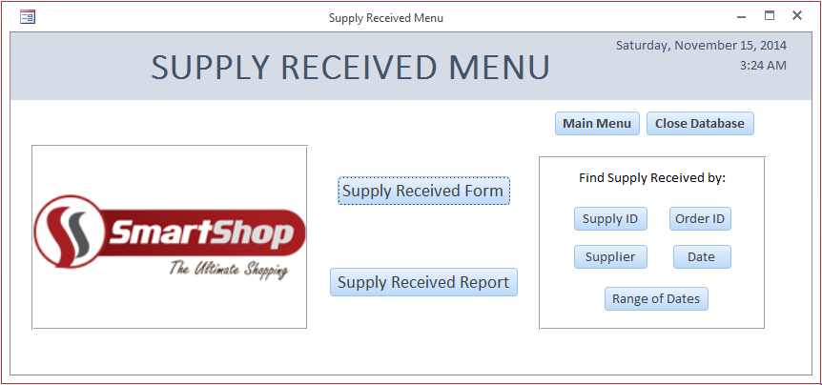

**Design View:**

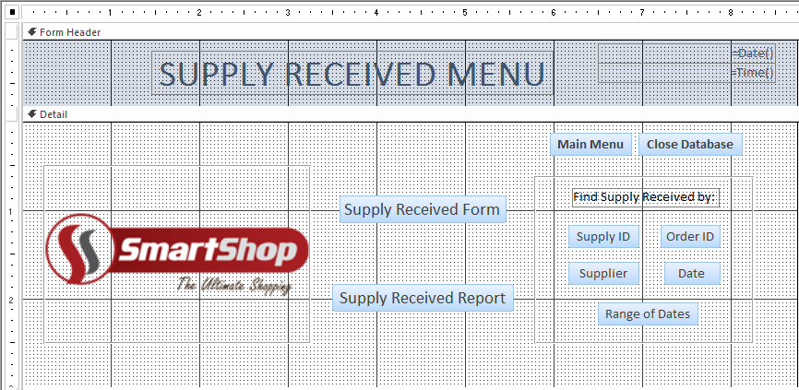

**Data Entry Forms:**

The user enters the data through the data entry forms and then the data will be stored in the specified data table. If the user enter data violating the validation rules a custom error message will be shown. The data entry forms in this database will be:

1. Stock Form
2. Suppliers Form
3. Sales Form
4. Orders Form
5. Supply Received Form
6. **Stock Form:**

This form is linked to the **Stock Table**. All the records entered in this form will be stored in the **Stock Table**. The name of this form in the database according to the naming convention is **frmStock**.

**Form View:**

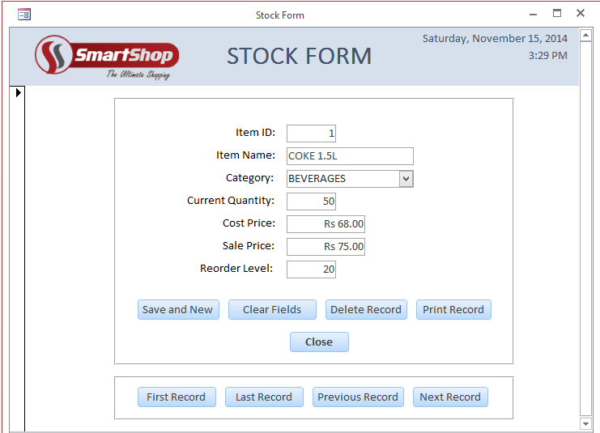

**Design View:**

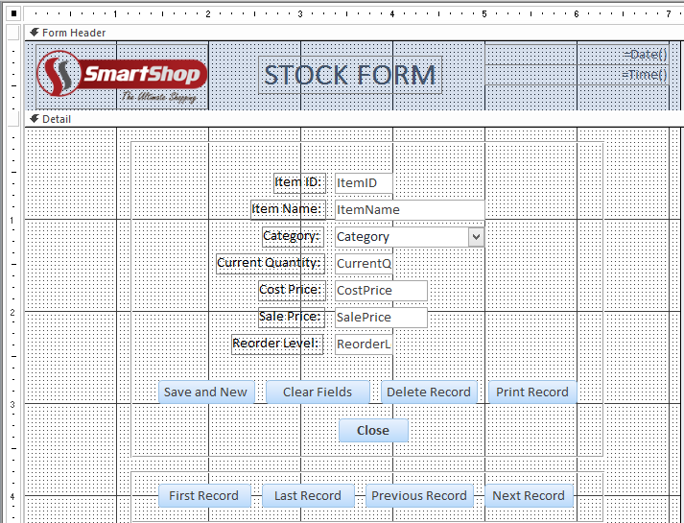

1. **Suppliers Form:**

This form is linked to the **Suppliers Table**. All the records entered in this form will be stored in the **Suppliers Table**. The name of this form in the database according to the naming convention is **frmSuppliers.**

**Form View:**

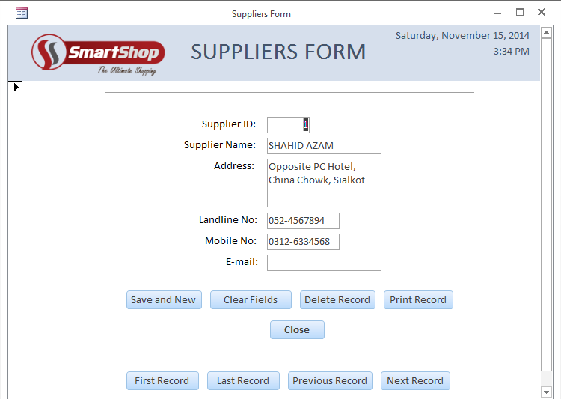

**Design View:**

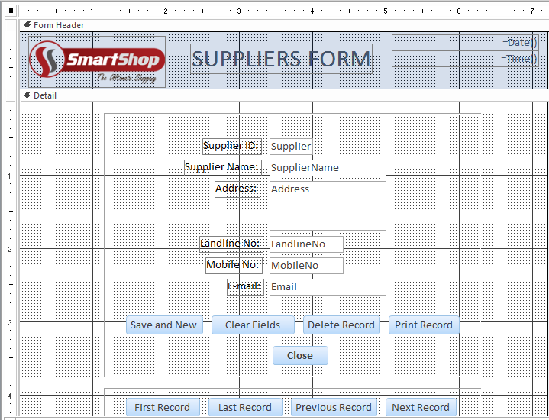

1. **Sales Form:**

This form is linked to the **Sales Table**. There is a sub form in this form called **Sales Details Form** and is linked to the **Sales Details Table**. All the records entered in this form will be stored in the **Sales Table** and **Sales Details Table** accordingly. The name of this form in the database according to the naming convention is **frmSales.**

**Form View:**

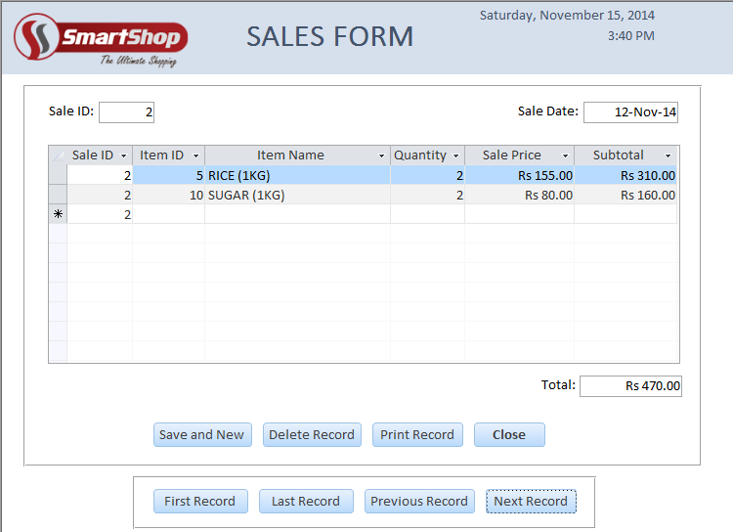

**Design View:**

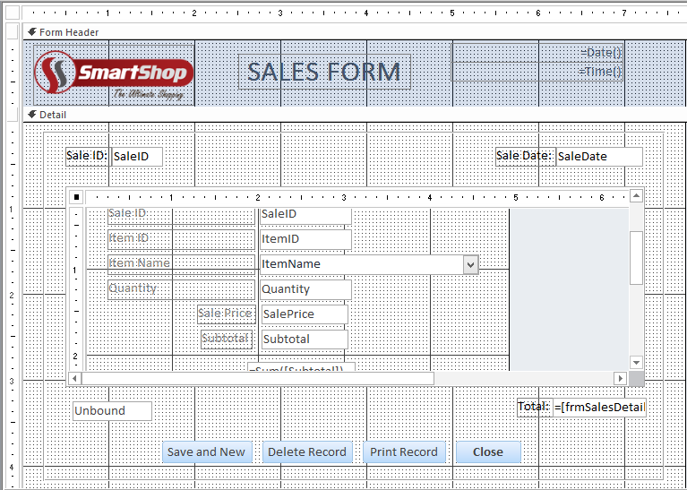

1. **Orders Form:**

This form will is to the **Orders Table**. There is a sub form in this form called **Order Details Form** and is linked to the **Order Details Table**. All the records entered in this form will be stored in the **Orders Table** and **Order Details Table** accordingly. The name of this form in the database according to the naming convention is **frmOrders.**

**Form View:**

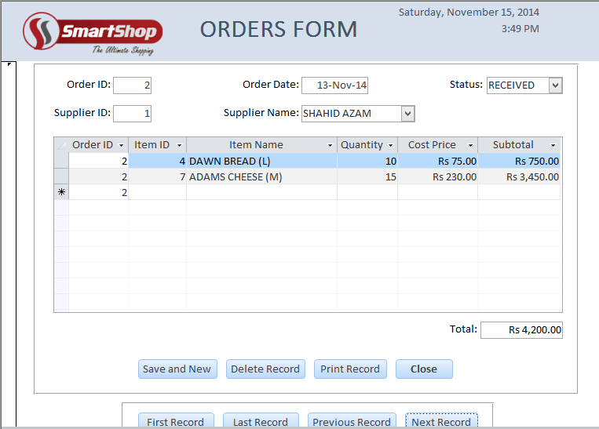

**Design View:**

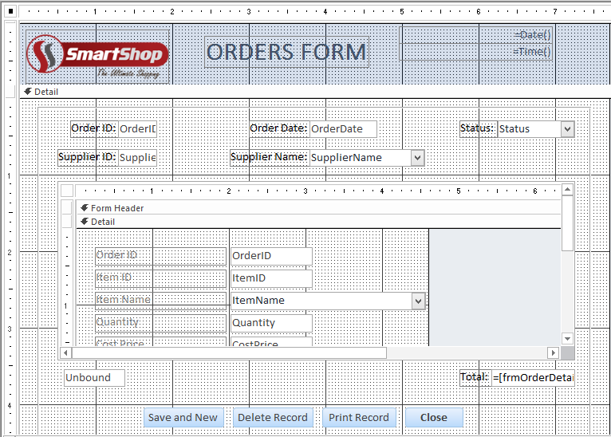

1. **Supply Received Form:**

This form is linked to the **Supply Received Table**. There is a sub form in this form called **Supply Received Details Form** and is linked to the **Supply Received Details Table**. All the records entered in this form will be stored in the **Supply Received Table** and **Supply Received Details Table** accordingly. The name of this form in the database according to the naming convention is **frmSupplyReceived.**

**Form View:**

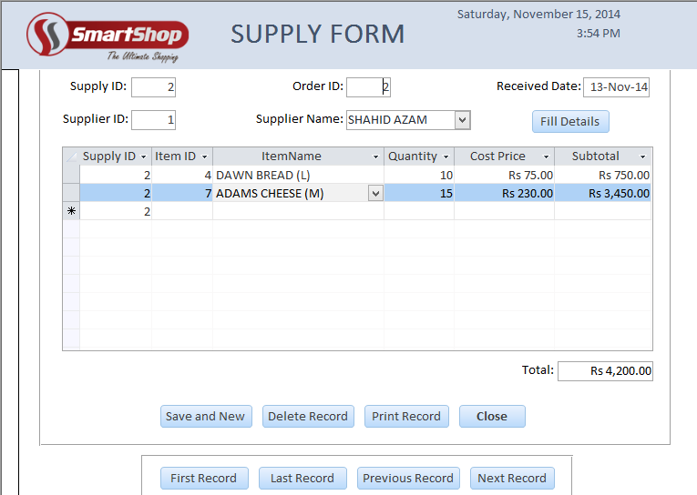

**Design View:**

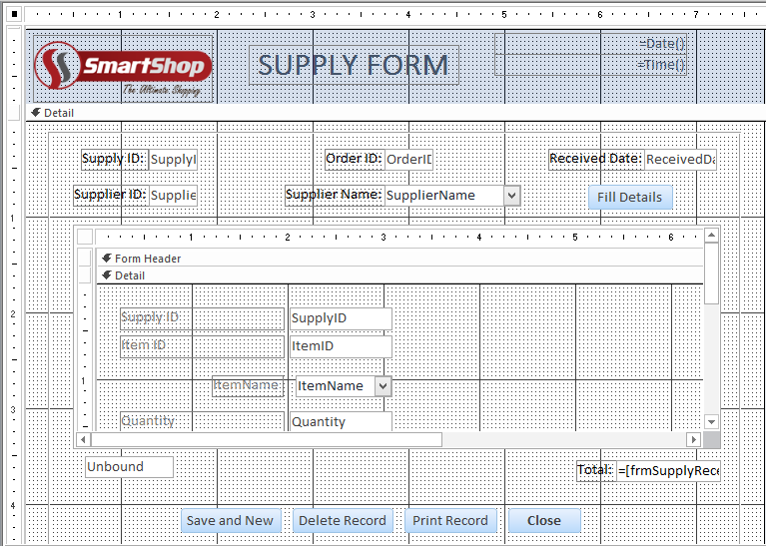

**Search Forms:**

The search forms allow the user to input data and find records according to the input. The result will be displayed on either form or report.

The search forms in this database are:

1. Find Item by ID
2. Find Item by Name
3. Find Item by Category
4. Find Supplier by ID
5. Find Supplier by Name
6. Find Sale by ID
7. Find Sale by Date
8. Find Sales From Until
9. Find Order by ID
10. Find Order by Date
11. Find Order by Supplier
12. Find Orders From Until
13. Find Supply by ID
14. Find Supply by Order ID
15. Find Supply by Supplier
16. Find Supply by Date
17. Find Supply Received From Until
18. **Find Item by ID:**

This form will allow the user to search for a record using the **ItemID**. As there will be a single record result so a form will open up to show the result. The name of this form in the database according to the naming convention is **frmItembyID.**

**Entry:**  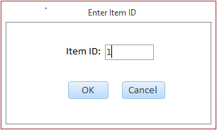

**Result:**

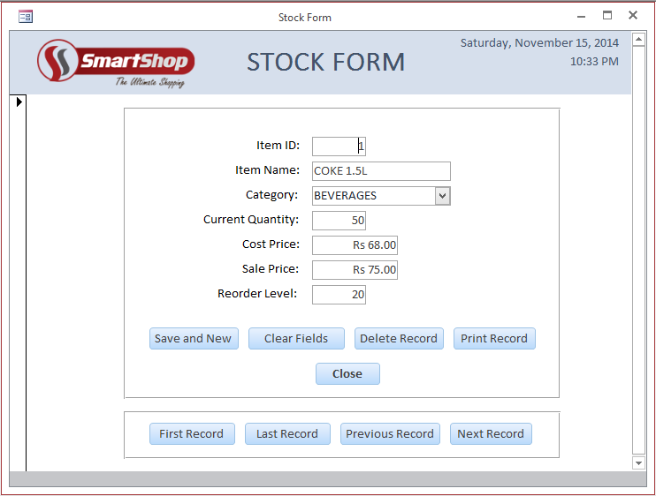

1. **Find Item by Name:**

This form allows the user to search for a record using the **ItemName**. It will be a combo box so user can only enter/select existing item name. As there will be a single record result so a form will open up to show the result. The name of this form in the database according to the naming convention is **frmItembyName.**

**Entry:**

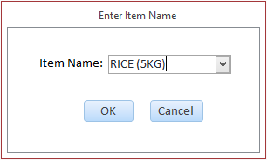

**Result:**

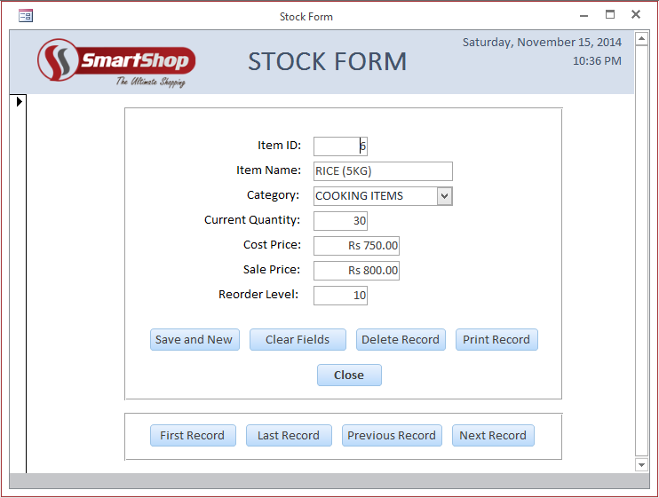

1. **Find Item by Category:**

This form allows the user to search for records using the **Category**. It will be a combo box so user can only enter/select available categories. As there will be a multiple records result so a report will open up to show the results. The name of this form in the database according to the naming convention is **frmItembyCategory.**

**Entry:**

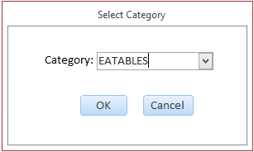

**Result:**

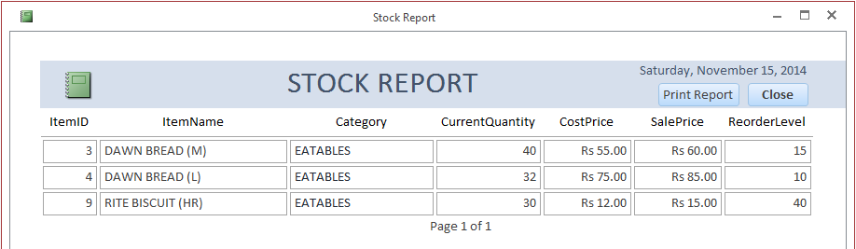

1. **Find Supplier by ID:**

This form allows the user to search for a record using the **SupplierID**. As there will be a single record result so a form will open up to show the result. The name of this form in the database according to the naming convention is **frmSupplierbyID.**

**Entry:**

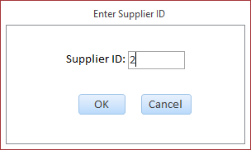

**Result:**

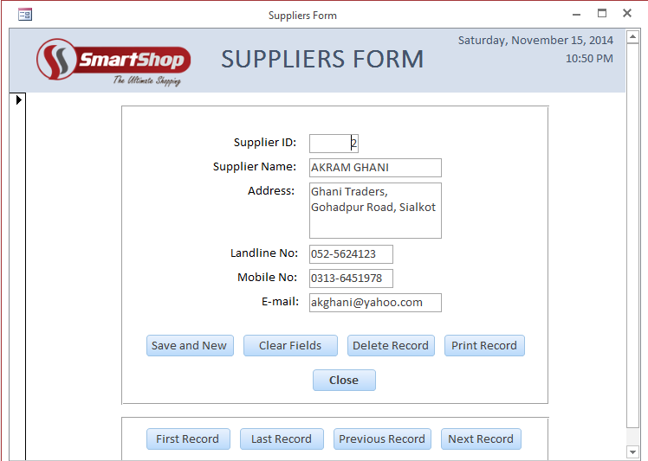

1. **Find Supplier by Name:**

This form alloes the user to search for a record using the **SupplierName**. It will be a combo box so user can only enter/select existing supplier name. As there will be a single record result so a form will open up to show the result. The name of this form in the database according to the naming convention is **frmSupplierbyName.**

**Entry:**

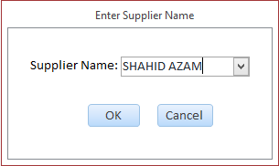

**Result:**

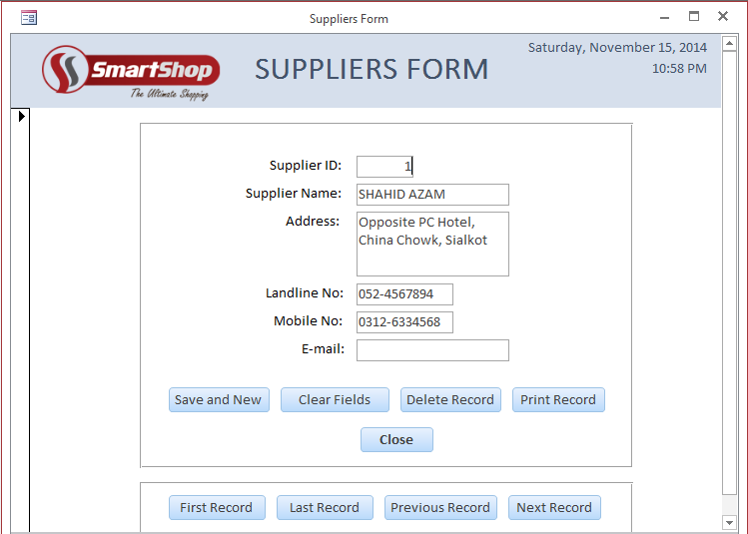

1. **Find Sale by ID:**

This form allows the user to search for a record using the **SaleID**. As there will be a single record result so a form will open up to show the result. The name of this form in the database according to the naming convention is **frmSalebyID.**

**Entry:**

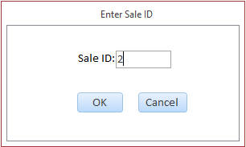

**Result:**



1. **Find Sale by Date:**

This form allows the user to search for records using the **SaleDate**. As there will be a multiple records result so a report will open up to show the results. The name of this form in the database according to the naming convention is **frmSalebyDate.**

**Entry:**

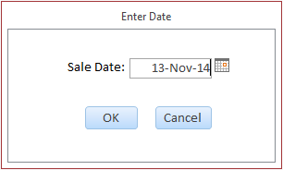

**Result:** 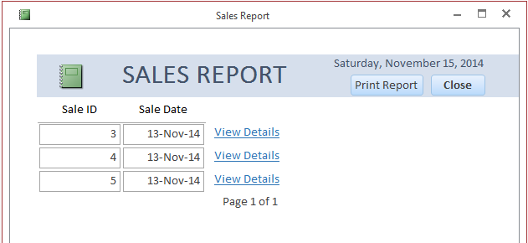

1. **Find Sales From Until:**

This form allows the user to search for records using the **SaleDate**. As there will be a multiple records result so a report will open up to show the results. The name of this form in the database according to the naming convention is **frmSalesFromUntil.**

**Entry:**

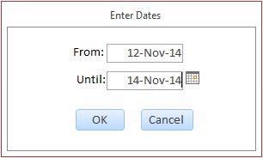

**Result:**

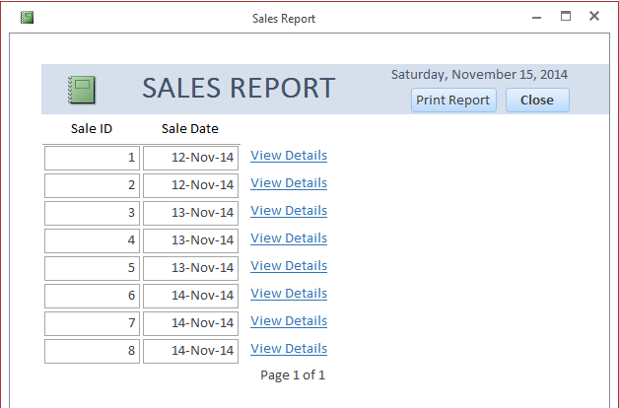

1. **Find Order by ID:**

This form allows the user to search for a record using the **OrderID**. As there will be a single record result so a form will open up to show the result. The name of this form in the database according to the naming convention is **frmOrderbyID.**

**Entry:**

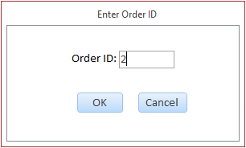

**Result:**



1. **Find Order by Date:**

This form allows the user to search for records using the **OrderDate**. As there will be a multiple records result so a report will open up to show the results. The name of this form in the database according to the naming convention is **frmOrderbyDate.**

**Entry:**

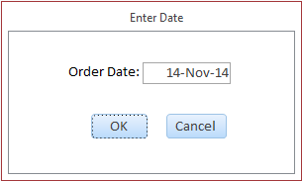

**Result:**

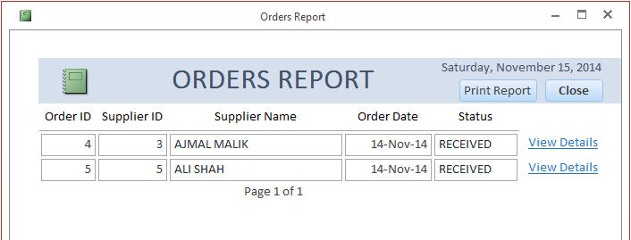

1. **Find Order by Supplier:**

This form allows the user to search for records using the **SupplierName**. It will be a combo box so user can only enter/select existing supplier name. As there will be a multiple records result so a report will open up to show the results. The name of this form in the database according to the naming convention is **frmOrderbySupplier.**

**Entry:**

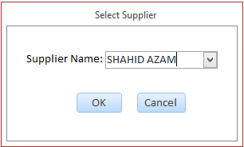

**Result:**

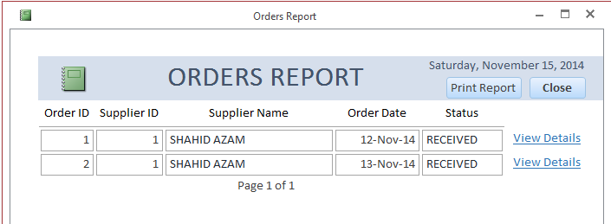

1. **Find Orders From Until:**

This form will allow the user to search for records using the **OrderDate**. As there will be a multiple records result so a report will open up to show the results. The name of this form in the database according to the naming convention is **frmOrdersFromUntil.**

**Entry:**

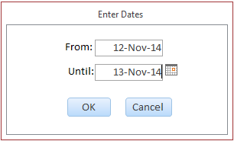

**Result:**

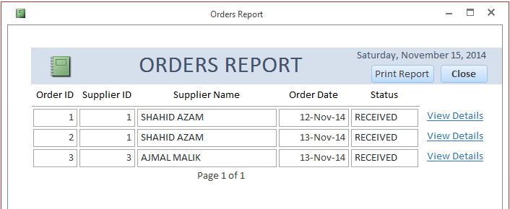

1. **Find Supply by ID:**

This form allows the user to search for a record using the **SupplyID**. As there will be a single record result so a form will open up to show the result. The name of this form in the database according to the naming convention is **frmSupplybyID.**

**Entry:**

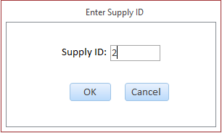

**Result:**



1. **Find Supply by Order ID:**

This form will allow the user to search for a record using the **OrderID**. As there will be a single record result so a form will open up to show the result. The name of this form in the database according to the naming convention is **frmSupplybyOrderID.**

**Entry:**

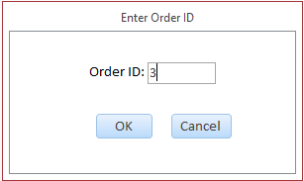

**Result:**

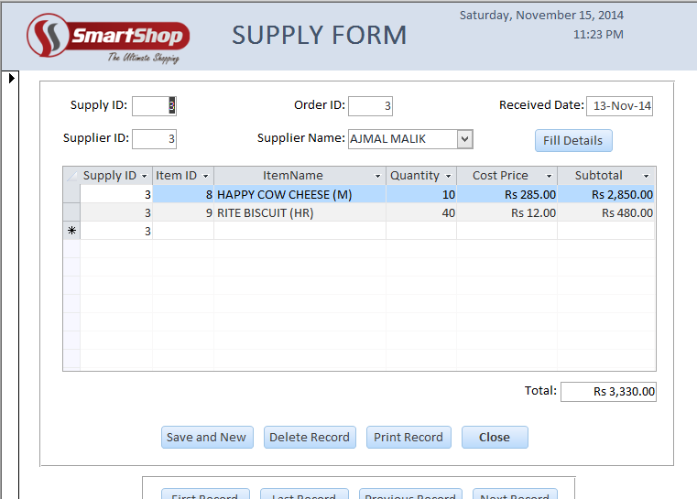

1. **Find Supply by Supplier:**

This form allows the user to search for records using the **SupplierName**. It will be a combo box so user can only enter/select existing supplier name. As there will be a multiple records result so a report will open up to show the results. The name of this form in the database according to the naming convention is **frmSupplybySupplier.**

**Entry:**

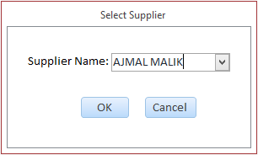

**Result:**

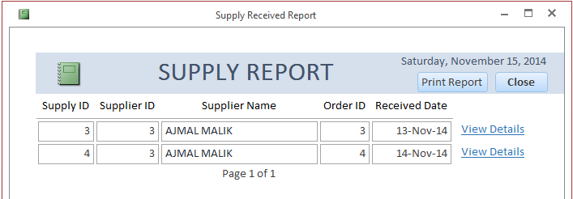

1. **Find Supply by Date:**

This form allows the user to search for records using the **ReceivedDate**. As there will be a multiple records result so a report will open up to show the results. The name of this form in the database according to the naming convention is **frmSupplybyDate.**

**Entry:**

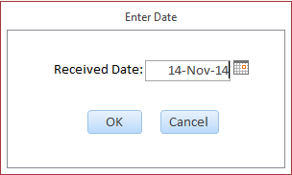

**Result:**

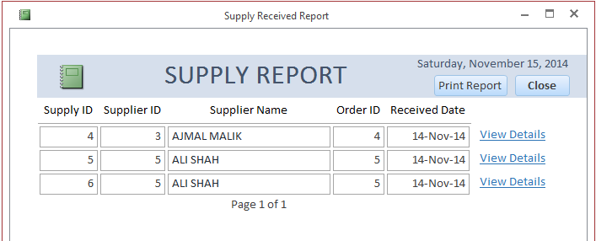

1. **Find Supply Received From Until:**

This form allows the user to search for records using the **ReceivedDate**. As there will be a multiple records result so a report will open up to show the results. The name of this form in the database according to the naming convention is **frmSupplyReceivedFromUntil.**

**Entry:**

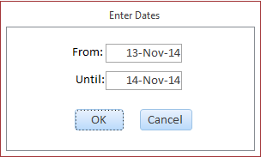

**Result:**

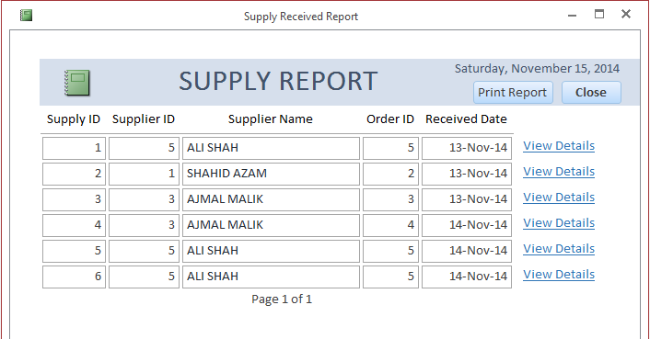

**Reports:**

The reports in the database will be used to display records. Each report will show data from its respective table. The reports in the database are:

1. Stock Report
2. Suppliers Report
3. Sales Report
4. Orders Report
5. Supply Received Report
6. **Stock Report:**

This report is linked to the **Stock Table** and shows the records from it. All the fields from the **Stock Table** are on this report, each showing data therefore forming a complete record. The name of this report in the database according to the naming convention is **rptStock.**

**Report View:**

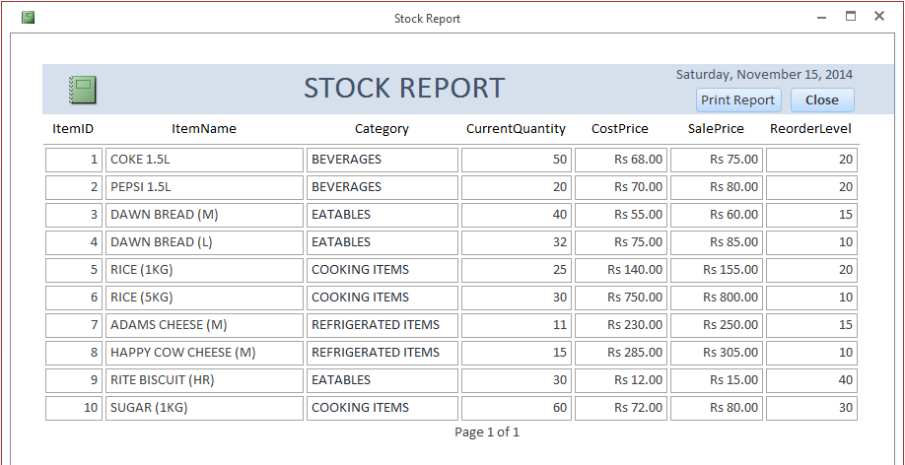

**Design View:**

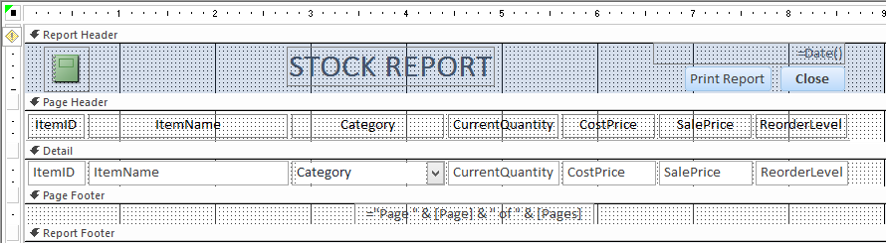

1. **Suppliers Report:**

This report is linked to the **Suppliers Table** and shows the records from it. All the fields from the **Suppliers Table** are on this report, each showing data therefore forming a complete record. The name of this report in the database according to the naming convention is **rptSuppliers.**

**Report View:**

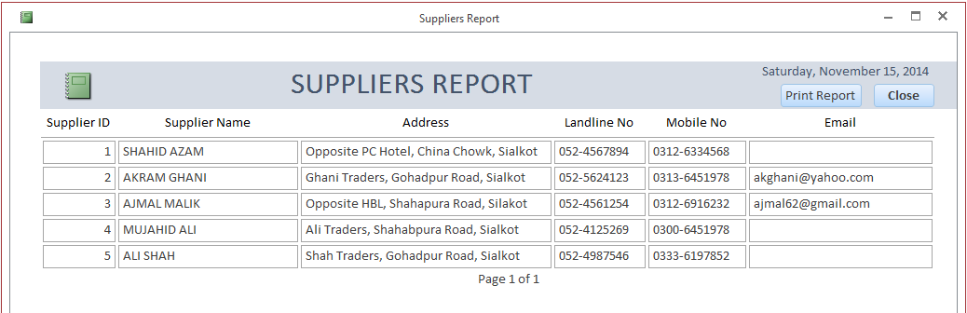

**Design View:**

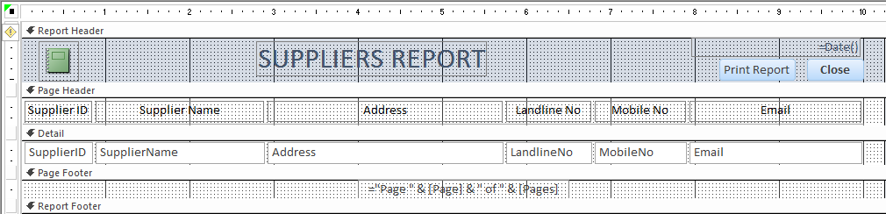

1. **Sales Report:**

This report is linked to the **Sales Table** and shows the records from it. All the fields from the **Sales Table** are on this report, each showing data therefore forming a complete record. The name of this report in the database according to the naming convention is **rptSales.**

**Report View:**

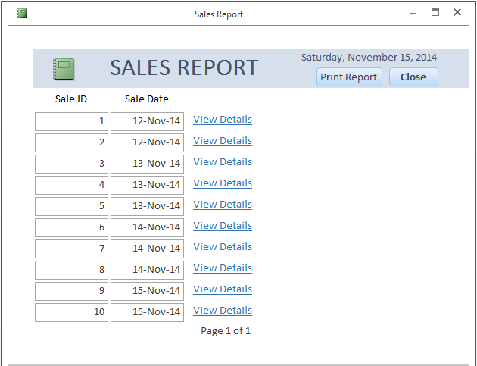

**Design View:**

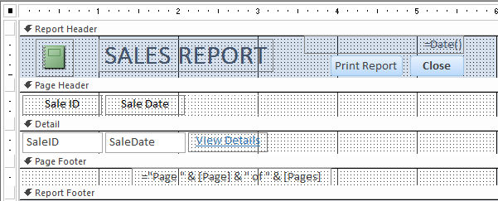

1. **Orders Report:**

This report is linked to the **Orders Table** and shows the records from it. All the fields from the **Orders Table** are on this report, each showing data therefore forming a complete record. The name of this report in the database according to the naming convention is **rptOrders.**

**Report View:**

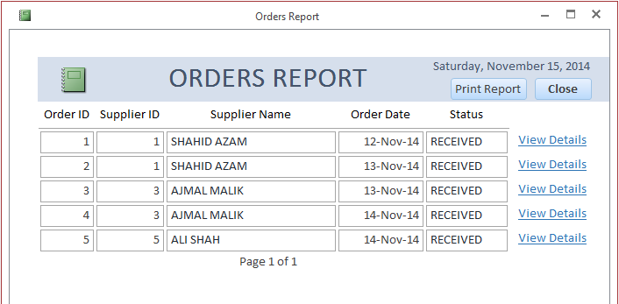

**Design View:**

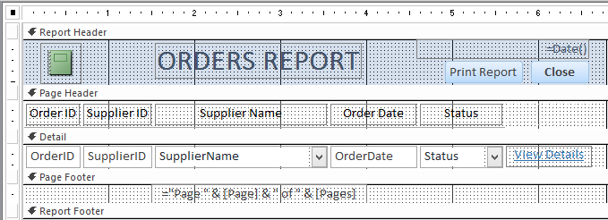

1. **Supply Received Report:**

This report is linked to the **Supply Received Table** and it will show the records from it. All the fields from the **Supply Received Table** are on this report, each showing data therefore forming a complete record. The name of this report in the database according to the naming convention is **rptSupplyReceived.**

**Report View:**

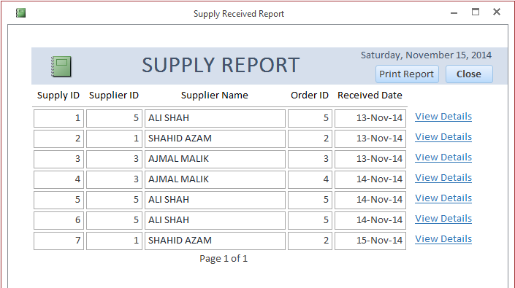

**Design View:**

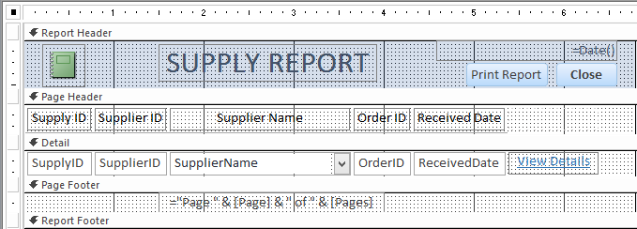

**PROGRAMMING**

The programming is the most integral part of this solution. All the programming has been done using **VBA.** Each object has its own programming done to add functionality so the code shown has been broken down and divided accordingly.

Comments are used to annotate the code and are highlighted in **green color** and start with the special character according to commenting rule in VBA.

* **Login Form (frmLogin):**

Private Sub btnExit_Click()

'Exit Database

DoCmd.Quit

End Sub

Private Sub btnLogin_Click()

'Declare variables to be used

Dim dbs As DAO.Database 'name for current database

Dim rst As DAO.Recordset 'name for new recordset

Dim Username As String 'name for current username

Dim Password As String 'name for current password

'Set values for database and recordset

Set dbs = CurrentDb

Set rst = dbs.OpenRecordset("tblLogin")

'Assign values for Username and Password

rst.MoveFirst

Password = rst("Password")

Username = "ch.ahmad"

'Error message if Username field is empty

If IsNull(Me.txtUsername) = True Then

MsgBox "Username is required!", vbExclamation, "The Smart Shop"

Me.txtUsername.SetFocus

'Exit the subroutine due to error

Exit Sub

End If

'Error if entered username doesn't match existing username

If Me.txtUsername <> Username Then

'Show error label

Me.lblWrongUsername.Visible = True

Me.txtUsername.SetFocus

'Exit the subroutine due to error

Exit Sub

End If

'Hide error label

Me.lblWrongUsername.Visible = False

'Error message if Password field is empty

If IsNull(Me.txtPassword) = True Then

MsgBox "Password is required!", vbExclamation, "The Smart Shop"

Me.txtPassword.SetFocus

'Exit the subroutine due to error

Exit Sub

End If

'Error if entered password doesn't match existing password

If Me.txtPassword <> Password Then

'Show error label

Me.lblWrongPassword.Visible = True

Me.txtPassword.SetFocus

'Exit the subroutine due to error

Exit Sub

End If

'Hide error label

Me.lblWrongPassword.Visible = False

'Set variables to nothing

Set rst = Nothing

Set dbs = Nothing

'Open Main Menu

DoCmd.OpenForm "frmMainMenu"

'Close Login Form

DoCmd.Close acForm, "frmLogin"

End Sub

* **Change Password Form (frmChangePassword):**

Private Sub btnClose_Click()

'Close the form

DoCmd.Close acForm, "frmChangePassword"

End Sub

Private Sub btnOK_Click()

'Declare variables to be used

Dim dbs As DAO.Database 'name for current database

Dim rst As DAO.Recordset 'name for new recordset

Dim Password As String 'name for current password

'Set values for database and recordset

Set dbs = CurrentDb

Set rst = dbs.OpenRecordset("tblLogin")

'Assign value for Password

rst.MoveFirst

Password = rst("Password")

'Error message if Current Password field is empty

If IsNull(Me.txtPassword) = True Then

MsgBox "Current Password is required!", vbExclamation, "The Smart Shop"

Me.txtPassword.SetFocus

'Exit the subroutine due to error

Exit Sub

End If

'Error if entered password is not same as current password

If Me.txtPassword <> Password Then

'Show error label

Me.lblWrongPassword.Visible = True

Me.txtPassword.SetFocus

'Exit the subroutine due to error

Exit Sub

End If

'Hide error label

Me.lblWrongPassword.Visible = False

'Error message if New Password field is empty

If IsNull(Me.txtNewPassword) = True Then

MsgBox "Enter new password!", vbExclamation, "The Smart Shop"

Me.txtNewPassword.SetFocus

'Exit the subroutine due to error

Exit Sub

End If

'Error message if Re-enter New Password field is empty

If IsNull(Me.txtReNewPassword) = True Then

MsgBox "Re-enter new password!", vbExclamation, "The Smart Shop"

Me.txtReNewPassword.SetFocus

'Exit the subroutine due to error

Exit Sub

End If

'Error if new passwords don't match

If Me.txtNewPassword <> Me.txtReNewPassword Then

'Show error label

Me.lblNoMatch.Visible = True

Me.txtReNewPassword.SetFocus

'Exit the subroutine due to error

Exit Sub

End If

'Hide error label

Me.lblNoMatch.Visible = False

'Edit and update the recordset

rst.Edit

rst("Password") = Me.txtNewPassword

rst.Update

'Close the recordset

rst.Close

'Show message that password has been changed

MsgBox "Password changed successfully!", vbInformation, "The Smart Shop"

'Close the form

DoCmd.Close acForm, "frmChangePassword"

'Set variables to nothing

Set rst = Nothing

Set dbs = Nothing

End Sub

* **Main Menu (frmMainMenu):**

Private Sub btnClose_Click()

'Exit Database

DoCmd.Quit

End Sub

Private Sub btnOrdersMenu_Click()

'Open Orders Menu

DoCmd.OpenForm "frmOrdersMenu", acNormal

'Close Main Menu

DoCmd.Close acForm, "frmMainMenu"

End Sub

Private Sub btnSalesMenu_Click()

'Open Sales Menu

DoCmd.OpenForm "frmSalesMenu", acNormal

'Close Main Menu

DoCmd.Close acForm, "frmMainMenu"

End Sub

Private Sub btnStockMenu_Click()

'Open Stock Menu

DoCmd.OpenForm "frmStockMenu", acNormal

'Close Main Menu

DoCmd.Close acForm, "frmMainMenu"

End Sub

Private Sub btnSuppliersMenu_Click()

'Open Suppliers Menu

DoCmd.OpenForm "frmSuppliersMenu", acNormal

'Close Main Menu

DoCmd.Close acForm, "frmMainMenu"

End Sub

Private Sub btnSupplyMenu_Click()

'Open Supply Received Menu

DoCmd.OpenForm "frmSupplyReceivedMenu", acNormal

'Close Main Menu

DoCmd.Close acForm, "frmMainMenu"

End Sub

Private Sub lblChangePassword_Click()

'Open Change Password Form

DoCmd.OpenForm "frmChangePassword", acNormal

End Sub

* **Stock Menu (frmStockMenu):**

Private Sub btnClose_Click()

'Exit Database

DoCmd.Quit

End Subn

Private Sub btnFindbyCategory_Click()

'Open Find Item by Category form

DoCmd.OpenForm "frmItembyCategory", acNormal

End Sub

Private Sub btnFindbyID_Click()

'Open Find Item by ID form

DoCmd.OpenForm "frmItembyID", acNormal

End Sub

Private Sub btnFindbyName_Click()

'Open Find Item by Name form

DoCmd.OpenForm "frmItembyName", acNormal

End Sub

Private Sub btnForm_Click()

'Open Stock form

DoCmd.OpenForm "frmStock", acNormal

End Sub

Private Sub btnItemReorder_Click()

'Declare variables to be used

Dim DocName As String 'name for document to be opened

Dim strCondition As String 'name for condition

'Assign value to DocName

DocName = "rptStock"

'Assign condition where current quantity is less and equal to reorder level

strCondition = "CurrentQuantity <= ReorderLevel"

'Open Stock Report according to condition

DoCmd.OpenReport DocName, acViewReport, , strCondition

End Sub

Private Sub btnMainMenu_Click()

'Open Main Menu

DoCmd.OpenForm "frmMainMenu", acNormal

'Close Stock Menu

DoCmd.Close acForm, "frmStockMenu"

End Sub

Private Sub btnReport_Click()

'Open Stock Report

DoCmd.OpenReport "rptStock", acViewReport

End Sub

* **Suppliers Menu (frmSuppliersMenu):**

Private Sub btnClose_Click()

'Exit Database

DoCmd.Quit

End Sub

Private Sub btnFindbyID_Click()

'Open Find Supplier by ID form

DoCmd.OpenForm "frmSupplierbyID", acNormal

End Sub

Private Sub btnFindbyName_Click()

'Open Find Supplier by Name form

DoCmd.OpenForm "frmSupplierbyName", acNormal

End Sub

Private Sub btnForm_Click()

'Open Suppliers Form

DoCmd.OpenForm "frmSuppliers", acNormal

End Sub

Private Sub btnMainMenu_Click()

'Open Main Menu

DoCmd.OpenForm "frmMainMenu", acNormal

'Close Suppliers Menu

DoCmd.Close acForm, "frmSuppliersMenu"

End Sub

Private Sub btnReport_Click()

'Open Suppliers Report

DoCmd.OpenReport "rptSuppliers", acViewReport

End Sub

* **Sales Menu (frmSalesMenu):**

Private Sub btnClose_Click()

'Exit Database

DoCmd.Quit

End Sub

Private Sub btnFindbyDate_Click()

'Open Find Sale by Date form

DoCmd.OpenForm "frmSalebyDate", acNormal

End Sub

Private Sub btnFindbyID_Click()

'Open Find Sale by ID form

DoCmd.OpenForm "frmSalebyID", acNormal

End Sub

Private Sub btnForm_Click()

'Open Sales Form

DoCmd.OpenForm "frmSales", acNormal

End Sub

Private Sub btnFromUntil_Click()

'Open Find Sales From Until form

DoCmd.OpenForm "frmSalesFromUntil", acNormal

End Sub

Private Sub btnMainMenu_Click()

'Open Main Menu

DoCmd.OpenForm "frmMainMenu", acNormal

'Close Sales Menu

DoCmd.Close acForm, "frmSalesMenu"

End Sub

Private Sub btnReport_Click()

'Open Sales Report

DoCmd.OpenReport "rptSales", acViewReport

End Sub

* **Orders Menu (frmOrdersMenu):**

Private Sub btnClose_Click()

'Exit Database

DoCmd.Quit

End Sub

Private Sub btnFindbyDate_Click()

'Open Find Order by Date form

DoCmd.OpenForm "frmOrderbyDate", acNormal

End Sub

Private Sub btnFindbyID_Click()

'Open Find Order by ID form

DoCmd.OpenForm "frmOrderbyID", acNormal

End Sub

Private Sub btnFindbySupplier_Click()

'Open Find Order by Supplier form

DoCmd.OpenForm "frmOrderbySupplier", acNormal

End Sub

Private Sub btnForm_Click()

'Open Orders Form

DoCmd.OpenForm "frmOrders", acNormal

End Sub

Private Sub btnFromUntil_Click()

'Open Find Orders From Until form

DoCmd.OpenForm "frmOrdersFromUntil", acNormal

End Sub

Private Sub btnMainMenu_Click()

'Open Main Menu

DoCmd.OpenForm "frmMainMenu", acNormal

'Close Orders Menu

DoCmd.Close acForm, "frmOrdersMenu"

End Sub

Private Sub btnPending_Click()

'Declare variables to be used

Dim DocName As String 'name for document to be opened

Dim strCondition As String 'name for condition

'Assign value to DocName

DocName = "rptOrders"

'Assign condition where Status is PENDING

strCondition = "Status = 'PENDING'"

'Open Orders Report according to condition

DoCmd.OpenReport DocName, acViewReport, , strCondition

End Sub

Private Sub btnReceived_Click()

'Declare variables to be used

Dim DocName As String 'name for document to be opened

Dim strCondition As String 'name for condition

'Assign value to DocName

DocName = "rptOrders"

'Assign condition where Status is RECEIVED

strCondition = "Status = 'RECEIVED'"

'Open Orders Report according to condition

DoCmd.OpenReport DocName, acViewReport, , strCondition

End Sub

Private Sub btnReport_Click()

'Open Orders Report

DoCmd.OpenReport "rptOrders", acViewReport

End Sub

* **Supply Received Menu (frmSupplyReceivedMenu):**

Private Sub btnClose_Click()

'Exit Database

DoCmd.Quit

End Sub

Private Sub btnFindbyDate_Click()

'Open Find Supply by Date form

DoCmd.OpenForm "frmSupplybyDate", acNormal

End Sub

Private Sub btnFindbyID_Click()

'Open Find Supply by ID form

DoCmd.OpenForm "frmSupplybyID", acNormal

End Sub

Private Sub btnFindbyOrderID_Click()

'Open Find Supply by Order ID form

DoCmd.OpenForm "frmSupplybyOrderID", acNormal

End Sub

Private Sub btnFindbySupplier_Click()

'Open Find Supply by Supplier form

DoCmd.OpenForm "frmSupplybySupplier", acNormal

End Sub

Private Sub btnForm_Click()

'Open Supply Received Form

DoCmd.OpenForm "frmSupplyReceived", acNormal

End Sub

Private Sub btnFromUntil_Click()

'Open Find Supply Received From Until form

DoCmd.OpenForm "frmSupplyReceivedFromUntil", acNormal

End Sub

Private Sub btnMainMenu_Click()

'Open Main Menu

DoCmd.OpenForm "frmMainMenu", acNormal

'Close Supply Received Menu

DoCmd.Close acForm, "frmSupplyReceivedMenu"

End Sub

Private Sub btnReport_Click()

'Open Supply Received Report

DoCmd.OpenReport "rptSupplyReceived", acViewReport

End Sub

* **Stock Form (frmStock):**

Private Sub btnClear_Click()

'Clear all fields

Me.Undo

End Sub

Private Sub btnClose_Click()

'Ask to save record before closing form if fields are updated

If Me.Dirty = True Then

'If choice is Yes

If MsgBox("Do you want to save the current record?", vbYesNo + vbQuestion, "Save

Record") = vbYes Then

'Call Save Button subroutine

Call btnSave_Click

'Close form if fields are not updated further

If Me.Dirty = False Then

DoCmd.Close acForm, "frmStock"

End If

'If choice is No

ElseIf vbNo Then

'Clear all fields and close the form

Me.Undo

DoCmd.Close

End If

Else

'Close form if fields are not updated

DoCmd.Close acForm, "frmStock"

End If

End Sub

Private Sub btnDelete_Click()

'Delete current record

DoCmd.RunCommand acCmdDeleteRecord

End Sub

Private Sub btnFirst_Click()

'Undo form if fields are updated

If Me.Dirty = True Then

Me.Undo

End If

'Open first record

DoCmd.GoToRecord , , acFirst

End Sub

Private Sub btnLast_Click()

'Undo form if fields are updated

If Me.Dirty = True Then

Me.Undo

End If

'Open last record

DoCmd.GoToRecord , , acLast

End Sub

Private Sub btnNext_Click()

'Undo form if fields are updated

If Me.Dirty = True Then

Me.Undo

End If

'Open next record

DoCmd.GoToRecord , , acNext

End Sub

Private Sub btnPrevious_Click()

'Undo form if fields are updated

If Me.Dirty = True Then

Me.Undo

End If

'Open previous record

DoCmd.GoToRecord , , acPrevious

End Sub

Private Sub btnSave_Click()

'Error messages if the respective fields are empty

If IsNull(Me.ItemName) = True Then

MsgBox "Item Name is required!", vbExclamation, "Error Message"

ElseIf IsNull(Me.Category) = True Then

MsgBox "Category is required!", vbExclamation, "Error Message"

ElseIf IsNull(Me.CurrentQuantity) = True Then

MsgBox "Current Quantity is required!", vbExclamation, "Error Message"

ElseIf IsNull(Me.CostPrice) = True Then

MsgBox "Cost Price is required!", vbExclamation, "Error Message"

ElseIf IsNull(Me.SalePrice) = True Then

MsgBox "Sale Price is required!", vbExclamation, "Error Message"

Else

'Save current record and open new record

DoCmd.RunCommand acCmdSaveRecord

DoCmd.GoToRecord , , acNewRec

End If

End Sub

Private Sub CostPrice_AfterUpdate()

'Error message if value is less and equal to zero

If Me.CostPrice <= 0 Then

MsgBox "Invalid Data! Make sure you enter a value greater than 0.", vbCritical,

"Error Message"

'Erase and return focus to the field

Me.CostPrice = Null

Me.ItemID.SetFocus

Me.CostPrice.SetFocus

End If

End Sub

Private Sub CurrentQuantity_AfterUpdate()

'Error message if value is less than zero

If Me.CurrentQuantity < 0 Then

MsgBox "Invalid Data! Make sure you enter a value of 0 or greater.", vbCritical,

"Error Message"

'Erase and return focus to the field

Me.CurrentQuantity = Null

Me.ItemID.SetFocus

Me.CurrentQuantity.SetFocus

End If

End Sub

Private Sub Form_Error(DataErr As Integer, Response As Integer)

Const conErrDataType = 2113

'Replace standard error message with custom error message

If DataErr = conErrDataType Then

MsgBox "Invalid Data! Please enter numeric data only.", vbCritical, "Error Message"

Response = acDataErrContinue

Else

'Display a standard error message

Response = acDataErrDisplay

End If

End Sub

Private Sub ItemName_AfterUpdate()

'Convert text to uppercase

Me.ItemName = UCase(Me.ItemName)

'Error message if length is greater than 60

If Len(Me.ItemName) > 60 Then

MsgBox "Field size cannot exceed 100 characters.", vbCritical, "Error Message"

'Return focus to the field

Me.ItemID.SetFocus

Me.ItemName.SetFocus

End If

End Sub

Private Sub ReorderLevel_AfterUpdate()

'Error message if value is less and equal to zero

If Me.ReorderLevel <= 0 Then

MsgBox "Invalid Data! Make sure you enter a value greater than 0.", vbCritical,

"Error Message"

'Erase and return focus to the field

Me.ReorderLevel = Null

Me.ItemID.SetFocus

Me.ReorderLevel.SetFocus

End If

End Sub

Private Sub SalePrice_AfterUpdate()

'Error message if value is less and equal to zero

If Me.SalePrice <= 0 Then

MsgBox "Invalid Data! Make sure you enter a value greater than 0.", vbCritical,

"Error Message"

'Erase and return focus to the field

Me.SalePrice = Null

Me.ItemID.SetFocus

Me.SalePrice.SetFocus

End If

End Sub

* **Suppliers Form (frmSuppliers):**

Private Sub btnClear_Click()

'Clear all fields

Me.Undo

End Sub

Private Sub btnClose_Click()

'Ask to save record before closing form if fields are updated

If Me.Dirty = True Then

'If choice is Yes

If MsgBox("Do you want to save the current record?", vbYesNo + vbQuestion, "Save

Record") = vbYes Then

'Call Save Button subroutine

Call btnSave_Click

'Close form if fields are not updated further

If Me.Dirty = False Then

DoCmd.Close acForm, "frmSuppliers"

End If

'If choice is No

ElseIf vbNo Then

'Clear all fields and close the form

Me.Undo

DoCmd.Close

End If

Else

'Close form if fields are not updated

DoCmd.Close acForm, "frmSuppliers"

End If

End Sub

Private Sub btnDelete_Click()

'Delete current record

DoCmd.RunCommand acCmdDeleteRecord

End Sub

Private Sub btnFirst_Click()

'Undo form if fields are updated

If Me.Dirty = True Then

Me.Undo

End If

'Open first record

DoCmd.GoToRecord , , acFirst

End Sub

Private Sub btnLast_Click()

'Undo form if fields are updated

If Me.Dirty = True Then

Me.Undo

End If

'Open last record

DoCmd.GoToRecord , , acLast

End Sub

Private Sub btnNext_Click()

'Undo form if fields are updated

If Me.Dirty = True Then

Me.Undo

End If

'Open next record

DoCmd.GoToRecord , , acNext

End Sub

Private Sub btnPrevious_Click()

'Undo form if fields are updated

If Me.Dirty = True Then

Me.Undo

End If

'Open previous record

DoCmd.GoToRecord , , acPrevious

End Sub

Private Sub btnSave_Click()

'Error messages if the respective fields are empty

If IsNull(Me.SupplierName) = True Then

MsgBox "Supplier Name is required!", vbExclamation, "Error Message"

ElseIf IsNull(Me.Address) = True Then

MsgBox "Address is required!", vbExclamation, "Error Message"

ElseIf IsNull(Me.MobileNo) = True Then

MsgBox "Mobile No is required!", vbExclamation, "Error Message"

Else

'Save current record and open new record

DoCmd.RunCommand acCmdSaveRecord

DoCmd.GoToRecord , , acNewRec

End If

End Sub

Private Sub LandlineNo_AfterUpdate()

'Error message if data is not numeric

If IsNumeric(Me.LandlineNo) = False Then

MsgBox "Invalid Data! Please enter numeric data only.", vbCritical, "Error Message"

'Erase and return focus to the field

Me.LandlineNo = Null

Me.SupplierID.SetFocus

Me.LandlineNo.SetFocus

End If

'Error message if length is greater than 10

If Len(Me.LandlineNo) > 10 Then

MsgBox "Field size cannot exceed 10 characters.", vbCritical, "Error Message"

'Erase and return focus to the field

Me.LandlineNo = Null

Me.SupplierID.SetFocus

Me.LandlineNo.SetFocus

End If

End Sub

Private Sub MobileNo_AfterUpdate()

'Error message if data is not numeric

If IsNumeric(Me.MobileNo) = False Then

MsgBox "Invalid Data! Please enter numeric data only.", vbCritical, "Error Message"

'Erase and return focus to the field

Me.MobileNo = Null

Me.SupplierID.SetFocus

Me.MobileNo.SetFocus

End If

'Error message if length is greater than 11

If Len(Me.MobileNo) > 11 Then

MsgBox "Field size cannot exceed 11 characters.", vbCritical, "Error Message"

'Erase and return focus to the field

Me.MobileNo = Null

Me.SupplierID.SetFocus

Me.MobileNo.SetFocus

End If

End Sub

Private Sub SupplierName_AfterUpdate()

'Convert text to uppercase

Me.SupplierName = UCase(Me.SupplierName)

'Error message if length is greater than 40

If Len(Me.SupplierName) > 40 Then

MsgBox "Field size cannot exceed 40 characters.", vbCritical, "Error Message"

'Return focus to the field

Me.SupplierID.SetFocus

Me.SupplierName.SetFocus

End If

End Sub

* **Sales Form (frmSales):**

Private Sub btnClose_Click()

'Ask to save record before closing form if Temp is equal to Yes

If Me.txtTemp = "Yes" Then

'If choice is Yes

If MsgBox("Do you want to save the current record?", vbYesNo + vbQuestion, "Save

Record") = vbYes Then

'Call Save Button subroutine

Call btnSave_Click

'Close form if fields are not updated further

If txtTemp = "No" Then

DoCmd.Close acForm, "frmSales"

End If

'If choice is No

ElseIf vbNo Then

'Delete existing record without warning and close the form

DoCmd.SetWarnings False

DoCmd.RunCommand acCmdDeleteRecord

DoCmd.SetWarnings True

DoCmd.Close

End If

Else

'Close form if Temp is equal to No

DoCmd.Close acForm, "frmSales"

End If

End Sub

Private Sub btnDelete_Click()

'Delete current record

DoCmd.RunCommand acCmdDeleteRecord

End Sub

Private Sub btnFirst_Click()

'Open first record

DoCmd.GoToRecord , , acFirst

End Sub

Private Sub btnLast_Click()

'Open last record

DoCmd.GoToRecord , , acLast

End Sub

Private Sub btnNext_Click()

'Open next record

DoCmd.GoToRecord , , acNext

End Sub

Private Sub btnPrevious_Click()

'Open previous record

DoCmd.GoToRecord , , acPrevious

End Sub

Private Sub btnSave_Click()

'Error messages if the respective fields are empty

If IsNull(Me.SaleDate) = True Then

MsgBox "Date is required!", vbExclamation, "Error Message"

ElseIf IsNull(Form_frmSalesDetails.ItemName) = True Then

MsgBox "Item Name is required!", vbExclamation, "Error Message"

ElseIf IsNull(Form_frmSalesDetails.ItemID) = True Then

MsgBox "Item ID is required!", vbExclamation, "Error Message"

ElseIf IsNull(Form_frmSalesDetails.Quantity) = True Then

MsgBox "Quantity is required!", vbExclamation, "Error Message"

ElseIf IsNull(Form_frmSalesDetails.SalePrice) = True Then

MsgBox "Sale Price is required!", vbExclamation, "Error Message"

Else

'Save current record and open new record

DoCmd.RunCommand acCmdSaveRecord

DoCmd.GoToRecord , , acNewRec

End If

End Sub

Private Sub Form_AfterUpdate()

'Change Temp value to Yes

Me.txtTemp = "Yes"

End Sub

Private Sub Form_Current()

'Deny access to subform

Me.frmSalesDetails.Locked = True

'Change Temp value to No

Me.txtTemp = "No"

End Sub

Private Sub SaleDate_AfterUpdate()

'Error message if data is not equal to current date

If Me.SaleDate <> Date Then

MsgBox "Invalid Data! Make sure you enter today's date.", vbCritical, "Error Message"

'Erase and return focus to the field

Me.SaleDate = Null

Me.SaleID.SetFocus

Me.SaleDate.SetFocus

End If

'Allow access to subform

Me.frmSalesDetails.Locked = False

'Change Temp value to Yes

Me.txtTemp = "Yes"

End Sub

* **Sales Details Form (frmSalesDetails):**

Private Sub Form_Error(DataErr As Integer, Response As Integer)

Const conErrDataType = 2113

'Replace standard error message with custom error message

If DataErr = conErrDataType Then

MsgBox "Invalid Data! Please enter numeric data only.", vbCritical, "Error Message"

Response = acDataErrContinue

Else

'Display a standard error message

Response = acDataErrDisplay

End If

End Sub

Private Sub ItemID_AfterUpdate()

'Error message if value is less and equal to zero

If Me.ItemID <= 0 Then

MsgBox "Invalid Data! Make sure you enter a value greater than 0", vbCritical,

"Error Message"

'Erase and return focus to the field

Me.ItemID = Null

Me.ItemName.SetFocus

Me.ItemID.SetFocus

End If

End Sub

Private Sub ItemName_AfterUpdate()

'Declare variables to be used

Dim dbs As DAO.Database 'name for current database

Dim rst As DAO.Recordset 'name for new recordset

'Set values for database and recordset

Set dbs = CurrentDb

Set rst = dbs.OpenRecordset("tblStock")

'Search recordset for required record

rst.Index = "tblStockItemName"

rst.Seek "=", Me!ItemName

'Copy values from recordset

Me!SalePrice = rst("SalePrice")

Me!ItemID = rst("ItemID")

'Close recordset

rst.Close

'Set variables to nothing

Set rst = Nothing

Set dbs = Nothing

End Sub

Private Sub Quantity_AfterUpdate()

'Error message if value is less than zero

If Me.Quantity < 0 Then

MsgBox "Invalid Data! Make sure you enter a value of 0 or greater.", vbCritical,

"Error Message"

'Erase and return focus to the field

Me.Quantity = Null

Me.ItemID.SetFocus

Me.Quantity.SetFocus

End If

'Declare variables to be used

Dim dbs As DAO.Database 'name for current database

Dim rst As DAO.Recordset 'name for new recordset

'Set values for database and recordset

Set dbs = CurrentDb

Set rst = dbs.OpenRecordset("tblStock", dbOpenTable)

'Search recordset for required record

rst.Index = "PrimaryKey"

rst.Seek "=", Me!ItemID

'Edit recordset

rst.Edit

If Me!Quantity < rst("CurrentQuantity") Then

'Subtract quantity entered from current quantity

rst("CurrentQuantity") = rst("CurrentQuantity") - Me!Quantity

Else

'Show message displaying the current quantity

MsgBox "The Current Quantity of " & Me!ItemName & " is " &

rst("CurrentQuantity") & ". Enter a value less or equal to it.", _

vbExclamation, "Error Message"

'Erase and return focus to the field

Me!Quantity = Null

Me!ItemID.SetFocus

Me!Quantity.SetFocus

End If

'Update and close the recordset

rst.Update

rst.Close

'Set variables to nothing

Set rst = Nothing

Set dbs = Nothing

End Sub

Private Sub SalePrice_AfterUpdate()

'Error message if value is less and equal to zero

If Me.SalePrice <= 0 Then

MsgBox "Invalid Data! Make sure you enter a value greater than 0.", vbCritical,

"Error Message"

'Erase and return focus to the field

Me.SalePrice = Null

Me.ItemID.SetFocus

Me.SalePrice.SetFocus

End If

End Sub

* **Orders Form (frmOrders):**

Private Sub btnClose_Click()

'Ask to save record before closing form if Temp is equal to Yes

If Me.txtTemp = "Yes" Then

'If choice is Yes

If MsgBox("Do you want to save the current record?", vbYesNo + vbQuestion, "Save

Record") = vbYes Then

'Call Save Button subroutine

Call btnSave_Click

'Close form if fields are not updated further

If txtTemp = "No" Then

DoCmd.Close acForm, "frmOrders"

End If

'If choice is No

ElseIf vbNo Then

'Delete existing record without warning and close the form

DoCmd.SetWarnings False

DoCmd.RunCommand acCmdDeleteRecord

DoCmd.SetWarnings True

DoCmd.Close

End If

Else

'Close form if Temp is equal to No

DoCmd.Close acForm, "frmOrders"

End If

End Sub

Private Sub btnDelete_Click()

'Delete current record

DoCmd.RunCommand acCmdDeleteRecord

End Sub

Private Sub btnFirst_Click()

'Open first record

DoCmd.GoToRecord , , acFirst

End Sub

Private Sub btnLast_Click()

'Open last record

DoCmd.GoToRecord , , acLast

End Sub

Private Sub btnNext_Click()

'Open next record

DoCmd.GoToRecord , , acNext

End Sub

Private Sub btnPrevious_Click()

'Open previous record

DoCmd.GoToRecord , , acPrevious

End Sub

Private Sub btnSave_Click()

'Error messages if the respective fields are empty

If IsNull(Me.SupplierID) = True Then

MsgBox "Supplier ID is required!", vbExclamation, "Error Message"

ElseIf IsNull(Me.SupplierName) = True Then

MsgBox "Supplier Name is required!", vbExclamation, "Error Message"

ElseIf IsNull(Me.OrderDate) = True Then

MsgBox "Order Date is required!", vbExclamation, "Error Message"

ElseIf IsNull(Me.Status) = True Then

MsgBox "Status is required!", vbExclamation, "Error Message"

ElseIf IsNull(Form_frmOrderDetails.ItemName) = True Then

MsgBox "Item Name is required!", vbExclamation, "Error Message"

ElseIf IsNull(Form_frmOrderDetails.ItemID) = True Then

MsgBox "Item ID is required!", vbExclamation, "Error Message"

ElseIf IsNull(Form_frmOrderDetails.Quantity) = True Then

MsgBox "Quantity is required!", vbExclamation, "Error Message"

ElseIf IsNull(Form_frmOrderDetails.CostPrice) = True Then

MsgBox "Cost Price is required!", vbExclamation, "Error Message"

Else

'Save current record and open new record

DoCmd.RunCommand acCmdSaveRecord

DoCmd.GoToRecord , , acNewRec

End If

End Sub

Private Sub Form_AfterUpdate()

'Change Temp value to Yes

Me.txtTemp = "Yes"

End Sub

Private Sub Form_Current()

'Deny access to subform

Me.frmOrderDetails.Locked = True

'Change Temp value to No

Me.txtTemp = "No"

End Sub

Private Sub OrderDate_AfterUpdate()

'Allow access to subform

Me.frmOrderDetails.Locked = False

'Change Temp value to Yes

Me.txtTemp = "Yes"

End Sub

Private Sub Status_AfterUpdate()

'Allow access to subform

Me.frmOrderDetails.Locked = False

'Change Temp value to Yes

Me.txtTemp = "Yes"

End Sub

Private Sub SupplierID_AfterUpdate()

'Error message if value is less and equal to zero

If Me.SupplierID <= 0 Then

MsgBox "Invalid Data! Make sure you enter a value greater than 0.", vbCritical,

"Error Message"

'Erase and return focus to the field

Me.SupplierID = Null

Me.OrderID.SetFocus

Me.SupplierID.SetFocus

End If

End Sub

Private Sub SupplierName_AfterUpdate()

'Declare variables to be used

Dim dbs As DAO.Database 'name for current database

Dim rst As DAO.Recordset 'name for new recordset

'Set values for database and recordset

Set dbs = CurrentDb

Set rst = dbs.OpenRecordset("tblSuppliers")

'Search recordset for required record

rst.Index = "tblSuppliersSupplierName"

rst.Seek "=", Me!SupplierName

'Copy value from recordset

Me!SupplierID = rst("SupplierID")

'Close recordset

rst.Close

'Set variables to nothing

Set rst = Nothing

Set dbs = Nothing

'Allow access to subform

Me.frmOrderDetails.Locked = False

'Change Temp value to Yes

Me.txtTemp = "Yes"

End Sub

* **Order Details Form (frmOrderDetails):**

Private Sub CostPrice_AfterUpdate()

'Error message if value is less and equal to zero

If Me.CostPrice <= 0 Then

MsgBox "Invalid Data! Make sure you enter a value greater than 0.", vbCritical,

"Error Message"

'Erase and return focus to the field

Me.CostPrice = Null

Me.ItemID.SetFocus

Me.CostPrice.SetFocus

End If

End Sub

Private Sub Form_Error(DataErr As Integer, Response As Integer)

Const conErrDataType = 2113

'Replace standard error message with custom error message

If DataErr = conErrDataType Then

MsgBox "Invalid Data! Please enter numeric data only.", vbCritical, "Error Message"

Response = acDataErrContinue

Else

'Display a standard error message

Response = acDataErrDisplay

End If

End Sub

Private Sub ItemID_AfterUpdate()

'Error message if value is less and equal to zero

If Me.ItemID <= 0 Then

MsgBox "Invalid Data! Make sure you enter a value greater than 0", vbCritical,

"Error Message"

'Erase and return focus to the field

Me.ItemID = Null

Me.ItemName.SetFocus

Me.ItemID.SetFocus

End If

End Sub

Private Sub ItemName_AfterUpdate()

'Declare variables to be used

Dim dbs As DAO.Database 'name for current database

Dim rst As DAO.Recordset 'name for new recordset

'Set values for database and recordset

Set dbs = CurrentDb

Set rst = dbs.OpenRecordset("tblStock")

'Search recordset for required record

rst.Index = "tblStockItemName"

rst.Seek "=", Me!ItemName

'Copy values from recordset

Me!CostPrice = rst("CostPrice")

Me!ItemID = rst("ItemID")

'Close recordset

rst.Close

'Set variables to nothing

Set rst = Nothing

Set dbs = Nothing

End Sub

Private Sub Quantity_AfterUpdate()

'Error message if value is less than zero

If Me.Quantity < 0 Then

MsgBox "Invalid Data! Make sure you enter a value of 0 or greater.", vbCritical,

"Error Message"

'Erase and return focus to the field

Me.Quantity = Null

Me.ItemID.SetFocus

Me.Quantity.SetFocus

End If

'Declare variables to be used

Dim dbs As DAO.Database 'name for current database

Dim rst As DAO.Recordset 'name for new recordset

'Set values for database and recordset

Set dbs = CurrentDb

Set rst = dbs.OpenRecordset("tblStock", dbOpenTable)

'Search recordset for required record

rst.Index = "PrimaryKey"

rst.Seek "=", Me!ItemID

'Error message if quantity entered is less than reorder level

If Me!Quantity < rst("ReorderLevel") Then

MsgBox "The minimum quantity of " & Me!ItemName & " that can be ordered is " &

rst("ReorderLevel") & _

". Enter a value greater or equal to it.", _

vbExclamation, "Error Message"

'Erase and return focus to the field

Me!Quantity = Null

Me!ItemID.SetFocus

Me!Quantity.SetFocus

End If

'Close recordset

rst.Close

'Set variables to nothing

Set rst = Nothing

Set dbs = Nothing

End Sub

* **Supply Received Form (frmSupplyReceived):**

Private Sub btnClose_Click()

'Ask to save record before closing form if Temp is equal to Yes

If Me.txtTemp = "Yes" Then

'If choice is Yes

If MsgBox("Do you want to save the current record?", vbYesNo + vbQuestion, "Save

Record") = vbYes Then

'Call Save Button subroutine

Call btnSave_Click

'Close form if fields are not updated further

If txtTemp = "No" Then

DoCmd.Close acForm, "frmSupplyReceived"

End If

'If choice is No

ElseIf vbNo Then

'Delete existing record without warning and close the form

DoCmd.SetWarnings False

DoCmd.RunCommand acCmdDeleteRecord

DoCmd.SetWarnings True

DoCmd.Close

End If

Else

'Close form if Temp is equal to No

DoCmd.Close acForm, "frmSupplyReceived"

End If

End Sub

Private Sub btnDelete_Click()

'Delete current record

DoCmd.RunCommand acCmdDeleteRecord

End Sub

Private Sub btnFill_Click()

'Declare variables to be used

Dim dbs As DAO.Database 'name for current database

Dim rst1 As DAO.Recordset 'name for new recordset

Dim rst2 As DAO.Recordset 'name for new recordset

Dim rst3 As DAO.Recordset 'name for new recordset

'Set values for database and recordsets

Set dbs = CurrentDb

Set rst1 = dbs.OpenRecordset("tblOrders")

Set rst2 = dbs.OpenRecordset("tblOrderDetails")

Set rst3 = Me.frmSupplyReceivedDetails.Form.Recordset

'Search recordset for required record

rst1.Index = "PrimaryKey"

rst1.Seek "=", Me!OrderID

'Search recordset for required record

rst2.Index = "tblOrderDetailsOrderID"

rst2.Seek "=", Me!OrderID

'If OrderID field is not empty then

If IsNull(OrderID) = False Then

'Display the order details and ask to fill fields

'If choice is Yes

If MsgBox("Do you want to fill the fields automatically based on the following

order:" & vbCrLf & _

"Order ID: " & rst1("OrderID") & vbCrLf & _

"Supplier ID: " & rst1("SupplierID") & vbCrLf & _

"Supplier Name: " & rst1("SupplierName") & vbCrLf & _

"Order Date: " & rst1("OrderDate"), _

vbYesNo + vbQuestion, "The Smart Shop") = vbYes Then

'Copy values from recordset

Me!SupplierID = rst1("SupplierID")

Me!SupplierName = rst1("SupplierName")

'Close recordset

rst1.Close

'Turn focus to subform

Me.frmSupplyReceivedDetails.SetFocus

'Do while end of file is reached

Do While Not rst2.EOF

'If both OrderID's match then

If Me!OrderID = rst2("OrderID") Then

'Add new record in the recordset

rst3.AddNew

rst3("SupplyID") = Me!SupplyID

'Copy values from the second recordset

rst3("ItemID") = rst2("ItemID")

rst3("ItemName") = rst2("ItemName")

rst3("CostPrice") = rst2("CostPrice")

'Update recordset

rst3.Update

End If

'Move to next record

rst2.MoveNext

Loop

'Close recordset

rst2.Close

End If

Else

'Error message if OrderID field is empty

MsgBox "Enter Order ID first!", vbExclamation, "Error Message"

End If

'Set variables to nothing

Set rst1 = Nothing

Set rst2 = Nothing

Set dbs = Nothing

End Sub

Private Sub btnFirst_Click()

'Open first record

DoCmd.GoToRecord , , acFirst

End Sub

Private Sub btnLast_Click()

'Open last record

DoCmd.GoToRecord , , acLast

End Sub

Private Sub btnNext_Click()

'Open next record

DoCmd.GoToRecord , , acNext

End Sub

Private Sub btnPrevious_Click()

'Open previous record

DoCmd.GoToRecord , , acPrevious

End Sub

Private Sub btnSave_Click()

'Error messages if the respective fields are empty

If IsNull(Me.SupplierName) = True Then

MsgBox "Supplier Name is required!", vbExclamation, "Error Message"

ElseIf IsNull(Me.SupplierID) = True Then

MsgBox "Supplier ID is required!", vbExclamation, "Error Message"

ElseIf IsNull(Me.ReceivedDate) = True Then

MsgBox "Received Date is required!", vbExclamation, "Error Message"

ElseIf IsNull(Form_frmSupplyReceivedDetails.ItemName) = True Then

MsgBox "Item Name is required!", vbExclamation, "Error Message"

ElseIf IsNull(Form_frmSupplyReceivedDetails.ItemID) = True Then

MsgBox "Item ID is required!", vbExclamation, "Error Message"

ElseIf IsNull(Form_frmSupplyReceivedDetails.Quantity) = True Then

MsgBox "Quantity is required!", vbExclamation, "Error Message"

ElseIf IsNull(Form_frmSupplyReceivedDetails.CostPrice) = True Then

MsgBox "Cost Price is required!", vbExclamation, "Error Message"

Else

'Save current record and open new record

DoCmd.RunCommand acCmdSaveRecord

DoCmd.GoToRecord , , acNewRec

End If

End Sub

Private Sub Form_AfterUpdate()

'Change Temp value to Yes

Me.txtTemp = "Yes"

End Sub

Private Sub Form_Current()

'Allow access to subform

Me.frmSupplyReceivedDetails.Locked = True

'Change Temp value to No

Me.txtTemp = "No"

End Sub

Private Sub OrderID_AfterUpdate()

'Error message if value is less and equal to zero

If Me.OrderID <= 0 Then

MsgBox "Invalid Data! Make sure you enter a value greater than 0.", vbCritical,

"Error Message"

'Erase and return focus to the field

Me.OrderID = Null

Me.SupplyID.SetFocus

Me.OrderID.SetFocus

End If

'Allow access to subform

Me.frmSupplyReceivedDetails.Locked = False

'Change Temp value to Yes

Me.txtTemp = "Yes"

'Declare variables to be used

Dim dbs As DAO.Database 'name for current database

Dim rst As DAO.Recordset 'name for new recordset

'Set values for database and recordset

Set dbs = CurrentDb

Set rst = dbs.OpenRecordset("tblOrders")

'Search recordset for required record

rst.Index = "PrimaryKey"

rst.Seek "=", Me!OrderID

If Me.NewRecord Then

'Edit and update the recordset

rst.Edit

rst("Status") = "RECEIVED"

rst.Update

End If

'Close recordset

rst.Close

'Set variables to nothing

Set rst = Nothing

Set dbs = Nothing

End Sub

Private Sub ReceivedDate_AfterUpdate()

'Allow access to subform

Me.frmSupplyReceivedDetails.Locked = False

'Change Temp value to Yes

Me.txtTemp = "Yes"

End Sub

Private Sub SupplierID_AfterUpdate()

'Error message if value is less and equal to zero

If Me.SupplierID <= 0 Then

MsgBox "Invalid Data! Make sure you enter a value greater than 0.", vbCritical,

"Error Message"

'Erase and return focus to the field

Me.SupplierID = Null

Me.SupplyID.SetFocus

Me.SupplierID.SetFocus

End If

End Sub

Private Sub SupplierName_AfterUpdate()

'Declare variables to be used

Dim dbs As DAO.Database 'name for current database

Dim rst As DAO.Recordset 'name for new recordset

'Set values for database and recordset

Set dbs = CurrentDb

Set rst = dbs.OpenRecordset("tblSuppliers")

'Search recordset for required record

rst.Index = "tblSuppliersSupplierName"

rst.Seek "=", Me!SupplierName

'Copy values from recordset

Me!SupplierID = rst("SupplierID")

'Close recordset

rst.Close

'Set variables to nothing

Set rst = Nothing

Set dbs = Nothing

'Allow access to subform

Me.frmSupplyReceivedDetails.Locked = False

'Change Temp value to Yes

Me.txtTemp = "Yes"

End Sub

* **Supply Received Details Form (frmSupplyReceivedDetails):**

Private Sub CostPrice_AfterUpdate()

'Error message if value is less and equal to zero

If Me.CostPrice <= 0 Then

MsgBox "Invalid Data! Make sure you enter a value greater than 0.", vbCritical,

"Error Message"

'Erase and return focus to the field

Me.CostPrice = Null

Me.ItemID.SetFocus

Me.CostPrice.SetFocus

End If

End Sub

Private Sub Form_Error(DataErr As Integer, Response As Integer)

Const conErrDataType = 2113

'Replace standard error message with custom error message

If DataErr = conErrDataType Then

MsgBox "Invalid Data! Please enter numeric data only.", vbCritical, "Error Message"

Response = acDataErrContinue

Else

'Display a standard error message

Response = acDataErrDisplay

End If

End Sub

Private Sub ItemID_AfterUpdate()

'Error message if value is less and equal to zero

If Me.ItemID <= 0 Then

MsgBox "Invalid Data! Make sure you enter a value greater than 0", vbCritical,

"Error Message"

'Erase and return focus to the field

Me.ItemID = Null

Me.ItemName.SetFocus

Me.ItemID.SetFocus

End If

End Sub

Private Sub ItemName_AfterUpdate()

'Declare variables to be used

Dim dbs As DAO.Database 'name for current database

Dim rst As DAO.Recordset 'name for new recordset

'Set values for database and recordset

Set dbs = CurrentDb

Set rst = dbs.OpenRecordset("tblStock")

'Search recordset for required record

rst.Index = "tblStockItemName"

rst.Seek "=", Me!ItemName

'Copy values from recordset

Me!CostPrice = rst("CostPrice")

Me!ItemID = rst("ItemID")

'Close recordset

rst.Close

'Set variables to nothing

Set rst = Nothing

Set dbs = Nothing

End Sub

Private Sub Quantity_AfterUpdate()

'Error message if value is less than zero

If Me.Quantity < 0 Then

MsgBox "Invalid Data! Make sure you enter a value of 0 or greater.", vbCritical,

"Error Message"

'Erase and return focus to the field

Me.Quantity = Null

Me.ItemID.SetFocus

Me.Quantity.SetFocus

End If

'Declare variables to be used

Dim dbs As DAO.Database 'name for current database

Dim rst As DAO.Recordset 'name for new recordset

'Set values for database and recordset

Set dbs = CurrentDb

Set rst = dbs.OpenRecordset("tblStock", dbOpenTable)

'Search recordset for required record

rst.Index = "PrimaryKey"

rst.Seek "=", Me!ItemID

'Edit recordset

rst.Edit

'Add entered quantity to current quantity

rst("CurrentQuantity") = rst("CurrentQuantity") + Me!Quantity

'Update and close recordset

rst.Update

rst.Close

'Set variables to nothing

Set rst = Nothing

Set dbs = Nothing

End Sub

* **Find Item by ID form (frmFindItembyID):**

Private Sub btnClose_Click()

'Close the form

DoCmd.Close acForm, "frmItembyID"

End Sub

Private Sub btnOK_Click()

'Declare variables to be used

Dim DocName As String 'name for document to be opened

Dim strCondition As String 'name for condition

'Assign value to DocName

DocName = "frmStock"

'Assign condition where ItemID matches

strCondition = "ItemID = " & Me.txtItemID

'Open Stock Form according to the condition

DoCmd.OpenForm DocName, acNormal, , strCondition

'Close the form

DoCmd.Close acForm, "frmItembyID"

End Sub

* **Find Item by Name form (frmFindItembyName):**

Private Sub btnClose_Click()

'Close the form

DoCmd.Close acForm, "frmItembyName"

End Sub

Private Sub btnOK_Click()

'Declare variables to be used

Dim DocName As String 'name for document to be opened

Dim strCondition As String 'name for condition

'Assign value to DocName

DocName = "frmStock"

'Assign condition where ItemName matches

strCondition = "ItemName = '" & Me.cboItemName & "'"

'Open Stock Form according to the condition

DoCmd.OpenForm DocName, acNormal, , strCondition

'Close the form

DoCmd.Close acForm, "frmItembyName"

End Sub

* **Find Item by Category form (frmFindItembyCategory):**

Private Sub btnClose_Click()

'Close the form

DoCmd.Close acForm, "frmItembyCategory"

End Sub

Private Sub btnOK_Click()

'Declare variables to be used

Dim DocName As String 'name for document to be opened

Dim strCondition As String 'name for condition

'Assign value to DocName

DocName = "rptStock"

'Assign condition where Category matches

strCondition = "Category = '" & Me.cboCategory & "'"

'Open Stock Form according to the condition

DoCmd.OpenReport DocName, acViewReport, , strCondition

'Close the form

DoCmd.Close acForm, "frmItembyCategory"

End Sub

* **Find Supplier by ID form (frmSupplierbyID):**

Private Sub btnClose_Click()

'Close the form

DoCmd.Close acForm, "frmSupplierbyID"

End Sub

Private Sub btnOK_Click()

'Declare variables to be used

Dim DocName As String 'name for document to be opened

Dim strCondition As String 'name for condition

'Assign value to DocName

DocName = "frmSuppliers"

'Assign condition where SupplierID matches

strCondition = "SupplierID = " & Me.txtSupplierID

'Open Suppliers Form according to the condition

DoCmd.OpenForm DocName, acNormal, , strCondition

'Close the form

DoCmd.Close acForm, "frmSupplierbyID"

End Sub

* **Find Supplier by Name form (frmSupplierbyName):**

Private Sub btnClose_Click()

'Close the form

DoCmd.Close acForm, "frmSupplierbyName"

End Sub

Private Sub btnOK_Click()

'Declare variables to be used

Dim DocName As String 'name for document to be opened

Dim strCondition As String 'name for condition

'Assign value to DocName

DocName = "frmSuppliers"

'Assign condition where SupplierName matches

strCondition = "SupplierName = '" & Me.cboSupplierName & "'"

'Open Suppliers Form according to the condition

DoCmd.OpenForm DocName, acNormal, , strCondition

'Close the form

DoCmd.Close acForm, "frmSupplierbyName"

End Sub

* **Find Sale by ID form (frmSalebyID):**

Private Sub btnClose_Click()

'Close the form

DoCmd.Close acForm, "frmSalebyID"

End Sub

Private Sub btnOK_Click()

'Declare variables to be used

Dim DocName As String 'name for document to be opened

Dim strCondition As String 'name for condition

'Assign value to DocName

DocName = "frmSales"

'Assign condition where SaleID matches

strCondition = "SaleID = " & Me.txtSaleID

'Open Sales Form according to the condition

DoCmd.OpenForm DocName, acNormal, , strCondition

'Close the form

DoCmd.Close acForm, "frmSalebyID"

End Sub

* **Find Sale by Date form (frmSalebyDate):**

Private Sub btnClose_Click()

'Close the form

DoCmd.Close acForm, "frmSalebyDate"

End Sub

Private Sub btnOK_Click()

'Declare variables to be used

Dim DocName As String 'name for document to be opened

Dim strCondition As String 'name for condition

'Assign value to DocName

DocName = "rptSales"

'Assign condition where SaleDate matches

strCondition = "SaleDate = #" & Me.txtSaleDate & "#"

'Open Sales Report according to the condition

DoCmd.OpenReport DocName, acViewReport, , strCondition

'Close the form

DoCmd.Close acForm, "frmSalebyDate"

End Sub

* **Find Sales From Until form (frmSalesFromUntil):**

Private Sub btnClose_Click()

'Close the form

DoCmd.Close acForm, "frmSalesFromUntil"

End Sub

Private Sub btnOK_Click()

'Declare variables to be used

Dim DocName As String 'name for document to be opened

Dim strCondition As String 'name for condition

'Assign value to DocName

DocName = "rptSales"

'Assign condition where SaleDate match or are between entered dates

strCondition = "SaleDate >= #" & Me.txtFrom & "# and SaleDate <= #" & Me.txtUntil &

"#"

'Open Sales Report according to the condition

DoCmd.OpenReport DocName, acViewReport, , strCondition

'Close the form

DoCmd.Close acForm, "frmSalesFromUntil"

End Sub

* **Find Order by ID form (frmOrderbyID):**

Private Sub btnClose_Click()

'Close the form

DoCmd.Close acForm, "frmOrderbyID"

End Sub

Private Sub btnOK_Click()

'Declare variables to be used

Dim DocName As String 'name for document to be opened

Dim strCondition As String 'name for condition

'Assign value to DocName

DocName = "frmOrders"

'Assign condition where OrderID matches

strCondition = "OrderID = " & Me.txtOrderID

'Open Orders Form according to the condition

DoCmd.OpenForm DocName, acNormal, , strCondition

'Close the form

DoCmd.Close acForm, "frmOrderbyID"

End Sub

* **Find Order by Date form (frmOrderbyDate):**

Private Sub btnClose_Click()

'Close the form

DoCmd.Close acForm, "frmOrderbyDate"

End Sub

Private Sub btnOK_Click()

'Declare variables to be used

Dim DocName As String 'name for document to be opened

Dim strCondition As String 'name for condition

'Assign value to DocName

DocName = "rptOrders"

'Assign condition where OrderDate matches

strCondition = "OrderDate = #" & Me.txtOrderDate & "#"

'Open Orders Report according to the condition

DoCmd.OpenReport DocName, acViewReport, , strCondition

'Close the form

DoCmd.Close acForm, "frmOrderbyDate"

End Sub

* **Find Order by Supplier form (frmOrderbySupplier):**

Private Sub btnClose_Click()

'Close the form

DoCmd.Close acForm, "frmOrderbySupplier"

End Sub

Private Sub btnOK_Click()

'Declare variables to be used

Dim DocName As String 'name for document to be opened

Dim strCondition As String 'name for condition

'Assign value to DocName

DocName = "rptOrders"

'Assign condition where SupplierName matches

strCondition = "SupplierName = '" & Me.cboSupplierName & "'"

'Open Orders Report according to the condition

DoCmd.OpenReport DocName, acViewReport, , strCondition

'Close the form

DoCmd.Close acForm, "frmOrderbySupplier"

End Sub

* **Find Orders From Until form (frmOrdersFromUntil):**

Private Sub btnClose_Click()

'Close the form

DoCmd.Close acForm, "frmOrdersFromUntil"

End Sub

Private Sub btnOK_Click()

'Declare variables to be used

Dim DocName As String 'name for document to be opened

Dim strCondition As String 'name for condition

'Assign value to DocName

DocName = "rptOrders"

'Assign condition where OrderDate match or are between entered dates

strCondition = "OrderDate >= #" & Me.txtFrom & "# and OrderDate <= #" &

Me.txtUntil & "#"

'Open Orders Report according to the condition

DoCmd.OpenReport DocName, acViewReport, , strCondition

'Close the form

DoCmd.Close acForm, "frmOrdersFromUntil"

End Sub

* **Find Supply by ID form (frmSupplybyID):**

Private Sub btnClose_Click()

'Close the form

DoCmd.Close acForm, "frmSupplybyID"

End Sub

Private Sub btnOK_Click()

'Declare variables to be used

Dim DocName As String 'name for document to be opened

Dim strCondition As String 'name for condition

'Assign value to DocName

DocName = "frmSupplyReceived"

'Assign condition where SupplyID matches

strCondition = "SupplyID = " & Me.txtSupplyID

'Open Supply Received Form according to the condition

DoCmd.OpenForm DocName, acNormal, , strCondition

'Close the form

DoCmd.Close acForm, "frmSupplybyID"

End Sub

* **Find Supply by Order ID form (frmSupplybyOrderID):**

Private Sub btnClose_Click()

'Close the form

DoCmd.Close acForm, "frmSupplybyOrderID"

End Sub

Private Sub btnOK_Click()

'Declare variables to be used

Dim DocName As String 'name for document to be opened

Dim strCondition As String 'name for condition

'Assign value to DocName

DocName = "frmSupplyReceived"

'Assign condition where OrderID matches

strCondition = "OrderID = " & Me.txtOrderID

'Open Supply Received Form according to the condition

DoCmd.OpenForm DocName, acNormal, , strCondition

'Close the form

DoCmd.Close acForm, "frmSupplybyOrderID"

End Sub

* **Find Supply by Supplier form (frmSupplybySupplier):**

Private Sub btnClose_Click()

'Close the form

DoCmd.Close acForm, "frmSupplybySupplier"

End Sub

Private Sub btnOK_Click()

'Declare variables to be used

Dim DocName As String 'name for document to be opened

Dim strCondition As String 'name for condition

'Assign value to DocName

DocName = "rptSupplyReceived"

'Assign condition where SupplierName matches

strCondition = "SupplierName = '" & Me.cboSupplierName & "'"

'Open Supply Received Report according to the condition

DoCmd.OpenReport DocName, acViewReport, , strCondition

'Close the form

DoCmd.Close acForm, "frmSupplybySupplier"

End Sub

* **Find Supply by Date form (frmSupplybyDate):**

Private Sub btnClose_Click()

'Close the form

DoCmd.Close acForm, "frmSupplybyDate"

End Sub

Private Sub btnOK_Click()

'Declare variables to be used

Dim DocName As String 'name for document to be opened

Dim strCondition As String 'name for condition

'Assign value to DocName

DocName = "rptSupplyReceived"

'Assign condition where ReceivedDate matches

strCondition = "ReceivedDate = #" & Me.txtReceivedDate & "#"

'Open Supply Received Report according to the condition

DoCmd.OpenReport DocName, acViewReport, , strCondition

'Close the form

DoCmd.Close acForm, "frmSupplybyDate"

End Sub

* **Find Supply Received From Until form (frmSupplyReceivedFromUntil):**

Private Sub btnClose_Click()

'Close the form

DoCmd.Close acForm, "frmSupplyReceivedFromUntil"

End Sub

Private Sub btnOK_Click()

'Declare variables to be used

Dim DocName As String 'name for document to be opened

Dim strCondition As String 'name for condition

'Assign value to DocName

DocName = "rptSupplyReceived"

'Assign condition where ReceivedDate match or are between entered dates

strCondition = "ReceivedDate >= #" & Me.txtFrom & "# and ReceivedDate <= #" &

Me.txtUntil & "#"

'Open Supply Received Report according to the condition

DoCmd.OpenReport DocName, acViewReport, , strCondition

'Close the form

DoCmd.Close acForm, "frmSupplyReceivedFromUntil"

End Sub

* **Stock Report (rptStock):**

Private Sub btnClose_Click()

'Close the report

DoCmd.Close acReport, "rptStock"

End Sub

* **Suppliers Report (rptSuppliers):**

Private Sub btnClose_Click()

'Close the report

DoCmd.Close acReport, "rptSuppliers"

End Sub

* **Sales Report (rptSales):**

Private Sub btnClose_Click()

'Close the report

DoCmd.Close acReport, "rptSales"

End Sub

Private Sub lblDetails_Click()

'Declare variables to be used

Dim DocName As String 'name for document to be opened

Dim strCondition As String 'name for condition

'Assign value to DocName

DocName = "frmSales"

'Assign condition where SaleID matches

strCondition = "SaleID=" & SaleID

'Open Sales Form according to the condition

DoCmd.OpenForm DocName, acNormal, , strCondition, acFormReadOnly

End Sub

* **Orders Report (rptOrders):**

Private Sub btnClose_Click()

'Close the report

DoCmd.Close acReport, "rptOrders"

End Sub

Private Sub lblDetails_Click()

'Declare variables to be used

Dim DocName As String 'name for document to be opened

Dim strCondition As String 'name for condition

'Assign value to DocName

DocName = "frmOrders"

'Assign condition where OrderID matches

strCondition = "OrderID=" & OrderID

'Open Orders Form according to the condition

DoCmd.OpenForm DocName, acNormal, , strCondition, acFormReadOnly

End Sub

* **Supply Received Report (rptSupplyReceived):**

Private Sub btnClose_Click()

'Close the report

DoCmd.Close acReport, "rptSupplyReceived"

End Sub

Private Sub lblDetails_Click()

'Declare variables to be used

Dim DocName As String 'name for document to be opened

Dim strCondition As String 'name for condition

'Assign value to DocName

DocName = "frmSupplyReceived"

'Assign condition where SupplyID matches

strCondition = "SupplyID=" & SupplyID

'Open Supply Received Form according to the condition

DoCmd.OpenForm DocName, acNormal, , strCondition, acFormReadOnly

End Sub

**TESTING**

The test plan has been devised and shown in the design specification. The major part of the testing includes testing of valid, invalid and extreme data cases. The functionality of the system is also to be tested like the login routine and important subroutines.

According to the test plan, the testing of the database has been divided in four parts:

* Testing of Data Entry Forms
* Testing of Login Routine
* Testing of Buttons
* Testing of Subroutines

In the test plan, every single test was given as **Test No.** to identify them easily. The result can be easily cross referenced using this number. For the Test Plan please go to **Page 104.**

**Testing of Data Entry Forms:**

The test plan for testing the data entry forms has been created and now they need to be tested for the results. The primary objective of the testing of these forms is to test the validation functions imposed on the fields.

The data entry forms to be tested are:

1. Stock Form
2. Suppliers Form
3. Sales Form
4. Orders Form
5. Supply Received Form
6. **Stock Form:**

* **ItemName Field**

1. **Normal Data (Test No. 1)**

In this test a valid Item Name is entered. No error message is shown and data is successfully recorded.

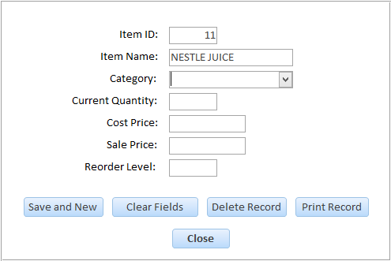

1. **Abnormal Data (Test No. 2)**

In this test invalid data is entered in the field. The following error message is shown:

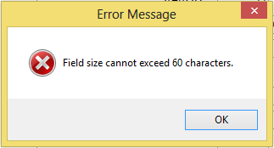

1. **Extreme Data (Test No. 3)**

In this test, the largest allowed data is entered. For this field the character length is 60 so an Item Name of 60 characters is entered. No error message is shown and the data is recorded.

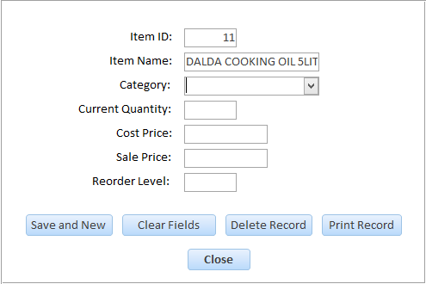

* **Category Field**

1. **Normal Data (Test No. 4)**

In this test a value from the list is selected. No error message is shown and the data is recorded successfully.

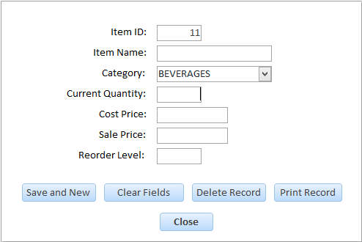

1. **Abnormal Data (Test No. 5)**

In this test a value outside the list is entered. An error message is shown and the data is not recorded.

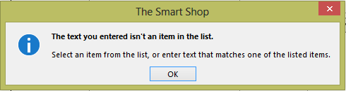

* **CurrentQuantity Field**

1. **Normal Data (Test No. 6)**

In this test a number greater than 0 is entered. No error message is shown and the data is recorded successfully.

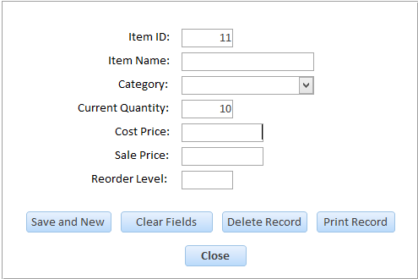

1. **Abnormal Data (Test No. 7)**

In this test a number less than 0 is entered. The following error message is shown:

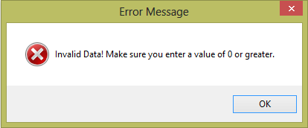

1. **Extreme Data (Test No. 8)**

In this test, the smallest data allowed is entered which is zero so 0 is entered. No error message is shown and the data is recorded successfully.

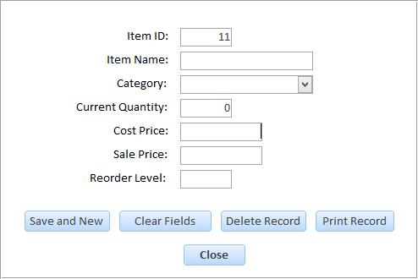

* **CostPrice Field**

1. **Normal Data (Test No. 9)**

In this test a number greater than 0 is entered. No error message is shown and the data is recorded successfully.

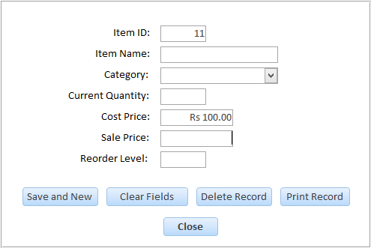

1. **Abnormal Data (Test No. 10)**

In this test a number less than 0 is entered. The following error message is shown:

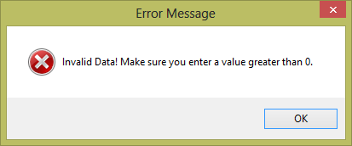

1. **Extreme Data (Test No. 11)**

In this test, the smallest data allowed is entered which is one so 1 is entered. No error message is shown and the data is recorded successfully.

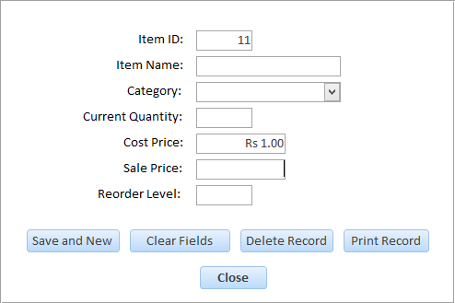

* **SalePrice Field**

1. **Normal Data (Test No. 12)**

In this test a number greater than 0 is entered. No error message is shown and the data is recorded successfully.

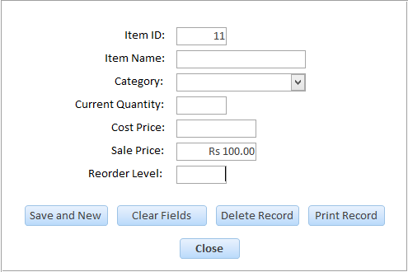

1. **Abnormal Data (Test No. 13)**

In this test a number less than 0 is entered. The following error message is shown:



1. **Extreme Data (Test No. 14)**

In this test, the smallest data allowed is entered which is one so 1 is entered. No error message is shown and the data is recorded successfully.

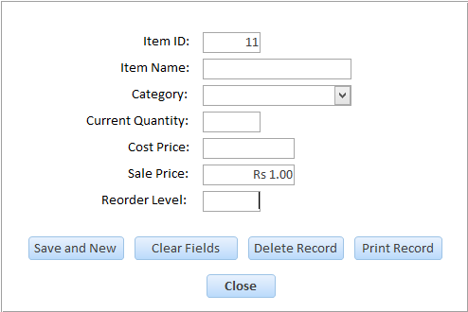

* **ReorderLevel Field**

1. **Normal Data (Test No. 15)**

In this test a number greater than 0 is entered. No error message is shown and the data is recorded successfully.

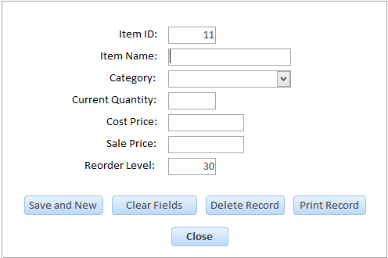

1. **Abnormal Data (Test No. 16)**

In this test a number less than 0 is entered. The following error message is shown:



1. **Extreme Data (Test No. 17)**

In this test, the smallest data allowed is entered which is one so 1 is entered. No error message is shown and the data is recorded successfully.

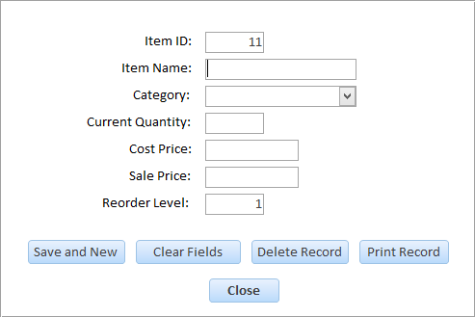

1. **Suppliers Form:**

* **SupplierName Field**

1. **Normal Data (Test No. 18)**

In this test a valid Supplier Name is entered. No error message is shown and data is successfully recorded.

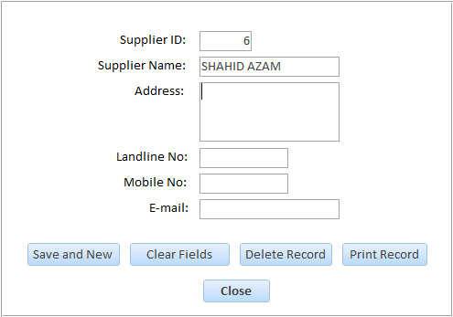

1. **Abnormal Data (Test No. 19)**

In this test invalid data is entered in the field. The following error message is shown:

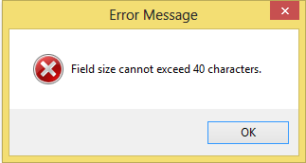

1. **Extreme Data (Test No. 20)**

In this test, the largest allowed data is entered. For this field the character length is 40 so a Supplier Name of 40 characters is entered. No error message is shown and the data is recorded.

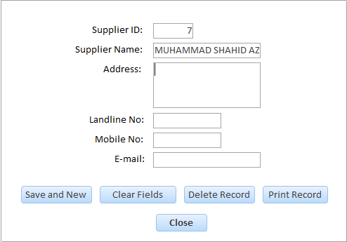

* **LandlineNo Field**

1. **Normal Data (Test No. 21)**

In this test a valid Landline No is entered. No error message is shown and the data is recorded successfully.

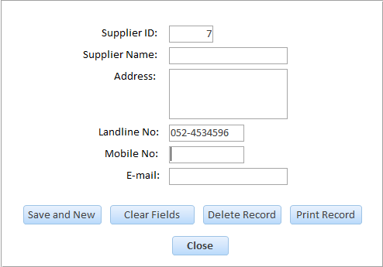

1. **Abnormal Data (Test No. 22)**

In this test a text is entered. The following error message is shown:

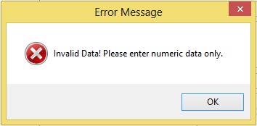

1. **Abnormal Data (Test No. 23)**

In this test, a Landline No of more than 10 characters is entered. The following error message is shown:

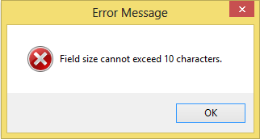

* **MobileNo Field**

1. **Normal Data (Test No. 24)**

In this test a valid Mobile No is entered. No error message is shown and the data is recorded successfully.

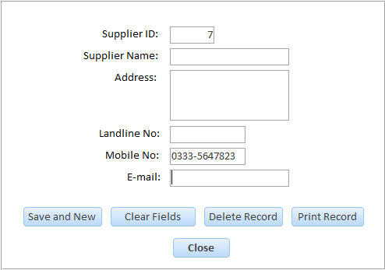

1. **Abnormal Data (Test No. 25)**

In this test a text is entered. The following error message is shown:



1. **Abnormal Data (Test No. 26)**

In this test, a Mobile No of more than 11 characters is entered. The following error message is shown:

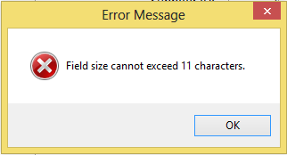

1. **Sales Form:**

* **SaleDate Field**

1. **Normal Data (Test No. 27)**

In this test current date is entered. No error message is shown and data is successfully recorded.

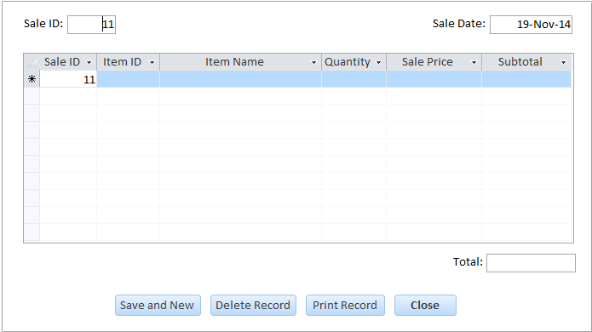

1. **Abnormal Data (Test No. 28)**

In this test a future data is entered. The following error message is shown:

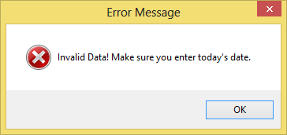

* **ItemID Field**

1. **Normal Data (Test No. 29)**

In this test a number greater than 0 is entered. No error message is shown and the data is recorded successfully.

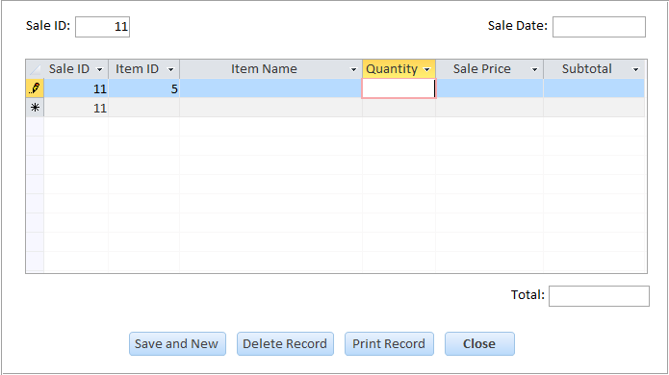

1. **Abnormal Data (Test No. 30)**

In this test a number less than 0 is entered. The following error message is shown:



1. **Extreme Data (Test No. 31)**

In this test, the smallest data allowed is entered which is one so 1 is entered. No error message is shown and the data is recorded successfully.

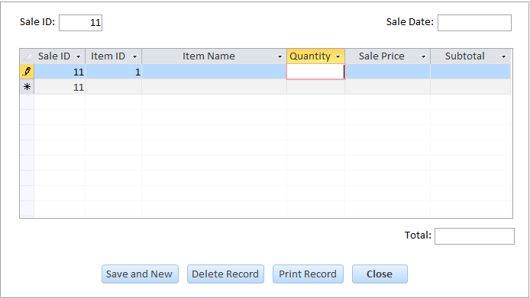

* **ItemName Field**

1. **Normal Data (Test No. 32)**

In this test a value from the list is selected. No error message is shown and the data is recorded successfully.

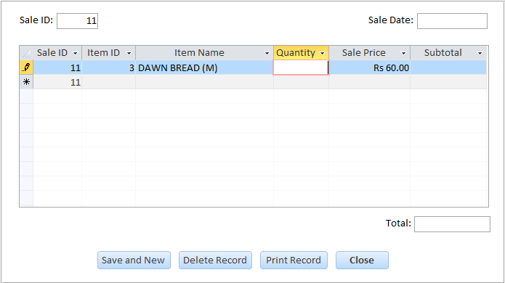

1. **Abnormal Data (Test No. 33)**

In this test a value outside the list is entered. An error message is shown and the data is not recorded.



* **Quantity Field**

1. **Normal Data (Test No. 34)**

In this test a number greater than 0 is entered. No error message is shown and the data is recorded successfully.

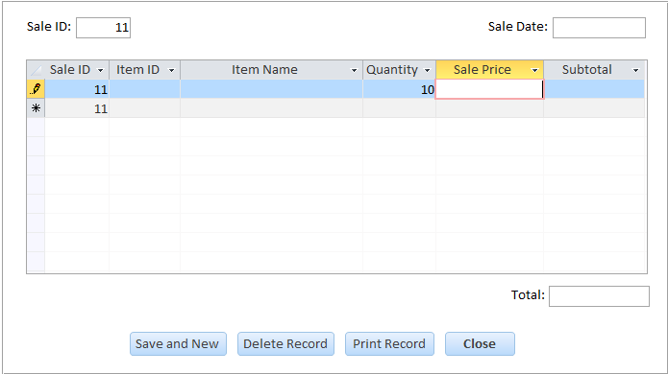

1. **Abnormal Data (Test No. 35)**

In this test a number less than 0 is entered. The following error message is shown:



1. **Extreme Data (Test No. 36)**

In this test, the smallest data allowed is entered which is zero so 0 is entered. No error message is shown and the data is recorded successfully.

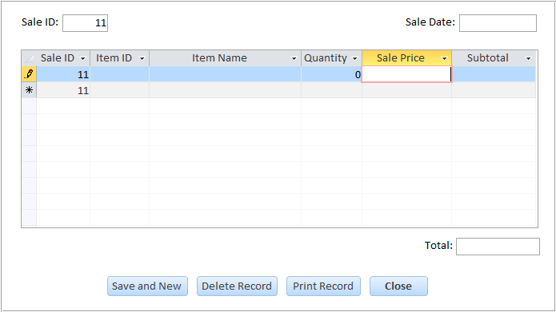

* **SalePrice Field**

1. **Normal Data (Test No. 37)**

In this test a number greater than 0 is entered. No error message is shown and the data is recorded successfully.

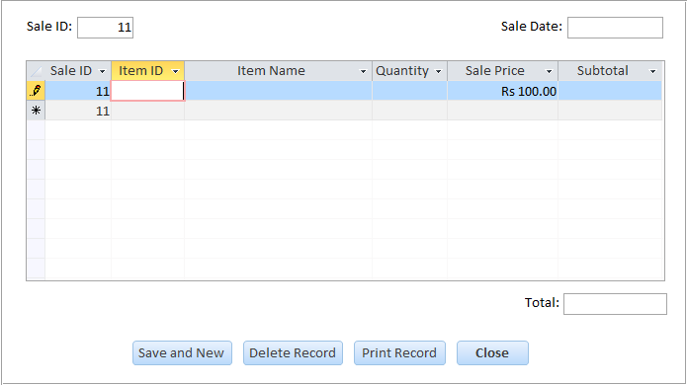

1. **Abnormal Data (Test No. 38)**

In this test a number less than 0 is entered. The following error message is shown:



1. **Extreme Data (Test No. 39)**

In this test, the smallest data allowed is entered which is one so 1 is entered. No error message is shown and the data is recorded successfully.

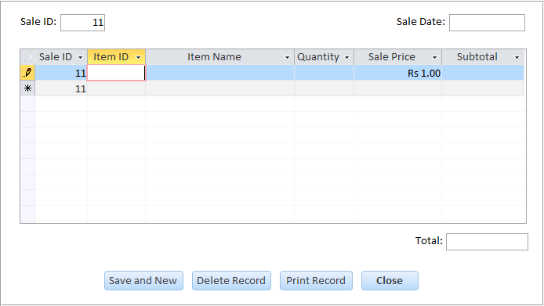

1. **Orders Form:**

* **OrderDate Field**

1. **Normal Data (Test No. 40)**

In this test a valid date is entered. No error message is shown and data is successfully recorded.

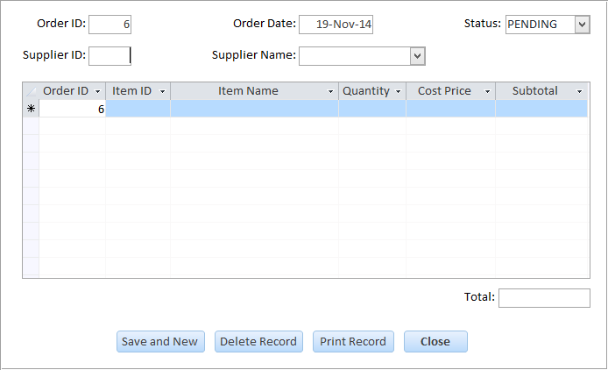

* **Status Field**

1. **Normal Data (Test No. 41)**

In this test a value from the list is selected. No error message is shown and the data is recorded successfully.

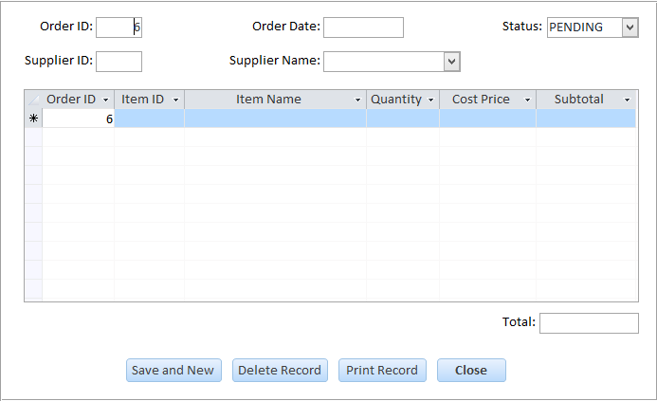

1. **Abnormal Data (Test No. 42)**

In this test a value outside the list is entered. An error message is shown and the data is not recorded.



* **SupplierID Field**

1. **Normal Data (Test No. 43)**

In this test a number greater than 0 is entered. No error message is shown and the data is recorded successfully.

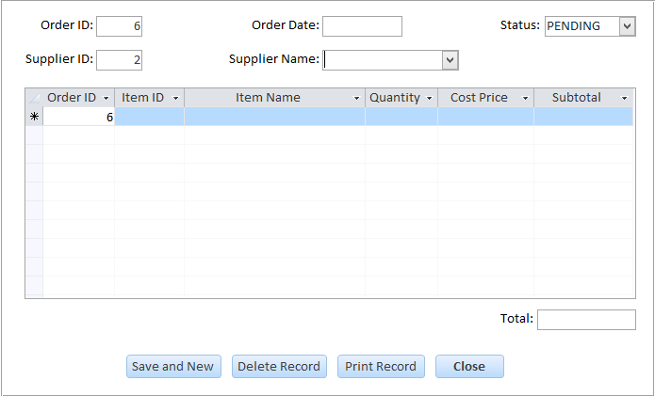

1. **Abnormal Data (Test No. 44)**

In this test a number less than 0 is entered. The following error message is shown:



1. **Extreme Data (Test No. 45)**

In this test, the smallest data allowed is entered which is one so 1 is entered. No error message is shown and the data is recorded successfully.

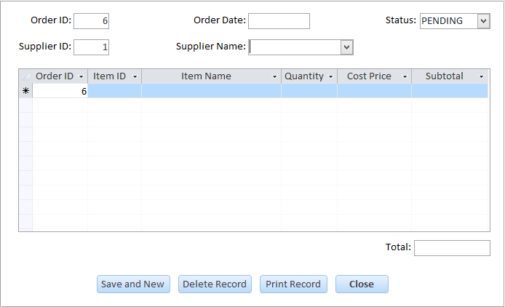

* **SupplierName Field**

1. **Normal Data (Test No. 46)**

In this test a value from the list is selected. No error message is shown and the data is recorded successfully.

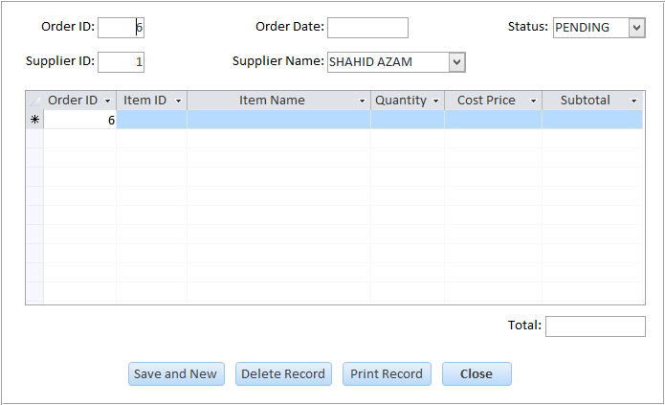

1. **Abnormal Data (Test No. 47)**

In this test a value outside the list is entered. An error message is shown and the data is not recorded.



* **ItemID Field**

1. **Normal Data (Test No. 48)**

In this test a number greater than 0 is entered. No error message is shown and the data is recorded successfully.

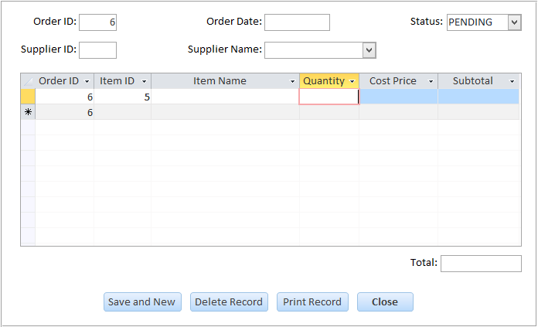

1. **Abnormal Data (Test No. 49)**

In this test a number less than 0 is entered. The following error message is shown:



1. **Extreme Data (Test No. 50)**

In this test, the smallest data allowed is entered which is one so 1 is entered. No error message is shown and the data is recorded successfully.

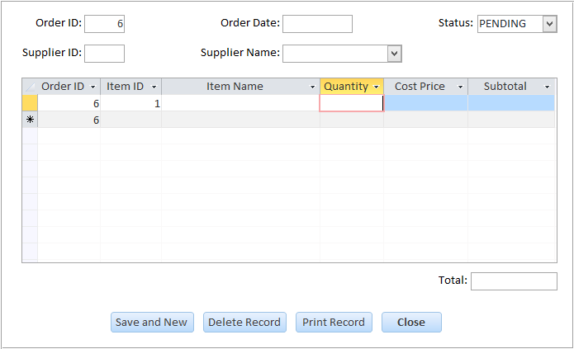

* **ItemName Field**

1. **Normal Data (Test No. 51)**

In this test a value from the list is selected. No error message is shown and the data is recorded successfully.

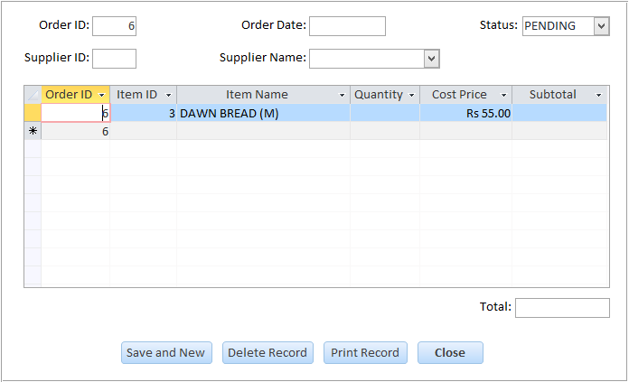

1. **Abnormal Data (Test No. 52)**

In this test a value outside the list is entered. An error message is shown and the data is not recorded.



* **Quantity Field**

1. **Normal Data (Test No. 53)**

In this test a number greater than 0 is entered. No error message is shown and the data is recorded successfully.

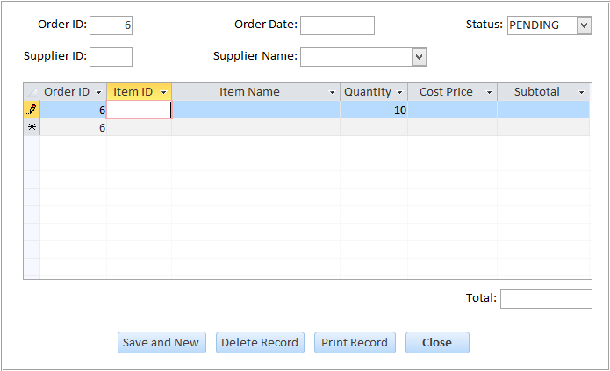

1. **Abnormal Data (Test No. 54)**

In this test a number less than 0 is entered. The following error message is shown:



1. **Extreme Data (Test No. 55)**

In this test, the smallest data allowed is entered which is zero so 0 is entered. No error message is shown and the data is recorded successfully.

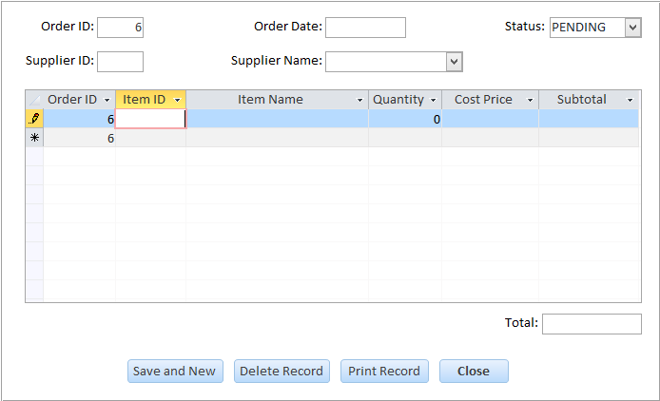

* **CostPrice Field**

1. **Normal Data (Test No. 56)**

In this test a number greater than 0 is entered. No error message is shown and the data is recorded successfully.

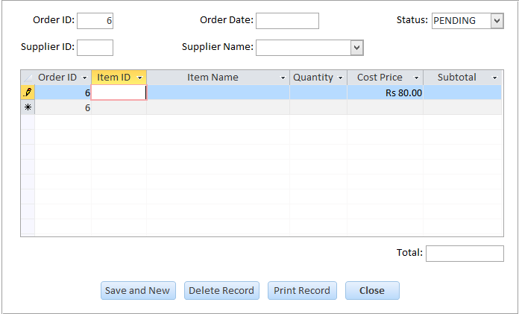

1. **Abnormal Data (Test No. 57)**

In this test a number less than 0 is entered. The following error message is shown:



1. **Extreme Data (Test No. 58)**

In this test, the smallest data allowed is entered which is one so 1 is entered. No error message is shown and the data is recorded successfully.

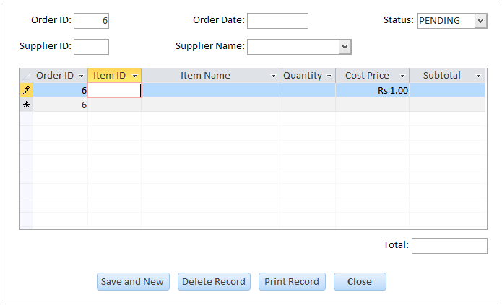

1. **Supply Received Form:**

* **OrderID Field**

1. **Normal Data (Test No. 59)**

In this test a number greater than 0 is entered. No error message is shown and the data is recorded successfully.

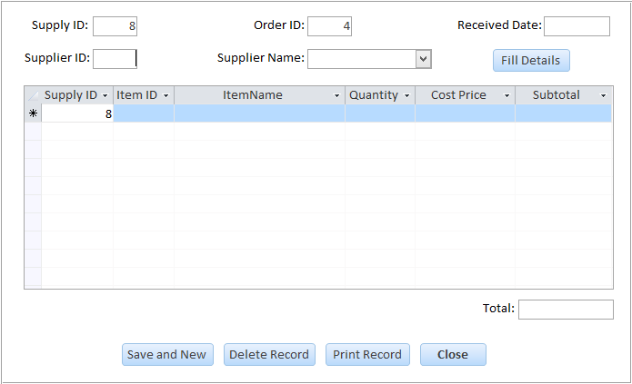

1. **Abnormal Data (Test No. 60)**

In this test a number less than 0 is entered. The following error message is shown:



1. **Extreme Data (Test No. 61)**

In this test, the smallest data allowed is entered which is one so 1 is entered. No error message is shown and the data is recorded successfully.

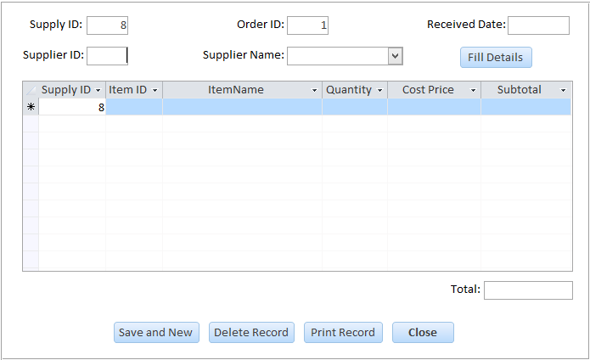

* **ReceivedDate Field**

1. **Normal Data (Test No. 62)**

In this test a valid date is entered. No error message is shown and data is successfully recorded.

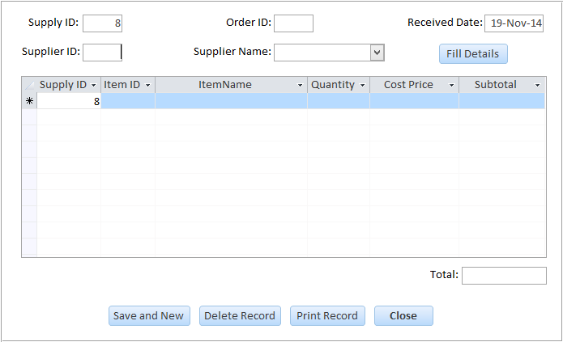

* **SupplierID Field**

1. **Normal Data (Test No. 63)**

In this test a number greater than 0 is entered. No error message is shown and the data is recorded successfully.

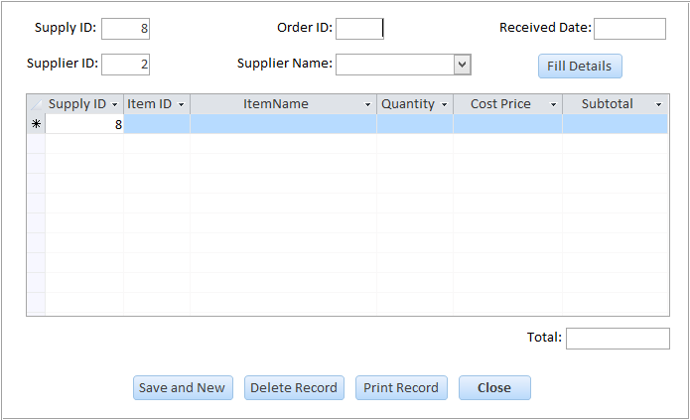

1. **Abnormal Data (Test No. 64)**

In this test a number less than 0 is entered. The following error message is shown:



1. **Extreme Data (Test No. 65)**

In this test, the smallest data allowed is entered which is one so 1 is entered. No error message is shown and the data is recorded successfully.

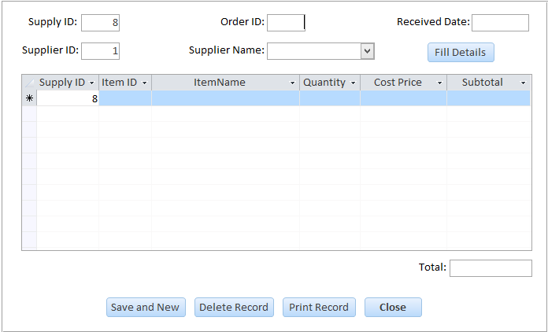

* **SupplierName Field**

1. **Normal Data (Test No. 66)**

In this test a value from the list is selected. No error message is shown and the data is recorded successfully.

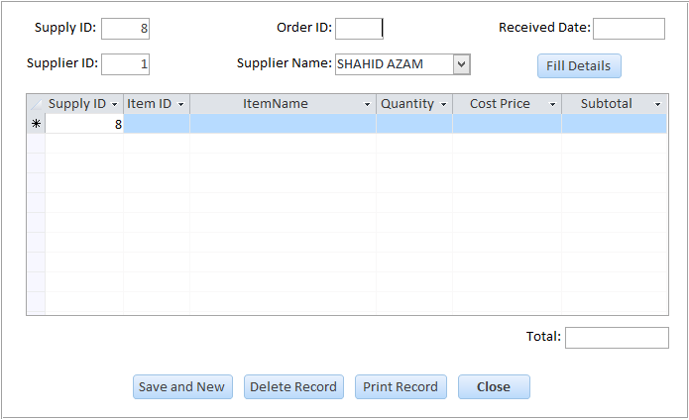

1. **Abnormal Data (Test No. 67)**

In this test a value outside the list is entered. An error message is shown and the data is not recorded.



* **ItemID Field**

1. **Normal Data (Test No. 68)**

In this test a number greater than 0 is entered. No error message is shown and the data is recorded successfully.

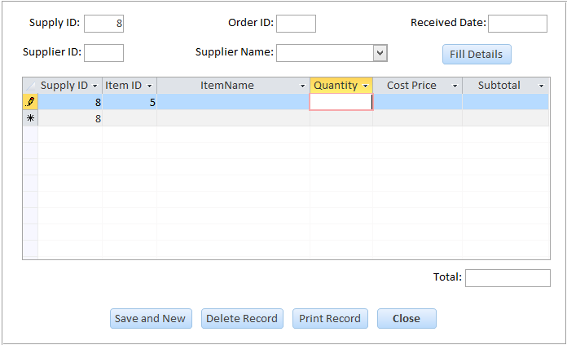

1. **Abnormal Data (Test No. 69)**

In this test a number less than 0 is entered. The following error message is shown:



1. **Extreme Data (Test No. 70)**

In this test, the smallest data allowed is entered which is one so 1 is entered. No error message is shown and the data is recorded successfully.

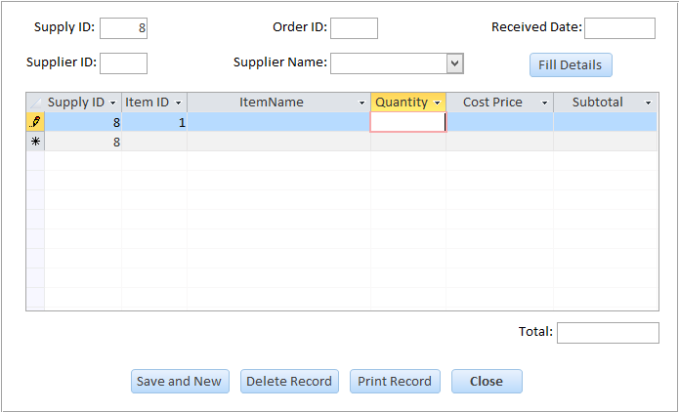

* **ItemName Field**

1. **Normal Data (Test No. 71)**

In this test a value from the list is selected. No error message is shown and the data is recorded successfully.

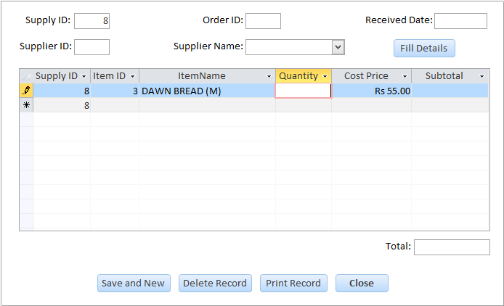

1. **Abnormal Data (Test No. 72)**

In this test a value outside the list is entered. An error message is shown and the data is not recorded.



* **Quantity Field**

1. **Normal Data (Test No. 73)**

In this test a number greater than 0 is entered. No error message is shown and the data is recorded successfully.

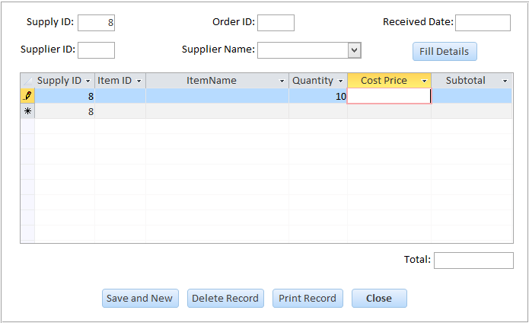

1. **Abnormal Data (Test No. 74)**

In this test a number less than 0 is entered. The following error message is shown:



1. **Extreme Data (Test No. 75)**

In this test, the smallest data allowed is entered which is zero so 0 is entered. No error message is shown and the data is recorded successfully.

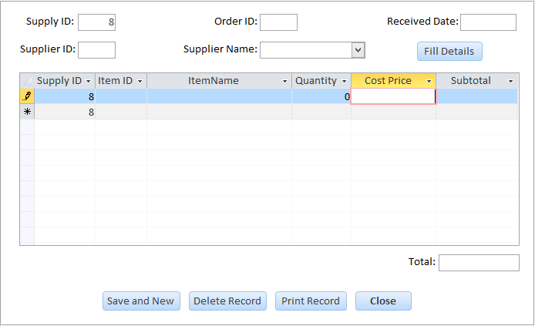

* **CostPrice Field**

1. **Normal Data (Test No. 76)**

In this test a number greater than 0 is entered. No error message is shown and the data is recorded successfully.

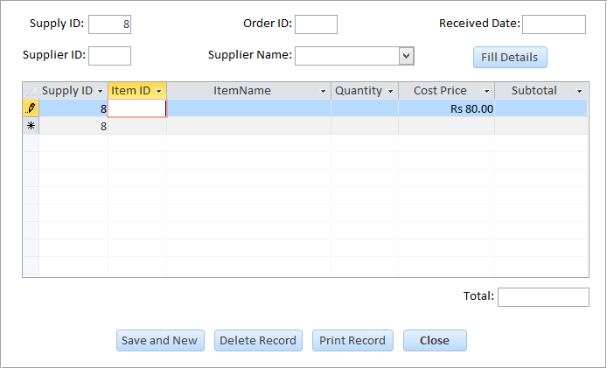

1. **Abnormal Data (Test No. 77)**

In this test a number less than 0 is entered. The following error message is shown:



1. **Extreme Data (Test No. 78)**

In this test, the smallest data allowed is entered which is one so 1 is entered. No error message is shown and the data is recorded successfully.

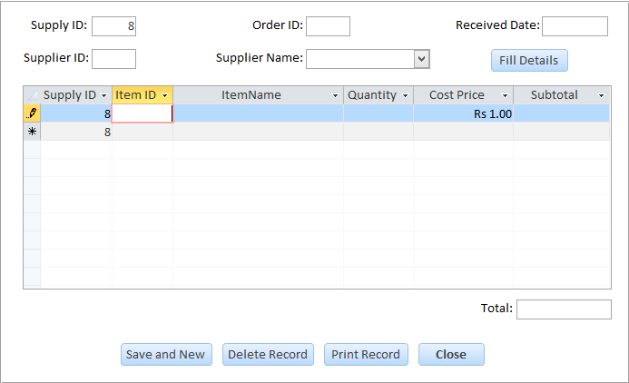

**Testing of Login Routine:**

The security of the database is crucial so a test plan was devised to test both the forms. The testing of these two forms will be done according the plan devised.

1. **Login Form:**

* **Basic Login Test (Test No. 79)**

In this test a valid username and a valid password are entered. There is no error message shown and the login is successful.

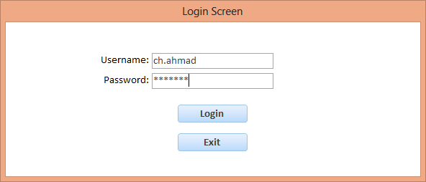

The Main Menu opens up after the successful login:

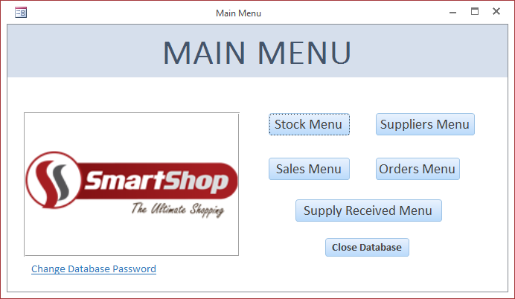

* **Username Field**

1. **Abnormal Data (Test No. 80)**

In this test an invalid username is entered. An error appears on a label on the form:

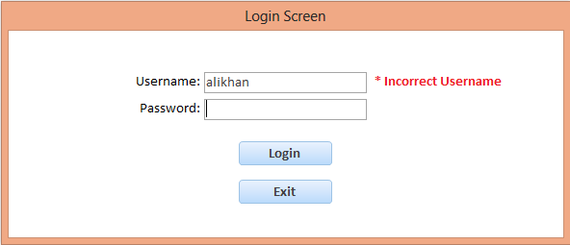

1. **Abnormal Data (Test No. 81)**

In this test, the field is left blank and the login button is clicked. The following error message is shown:

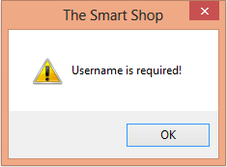

* **Password Field**

1. **Abnormal Data (Test No. 82)**

In this test an invalid password is entered. An error appears on a label on the form:

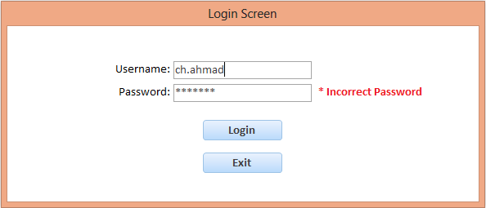

1. **Abnormal Data (Test No. 83)**

In this test, the field is left blank and the login button is clicked. The following error message is shown:

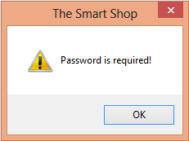

1. **Change Password Form:**

* **Basic Password Change Test (Test No. 84)**

In this test valid data is entered in all the fields. The password is changed successfully:

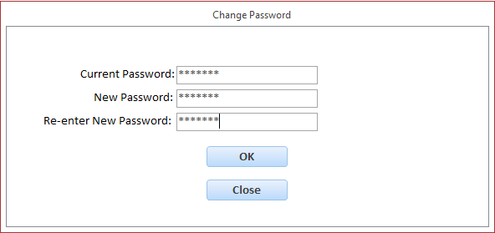

The following message box is shown:

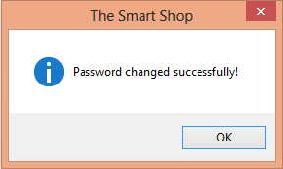

* **Current Password Field**

1. **Normal Data (Test No. 85)**

In this test a valid current password is entered. No error message is shown and the data is recorded successfully.

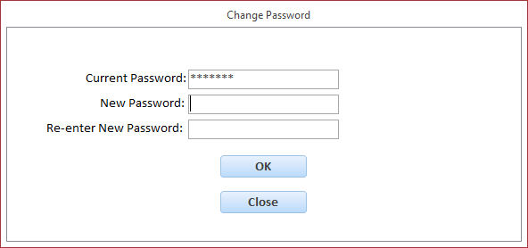

1. **Abnormal Data (Test No. 86)**

In this test an invalid current password is entered. An error appears on a label on the form.

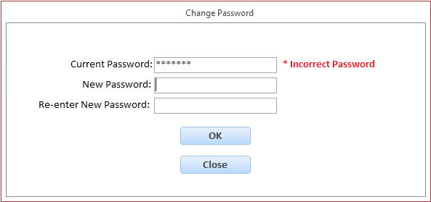

1. **Abnormal Data (Test No. 87)**

In this test the field is left blank and the button is clicked. The following error message is shown:

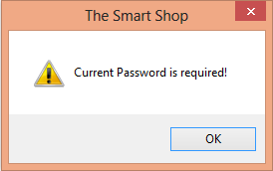

* **New Password Field**

1. **Abnormal Data (Test No. 88)**

In this test the field is left blank and the button is clicked. The following error message is shown:

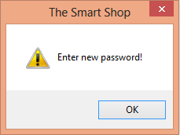

* **Re-enter New Password Field**

1. **Abnormal Data (Test No. 89)**

In this test the field is left blank and the button is clicked. The following error message is shown:

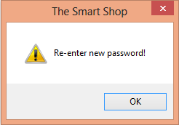

1. **Normal Data (Test No. 90)**

In this test the same password is entered as in New Password field. No error message is shown and the data is recorded successfully.

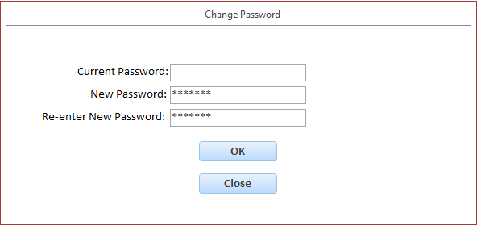

1. **Abnormal Data (Test No. 91)**

In this test a different password is entered than New Password field. An error appears on a label on the form.

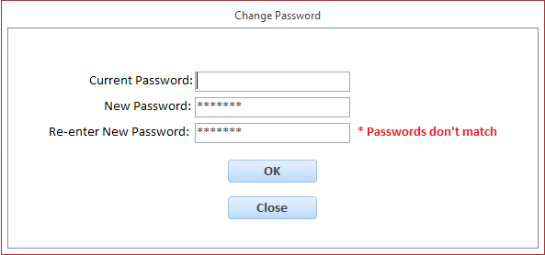

**Testing of Buttons:**

There are command buttons involved in each form. The testing of the important buttons is done and shown. In each case, the button is to be clicked to get expected result.

1. **Stock Form:**

* **Test No. 92:**

In this test all the required fields are filled and the **Save and New** button is clicked. No error message is shown and the record is saved successfully and all the fields are cleared.

Before button is clicked:

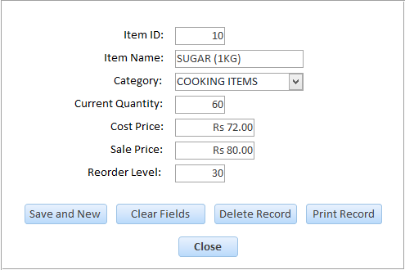

After the button is clicked:

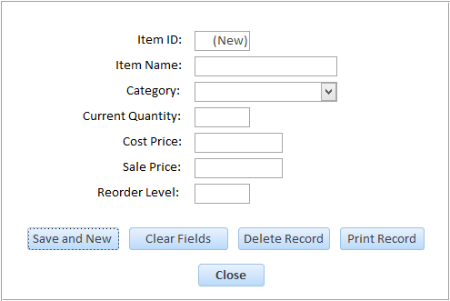

* **Test No. 93:**

In this test the ItemName field is left blank and the **Save and New** button is clicked. The following error message is shown:

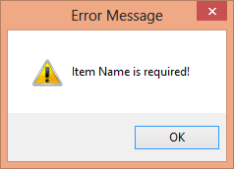

* **Test No. 94:**

In this test the Category field is left blank and the **Save and New** button is clicked. The following error message is shown:

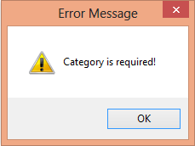

* **Test No. 95:**

In this test the CurrentQuantity field is left blank and the **Save and New** button is clicked. The following error message is shown:

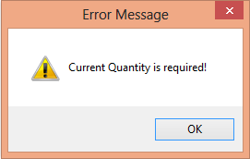

* **Test No. 96:**

In this test the CostPrice field is left blank and the **Save and New** button is clicked. The following error message is shown:

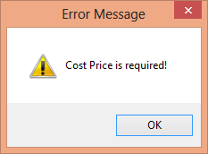

* **Test No. 97:**

In this test the SalePrice field is left blank and the **Save and New** button is clicked. The following error message is shown:

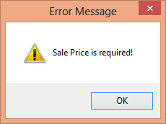

* **Test No. 98:**

In this test the form or any field is not updated and **Close** button is clicked. No message is shown and the form closes. There is no evidence to show as the form closes on the instance the button is clicked.

* **Test No. 99:**

In this test the form or any field is updated and **Close** button is clicked. The following confirmation message is shown.

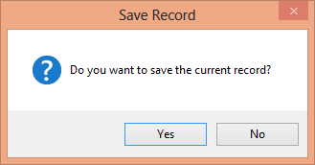

1. **Suppliers Form:**

* **Test No. 100:**

In this test all the required fields are filled and the **Save and New** button is clicked. No error message is shown and the record is saved successfully and all the fields are cleared.

Before button is clicked:

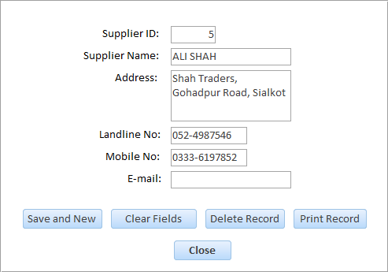

After the button is clicked:

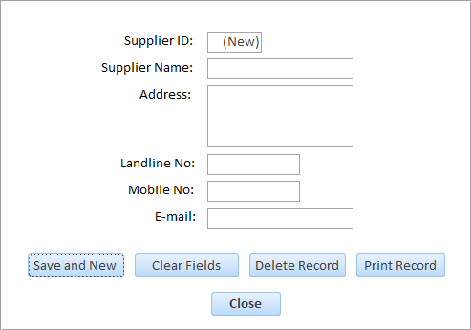

* **Test No. 101:**

In this test the SupplierName field is left blank and the **Save and New** button is clicked. The following error message is shown:

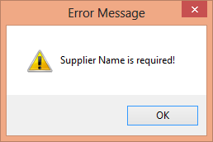

* **Test No. 102:**

In this test the Address field is left blank and the **Save and New** button is clicked. The following error message is shown:

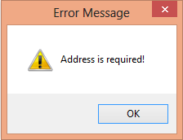

* **Test No. 103:**

In this test the MobileNo field is left blank and the **Save and New** button is clicked. The following error message is shown:

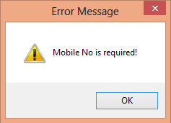

* **Test No. 104:**

In this test the form or any field is not updated and **Close** button is clicked. No message is shown and the form closes. There is no evidence to show as the form closes on the instance the button is clicked.

* **Test No. 105:**

In this test the form or any field is updated and **Close** button is clicked. The following confirmation message is shown.



1. **Sales Form:**

* **Test No. 106:**

In this test all the required fields are filled and the **Save and New** button is clicked. No error message is shown and the record is saved successfully and all the fields are cleared.

Before button is clicked:

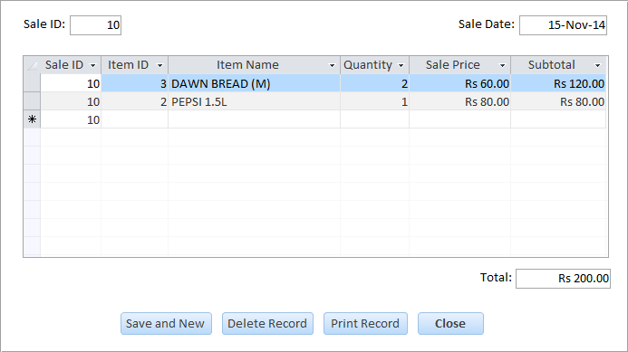

After the button is clicked:

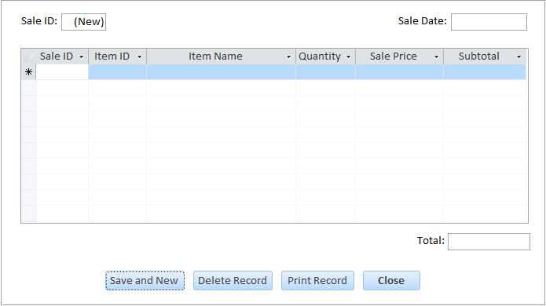

* **Test No. 107:**

In this test the SaleDate field is left blank and the **Save and New** button is clicked. The following error message is shown:

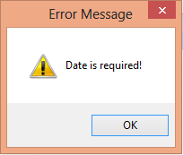

* **Test No. 108:**

In this test the ItemName field is left blank and the **Save and New** button is clicked. The following error message is shown:



* **Test No. 109:**

In this test the ItemID field is left blank and the **Save and New** button is clicked. The following error message is shown:

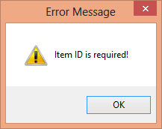

* **Test No. 110:**

In this test the Quantity field is left blank and the **Save and New** button is clicked. The following error message is shown:

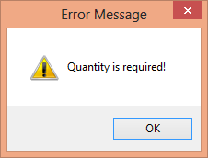

* **Test No. 111:**

In this test the SalePrice field is left blank and the **Save and New** button is clicked. The following error message is shown:



* **Test No. 112:**

In this test the form or any field is not updated and **Close** button is clicked. No message is shown and the form closes. There is no evidence to show as the form closes on the instance the button is clicked.

* **Test No. 113:**

In this test the form or any field is updated and **Close** button is clicked. The following confirmation message is shown.



1. **Orders Form:**

* **Test No. 114:**

In this test all the required fields are filled and the **Save and New** button is clicked. No error message is shown and the record is saved successfully and all the fields are cleared.

Before button is clicked:

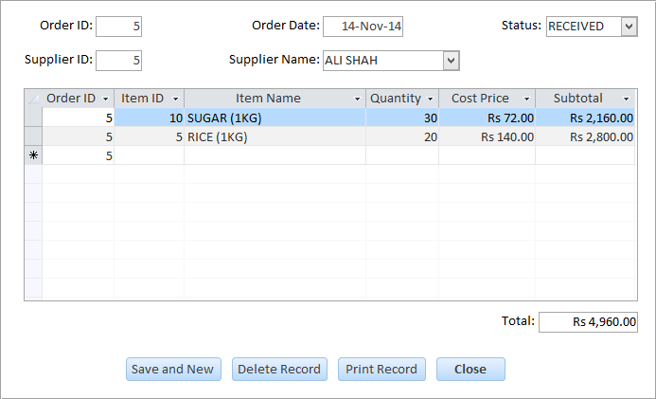

After the button is clicked:

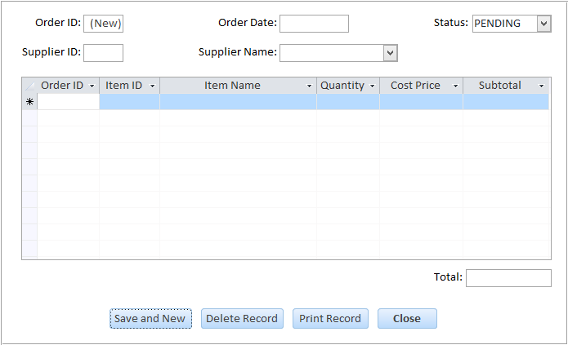

* **Test No. 115:**

In this test the SupplierID field is left blank and the **Save and New** button is clicked. The following error message is shown:

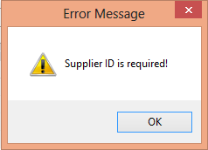

* **Test No. 116:**

In this test the SupplierName field is left blank and the **Save and New** button is clicked. The following error message is shown:



* **Test No. 117:**

In this test the OrderDate field is left blank and the **Save and New** button is clicked. The following error message is shown:

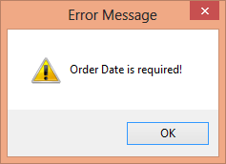

* **Test No. 118:**

In this test the Status field is left blank and the **Save and New** button is clicked. The following error message is shown:

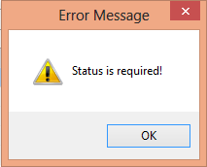

* **Test No. 119:**

In this test the ItemName field is left blank and the **Save and New** button is clicked. The following error message is shown:



* **Test No. 120:**

In this test the ItemID field is left blank and the **Save and New** button is clicked. The following error message is shown:



* **Test No. 121:**

In this test the Quantity field is left blank and the **Save and New** button is clicked. The following error message is shown:



* **Test No. 122:**

In this test the CostPrice field is left blank and the **Save and New** button is clicked. The following error message is shown:



* **Test No. 123:**

In this test the form or any field is not updated and **Close** button is clicked. No message is shown and the form closes. There is no evidence to show as the form closes on the instance the button is clicked.

* **Test No. 124:**

In this test the form or any field is updated and **Close** button is clicked. The following confirmation message is shown.



1. **Supply Received Form:**

* **Test No. 125:**

In this test the OrderID is entered and the **Fill Details** button is clicked. The following message is shown:

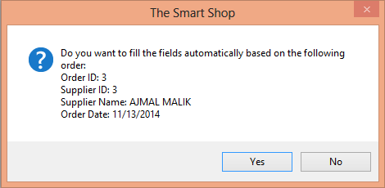

* **Test No. 126:**

In this test the OrderID field is left blank and the **Fill Details** button is clicked. The following error message is shown.

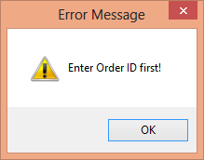

* **Test No. 127:**

In this test all the required fields are filled and the **Save and New** button is clicked. No error message is shown and the record is saved successfully and all the fields are cleared.

Before button is clicked:

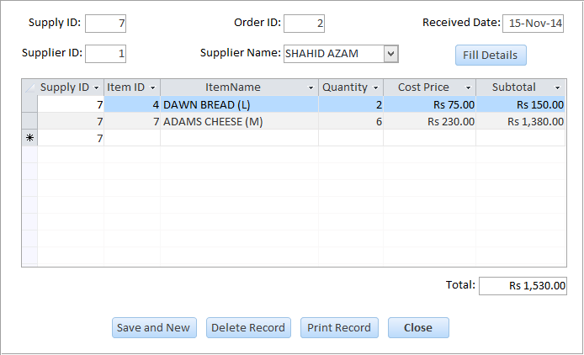

After the button is clicked:

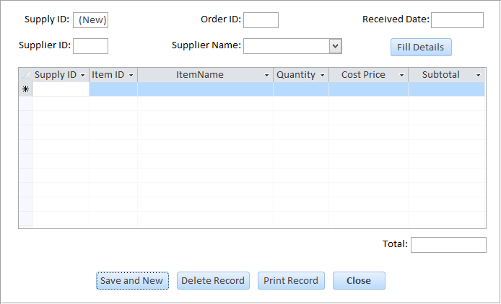

* **Test No. 128:**

In this test the SupplierID field is left blank and the **Save and New** button is clicked. The following error message is shown:



* **Test No. 129:**

In this test the SupplierName field is left blank and the **Save and New** button is clicked. The following error message is shown:



* **Test No. 130:**

In this test the ReceivedDate field is left blank and the **Save and New** button is clicked. The following error message is shown:

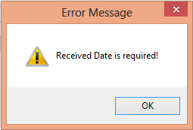

* **Test No. 131:**

In this test the ItemName field is left blank and the **Save and New** button is clicked. The following error message is shown:



* **Test No. 132:**

In this test the ItemID field is left blank and the **Save and New** button is clicked. The following error message is shown:



* **Test No. 133:**

In this test the Quantity field is left blank and the **Save and New** button is clicked. The following error message is shown:



* **Test No. 134:**

In this test the CostPrice field is left blank and the **Save and New** button is clicked. The following error message is shown:



* **Test No. 135:**

In this test the form or any field is not updated and **Close** button is clicked. No message is shown and the form closes. There is no evidence to show as the form closes on the instance the button is clicked.

* **Test No. 136:**

In this test the form or any field is updated and **Close** button is clicked. The following confirmation message is shown.



**Testing of Subroutines:**

The forms have subroutines to execute special tasks when required .In this section, the testing of the significant subroutines will be done.

* **Test No. 137**

This is the **Sales Form – ItemName (AfterUpdate)** subroutine. In this test the ItemName is entered/selected in the combo box. The ItemID and SalePrice fields are filled automatically according to the choice.

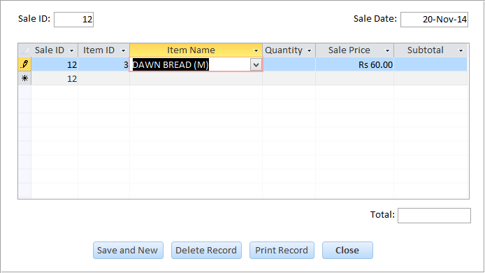

* **Test No. 138**

This is the **Sales Form – Quantiy (AfterUpdate)** subroutine. In this test a Quantity of an item is entered which is greater than CurrentQuantity. The following error message is shown:

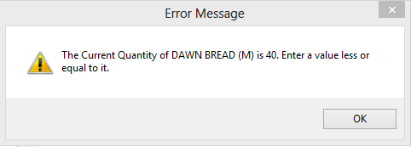

* **Test No. 139**

This is the **Sales Form – Quantiy (AfterUpdate)** subroutine. In this test a valid Quantity is entered. The data is recorded and the CurrentQuantity in Stock Table decreases by 10.

The CurrentQuantity of the item is shown:



Then the Quantity of the item sold is 10 as shown:

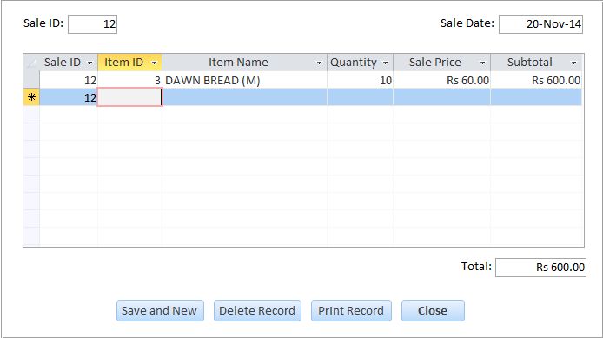

The CurrentQuantity of the item decreases by 10 as shown:



* **Test No. 140**

This is the **Orders Form – SupplierName (AfterUpdate)** subroutine. In this test the SupplierName is entered/selected in the combo box. The SupplierID field is filled automatically according to the choice.

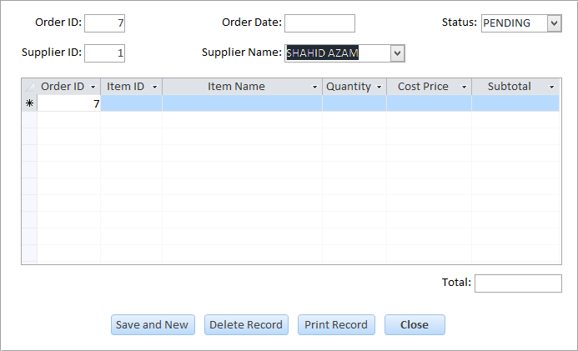

* **Test No. 141**

This is the **Orders Form – ItemName (AfterUpdate)** subroutine. In this test the ItemName is entered/selected in the combo box. The ItemID and CostPrice fields are filled automatically according to the choice.

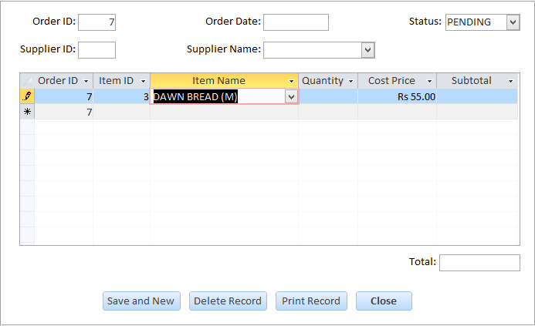

* **Test No. 142**

This is the **Orders Form – Quantiy (AfterUpdate)** subroutine. In this test a Quantity of an item is entered which is less than ReorderLevel. The following error message is shown:

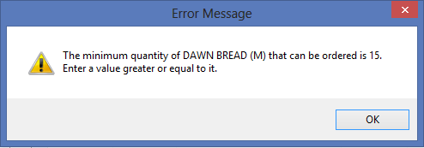

* **Test No. 143**

This is the **Supply Received Form – OrderID (AfterUpdate)** subroutine. In this test a valid OrderID is entered. The Status of the order in Orders Table changes to “RECEIVED”.

The initial Status of the order is shown:

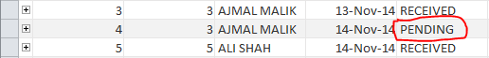

The OrderID 4 is entered in the form:

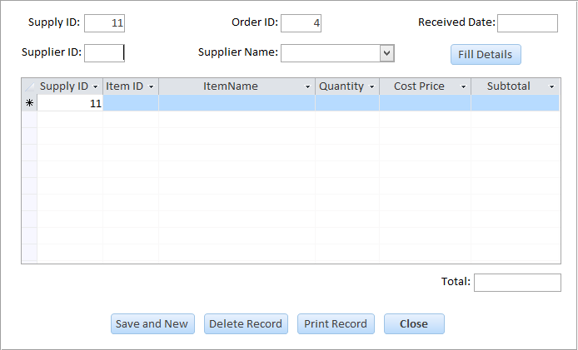

The Status if the order changes to “RECEIVED”:

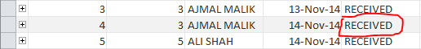

* **Test No. 144**

This is the **Supply Received Form – SupplierName (AfterUpdate)** subroutine. In this test the SupplierName is entered/selected in the combo box. The SupplierID field is filled automatically according to the choice.

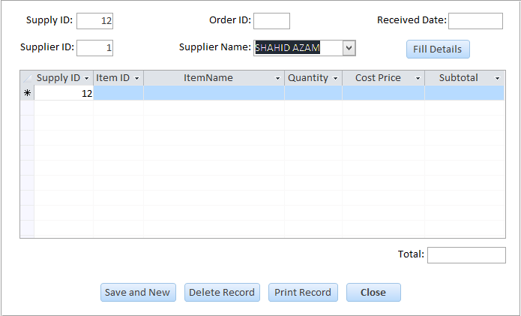

* **Test No. 145**

This is the **Supply Received Form – ItemName (AfterUpdate)** subroutine. In this test the ItemName is entered/selected in the combo box. The ItemID and CostPrice fields are filled automatically according to the choice.

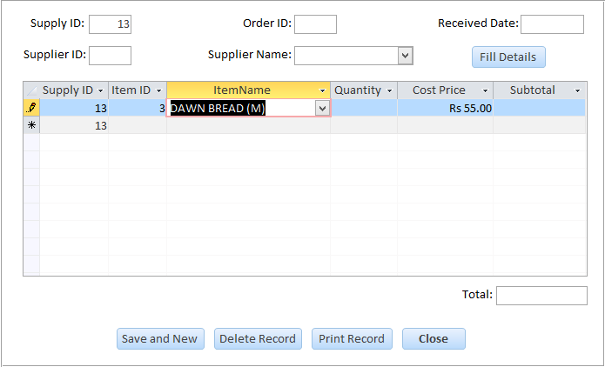

* **Test No. 146**

This is the **Supply Received Form – Quantiy (AfterUpdate)** subroutine. In this test a valid Quantity is entered. The data is recorded and the CurrentQuantity in Stock Table increases by 50.

The CurrentQuantity of the item is shown:



Then the Quantity of the item received is 50 as shown:

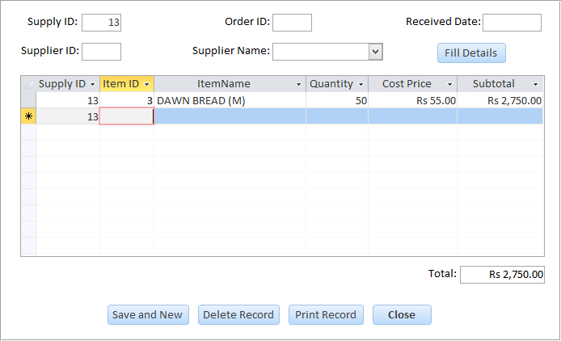

The CurrentQuantity of the item increases by 50 as shown:



**INSTALLATION**

**Installation Plan:**

The new system has been developed accordingly to the design plan and the phase of alpha testing has been done i.e. I, the developer, have tested the solution according to the test plan. Now the time has come to show the solution to the client for who it was developed.

This installation plan **does not** include the strategy for **system changeover**. That has to be discussed with the client first.

This installation plan includes:

* Installation of Hardware and Software
* Implementation of Data Files
* Plan for User Testing
* **Installation of Hardware and Software:**

The hardware and software requirements are shown in the **requirement specification**. But as described in the **Limits of solution**, some of them had to be reduced or excluded due to the financial costs.

The client has yet to purchase the hardware and software for the new system. So a plan for installing the hardware and the software is decided. The purchase of the hardware and software has been already discussed with the client.

The plan for hardware is as follows:

|  |  |
| --- | --- |
| **Processor** | Intel® Core™2 Duo Processor E4600 |
| **RAM** | Kingston – 1 GB RAM |
| **Hard Disk** | Intel® Solid-State Drive 80 GB |
| **Monitor** | Dell 14 inch LCD Monitor |
| **Printer** | HP ® LaserJet 1020 Printer |
| **Scanner** | HP ® ScanJet G2410 Flatbed Scanner |
| **Keyboard** | HP ® Standard USB Keyboard |
| **Mouse** | HP ® USB Optical Mouse |
| **DVD/CD Drive** | Sony ® DRU-870S |

The plan for software is as follows:

|  |  |
| --- | --- |
| **Operating System** | Microsoft ® Windows 7 |
| **Database Management System** | Microsoft ® Access 2013 |
| **Word Processor** | Microsoft ® Word 2013 |
| **Antivirus** | Microsoft ® Security Essentials (Default) |

After the hardware and software are purchased, they will be installed at the sales counter accordingly. The software will be installed on the computer after the hardware has been arranged and installed.

* **Implementation of Data Files:**

I have only developed the system and tested the data files by inputting sample data. It will be the user of the system who will input all the necessary records in the new system. However, a plan for implementing the data files is necessary on which the user can work accordingly.

**Stock File:**

The approximate amount of records in the Stock file will be around 400. According to the workload, we can expect the data operator to input the details of 40 items per hour or 320 items per day. It would take total of 10 hours to input all of the items in the database.

**Suppliers File:**

The approximate amount of records in the Suppliers file will be around 10. It would take less than 30 minutes to input all of the suppliers in the database.

**Sales File:**

There were no sales records kept previously so it is a new addition. There will be no previous records to enter in the new database.

**Orders File:**

The shop has a lot of manual orders records. It will be only necessary to input records which go far as back as 6 months. Older records will not be required. The approximate amount of records to be entered in the Orders file will be around 300. According to the workload, we can expect the data operator to input the details of 40 items per hour or 320 items per day. It would take total of 8 hours to input all of the items in the database.

**Supply Received File:**

The shop has a lot of manual supply records. It will be only necessary to input records which go far as back as 6 months. Older records will not be required. The approximate amount of records to be entered in the Supply Received file will be around 300. According to the workload, we can expect the data operator to input the details of 40 items per hour or 320 items per day. It would take total of 8 hours to input all of the items in the database.

* **Plan for User Testing:**

The alpha testing of the system has been done thoroughly. The beta testing of the system needs to be done now i.e. testing done by the client/user.

I will be present at the time of this testing along with the user guiding them through the system and database.

There will be no very specific plan for this testing. For instance we cannot force the user to enter the data we want. It will be up to the user to enter any data in the valid or invalid range. The plan will be more generalized.

All the objects will not be tested because it will be very detailed and lengthy. The important objects are to be tested to convince the client that system works.

|  |  |  |  |
| --- | --- | --- | --- |
| **Test No.** | **Object** | **Test Case** | **Expected Result** |
| **1** | Login Form | Invalid Username and Password entered | Errors will be shown |
| **2** | Login Form | Valid Username and Password entered | Login will be successful |
| **3** | Main Menu | The buttons are clicked to check the navigation | The objects will open according to the button clicked |
| **4** | Stock Menu | The buttons are clicked to check the navigation | The objects will open according to the button clicked |
| **5** | Suppliers Menu | The buttons are clicked to check the navigation | The objects will open according to the button clicked |
| **6** | Sales Menu | The buttons are clicked to check the navigation | The objects will open according to the button clicked |
| **7** | Orders Menu | The buttons are clicked to check the navigation | The objects will open according to the button clicked |
| **8** | Supply Received Menu | The buttons are clicked to check the navigation | The objects will open according to the button clicked |
| **9** | Stock Form | Valid data will be entered in the fields | The data will be accepted |
| **10** | Stock Form | Invalid data will be entered in the fields | Error messages will be shown |
| **11** | Suppliers Form | Valid data will be entered in the fields | The data will be accepted |
| **12** | Suppliers Form | Invalid data will be entered in the fields | Error messages will be shown |
| **13** | Sales Form | Valid data will be entered in the fields | The data will be accepted |
| **14** | Sales Form | Invalid data will be entered in the fields | Error messages will be shown |
| **15** | Orders Form | Valid data will be entered in the fields | The data will be accepted |
| **16** | Orders Form | Invalid data will be entered in the fields | Error messages will be shown |
| **17** | Supply Received Form | Valid data will be entered in the fields | The data will be accepted |
| **18** | Supply Received Form | Invalid data will be entered in the fields | Error messages will be shown |
| **19** | Find Item by ID form | Data will be entered to find record(s) | The record(s) will be shown accordingly |
| **20** | Find Item by Category form | Data will be entered to find record(s) | The record(s) will be shown accordingly |
| **21** | Find Supplier by ID form | Data will be entered to find record(s) | The record(s) will be shown accordingly |
| **22** | Find Supplier by Name form | Data will be entered to find record(s) | The record(s) will be shown accordingly |
| **23** | Find Sale by ID form | Data will be entered to find record(s) | The record(s) will be shown accordingly |
| **24** | Find Sales From Until form | Data will be entered to find record(s) | The record(s) will be shown accordingly |
| **25** | Find Order by Date form | Data will be entered to find record(s) | The record(s) will be shown accordingly |
| **26** | Find Order by Supplier form | Data will be entered to find record(s) | The record(s) will be shown accordingly |
| **27** | Find Supply by ID form | Data will be entered to find record(s) | The record(s) will be shown accordingly |
| **28** | Find Supply Received From Until form | Data will be entered to find record(s) | The record(s) will be shown accordingly |
| **29** | Stock Report | The button will be clicked to view the report | The report will open showing all records |
| **30** | Suppliers Report | The button will be clicked to view the report | The report will open showing all records |
| **31** | Sales Report | The button will be clicked to view the report | The report will open showing all records |
| **32** | Orders Report | The button will be clicked to view the report | The report will open showing all records |
| **33** | Supply Received Report | The button will be clicked to view the report | The report will open showing all records |

**Training:**

The training of the user is an essential part of the installation process. The owner of the shop who is the client will be the primal user of the new system. As it happens, the owner has a good experience with computers and has a good basic knowledge about them. In his absence, the manager of the shop will have to use the system. The manager has basic knowledge of using computer but is not enough. The training of both the users has to be done because both of them have never had any experience with databases.

The database is not a very complicated thing to handle. The most possible ‘easy to understand’ user interface has been created and proper navigation forms have been created to aid the user.

There are several aspects of the training process which are planned:

* The users need to understand every aspect of the database. I will sit by the users and will guide them how to do basic processes and how to tackle any possible problem. As the developer, I understand which process can be complicated so by being present with the users, I will be able to guide them properly. I have created a timetable for that. For a whole week, every day I will be present for one hour to guide the user and see them use the system and correct them if any mistake is made.
* The user needs to have a manual or printed material to which he can refer to if any problem is encountered or any help required as I will not be present at all times. For this purpose, I will create a **User Guide** which will help the user in that aspect. It will be printed training material for the user.
* The user needs to have a proper knowledge on how to operate the printer and the scanner. The printer will be used the most as to print the sales receipts and the scanner often if documents need to be stored. I will guide the users on how to handle both of these hardware safely and properly. I see them work with it after training them to use it.
* One of the important requirements was that the system should have a proper backup facility. The backups will be taken on a rewritable DVD. I will train the users on how to rewrite the DVDs and how to take the backups. The backups will be incremental after like a week or so. They will be trained to keep more than one backup.

**User Testing:**

The process of beta testing now has to be done finally. As shown previously, the plan for user testing has been created and I will be beside the user to guide him through the test plan. The important thing is that the user will do all the tests himself and can do other things beside the plan to test the system. There is no restriction on him on that matter. The client is the user in this case. The result of each test were captured to create an evidence that this testing took place.

* **Test No. 1**

In this test the user entered invalid Username and Password. The following errors were shown as a result:





* **Test No. 2**

In this test the user entered valid data Username and Password. There is no error message shown and the login is successful.



The Main Menu opens up after the successful login:



* **Test No. 3**

In this test the user clicked the buttons on the Main Menu to check the navigation. The user clicked nearly on all the buttons of the Main Menu all of them did what they were supposed to do giving no error. E.g. the user clicked the Stock Menu button and the Stock Menu opened up. No evidence is shown as it was a lengthy process to take screenshots and it would have prolonged the user testing process and navigation buttons are not complex to show evidence for.

* **Test No. 4**

In this test the user clicked the buttons on the Stock Menu to check the navigation. The user clicked main buttons of the Stock Menu all of them did what they were supposed to do giving no error. E.g. the user clicked the Stock Form button and the Stock Form opened up. No evidence is shown as it was a lengthy process to take screenshots and it would have prolonged the user testing process and navigation buttons are not complex to show evidence for.

* **Test No. 5**

In this test the user clicked the buttons on the Suppliers Menu to check the navigation. The user clicked main buttons of the Suppliers Menu all of them did what they were supposed to do giving no error. E.g. the user clicked the Find Supplier by ID button and the search form opened up. No evidence is shown as it was a lengthy process to take screenshots and it would have prolonged the user testing process and navigation buttons are not complex to show evidence for.

* **Test No. 6**

In this test the user clicked the buttons on the Sales Menu to check the navigation. The user clicked main buttons of the Sales Menu all of them did what they were supposed to do giving no error. E.g. the user clicked the Sales Report button and the Sales Report opened up. No evidence is shown as it was a lengthy process to take screenshots and it would have prolonged the user testing process and navigation buttons are not complex to show evidence for.

* **Test No. 7**

In this test the user clicked the buttons on the Orders Menu to check the navigation. The user clicked main buttons of the Orders Menu all of them did what they were supposed to do giving no error. E.g. the user clicked the Find Order by Supplier button and the search form opened up. No evidence is shown as it was a lengthy process to take screenshots and it would have prolonged the user testing process and navigation buttons are not complex to show evidence for.

* **Test No. 8**

In this test the user clicked the buttons on the Supply Received Menu to check the navigation. The user clicked main buttons of the Supply Received Menu all of them did what they were supposed to do giving no error. E.g. the user clicked the Supply Received From Until button and the search form opened up. No evidence is shown as it was a lengthy process to take screenshots and it would have prolonged the user testing process and navigation buttons are not complex to show evidence for.

* **Test No. 9**

In this test the user entered valid data in the fields of Stock Form according to the limits defined i.e valid and extreme data. The data was accepted in all the fields.

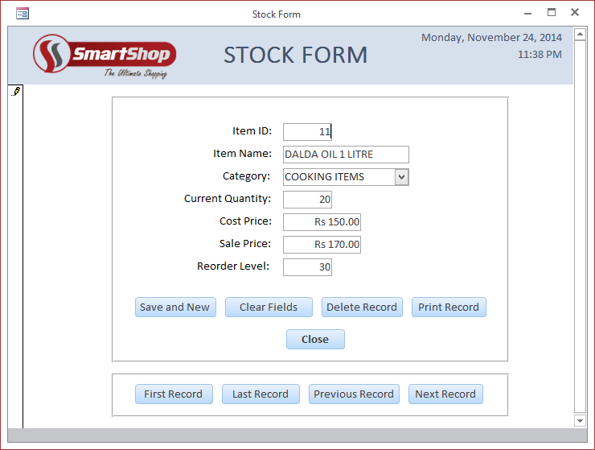

* **Test No. 10**

In this test the user entered invalid data in the fields of Stock Form. The following different error messages shown were:









* **Test No. 11**

In this test the user entered valid data in the fields of Suppliers Form according to the limits defined i.e valid and extreme data. The data was accepted in all the fields.

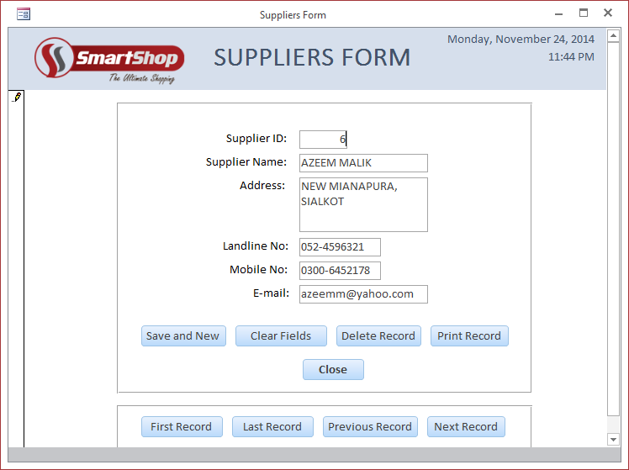

* **Test No. 12**

In this test the user entered invalid data in the fields of Suppliers Form. The following different error messages shown were:









* **Test No. 13**

In this test the user entered valid data in the fields of Sales Form according to the limits defined i.e valid and extreme data. The data was accepted in all the fields.

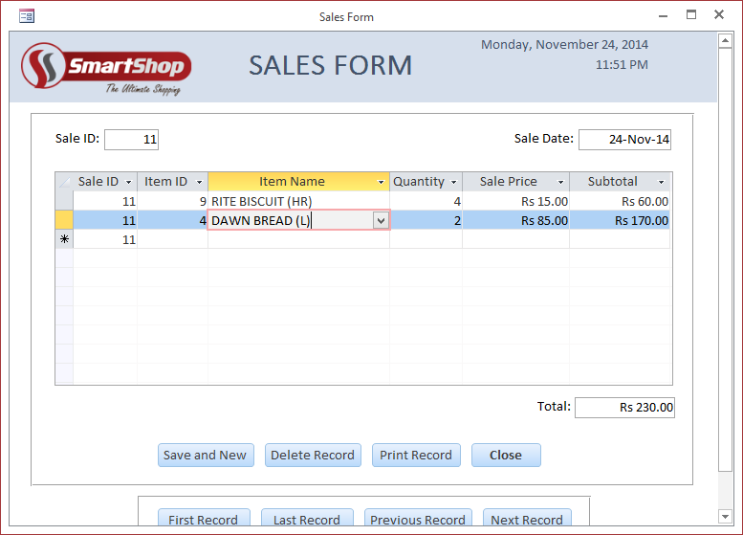

* **Test No. 14**

In this test the user entered invalid data in the fields of Sales Form. The following different error messages shown were:









* **Test No. 15**

In this test the user entered valid data in the fields of Orders Form according to the limits defined i.e valid and extreme data. The data was accepted in all the fields.

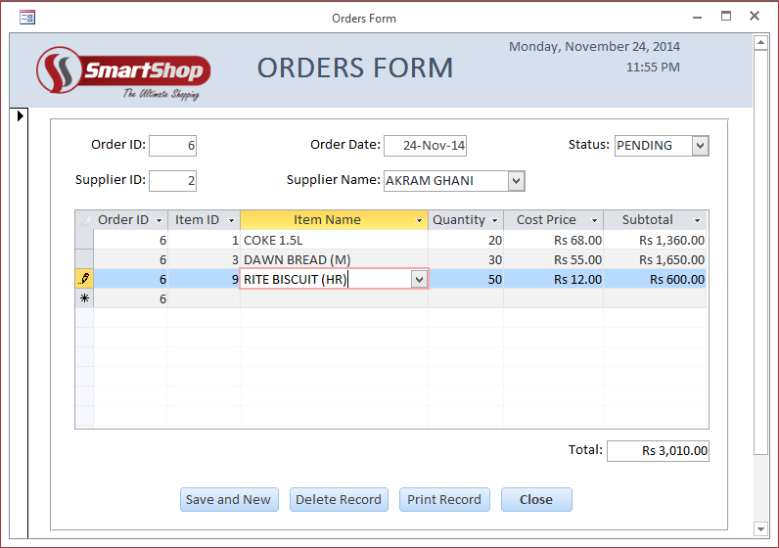

* **Test No. 16**

In this test the user entered invalid data in the fields of Orders Form. The following different error messages shown were:







* **Test No. 17**

In this test the user entered valid data in the fields of Supply Received Form according to the limits defined i.e valid and extreme data. The data was accepted in all the fields.

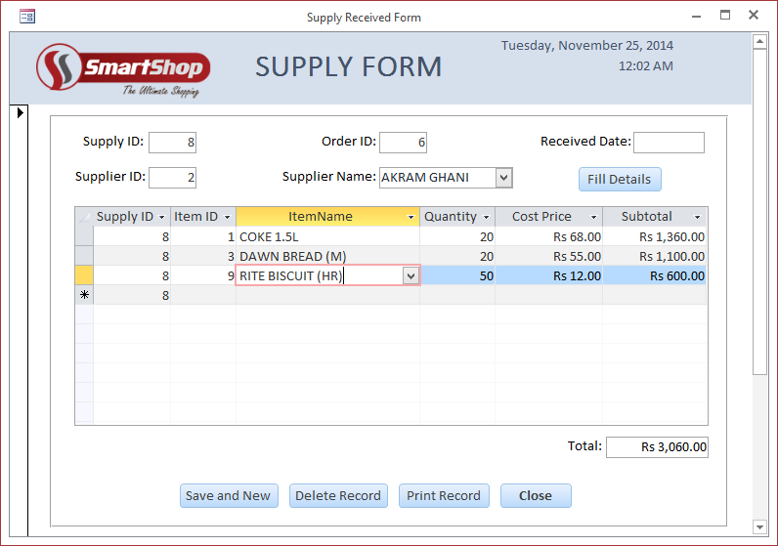

* **Test No. 18**

In this test the user entered invalid data in the fields of Supply Received Form. The following different error messages shown were:







* **Test No. 19**

In this test the user entered data in the search form Find Item by ID to find record(s).

**Entry:**

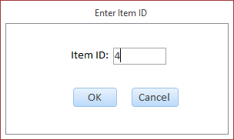

**Result:**

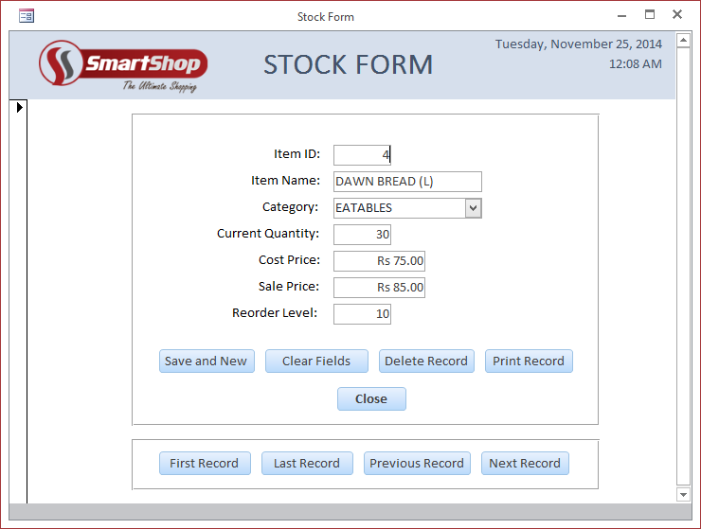

* **Test No. 20**

In this test the user entered data in the search form Find Item by Category to find record(s).

**Entry:**

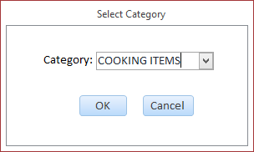

**Result:**

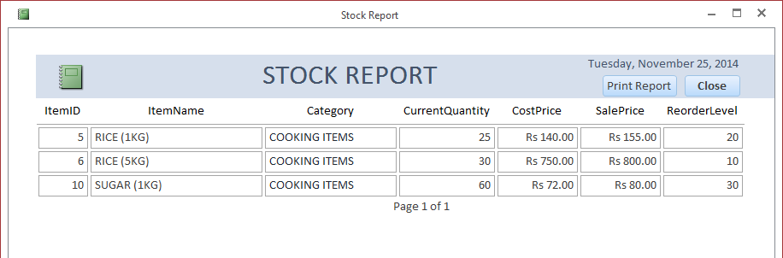

* **Test No. 21**

In this test the user entered data in the search form Find Supplier by ID to find record(s).

**Entry:**

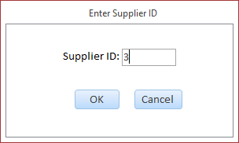

**Result:**

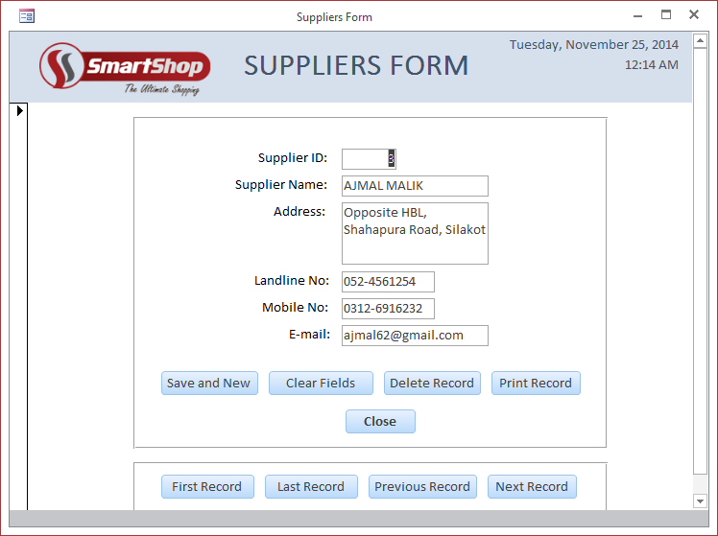

* **Test No. 22**

In this test the user entered data in the search form Find Supplier by Name to find record(s).

**Entry:**

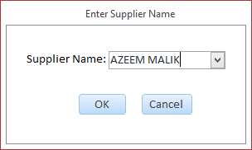

**Result:**

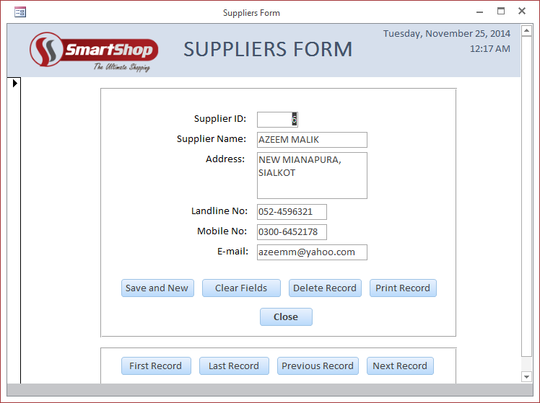

* **Test No. 23**

In this test the user entered data in the search form Find Sale by ID to find record(s).

**Entry:**

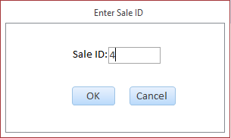

**Result:**

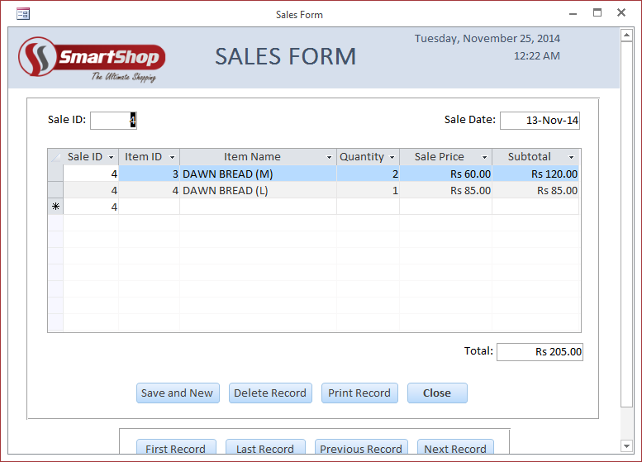

* **Test No. 24**

In this test the user entered data in the search form Find Sales From Until to find record(s).

**Entry:**

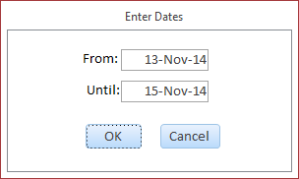

**Result:**

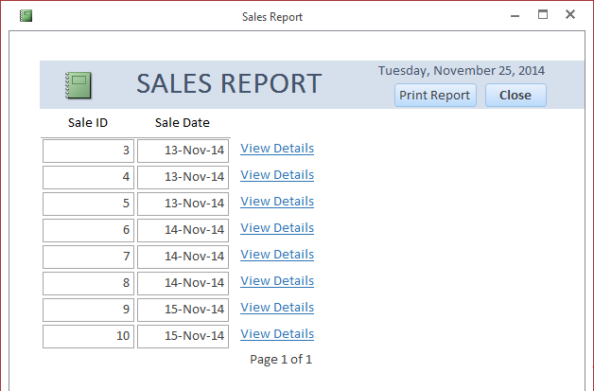

* **Test No. 25**

In this test the user entered data in the search form Find Order by Date to find record(s).

**Entry:**

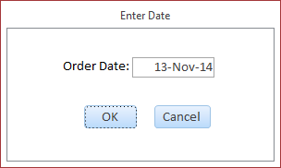

**Result:**

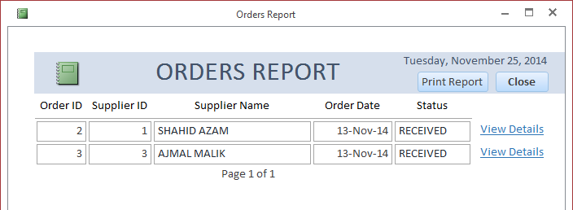

* **Test No. 26**

In this test the user entered data in the search form Find Order by Supplier to find record(s).

**Entry:**

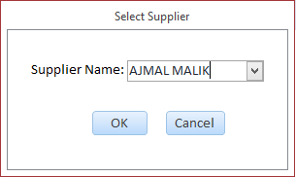

**Result:**

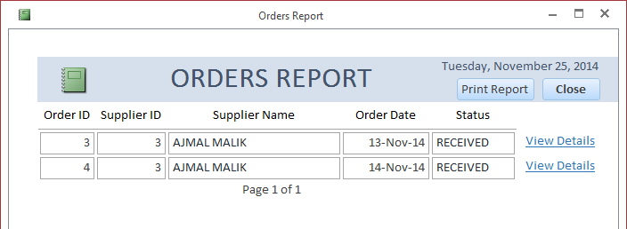

* **Test No. 27**

In this test the user entered data in the search form Find Supply by ID to find record(s).

**Entry:**

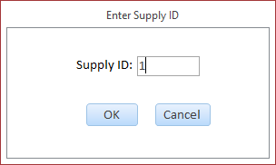

**Result:**

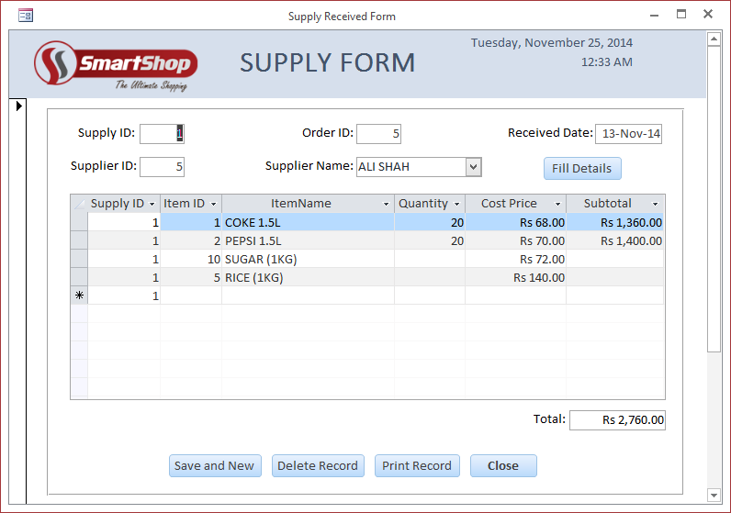

* **Test No. 28**

In this test the user entered data in the search form Find Supply Received From Until to find record(s).

**Entry:**

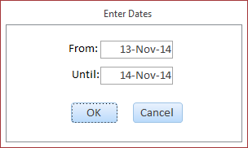

**Result:**

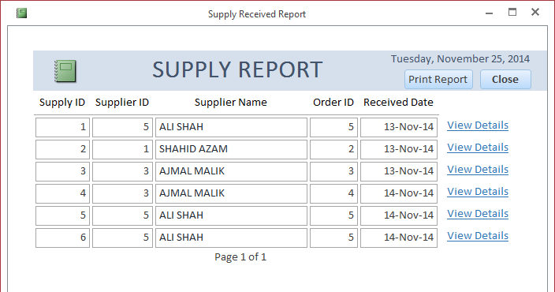

* **Test No. 29**

In this test the user opened the Stock Report to view it. The report opened up successfully and showed all the records.

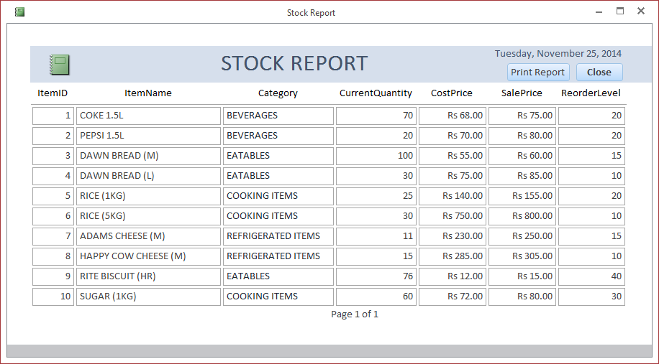

* **Test No. 30**

In this test the user opened the Suppliers Report to view it. The report opened up successfully and showed all the records.

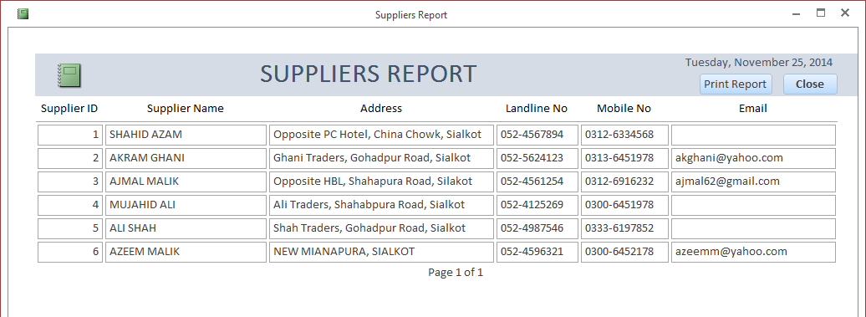

* **Test No. 31**

In this test the user opened the Sales Report to view it. The report opened up successfully and showed all the records.

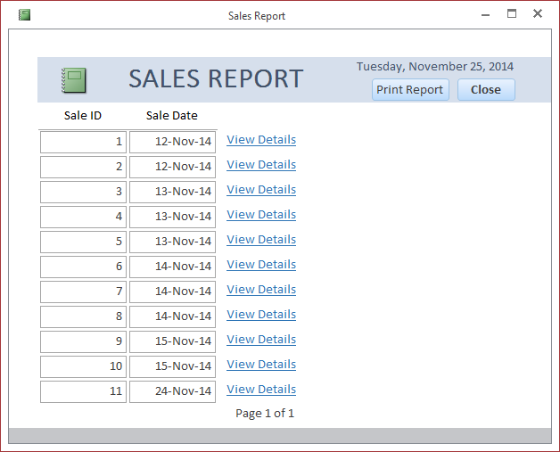

* **Test No. 32**

In this test the user opened the Orders Report to view it. The report opened up successfully and showed all the records.

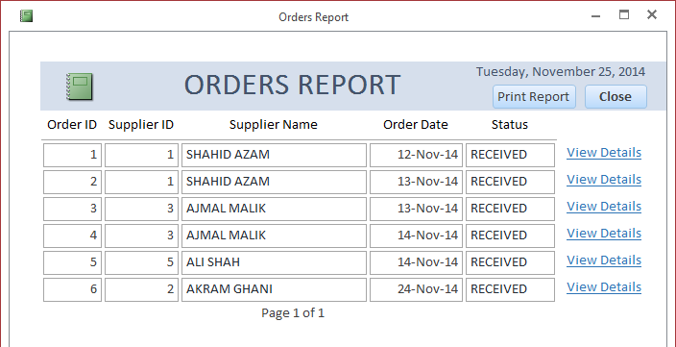

* **Test No. 33**

In this test the user opened the Supply Received Report to view it. The report opened up successfully and showed all the records.

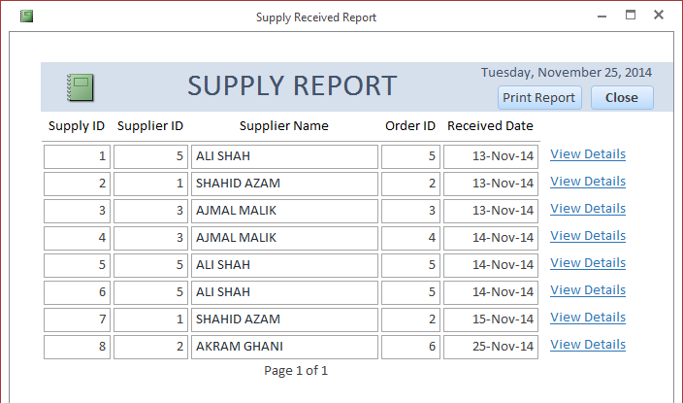

**System Changeover:**

The hardware and software has been purchased and the user testing has been thoroughly. The users have been trained to a certain degree so they can handle the new system. Now the working of the shop need to be changed to the new system and a strategy for implementation needs to be decided.

There are four available methods of implementation:

1. Direct Implementation
2. Parallel Implementation
3. Phased Implementation
4. Pilot Implementation
5. **Direct Implementation:**

This method is the simplest as with this method the old system is discontinued and the new system is implemented straight away. Although this method in better in terms of time as less time will be wasted; however the major disadvantage is that this method can be disastrous if the new system fails which can cause chaos in the shop.

1. **Parallel Implementation:**

In this method the old and new system are run together for a time period. The advantage of this technique is that if the new system fails at any point, the old system can be implemented which does not affect the routine. Similarly via this method the new system can be evaluated. However the major disadvantage of this system is that it is more time consuming and involves duplication of data which can cause confusion. This method is ideal for the shop on the basis of its scale.

1. **Phased Implementation:**

The method is basically suitable for larger systems (mainly computerized system for a big organization). In this method the new system is divided into several parts which are implemented in series, if the subsequent part works perfect. However this method is not suitable as the shop is of small scale.

1. **Pilot Implementation:**

In this method only the key parts of the new system are run alongside the old system until it is considered that they have been fully tested. This is a compromise with the idea of parallel running but it does not give a clear idea of effects on the system of the large amounts of data that are going to be encountered in the application.

**Selected Method of Implementation:**

I presented the client with the four possible methods of conversion and explained the merits and drawbacks of each method. The client did a careful judgment and it was decided that **Parallel Implementation** will be used for the system changeover.

The reasons for choosing this method are:

* If the new system fails to fulfill the requirements or operate properly, the old system can still be resumed without affecting the working of the shop.
* When both the systems will be run alongside, the new system can be evaluated properly and its advantages over the manual system will be more obvious.
* The new system has been tested both by the user and developer and it has a very low chance of failure so this is a ‘safe’ method of implementation.
* The business scale of the shop is not very high, its average. So running both the systems simultaneously is possible even though the workforce will have more workload.

Before running the new system, it is mandatory to transfer all the data in the old system into the new system. Once the data is fully transferred the method **Parallel Implementation** will be used for the changeover. Similarly via this method a backup of all records will be retained which can help further.

The following letter from the client highlights the success of the user testing giving proof that he has seen the system in work. The client also tells about selected method of changeover i.e. **Parallel Implementation.**

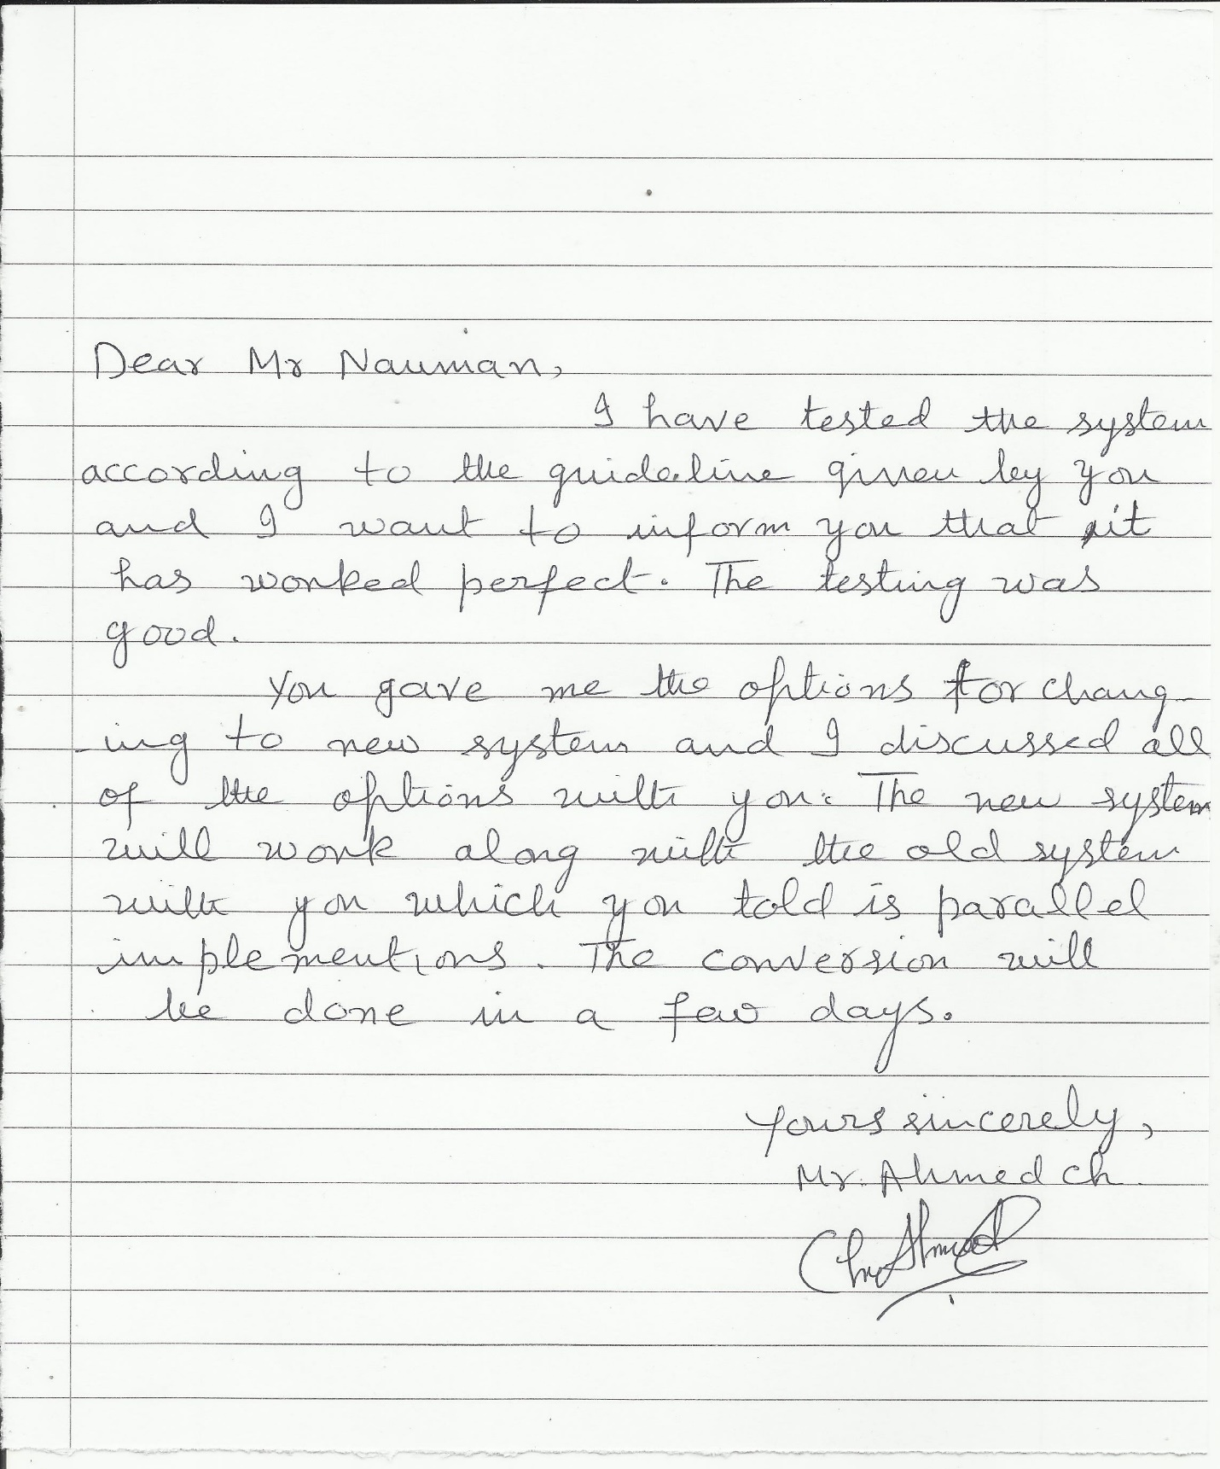

**SYSTEM MAINTENANCE DOCUMENTATION**

**CONTENTS**

System Requirements ……………………………………………………………………………………. **374**

Data Structures ………………………………………………………………………………………………. **375**

Data Relationships …………………………………………………………………………………………. **388**

Data Flow Diagram …………………………………………………………………………………………. **393**

Algorithms ……………………………………………………………………………………………………… **394**

Program Code…………………………………………………………………………………………………. **407**

Adaptive Maintenance …………………………………………………………………………………… **408**

**SYSTEM REQUIREMENTS**

**Hardware Requirements:**

The hardware requirements for this database to work are:

|  |  |
| --- | --- |
| **Processor** | 1 GHZ Dual Core or Higher |
| **RAM** | 1 GB minimum; 2 GB recommended  (On Microsoft ® Windows 7, the minimum requirement is 1GB ) |
| **Disk Space** | 40 GB minimum; 80 GB recommended |
| **Graphics** | 128 MB minimum; 256 MB recommended  (On Microsoft ® Windows 7, the minimum requirement is 128 MB) |

**Important:** The hardware requirements drafted above are in accordance with *Microsoft ® Windows 7* as the operating system.

**Software Requirements:**

The software requirements for this database to work are:

|  |  |
| --- | --- |
| **Operating System** | Microsoft ® Windows 7 |
| **Database Management System** | Microsoft ® Access 2013 |
| **Antivirus** | Microsoft ® Security Essentials |

**DATA STRUCTURES**

The tables in the database serve the purpose of data structures in this solution. Normalization is done to organize the fields and tables of the database to minimize redundancy and the larger tables are divided into smaller so relationships can be defined between them.

The tables in this database are:

1. Stock Table
2. Suppliers Table
3. Sales Table
4. Sales Details Table
5. Orders Table
6. Order Details Table
7. Supply Received Table
8. Supply Received Details Table
9. **Stock Table:**

**Design View:**



This table stores data about each item in the shop. The table below shows the fields in the table and the other details about them.

Primary Key: ItemID

|  |  |  |  |  |
| --- | --- | --- | --- | --- |
| **Field Name** | **Data Type** | **Field Size** | **Format** | **Description** |
| ItemID | AutoNumber | Long Integer | - | It is the unique number assigned to every item and is auto generated |
| ItemName | Short Text | 60 | - | The name of the item is stored in this field |
| Category | Short Text | - | - | The category of the item is selected from combo box and stored in this field |
| CurrentQuantity | Number | Long Integer | - | The present quantity of the item is stored in this field |
| CostPrice | Number | Long Integer | "Rs "#,##0.00 | The cost price of the item is stored in this field |
| SalePrice | Number | Long Integer | "Rs "#,##0.00 | The selling price of the item is stored in this field |
| ReorderLevel | Number | Long Integer | - | The quantity at which item needs to be reordered is stored in this field |

All the validation of the fields is done using **VBA** Code on the **Stock Form**. The validation rules in table design are not used.

|  |  |  |
| --- | --- | --- |
| **Field Name** | **Validation Rule** | **Validation Rule Description** |
| ItemID | - | - |
| ItemName | IsNull() = False And  Len() <= 60 | Field is required and Length should be less and equal to 60 |
| Category | IsNull() = False | Field is required |
| CurrentQuantity | IsNull() = False And  >=0 | Field is required and Allow number greater or equal to 0 |
| CostPrice | IsNull() = False  And  >0 | Field is required and Allow number greater than 0 |
| SalePrice | IsNull() = False  And  >0 | Field is required and Allow number greater than 0 |
| ReorderLevel | >0 | Allow number greater than 0 |

1. **Suppliers Table:**

**Design View:**



This table stores data about each supplier. The table below shows the fields in the table and the other details about them.

Primary Key: SupplierID

|  |  |  |  |  |
| --- | --- | --- | --- | --- |
| **Field Name** | **Data Type** | **Field Size** | **Format** | **Description** |
| SupplierID | AutoNumber | Long Integer | - | It is the unique number assigned to every supplier and is auto generated |
| SupplierName | Short Text | 40 | - | The name of the supplier is stored in this field |
| Address | Short Text | 150 | - | The address of the supplier is stored in this field |
| LandlineNo | Short Text | 10 | !@@@-@@@@@@@ | The landline number of the supplier is stored in this field |
| MobileNo | Short Text | 11 | !@@@@-@@@@@@@ | The mobile number of the supplier is stored in this field |
| Email | Short Text | 40 | - | The email of the supplier is stored in this field |

All the validation of the fields is done using **VBA** Code on the **Suppliers Form**. The validation rules in table design are not used.

|  |  |  |
| --- | --- | --- |
| **Field Name** | **Validation Rule** | **Validation Rule Description** |
| SupplierID | - | - |
| SupplierName | IsNull() = False And  Len() <= 40 | Field is required and Length should be less and equal to 40 |
| Address | IsNull() = False | Field is required |
| LandlineNo | Len() <= 10  And  IsNumeric() = True | Length should be less and equal to 10 and Allow numbers only |
| MobileNo | IsNull() = False  And  Len() <= 11  And  IsNumeric() = True | Field is required and Length should be less and equal to 11 and Allow numbers only |
| Email | - | - |

1. **Sales Table:**

**Design View:**



This table stores data about the sales that happen. The table below shows the fields in the table and the other details about them.

Primary Key: SaleID

|  |  |  |  |  |
| --- | --- | --- | --- | --- |
| **Field Name** | **Data Type** | **Field Size** | **Format** | **Description** |
| SaleID | AutoNumber | Long Integer | - | It is the unique number assigned to every sale and is auto generated |
| SaleDate | Date/Time | - | Medium Date | The date of the sale in stored in this field |

All the validation of the fields is done using **VBA** Code on the **Sales Form**. The validation rules in table design are not used.

|  |  |  |
| --- | --- | --- |
| **Field Name** | **Validation Rule** | **Validation Rule Description** |
| SaleID | - | - |
| SaleDate | IsNull() = False And  = Date | Field is required and Value should be equal to current date |

1. **Sales Details Table:**

**Design View:**



This table stores data about details of each sale. The table below shows the fields in the table and the other details about them.

|  |  |  |  |  |
| --- | --- | --- | --- | --- |
| **Field Name** | **Data Type** | **Field Size** | **Format** | **Description** |
| SaleID | Number | Long Integer | - | The ID of the sale is stored in this field |
| ItemID | Number | Long Integer | - | The ID of the item is stored in this field |
| ItemName | Short Text | - | - | The name of the item selected from the combo box and stored in this field |
| Quantity | Number | Long Integer | - | The quantity of the item is stored in this field |
| SalePrice | Number | Long Integer | "Rs "#,##0.00 | The selling price of the item is stored in this field |
| Subtotal | Calculated | Long Integer | "Rs "#,##0.00 | It is a calculated field which stores the product of Quantity and SalePrice |

All the validation of the fields is done using **VBA** Code on the **Sales Form**. The validation rules in table design are not used.

|  |  |  |
| --- | --- | --- |
| **Field Name** | **Validation Rule** | **Validation Rule Description** |
| SaleID | - | - |
| ItemID | IsNull() = False  And  >0 | Field is required and Allow number greater than 0 |
| ItemName | IsNull = False | Field is required |
| Quantity | IsNull() = False  And  >=0 | Field is required and Allow number greater or equal to 0 |
| SalePrice | IsNull() = False  And  >0 | Field is required and Allow number greater than 0 |
| Subtotal | - | - |

1. **Orders Table:**

**Design View:**



This table stores data about each order that is placed. The table below shows the fields in the table and the other details about them.

Primary Key: OrderID

|  |  |  |  |  |
| --- | --- | --- | --- | --- |
| **Field Name** | **Data Type** | **Field Size** | **Format** | **Description** |
| OrderID | AutoNumber | Long Integer | - | It is the unique number assigned to every order and is auto generated |
| SupplierID | Number | Long Integer | - | The ID of the supplier is stored in this field |
| SupplierName | Short Text | - | - | The name of the supplier is selected from the combo box and stored in this field |
| OrderDate | Date/Time | - | Medium Date | The date of the order is stored in this field |
| Status | Short Text | - | - | The order status is selected from the combo box and stored in this field |

All the validation of the fields is done using **VBA** Code on the **Orders Form**. The validation rules in table design are not used.

|  |  |  |
| --- | --- | --- |
| **Field Name** | **Validation Rule** | **Validation Rule Description** |
| Order ID | - | - |
| SupplierID | IsNull() = False  And  >0 | Field is required and Allow number greater than 0 |
| SupplierName | IsNull() = False | Field is required |
| OrderDate | IsNull() = False | Field is required |
| Status | IsNull() = False | Field is required |

1. **Order Details Table:**

**Design View:**



This table stores data about details of each order. The table below shows the fields in the table and the other details about them.

|  |  |  |  |  |
| --- | --- | --- | --- | --- |
| **Field Name** | **Data Type** | **Field Size** | **Format** | **Description** |
| OrderID | Number | Long Integer | - | The ID of the order is stored in this field |
| ItemID | Number | Long Integer | - | The ID of the item is stored in this field |
| ItemName | Short Text | - | - | The name of the item selected from the combo box and stored in this field |
| Quantity | Number | Long Integer | - | The quantity of the item is stored in this field |
| CostPrice | Number | Long Integer | "Rs "#,##0.00 | The cost price of the item is stored in this field |
| Subtotal | Calculated | Long Integer | "Rs "#,##0.00 | It is a calculated field which stores the product of Quantity and CostPrice |

All the validation of the fields is done using **VBA** Code on the **Orders Form**. The validation rules in table design are not used.

|  |  |  |
| --- | --- | --- |
| **Field Name** | **Validation Rule** | **Validation Rule Description** |
| OrderID | - | - |
| ItemID | IsNull() = False  And  >0 | Field is required and Allow number greater than 0 |
| ItemName | IsNull = False | Field is required |
| Quantity | IsNull() = False  And  >=0 | Field is required and Allow number greater or equal to 0 |
| CostPrice | IsNull() = False  And  >0 | Field is required and Allow number greater than 0 |
| Subtotal | - | - |

1. **Supply Received Table:**

**Design View:**



This table stores data about each supply that is received. The table below shows the fields in the table and the other details about them.

Primary Key: SupplyID

|  |  |  |  |  |
| --- | --- | --- | --- | --- |
| **Field Name** | **Data Type** | **Field Size** | **Format** | **Description** |
| SupplyID | AutoNumber | Long Integer | - | It is the unique number assigned to every supply and is auto generated |
| SupplierID | Number | Long Integer | - | The ID of the supplier is stored in this field |
| SupplierName | Short Text | - | - | The name of the supplier is selected from the combo box and stored in this field |
| OrderID | Number | Long Integer | - | The ID of the order is stored in this field |
| ReceivedDate | Date/Time | - | Medium Date | The date on which supply was received is stored in this field |

All the validation of the fields is done using **VBA** Code on the **Supply Received Form**. The validation rules in table design are not be used.

|  |  |  |
| --- | --- | --- |
| **Field Name** | **Validation Rule** | **Validation Rule Description** |
| Supply ID | - | - |
| SupplierID | IsNull() = False  And  >0 | Field is required and Allow number greater than 0 |
| SupplierName | IsNull() = False | Field is required |
| OrderID | >0 | Allow number greater than 0 |
| ReceivedDate | IsNull() = False | Field is required |

1. **Supply Received Details Table:**

**Design View:**



This table stores data about details of each supply that is received. The table below shows the fields in the table and the other details about them.

|  |  |  |  |  |
| --- | --- | --- | --- | --- |
| **Field Name** | **Data Type** | **Field Size** | **Format** | **Description** |
| SupplyID | Number | Long Integer | - | The ID of the supply is stored in this field |
| ItemID | Number | Long Integer | - | The ID of the item is stored in this field |
| ItemName | Short Text | - | - | The name of the item selected from the combo box and stored in this field |
| Quantity | Number | Long Integer | - | The quantity of the item is stored in this field |
| CostPrice | Number | Long Integer | "Rs "#,##0.00 | The cost price of the item is stored in this field |
| Subtotal | Calculated | Long Integer | "Rs "#,##0.00 | It is a calculated field which stores the product of Quantity and CostPrice |

All the validation of the fields is done using **VBA** Code on the **Supply Received Form**. The validation rules in table design are not used.

|  |  |  |
| --- | --- | --- |
| **Field Name** | **Validation Rule** | **Validation Rule Description** |
| SupplyID | - | - |
| ItemID | IsNull() = False  And  >0 | Field is required and Allow number greater than 0 |
| ItemName | IsNull = False | Field is required |
| Quantity | IsNull() = False  And  >=0 | Field is required and Allow number greater or equal to 0 |
| CostPrice | IsNull() = False  And  >0 | Field is required and Allow number greater than 0 |
| Subtotal | - | - |

**DATA RELATIONSHIPS**

The following diagram shows the relationships between the tables:



1. **Stock Table TO Sales Details Table**

In this relationship the **Stock** table is linked to **Sales Details** table. The key field **ItemID**, from **Stock** table is linked to its foreign field **ItemID** in **Sales Details** table. As there can be more than one item so **One-To-Many** relationship has been created between both tables.

**Relationship Type: One-To-Many**

For better Data Integrity the following options have been selected so amendments in tables are applied to the relationship:

• **Enforce Referential Integrity** ✓

• **Cascade Update Related Fields** ✓

• **Cascade Delete Related Fields** ✓

The joint property for this field is:

**Only include rows where the joined fields from both tables are equal.**

This means when ItemID is same in both table, only then rows would be included.

1. **Stock Table TO Supply Received Details Table**

In this relationship the **Stock** table is linked to **Supply Received Details** table. The key field **ItemID**, from **Stock** table is linked to its foreign field **ItemID** in **Supply Received Details** table. As there can be more than one item so **One-To-Many** relationship has been created between both tables.

**Relationship Type: One-To-Many**

For better Data Integrity the following options have been selected so amendments in tables are applied to the relationship:

• **Enforce Referential Integrity** ✓

• **Cascade Update Related Fields** ✓

• **Cascade Delete Related Fields** ✓

The joint property for this field is:

**Only include rows where the joined fields from both tables are equal.**

This means when ItemID is same in both table, only then rows would be included.

1. **Stock Table TO Order Details Table**

In this relationship the **Stock** table is linked to **Order Details** table. The key field **ItemID**, from **Stock** table is linked to its foreign field **ItemID** in **Order Details** table. As there can be more than one item so **One-To-Many** relationship has been created between both tables.

**Relationship Type: One-To-Many**

For better Data Integrity the following options have been selected so amendments in tables are applied to the relationship:

• **Enforce Referential Integrity** ✓

• **Cascade Update Related Fields** ✓

• **Cascade Delete Related Fields** ✓

The joint property for this field is:

**Only include rows where the joined fields from both tables are equal.**

This means when ItemID is same in both table, only then rows would be included.

1. **Sales Table TO Sales Details Table**

In this relationship the **Sales** table is linked to **Sales Details** table. The key field **SaleID**, from **Sales** table is linked to its foreign field **SaleID** in **Sales Details** table. As there can be more than one item sold in each sale so **One-To-Many** relationship has been created between both tables.

**Relationship Type: One-To-Many**

For better Data Integrity the following options have been selected so amendments in tables are applied to the relationship:

• **Enforce Referential Integrity** ✓

• **Cascade Update Related Fields** ✓

• **Cascade Delete Related Fields** ✓

The joint property for this field is:

**Only include rows where the joined fields from both tables are equal.**

This means when SaleID is same in both table, only then rows would be included.

1. **Supply Received Table TO Supply Received Details Table**

In this relationship the **Supply Received** table is linked to **Supply Received Details** table. The key field **SupplyID**, from **Supply Received** table is linked to its foreign field **SupplyID** in **Supply Received** table. As there can be more than one item received in a supply so **One-To-Many** relationship has been created between both tables.

**Relationship Type: One-To-Many**

For better Data Integrity the following options have been selected so amendments in tables are applied to the relationship:

• **Enforce Referential Integrity** ✓

• **Cascade Update Related Fields** ✓

• **Cascade Delete Related Fields** ✓

The joint property for this field is:

**Only include rows where the joined fields from both tables are equal.**

This means when SupplyID is same in both table, only then rows would be included.

1. **Orders Table TO Order Details Table**

In this relationship the **Orders** table is linked to **Order Details** table. The key field **OrderID**, from **Supply Received** table is linked to its foreign field **OrderID** in **Supply Received** table. As there can be more than one item in a single order so **One-To-Many** relationship has been created between both tables.

**Relationship Type: One-To-Many**

For better Data Integrity the following options have been selected so amendments in tables are applied to the relationship:

• **Enforce Referential Integrity** ✓

• **Cascade Update Related Fields** ✓

• **Cascade Delete Related Fields** ✓

The joint property for this field is:

**Only include rows where the joined fields from both tables are equal.**

This means when OrderID is same in both table, only then rows would be included.

1. **Orders Table TO Supply Received Table**

In this relationship the **Orders** table is linked to **Supply Received Details** table. The key field **OrderID**, from **Order** table is linked to its foreign field **OrderID** in **Supply Received** table. **One-To-Many** relationship has been created between both tables.

**Relationship Type: One-To-Many**

For better Data Integrity the following options have been selected so amendments in tables are applied to the relationship:

• **Enforce Referential Integrity** ✓

• **Cascade Update Related Fields** ✓

• **Cascade Delete Related Fields** ✓

The joint property for this field is:

**Only include rows where the joined fields from both tables are equal.**

This means when OrderID is same in both table, only then rows would be included.

1. **Suppliers Table TO Orders Table**

In this relationship the **Suppliers** table is linked to **Orders** table. The key field **SupplierID**, from **Suppliers** table is linked to its foreign field **SupplierID** in **Orders** table. As there can be more than one order to a supplier so **One-To-Many** relationship has been created between both tables.

**Relationship Type: One-To-Many**

For better Data Integrity the following options have been selected so amendments in tables are applied to the relationship:

• **Enforce Referential Integrity** ✓

• **Cascade Update Related Fields** ✓

• **Cascade Delete Related Fields** ✓

The joint property for this field is:

**Only include rows where the joined fields from both tables are equal.**

This means when SupplierID is same in both table, only then rows would be included.

1. **Suppliers Table TO Supply Received Table**

In this relationship the **Suppliers** table is linked to **Supply Received** table. The key field **SupplierID**, from **Suppliers** table is linked to its foreign field **SupplierID** in **Supply Received** table. As there can be more than one supply from a supplier so **One-To-Many** relationship has been created between both tables.

**Relationship Type: One-To-Many**

For better Data Integrity the following options have been selected so amendments in tables are applied to the relationship:

• **Enforce Referential Integrity** ✓

• **Cascade Update Related Fields** ✓

• **Cascade Delete Related Fields** ✓

The joint property for this field is:

**Only include rows where the joined fields from both tables are equal.**

This means when SupplierID is same in both table, only then rows would be included.

**DATA FLOW DIAGRAM**

The data flow diagram (DFD) of the new system is as follows:



**ALGORITHMS**

Program code is a necessary part of the solution because it will customizes and adds functionality to the database according to the requirements. All the code is written in **VBA** and is on the forms and reports.

In this section all the program code is explained using algorithms and is in the form of **Pseudocode**.

* **Login Form:**

The primary code of the Login form is on the **OnClick** event of the **Login** button.

Below is the simple Pseudocode:

**Login (OnClick)**

OPEN RECORDSET(LoginTable)

MOVE TO FIRST RECORD

Password = RECORDSET(“Password”)

Username = “ch.ahmad”

IF Form.Username = Null THEN

SHOW MESSAGE “Username is required!”

SET FOCUS Form.Username

EXIT SUBROUTINE

END IF

IF Form.Username <> Username THEN

SHOW Label “Wrong Username”

SET FOCUS Form.Username

EXIT SUBROUTINE

END IF

IF Form.Password = Null THEN

SHOW MESSAGE “Password is required!”

SET FOCUS Form.Password

EXIT SUBROUTINE

END IF

IF Form.Password <> Passoword THEN

SHOW Label “Wrong Password”

SET FOCUS Form.Password

EXIT SUBROUTINE

END IF

ClOSE RECORDSET

OPEN Main Menu

CLOSE Login Form

* **Change Password Form:**

The primary code of the Change Password form is on the **OnClick** event of the **OK** button.

Below is the simple Pseudocode:

**OK (OnClick)**

OPEN RECORDSET(LoginTable)

MOVE TO FIRST RECORD

Password = RECORDSET(“Password”)

IF Form.Password = Null THEN

SHOW MESSAGE “Password is required!”

SET FOCUS Form.Password

EXIT SUBROUTINE

END IF

IF Form.Password <> Passoword THEN

SHOW Label “Wrong Password”

SET FOCUS Form.Password

EXIT SUBROUTINE

END IF

IF Form.NewPassword = Null THEN

SHOW MESSAGE “Enter new password!”

SET FOCUS Form.Password

EXIT SUBROUTINE

END IF

IF Form.ReNewPassword = Null THEN

SHOW MESSAGE “Re-enter new password!”

SET FOCUS Form.Password

EXIT SUBROUTINE

END IF

IF Form.NewPassword <> Form.ReNewPassoword THEN

SHOW Label “Password don’t match”

SET FOCUS Form.ReNewPassword

EXIT SUBROUTINE

END IF

EDIT RECORDSET

RECORDSET(“Pasword”) = Form.NewPassword

UPDATE RECORDSET

CLOSE RECORDSET

SHOW MESSAGE “Password changed successfully!”

CLOSE Change Password Form

* **Stock Form**

The code for validation has been described in **Data Structures** Section. The remaining code is on the **OnClick** event of **Save and New** and **Close** button.

**Save and New (OnClick)**

IF Form.ItemName = Null THEN

SHOW MESSAGE “Item Name is required!”

ELSE IF Form.Category = Null THEN

SHOW MESSAGE “Category is required!”

ELSE IF Form.CurrentQuantity = Null THEN

SHOW MESSAGE “Current Quantity is required!”

ELSE IF Form.CostPrice = Null THEN

SHOW MESSAGE “Cost Price is required!”

ELSE IF Form.SalePrice = Null THEN

SHOW MESSAGE “Sale Price is required!”

ELSE

SAVE Current Record

GO TO New Record

END IF

**Close (OnClick)**

IF Form.Dirty = True THEN

IF MSGBOX “Do you want to save current record?” Choice = Yes THEN

CALL Save SUBROUTINE

IF Form.Dirty = False THEN

CLOSE Stock Form

END IF

ELSE IF Choice = No THEN

Form.Undo

CLOSE Stock Form

END IF

ELSE

CLOSE Stock Form

END IF

* **Suppliers Form**

The code for validation has been described in **Data Structures** Section. The remaining code is on the **OnClick** event of **Save and New** and **Close** button.

**Save and New (OnClick)**

IF Form.SupplierName = Null THEN

SHOW MESSAGE “Supplier Name is required!”

ELSE IF Form.Address = Null THEN

SHOW MESSAGE “Address is required!”

ELSE IF Form.MobileNo = Null THEN

SHOW MESSAGE “Mobile No is required!”

ELSE

SAVE Current Record

GO TO New Record

END IF

**Close (OnClick)**

IF Form.Dirty = True THEN

IF MSGBOX “Do you want to save current record?” Choice = Yes THEN

CALL Save SUBROUTINE

IF Form.Dirty = False THEN

CLOSE Stock Form

END IF

ELSE IF Choice = No THEN

Form.Undo

CLOSE Stock Form

END IF

ELSE

CLOSE Stock Form

END IF

* **Sales Form**

The code for validation has been described **Data Structures** Section. The remaining code is on the **OnClick** event of **Save and New** and **Close** button.

**Save and New (OnClick)**

IF Form.SaleDate = Null THEN

SHOW MESSAGE “Sale Date is required!”

ELSE IF SalesDetailsForm.ItemName = Null THEN

SHOW MESSAGE “Item Name is required!”

ELSE IF SalesDetailsForm.ItemID = Null THEN

SHOW MESSAGE “Item ID is required!”

ELSE IF SalesDetailsForm.Quantity = Null THEN

SHOW MESSAGE “Quantity is required!”

ELSE IF SalesDetailsForm.SalePrice = Null THEN

SHOW MESSAGE “Sale Price is required!”

ELSE

SAVE Current Record

GO TO New Record

END IF

**Close (OnClick)**

IF Form.Temp = “Yes” THEN

IF MSGBOX “Do you want to save current record?” Choice = Yes THEN

CALL Save SUBROUTINE

IF Form.Temp = “No” THEN

CLOSE Sales Form

END IF

ELSE IF Choice = No THEN

DELETE Current Record

CLOSE Sales Form

END IF

ELSE

CLOSE Sales Form

END IF

* **Sales Details Form**

The code is on the **AfterUpdate** event of **ItemName** and **Quantity** fields.

**ItemName (AfterUpdate)**

OPEN RECORDSET(StockTable)

RECORDSET.SEEK = Form.ItemName

Form.SalePrice = RECORDSET(“SalePrice”)

Form.ItemID = RECORDSET(“ItemID”)

CLOSE RECORDSET

**Quantity (AfterUpdate)**

OPEN RECORDSET(StockTable)

RECORDSET.SEEK = Form.ItemID

EDIT RECORDSET

IF Form.Quantity < RECORDSET(“Quantity”) THEN

RECORDSET(“Quantity”) = RECORDSET(“CurrentQuantity”) – Form.Quantity

ELSE

SHOW MESSAGE “The Current Quantity of ” & Form.ItemName & “ is ” & REOCORDSET("CurrentQuantity") & ". Enter a value less or equal to it."

END IF

UPDATE RECORDSET

CLOSE RECORDSET

* **Orders Form**

The code for validation has been described in **Data Structures** Section. The remaining code is on the **OnClick** event of **Save and New** and **Close** button and the **AfterUpdate** event of **SupplierName** field.

**Save and New (OnClick)**

IF Form.SupplierID = Null THEN

SHOW MESSAGE “Supplier ID is required!”

ELSE IF Form.SupplierName = Null THEN

SHOW MESSAGE “Supplier Name is required!”

ELSE IF Form.OrderDate= Null THEN

SHOW MESSAGE “Order Date is required!”

ELSE IF Form.Status = Null THEN

SHOW MESSAGE “Status is required!”

ELSE IF OrderDetailsForm.ItemName = Null THEN

SHOW MESSAGE “Item Name is required!”

ELSE IF OrderDetailsForm.ItemID = Null THEN

SHOW MESSAGE “Item ID is required!”

ELSE IF OrderDetailsForm.Quantity = Null THEN

SHOW MESSAGE “Quantity is required!”

ELSE IF OrderDetailsForm.CostPrice = Null THEN

SHOW MESSAGE “Cost Price is required!”

ELSE

SAVE Current Record

GO TO New Record

END IF

**Close (OnClick)**

IF Form.Temp = “Yes” THEN

IF MSGBOX “Do you want to save current record?” Choice = Yes THEN

CALL Save SUBROUTINE

IF Form.Temp = “No” THEN

CLOSE Orders Form

END IF

ELSE IF Choice = No THEN

DELETE Current Record

CLOSE Orders Form

END IF

ELSE

CLOSE Orders Form

END IF

**SupplierName (AfterUpdate)**

OPEN RECORDSET(SuppliersTable)

RECORDSET.SEEK = Form.SupplierName

Form.SupplierID = RECORDSET(“SupplierID”)

CLOSE RECORDSET

* **Order Details Form:**

The code is on the **AfterUpdate** event of **ItemName** and **Quantity** fields.

**ItemName (AfterUpdate)**

OPEN RECORDSET(StockTable)

RECORDSET.SEEK = Form.ItemName

Form.CostPrice = RECORDSET(“CostPrice”)

Form.ItemID = RECORDSET(“ItemID”)

CLOSE RECORDSET

**Quantity (AfterUpdate)**

OPEN RECORDSET(StockTable)

RECORDSET.SEEK = Form.ItemID

IF Form.Quantity < RECORDSET(“ReorderLevel”) THEN

SHOW MESSAGE “The minimum quantity of ” & Me!ItemName & “ that can be ordered is ” & rst("ReorderLevel") & “. Enter a value greater or equal to it.”

END IF

UPDATE RECORDSET

CLOSE RECORDSET

* **Supply Received Form**

The code for validation has been described in **Data Structures** Section. The remaining code is on the **OnClick** event of **Save and New**, **Close** and **Fill Details** button and the **AfterUpdate** event of **OrderID** field.

**Save and New (OnClick)**

IF Form.SupplierID = Null THEN

SHOW MESSAGE “Supplier ID is required!”

ELSE IF Form.SupplierName = Null THEN

SHOW MESSAGE “Supplier Name is required!”

ELSE IF Form.ReceivedDate= Null THEN

SHOW MESSAGE “Received Date is required!”

ELSE IF Form.Status = Null THEN

SHOW MESSAGE “Status is required!”

ELSE IF SupplyReceivedDetailsForm.ItemName = Null THEN

SHOW MESSAGE “Item Name is required!”

ELSE IF SupplyReceivedDetailsForm.ItemID = Null THEN

SHOW MESSAGE “Item ID is required!”

ELSE IF SupplyReceivedDetailsForm.Quantity = Null THEN

SHOW MESSAGE “Quantity is required!”

ELSE IF OrderDetailsForm.CostPrice = Null THEN

SHOW MESSAGE “Cost Price is required!”

ELSE

SAVE Current Record

GO TO New Record

END IF

**Close (OnClick)**

IF Form.Temp = “Yes” THEN

IF MSGBOX “Do you want to save current record?” Choice = Yes THEN

CALL Save SUBROUTINE

IF Form.Temp = “No” THEN

CLOSE Supply Received Form

END IF

ELSE IF Choice = No THEN

DELETE Current Record

CLOSE Supply Received Form

END IF

ELSE

CLOSE Supply Received Form

END IF

**Fill Details (OnClick)**

OPEN RECORDSET1(OrdersTable)

OPEN RECORDSET2(OrderDetailsTable)

RECORDSET3 = Form.SupplyReceivedDetailsForm.Recordset

RECORDSET1.SEEK = Form.OrderID

RECORDSET2.SEEK = Form.OrderID

IF Form.OrderID <> Null THEN

IF MSGBOX “Do you want to fill the fields automatically based on the following order:” & _

“Order ID: “ & rst1(“OrderID”) & _

“Supplier ID: “ & rst1(“SupplierID”) & _

“Supplier Name: “ & rst1(“SupplierName”) & _

“Order Date: “ & rst1(“OrderDate”),” Choice = Yes THEN

Form.SupplierID = RECORDSET1(“SupplierID”)

From.SupplierName = RECORDSET1(“SupplierName”)

CLOSE RECORDSET1

DO WHILE NOT RECORDSET2.EOF

IF Form.OrderID = RECORDSET2(“OrderID”) THEN

RECORDSET3.AddNew

RECORDSET3(“SupplyID”) = Form.SupplyID

RECORDSET3(“ItemID”) = Form.ItemID

RECORDSET3(“ItemName”) = Form.ItemName

RECORDSET3(“CostPrice”) = Form.CostPrice

RECORDSET3.UPDATE

END IF

ENDWHILE

CLOSE RECORDSET2

ELSE

SHOW MESSAGE “Enter Order ID First”

END IF

**OrderID (AfterUpdate)**

OPEN RECORDSET(“OrdersTable”)

RECORDSET.SEEK = Form.OrderID

RECODSET.EDIT

RECORDSET(“Status”) = “RECEIVED”

RECORDSET.UPDATE

RECORDSET.CLOSE

* **Supply Received Details Form:**

The code is on the **AfterUpdate** event of **ItemName** and **Quantity** fields.

**ItemName (AfterUpdate)**

OPEN RECORDSET(StockTable)

RECORDSET.SEEK = Form.ItemName

Form.CostPrice = RECORDSET(“CostPrice”)

Form.ItemID = RECORDSET(“ItemID”)

CLOSE RECORDSET

**Quantity (AfterUpdate)**

OPEN RECORDSET(StockTable)

RECORDSET.SEEK = Form.ItemID

RECORDSET.EDIT

RECORDSET(“CurrentQuantity”) = RECORDSET(“CurrentQuantity”) + Form.Quantity

RECORDSET.UPDATE

CLOSE RECORDSET

**PROGRAM CODE**

The programming has been done in **VBA.** The program code is very a very large document consisting of more than 50 pages. Adding it again would make the report lengthier. In the original System Maintenance Documentation given to the client it is included. But in this one it has not been added. Due to that it has not been shown directly in this documentation. For the complete annotated program code refer to **Page 197.**

**ADAPTIVE MAINTENANCE**

The system has been developed according to the requirements of the user making sure every problem is dealt with. The system has been tested thoroughly so there is a very less chance of bugs being present in it.

However, adaptive maintenance will need to done in the future because there will be external changes to the shop and the system would need to adapt with the changes and work according to the changing requirements.

Here are some changes that are anticipated and might need adaptive maintenance:

* The Smart Shop is currently a medium scale shop. But soon its business scale will increase. When that will happen more sales will happen and the invoice making at sales counter will need to be faster. Like his competitors, the owner will need to start using barcode scanners. It is a change that is likely to happen. To introduce barcodes, the data structure of Stock Table will be modified and barcode of the item will be introduced in it.
* When the business scale of the shop will increase, so might the size of the shop as the owner may be willing to extend it. In this case the shelves and racks in the shop will increase so it will be wiser to add a location field in the Stock table as it will be more convenient to find an item.
* In future, as the business of the shop will flourish the responsibilities and work pressure on the client and employees will increase. To make proper decisions under more work load, they will need statistics to cope with the increasing economic activity. To provide statistics, custom code will be written in the required objects which will produce information such as how much quantity of an item was sold last month. These statistics will enable the client to make more wise decisions and they will become a necessity in the near future so the system would need to be modified according to that.

**USER GUIDE**

**CONTENTS**

Setup Guide …………………………………………………………………………………………………… **411**

Navigating the Database ………………………………………………………………………………… **414**

Working with Data Entry Forms ……………………………………………………………………… **420**

Error Messages ………………………………………………………………………………………………. **431**

Searching the Database …………………………………………………………………………………. **435**

Working with Reports ……………………………………………………………………………………. **440**

Database Security ………………………………………………………………………………………….. **445**

Backup Routine ……………………………………………………………………………………………… **451**

Guide to Common Errors ……………………………………………………………………………….. **453**

Frequently Asked Questions …………………………………………………………………………… **454**

**SETUP GUIDE**

The system needs to be setup properly before it can be used. The user needs Microsoft ® Access 2013 and Microsoft ® Word 2013 to be installed on the computer. The installation steps for these two programs are:

1. Insert Microsoft ® Office 2013 Professional Plus disk in the optical drive.
2. Wait until the computer reads the data.
3. Open the disk and the following files and folders appears:

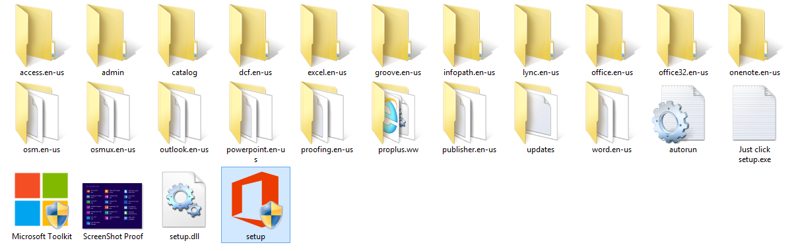

1. Double click on “setup.exe”. Following window opens. Click **Install Now**.

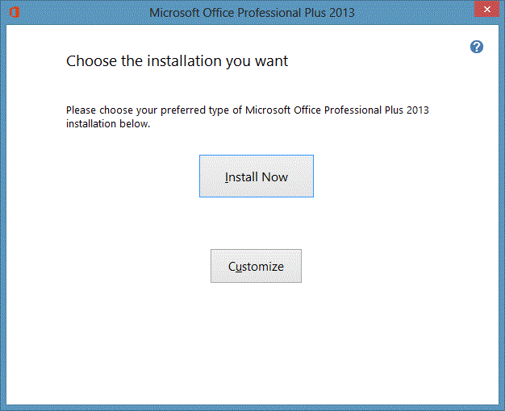

1. Wait for the installation to complete.

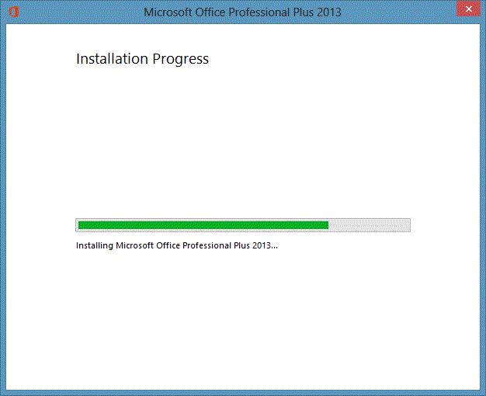

1. Click **Continue Online** for additional support, or click **Close** to begin using Microsoft ® Office 2013 Professional Plus.

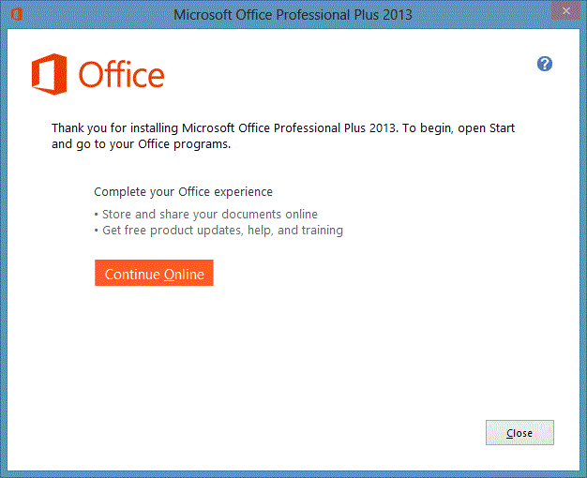

**Opening the Database:**

1. Copy the database from, whatever the source is, to any desired location. Double click the file to open the database.



1. The Login Screen opens up. Enter the username “ch.ahmad” and the default password “tss2014” (password can be changed later) and click **Login** to proceed.

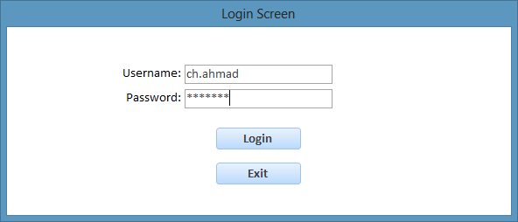

**NAVIGATING THE DATABASE**

There are a total of six navigation menus in the database which allow the user to browse through the database.

1. **Main Menu:**

After the successful login, this menu opens up. It can be used to access the other submenus.

Clicking this button will open the **Suppliers Menu**

Clicking this button will open the **Orders Menu**

Clicking this button will open the **Stock Menu**



Clicking this will open the **Change Password** form

Clicking this button will open the **Sales Menu**

Clicking this button will open the **Supply Received Menu**

Clicking this button will close the database

1. **Stock Menu:**

This form allows the user to view all the objects and processes in the database related to Stock.

Clicking this button will open the **Stock Form**

Clicking this button will close the database

Clicking this button will return the user to the **Main Menu**

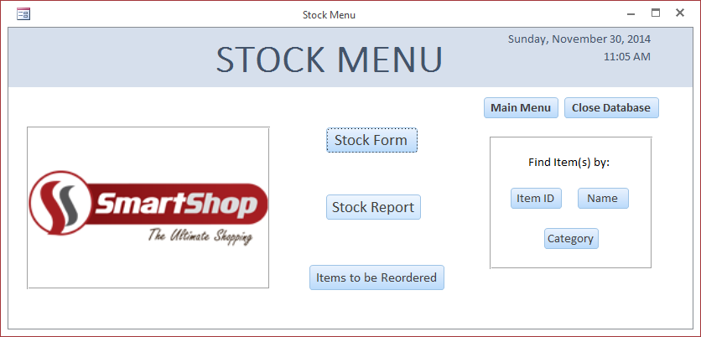

These buttons allow to search for item records according to specified criteria

Clicking this button will open the **Stock Report** showing items that need to be reordered

Clicking this button will open the **Stock Report**

1. **Suppliers Menu:**

This form allows the user to view all the objects and processes in the database related to Suppliers.

Clicking this button will close the database

Clicking this button will return the user to the **Main Menu**

Clicking this button will open the **Suppliers Form**

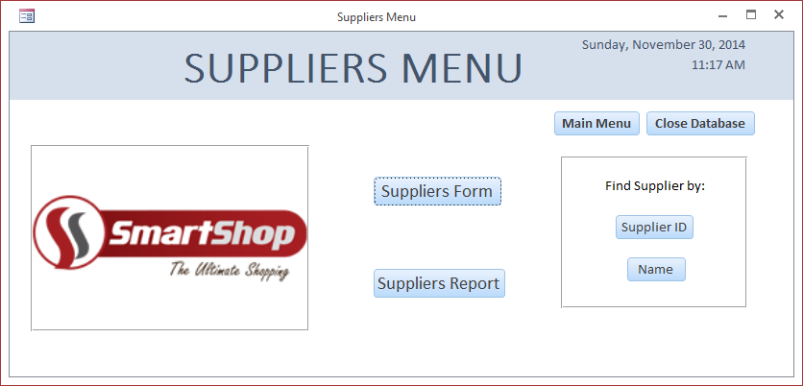

These buttons allow to search for supplier records according to specified criteria

Clicking this button will open the **Suppliers Report**

1. **Sales Menu:**

This form allows the user to view all the objects and processes in the database related to Sales.

Clicking this button will return the user to the **Main Menu**

Clicking this button will open the **Sales Form**

Clicking this button will close the database

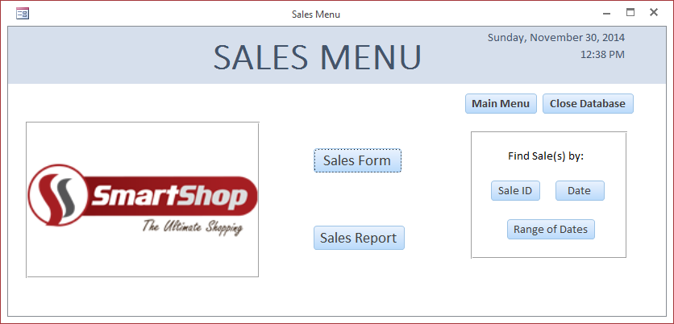

Clicking this button will open the **Sales Report**

These buttons allow to search for sales records according to specified criteria

1. **Orders Menu:**

This form allows the user to view all the objects and processes in the database related to Orders.

Clicking this button will return the user to the **Main Menu**

Clicking this button will open the **Orders Form**

Clicking this button will close the database

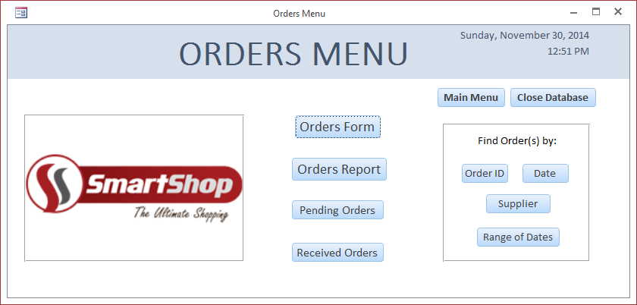

Clicking this button will open the **Orders Report**

These buttons allow to search for order records according to specified criteria

Clicking this button will open the **Orders Report** showing received orders only

Clicking this button will open the **Orders Report** showing pending orders only

1. **Supply Received Menu:**

This form allows the user to view all the objects and processes in the database related to the Supply Received.

Clicking this button will return the user to the **Main Menu**

Clicking this button will open the **Supply Received Form**

Clicking this button will close the database

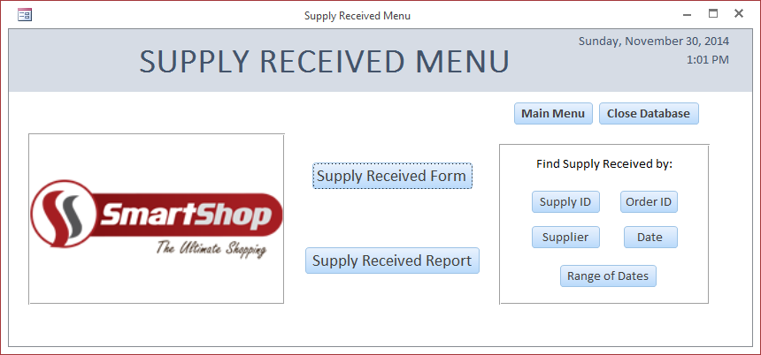

These buttons allow to search for supply records according to specified criteria

Clicking this button will open the **Supply Received Report**

**WORKING WITH DATA ENTRY FORMS**

The user will enter data in the database through the data entry forms. The data entry forms will be used to enter, edit, delete and view records.

There are a total of five data entry forms in the database:

1. Stock Form
2. Suppliers Form
3. Sales Form
4. Orders Form
5. Supply Received Form
6. **Stock Form:**

This form is used to enter data about items. To open this form, go to **Stock Menu** then click **Stock Form** button.

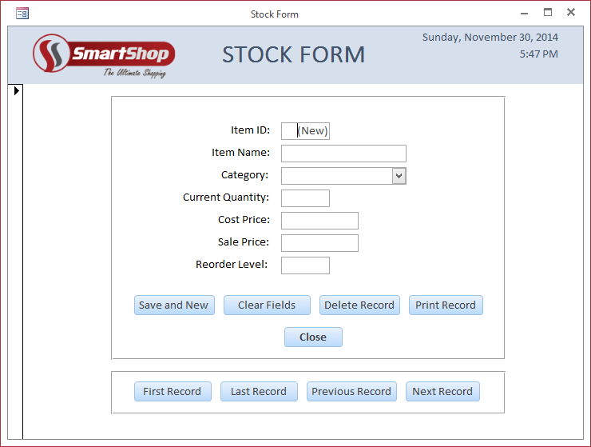

Clicking this button will close the form

Clicking this button will print the record

Clicking this button will clear the fields

Clicking this button will save the record and clear the fields

Clicking this button will delete the record

These buttons allow to navigate between existing records

The following table describes what type of data is acceptable in each field and example data:

|  |  |  |
| --- | --- | --- |
| **Field Name** | **Description** | **Example** |
| Item Name | A name up to 60 characters or less is acceptable | Dawn Bread |
| Category | A value only from the list is acceptable | EATABLES |
| Current Quantity | Any number greater or equal to 0 is acceptable | 10 |
| Cost Price | Any number greater than 0 is acceptable | 50 |
| Sale Price | Any number greater than 0 is acceptable | 60 |
| Reorder Level | Any number greater than 0 is acceptable | 20 |

If you enter data other than the description, you will experience error messages. To deal with the error messages simply click **OK** and enter data that is acceptable. To get a detailed description of the error messages please refer to the section: **Error Messages** on **Page 431.**

1. **Suppliers Form:**

This form is used to enter data about suppliers. To open this form, go to **Suppliers Menu** then click **Suppliers Form** button.

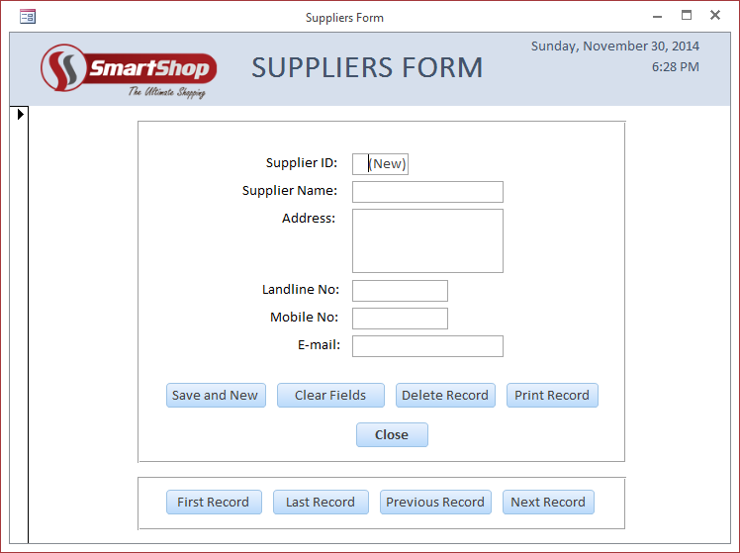

Clicking this button will close the form

Clicking this button will print the record

Clicking this button will clear the fields

Clicking this button will save the record and clear the fields

Clicking this button will delete the record

These buttons allow to navigate between existing records

The following table describes what type of data is acceptable in each field and example data:

|  |  |  |
| --- | --- | --- |
| **Field Name** | **Description** | **Example** |
| Supplier Name | A name up to 40 characters or less is acceptable | Shahid |
| Address | An address up to 150 characters or less is acceptable | - |
| Landline No | A landline number up to 10 characters is acceptable. It should have numbers only | 0524654789 |
| Mobile No | A landline number up to 11 characters is acceptable. It should have numbers only | 03336452985 |
| Email | An email up to 40 characters or less is acceptable | shahid@gmail.com |

If you enter data other than the description, you will experience error messages. To deal with the error messages simply click **OK** and enter data that is acceptable. To get a detailed description of the error messages please refer to the section: **Error Messages** on **Page 431.**

1. **Sales Form:**

This form is used to enter data about sales. To open this form, go to **Sales Menu** then click **Sales Form** button.

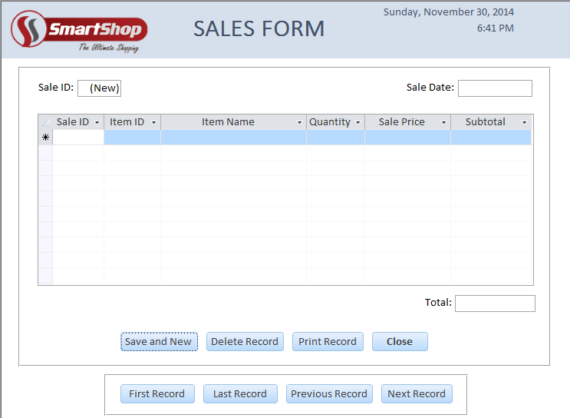

Clicking this button will save the record and clear the fields

Clicking this button will delete the record

Clicking this button will print the record

Clicking this button will close the form

These buttons allow to navigate between existing records

The following table describes what type of data is acceptable in each field and example data:

|  |  |  |
| --- | --- | --- |
| **Field Name** | **Description** | **Example** |
| Sale Date | Date in the format dd-mm-yy. Only the current date is acceptable | 30-Nov-14 |
| Item ID | Any number greater than 0 is acceptable | 2 |
| Item Name | A name only from the list is acceptable. When you enter/select an item from the list, the **Item ID** and **Sale Price** fields will fill automatically | DAWN BREAD |
| Quantity | Any number greater or equal to 0 is acceptable | 10 |
| Sale Price | Any number greater than 0 is acceptable | 60 |

If you enter data other than the description, you will experience error messages. To deal with the error messages simply click **OK** and enter data that is acceptable. To get a detailed description of the error messages please refer to the section: **Error Messages** on **Page 431.**

1. **Orders Form:**

This form is used to enter data about orders. To open this form, go to **Orders Menu** then click **Orders Form** button.

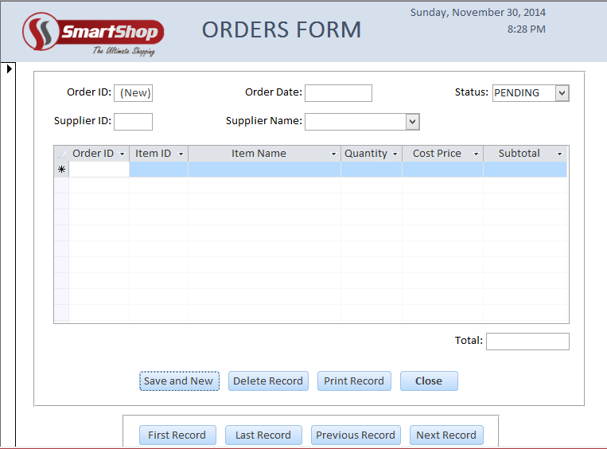

Clicking this button will save the record and clear the fields

Clicking this button will delete the record

Clicking this button will print the record

Clicking this button will close the form

These buttons allow to navigate between existing records

The following table describes what type of data is acceptable in each field and example data:

|  |  |  |
| --- | --- | --- |
| **Field Name** | **Description** | **Example** |
| Order Date | Date in the format dd-mm-yy | 30-Nov-14 |
| Status | A value only from the list is acceptable | PENDING |
| Supplier ID | Any number greater than 0 is acceptable | 3 |
| Supplier Name | A name only from the list is acceptable. When you enter/select a name from the list, the **Supplier ID** field will fill automatically | SHAHID AZAM |
| Item ID | Any number greater than 0 is acceptable | 2 |
| Item Name | A name only from the list is acceptable. When you enter/select an item from the list, the **Item ID** and **Cost Price** fields will fill automatically | DAWN BREAD |
| Quantity | Any number greater or equal to 0 is acceptable | 10 |
| Cost Price | Any number greater than 0 is acceptable | 50 |

If you enter data other than the description, you will experience error messages. To deal with the error messages simply click **OK** and enter data that is acceptable. To get a detailed description of the error messages please refer to the section: **Error Messages** on **Page 431.**

1. **Supply Received Form:**

This form is used to enter data about supply received. To open this form, go to **Supply Received Menu** then click **Supply Received Form** button.

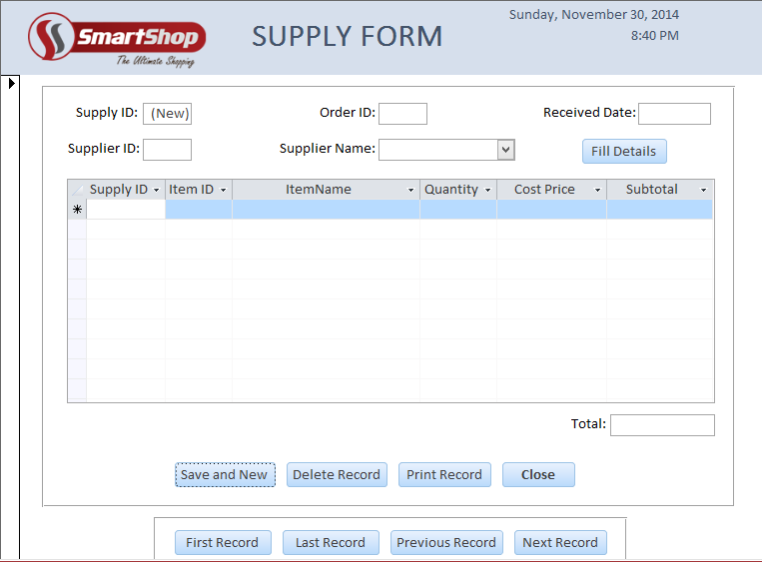

Clicking this button will save the record and clear the fields

Clicking this button will delete the record

Clicking this button will print the record

Clicking this button will close the form

These buttons allow to navigate between existing records

The following table describes what type of data is acceptable in each field and example data:

|  |  |  |
| --- | --- | --- |
| **Field Name** | **Description** | **Example** |
| Received Date | Date in the format dd-mm-yy | 30-Nov-14 |
| Order ID | Any number greater than 0 is acceptable | 4 |
| Supplier ID | Any number greater than 0 is acceptable | 3 |
| Supplier Name | A name only from the list is acceptable. When you enter/select a name from the list, the **Supplier ID** field will fill automatically | SHAHID AZAM |
| Item ID | Any number greater than 0 is acceptable | 2 |
| Item Name | A name only from the list is acceptable. When you enter/select an item from the list, the **Item ID** and **Cost Price** fields will fill automatically | DAWN BREAD |
| Quantity | Any number greater or equal to 0 is acceptable | 10 |
| Cost Price | Any number greater than 0 is acceptable | 50 |

If you enter data other than the description, you will experience error messages. To deal with the error messages simply click **OK** and enter data that is acceptable. To get a detailed description of the error messages please refer to the section: **Error Messages** on **Page 431.**

**ERROR MESSAGES**

There are more than one type of error messages in this database which appear when invalid data is entered in the fields of the data entry forms. Each error message tells what type of data is required in the field.

The different type of error messages are discussed in this section and the circumstances in which they appear are also mentioned.

* **Type 1**

This error message appears when the limit for characters in a field is exceeded. For example, the limit for Supplier Name field in Supplier Form is 40 and the user enters 42 characters, then this error message is shown. Click **OK** to close this error message and then enter data less than maximum length.



* **Type 2**

This error message appears when a value outside the list is entered. For example, DISPATCHED is entered in Status field in Orders Form, then this error message is shown. Click **OK** to close this error message and select a value from the list.



* **Type 3**

This error message appears when a value less than 0 is entered. For example, -2 is entered in the Current Quantity field in Stock Form, then this error message is shown. Click **OK** to close this error message and then enter a value greater or equal to 0.



* **Type 4**

This error message appears when a value less than or equal to 0 is entered. For example, 0 is entered in the Sale Price field in Stock Form, then this error message is shown. Click **OK** to close this error message and then enter a value greater than 0.



* **Type 5**

This error message appears when alphabets or non-numeric data is entered. For example, “four” is entered in the Landline No field in Suppliers Form, then this error message is shown. Click **OK** to close this error message and then enter numeric data only.



* **Type 6**

This error message appears when current data is not entered. For example, today’s date is not entered in the Sale Date field in the Sales Form, then this error message is shown. Click **OK** to close this error message and then enter the current date.



* **Type 7**

This error message appears when a field that is required is left blank. For example, Item Name field in the Stock Form is left black and record is tried to be save, then this error message is shown. Click **OK** to close this error message and enter data in the field.

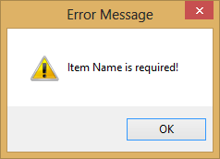

**SEARCHING THE DATABASE**

The database not only store records but also enables the search for the required records in the database. The following steps should be followed to search for record(s):

**Item Searches:**

1. Open **Stock Menu** and click the button of the required search.
2. An input box will be prompted, asking the user to enter the required data.
3. Enter the data and click the **OK** button. If the data is valid, then the required record(s) will be displayed.
4. The user can also click the **Cancel** button on the input prompt box to close it.

* Click the **Item ID** button to search for an item by its Item ID. **Stock Form** will open to display the record.
* Click the **Name** button to search for an item by its Item Name. **Stock Form** will open to display the record.
* Click the **Category** button to search for multiple items by their Category. **Stock Report** will open to display the records.

**Example**

Click the **Item ID** button to search for an item by its Item ID. Enter a value in the field and click the **OK** button to search for the record.



Click this button to close the search form

Click this button to search for the record

**Supplier Searches:**

1. Open **Suppliers Menu** and click the button of the required search.
2. An input box will be prompted, asking the user to enter the required data.
3. Enter the data and click the **OK** button. If the data is valid, then the required record(s) will be displayed.
4. The user can also click the **Cancel** button on the input prompt box to close it.

* Click the **Supplier ID** button to search for a supplier by its Supplier ID. **Suppliers Form** will open to display the record.
* Click the **Name** button to search for a supplier by its Supplier Name. **Suppliers Form** will open to display the record.

**Example**

Click the **Name** button to search for a supplier by its Supplier Name. Select a name from the list and click the **OK** button to search for the record.



Click this button to close the search form

Click this button to search for the record

**Sale Searches:**

1. Open **Sales Menu** and click the button of the required search.
2. An input box will be prompted, asking the user to enter the required data.
3. Enter the data and click the **OK** button. If the data is valid, then the required record(s) will be displayed.
4. The user can also click the **Cancel** button on the input prompt box to close it.

* Click the **Sale ID** button to search for a sale by its Sale ID. **Sales Form** will open to display the record.
* Click the **Date** button to search for multiple sales by their Sale Date. **Sales Report** will open to display the records.
* Click the **Range of Dates** button to search for multiple sales within the specified range of Sale Date. **Sales Report** will open to display the records.

**Example**

Click the **Date** button to search for multiple sales by their Sale Date. Enter a date in the field and click the **OK** button to search for the records.



Click this button to close the search form

Click this button to search for the records

**Order Searches:**

1. Open **Orders Menu** and click the button of the required search.
2. An input box will be prompted, asking the user to enter the required data.
3. Enter the data and click the **OK** button. If the data is valid, then the required record(s) will be displayed.
4. The user can also click the **Cancel** button on the input prompt box to close it.

* Click the **Order ID** button to search for an order by its Order ID. **Orders Form** will open to display the record.
* Click the **Date** button to search for multiple orders by their Order Date. **Orders Report** will open to display the records.
* Click the **Supplier** button to search for multiple orders by their Supplier Name. **Orders Report** will open to display the records.
* Click the **Range of Dates** button to search for multiple orders within the specified range of Order Date. **Orders Report** will open to display the records.

**Example**

Click the **Supplier** button to search for multiple orders by their Supplier Name. Select a supplier from the list and click the **OK** button to search for the records.



Click this button to close the search form

Click this button to search for the records

**Supply Received Searches:**

1. Open **Supply Received Menu** and click the button of the required search.
2. An input box will be prompted, asking the user to enter the required data.
3. Enter the data and click the **OK** button. If the data is valid, then the required record(s) will be displayed.
4. The user can also click the **Cancel** button on the input prompt box to close it.

* Click the **Supply ID** button to search for a supply by its Supply ID. **Supply Received Form** will open to display the record.
* Click the **Order ID** button to search for a supply by its Order ID. **Supply Received Form** will open to display the record.
* Click the **Date** button to search for multiple supplies by their Received Date. **Supply Received Report** will open to display the records.
* Click the **Supplier** button to search for multiple supplies by their Supplier Name. **Supply Received Report** will open to display the records.
* Click the **Range of Dates** button to search for multiple supplies within the specified range of Received Date. **Supply Received Report** will open to display the records.

**Example**

Click the **Range of Dates** button to search for multiple supplies within the specified range of Received Date. Enter the dates in the fields and click the **OK** button to search for the records.



Click this button to close the search form

Click this button to search for the records

**WORKING WITH REPORTS**

The reports will be used to view records in the database and print them if required. There are a total of five reports in the database.

1. **Stock Report:**

This report will show the item records. To open this report, go to **Stock Menu** then click **Stock Report** button.

Clicking this button will print the report

Clicking this button will close the report

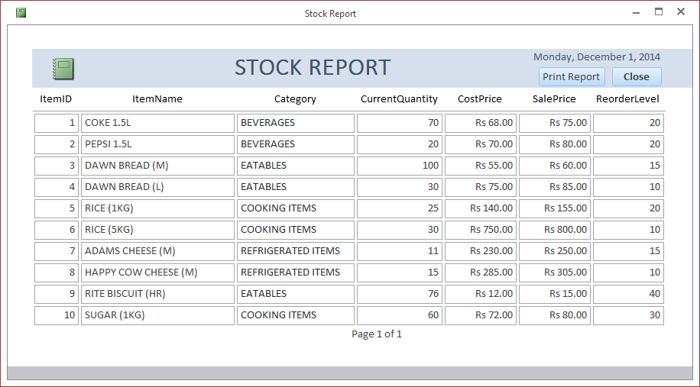

1. **Suppliers Report:**

This report will show the supplier records. To open this report, go to **Suppliers Menu** then click **Suppliers Report** button.

Clicking this button will print the report

Clicking this button will close the report

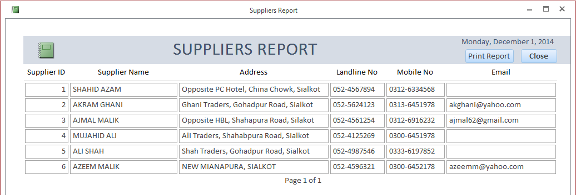

1. **Sales Report:**

This report will show the sales records. To open this report, go to **Sales Menu** then click **Sales Report** button.

Clicking this button will close the report

Clicking this button will print the report

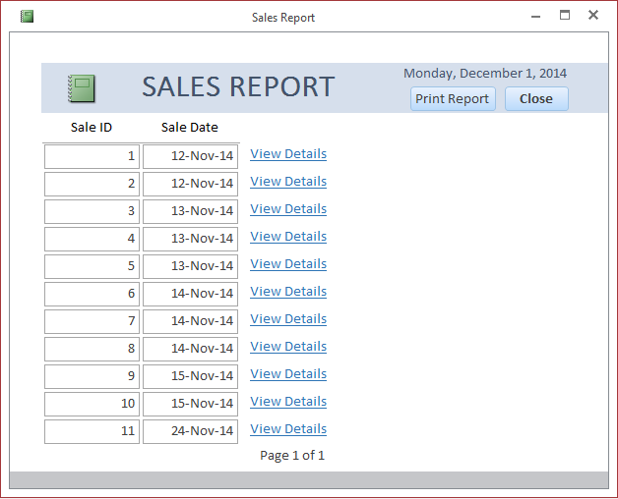

Clicking any of these labels will open the Sales Form showing details of that particular sale

1. **Orders Report:**

This report will show the order records. To open this report, go to **Orders Menu** then click **Orders Report** button.

Clicking this button will print the report

Clicking this button will close the report

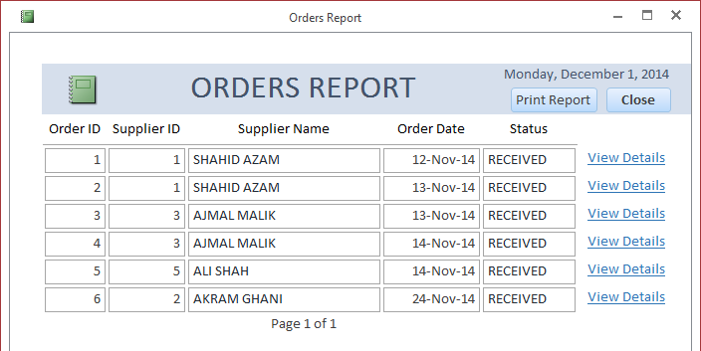

Clicking any of these labels will open the Orders Form showing details of that particular order

1. **Supply Received Report:**

This report will show the supply records. To open this report, go to **Supply Received Menu** then click **Supply Received Report** button.

Clicking this button will print the report

Clicking this button will close the report

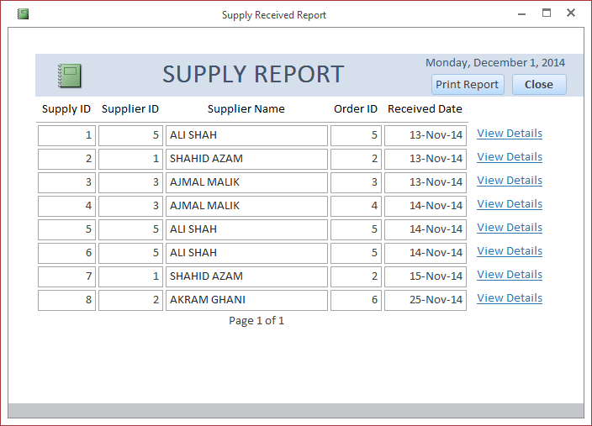

Clicking any of these labels will open the Supply Received Form showing details of that particular supply

**DATABASE SECURITY**

The database is secured using a username and password. It does not allow any unauthorized person to access the database. The login screen opens up when the database is opened and any other part of the database cannot be accessed until the login is successful.

The default Username of the database is “ch.ahmad”. However the Password can be changed when required.

**Login Routine:**

The login screen shows up when the database is opened. Enter the Username and the Password and then click the **Login** button to proceed.



Click this button to close the database

Click this button to Login and proceed to Main Menu

If you do not enter the correct Username and Password, you will experience errors. The errors that can appear are discussed:

* If you enter an incorrect Username, you will get the following error as circled below. Enter the correct Username which is “ch.ahmad” and this will remove the error.



* If you enter an incorrect Password, you will get the following error as circled below. Enter the correct Password and this will remove the error.



* If you leave the Username field blank and try to login you will get an error message. Do not leave the field blank and enter the Username to avoid this error message.



* If you leave the Password field blank and try to login you will get an error message. Do not leave the field blank and enter the Password to avoid this error message.



**Changing the Password:**

To change the database password, go the **Main Menu** and then click the **Change Database Password** label (under the company logo).

Enter the Current Password and then enter the new password in both fields. The click the **OK** button



Click this button to change the password

Click this button to close the form

The following message appears to confirm that password has changed successfully.



If you do not enter valid data in the fields, you will experience error. The errors that can appear are discussed:

* If you enter an incorrect Current Password, you will get the following error as circled below. Enter the correct Password and this will remove the error.



* If you enter a different passwords in the new password fields, you will get the following error as circled below. Enter the same password in both fields and this will remove the error.



* If you leave the Current Password field blank and click OK you will get an error message. Do not leave the field blank and enter the Current Password to avoid this error message.



* If you leave the New Password field blank and click OK you will get an error message. Do not leave the field blank and enter the New Password to avoid this error message.



* If you leave the Re-enter New Password field blank and click OK you will get an error message. Do not leave the field blank and re-enter the New Password to avoid this error message.



**BACKUP ROUTINE**

Taking backups after a certain period of time is essential. In case the original file gets corrupted or damaged, the backup file can be used. In this way there would be no data loss.

The recommended time period to take a backup is 3-4 days. Means you should take backups twice a week. This would ensure an updated backup file is kept. Also keep 2 different backups in two different CDs.

To take a backup follow these steps:

1. Insert the CD/DVD in the DVD-RW drive
2. Right click the database file and select ‘Copy’ as shown below:

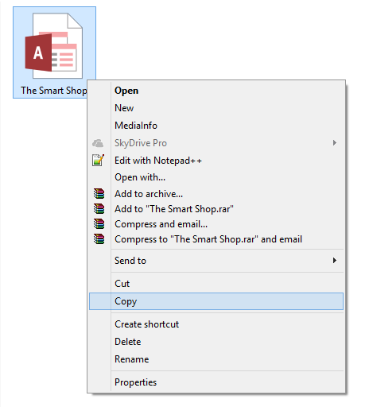

1. Go to My Computer and double click the DVD/CD drive to open it:

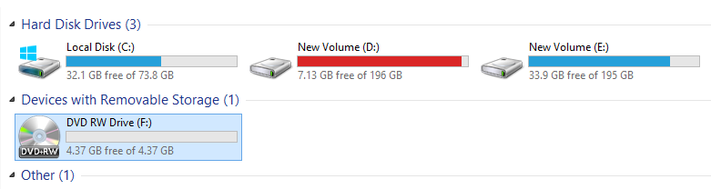

1. After opening the DVD/CD, right click and select ‘Paste’ to burn the file to the DVD/CD.
2. The files will be automatically burned to the CD/DVD.
3. Alternatively, you can click ‘Send to’ and then select the DVD/CD as shown below. It will also burn the file to the disc.

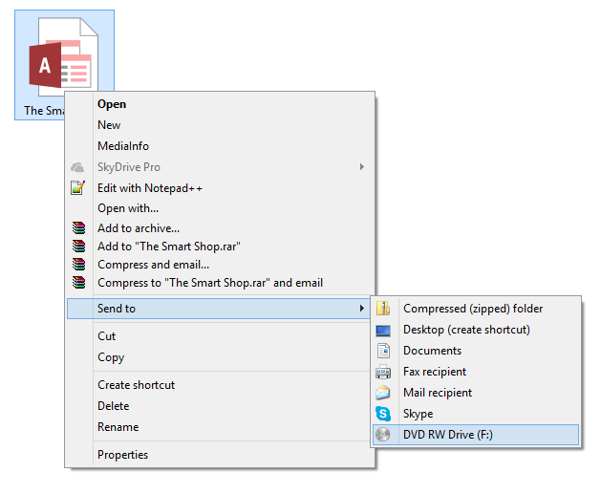

**GUIDE TO COMMON ERRORS**

The database has been tested thoroughly. On each error there is an error message displayed but still some errors need some explanation so in future no time should be wasted. The common errors are discussed below:

* **Adding Items:**

Please make sure that you add an item only once in the database. If you add it more than once problems may be created. Search the database to ensure while adding an item that it does not exist previously.

* **Searching the Database:**

Please make sure that data you are searching for exists and the search criteria matches it correctly otherwise a blank form/report will open in front of you.

* **Printing:**

Please make sure that you have installed latest drivers for your printer and it is set up in the ideal format to print reports. Improper setup might give undesirable results and errors.

**FREQUENTLY ASKED QUESTIONS**

**Q1. After deleting an Item, or Supplier, the ID fields do not have a sequence?**

**Ans**. As soon as you delete a data, Click the File tab and in menu list on the left side Click Info. In the Info menu click Compact and Repair Database to create a sequence in the ID fields.

**Q2. How often should the backup(s) be taken?**

**Ans**. Backup should be taken preferably twice a week to avoid data loss and corruption. This would ensure an updated backup file is kept.

**Q3. When running the database on a new computer, some features do not function as they are supposed to. How to correct this?**

**Ans**. Microsoft Access sometimes blocks content that it may think is potentially harmful and may incorrectly portray the database program as a harmful program so always enable the contents from the security warning before using the program.

**Q4. No records are shown when a correct Date is entered in the format: (dd-mm-yyyy)?**

**Ans**. The Date format is not set in the database. It is based upon your Operating System **Date and Time** settings. Make sure that the Date format is set to (dd-mm-yyyy) so you can retrieve records in this format.

**Q5. I cannot access or enter anything in the Sales sub form or Orders sub form or Supply Received sub form. How do I correct this?**

**Ans**. The sub forms are locked when the main forms are first opened. Make sure you fill any one of the fields on the main form first. Then automatically the sub forms will be unlocked and data can be entered in them.

**EVALUATION**

**DISCUSSION OF THE DEGREE OF SUCCESS IN MEETING THE ORIGINAL OBJECTIVES**

The new system has been developed and successfully implemented in the shop. Yet the success of the new system still needs to be analyzed according to the objectives and requirements that were set initially in agreement with the client.

Each of the Objectives (**Page 36**) are stated below and it is discussed to what degree were they successfully achieved:

1. **‘There should be proper navigation forms which allow the user to move between different parts of the database and select required items providing an easier access.’**

This objective was successfully achieved. The new system has user friendly navigation forms which allow the user to browse through the database and have all the valid options on them which the user can work with. The navigations forms are the Main Menu, Stock Menu, Sales Menu etc. The evidence for this objective can be found in the Development section on **Page 156.**

1. **‘There should be a customized login screen which restricts unauthorized access by using a username and password making the system secure.’**

This objective was also fulfilled with success. The new system does have a customized login screen which requires a Username and Password to authenticate the access to the database. It makes the system secure from any kind of intrusion or data theft. The evidence for this objective can be found in the Development section on **Page 154** and in the Testing section on **Page** **299.**

1. **‘The data entry fields should accept normal (valid) data and extreme (boundary) data which is described by the validation checks’**

This objective was successfully achieved. The data entry forms in the database only accept the valid and extreme data. The system was tested using the valid and extreme data and the data was accepted without any error. The evidence for this objective can be found in the Testing section on **Page 249.**

1. **‘The data entry fields should reject abnormal (invalid) data which violates validation rules and show error messages stating the problem with the entered data.’**

This objective was of critical importance and it was achieved successfully. The data entry forms in the database reject invalid data and custom error messages are shown which tell the user what data is required in the specific field. This ensures only correct data is entered and data integrity is ensured. The evidence for this objective can be found in the Testing section on **Page 249.**

1. **‘The user should be provided with proper search options allowing him to search through the database with several criteria.’**

This objective was also fulfilled with success. The database allow the user to search for record(s) using several criteria. The search of each type of entity is found on its navigation form. The user has more than one method for searching e.g. an item can be searched by ID, Name or Category. The evidence for this objective can be found in the Development section on **Page 173.**

1. **‘The system should have a Password change facility allowing the user to change the password when necessary making the system less vulnerable.’**

This objective was concerned with security and was achieved with success. The new system allow the user to change the current database Password by the Change Password Form. If the user feels the need, he can change it whenever he wants. The evidence for this objective can be found in the Development section on **Page 155** and in the Testing section on **Page 302.**

1. **‘The system should do all the necessary calculations e.g. calculating totals. The user would not have to perform manual calculations.’**

This objective was successfully achieved. The database does all the calculations freeing the user from them ensuring perfection and accuracy. The Sales Form, Orders Form and Supply Received Form have Subtotal and Total fields which are automatically computed and filled. The evidence for this objective can be found in the Development section on **Page 167, 169 and 171.**

1. **‘Data redundancy should be reduced by using primary keys so that no repetition happens and each record is unique.’**

This objective was simple and achieved easily. The tables in the database have Primary Keys which are unique and make sure no repetition is done. Each table has a unique ID to distinguish the records. The evidence for this objective can be found in the Development section on **Page 132, 135, 138, 143 and 148.**

1. **‘There should be automatic stock quantity updating. After a sale, the quantity should decrease accordingly and after a supply is received, quantity should increase accordingly.’**

This objective was perhaps the most important and it was achieved with utmost success. The new system has automatic stock quantity management. After a sale the quantity reduces and after a supply, the quantity increases. The evidence for this objective can be found in the Testing section on **Page** **330 and 336.**

1. **‘There should be separate tables to store records of stock, suppliers, sales, orders and supply received.’**

This objective was simple and was achieved easily. The new system has separate tables for each entity and the records are stored in the tables. The forms are used to access the data and manipulate them accordingly. The evidence for this objective can be found in the Development section on **Page 132, 135, 138, 143 and 148.**

1. **‘The user should be trained to keep proper backups of the database after a specified period of time so that it can be accessed when needed.’**

This objective was fulfilled successfully. The user has been trained to keep backups twice a week. The user can access these backups when required. The evidence for this objective can be found in the User Documentation on **Page 451.**

1. **‘The data entry forms should allow the user to navigate through records and allow updating and deletion of the respective records.’**

This objective was achieved successfully. The data entry forms in the database have buttons which allow the user to navigate between existing records and buttons which allow to update and delete the records. The evidence for this objective can be found in the User Documentation on **Page 420** and in the Development section on **Page** **163.**

1. **‘The new system should be properly documented. There should be System Maintenance Documentation for a system developer. There should be a User Guide for the user to help him use the system and solve any problem faced.’**

This objective has been achieved with success and was essential too. The new system has been developed with a complete System Maintenance Documentation and a comprehensive User Guide. The first one will allow future changes to me made and the second will help the user in every aspect. The System Maintenance Documentation is on **Page 372** and the User Guide is on **Page 409**.

**Testing with Real Data:**

The system has been tested completely by the developer and also by the client. For Alpha testing see **Page 249** and for Beta testing see **Page 343.** During the phase of Beta testing real data was used and no errors were encountered. The client entered real data that is likely to occur in practice. The sets of data entered were:

|  |  |  |  |
| --- | --- | --- | --- |
| **Test No.** | **Data Entry Form** | **Real Data in each Field** | **Evidence** |
| **1** | Stock Form | Item Name: DALDA OIL 1 LITRE  Category: COOKING ITEMS  Current Quantity: 20  Cost Price: 150  Sale Price: 170  Reorder Level: 30 | **Page 346** |
| **2** | Suppliers Form | Supplier Name: AZEEM MALIK  Landline No: 052-4596321  Mobile No: 0300-6452178  E-mail: azeemm@yahoo.com | **Page 348** |
| **3** | Sales Form | Sale Date: 24-Nov-14  Item Name: DAWN BREAD (L)  Quantity: 2  Sale Price: 85 | **Page 350** |
| **4** | Orders Form | Order Date: 24-Nov-14  Status: PENDING  Supplier Name: AKRAM GHANI  Item Name: COKE 1.5L  Quantity: 20  Cost Price: 68 | **Page 352** |
| **5** | Supply Received Form | Order ID: 6  Supplier Name: AKRAM GHANI  Item Name: COKE 1.5L  Quantity: 20  Cost Price: 68 | **Page 354** |

**EVALUATION OF THE CLIENT’S AND USER’S RESPONSE TO THE SYSTEM**

The system has been developed according the specification that was agreed with the client and it has been tested to every possible extent. It has been implemented and installed in the shop according to the agreed plan.

The system was developed keeping in mind every objective that was to be achieved and as proved in the previous section, all the objectives are achieved. According to the testing, there are no known faults in the system but the client’s and user’s response is the key point here. Their approval is the center of this whole solution.

Mr. Ahmad Chaudhry is the client and he is also the user if the system. So his response is what matters the most. The whole effort proved to be a success when I received an overwhelmingly positive response from the client/user.

The new system is upto the expectations of the client and it has made the working of the shop much easier. Stock management has become easy and the overall performance of the shop has a positive change in the time the solution was working. The feedback of the client is the final verdict which has proven the new system to be a success.

Evidence of the user using the system is on **Page 343.**

On the **next page,** a letter received from the client has been shown.

Following is a response from the client who is also the user of the system:

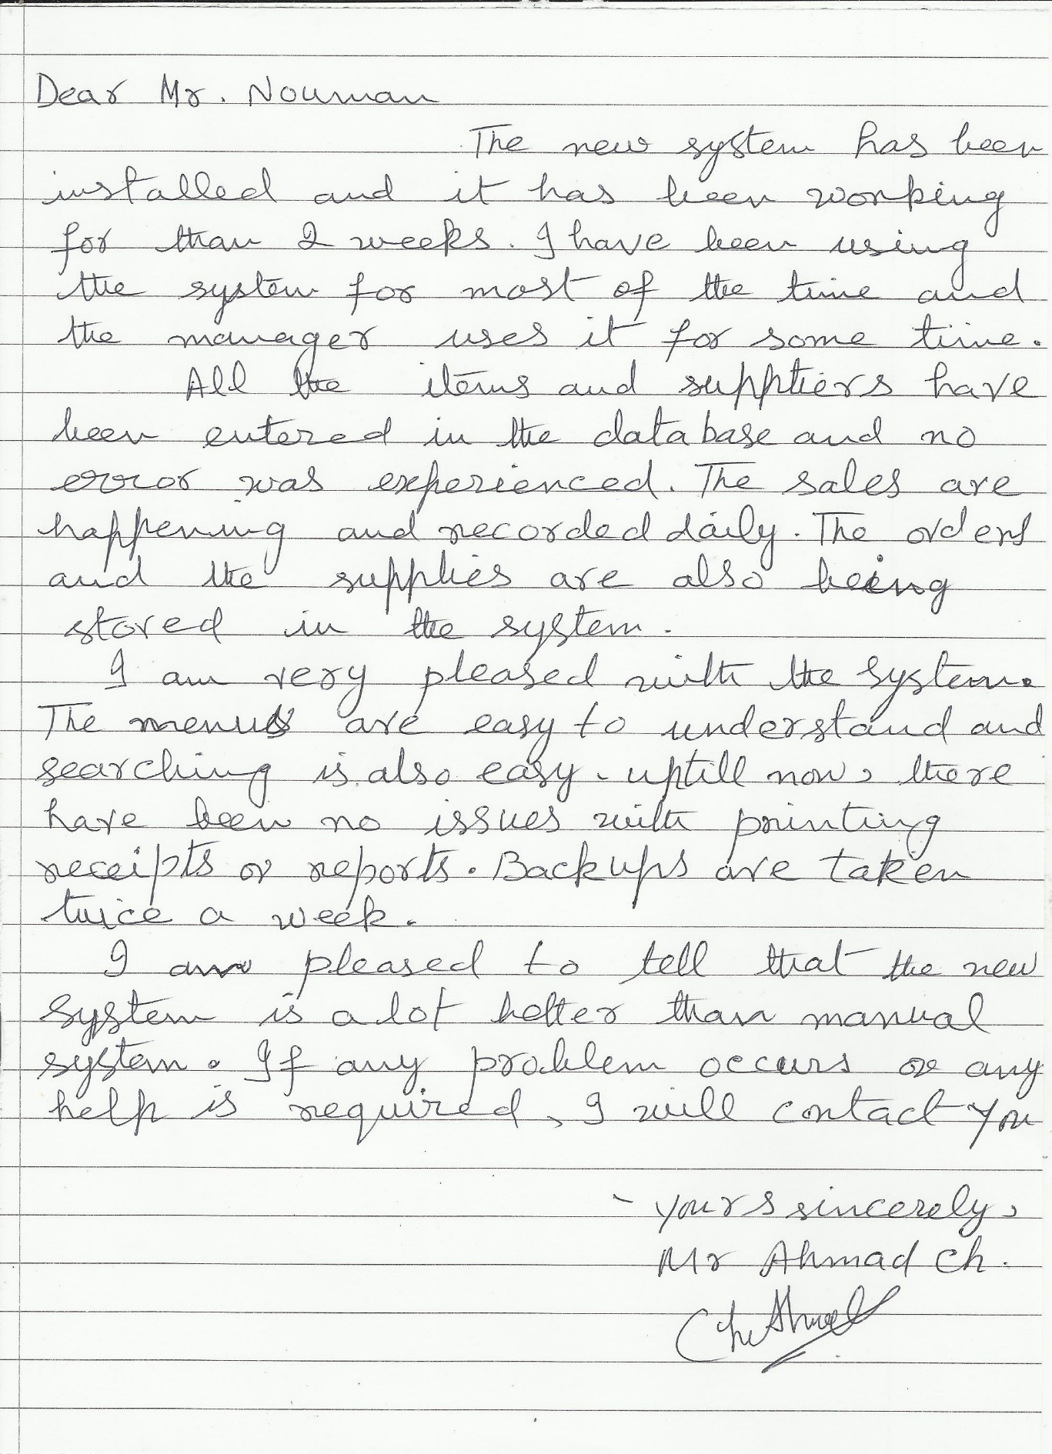

The letter from the client from the previous page is typed below as it would be difficult to understand the content from the picture:

*Dear Mr. Nouman,*

*The new system has been installed and it has been working for more than 2 weeks. I have been using the system for most of the time and the manager uses it for some time.*

*All the items and suppliers have been entered in the database and no error was experienced. The sales are happening and recorded daily. The orders and the supplies are also being stored in the system.*

*I am very pleased with the system. The menus are easy to understand and searching is also easy. Up till now, there have been no issues with printing receipts or reports. Backups are taken twice a week.*

*I am pleased to tell that the new system is a lot better than the manual system and it is running perfectly without any issues. If any problem occurs or any help is required, I will contact you.*

*Yours sincerely,*

*Mr. Ahmad Ch.*

The following deductions can be made from the response:

* The new system is easy to use and understand as indicated by the client.
* The user has added the items and suppliers without facing problems so it is working perfectly. The daily tasks are also being done easily.
* Printing and taking backups is happeing which shows tasks related to the system are easy to perform.
* The user/client points out that the new system is running perfectly without any issues and it is better than the old manual system.
* The client has not asked for any changes and improvements which means it is working according to his requirements.